**Installing Node.js on Windows**

In this section, we'll look at installing Node.js on Windows 10 and up. As a non-Windows user feel free to skip this section.

While **nvm** is recommended for macOS and Linux, and there is an unaffiliated **nvm-windows** version manager the recommended version manager for Windows is **[nvs](https://github.com/jasongin/nvs" \t "_blank)**. The **nvs** version manager is actually cross-platform so can be used on macOS and Linux but **nvm** is a lot more popular.

To install **nvs** on Windows go to the release page here, <https://github.com/jasongin/nvs/releases> and download the MSI installer file of the latest release:

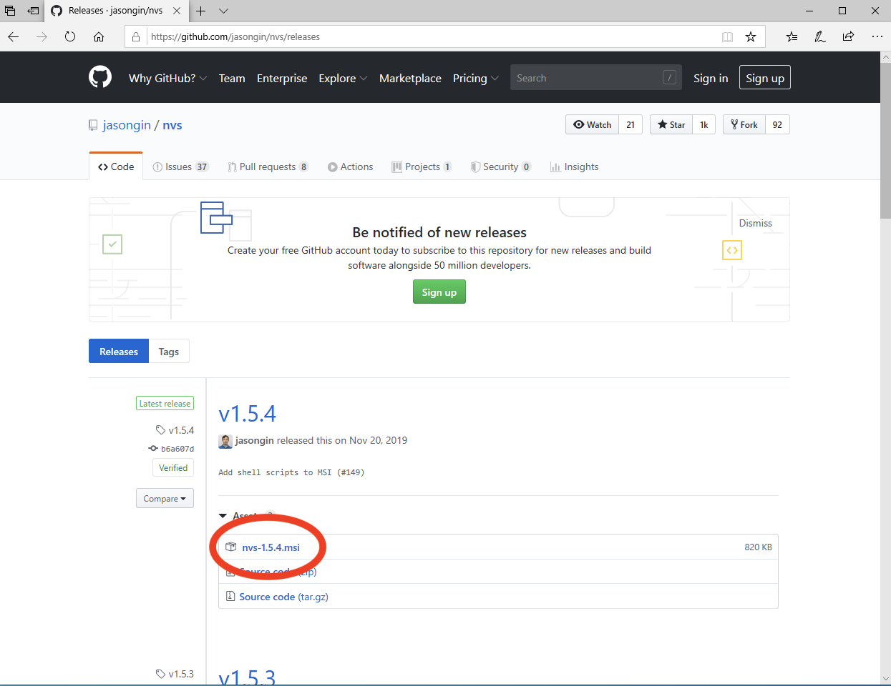

If a later release than v1.5.4 is available, download the MSI for that release. Once downloaded, run the installer and follow the steps to install. After it's installed open a **cmd.exe** or powershell prompt and run the following:

**nvs add 12**

This should result in the latest version of Node 12 being installed:

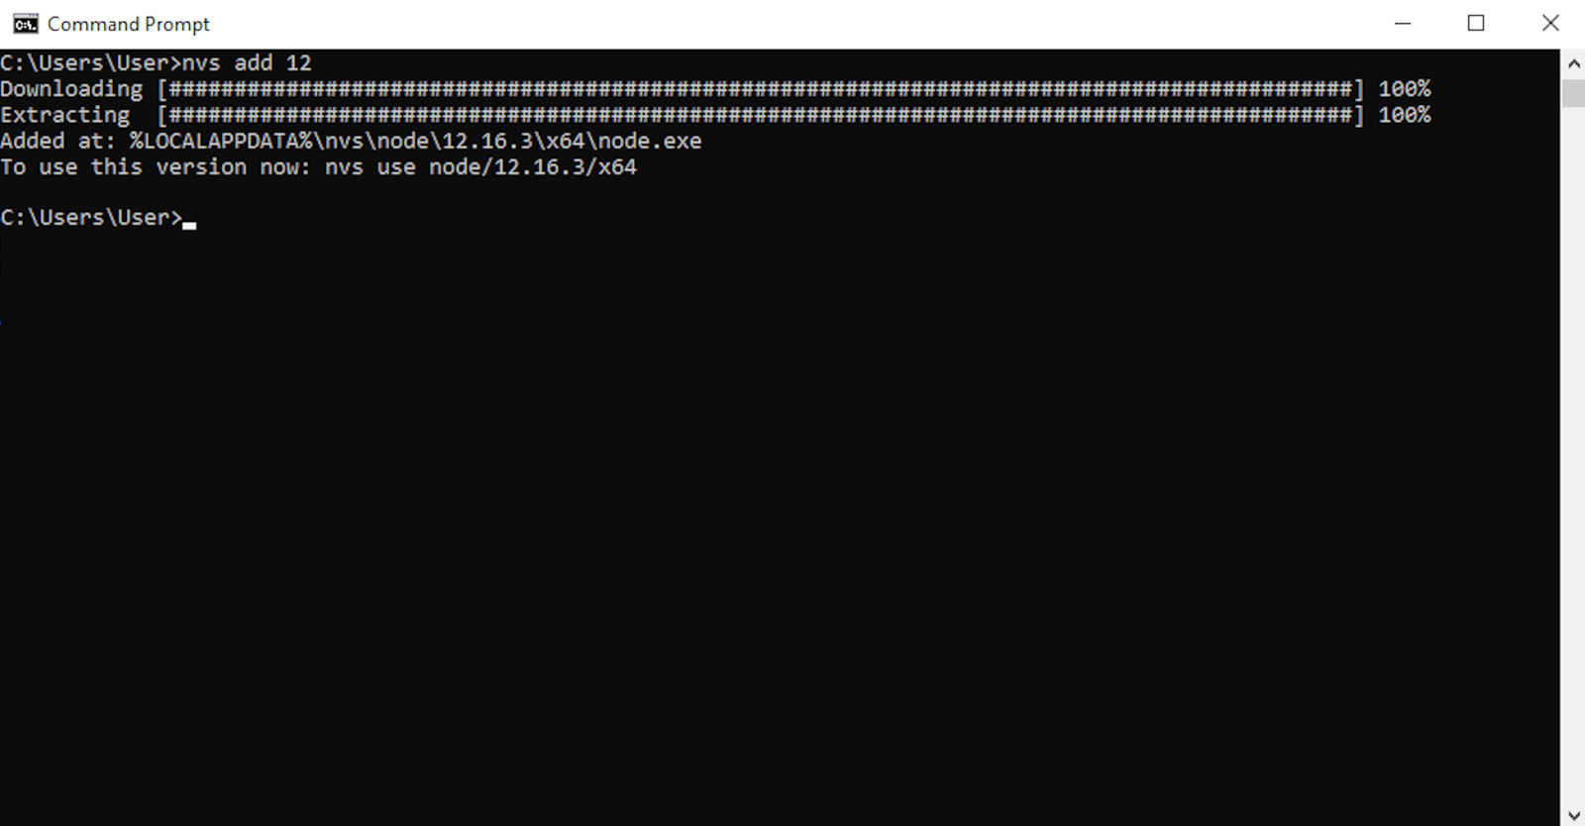

In this case the command installed Node v12.16.3, it doesn't matter if the right-most numbers are higher for this course, as long as the major number (the first number) is 12.

To activate the newly installed version we also need to run the following command:

**nvs use 12**

This should result in output similar to the following:

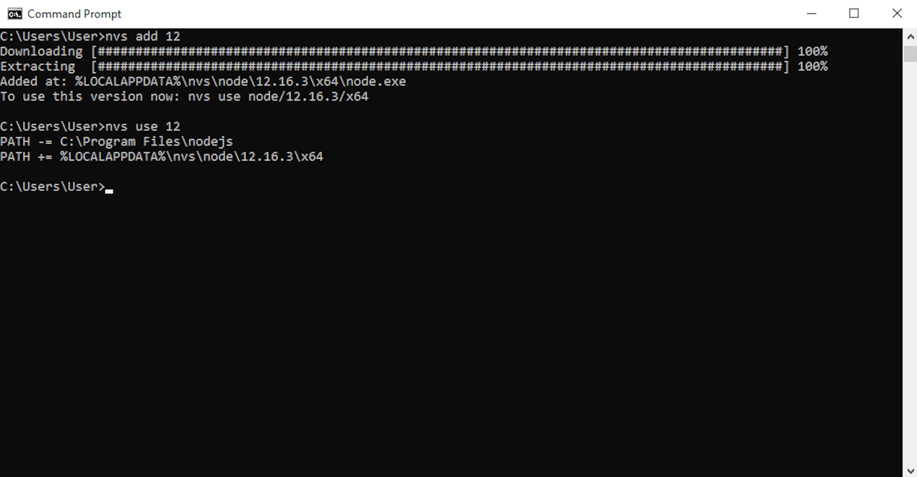

We can verify that Node is installed, and which version, with the following command:

**node -v**

Congratulations, you now have the right setup on your Windows machine to proceed with the course.