**The npm Command**

When Node.js is installed, the **node** binary and the **npm** executable are both made available to the Operating System that Node.js has been installed into. The **npm** command is CLI tool that acts as a package manager for Node.js. By default it points to the npmjs.com registry, which is the default module registry.

The **npm help** command will print out a list of available commands:

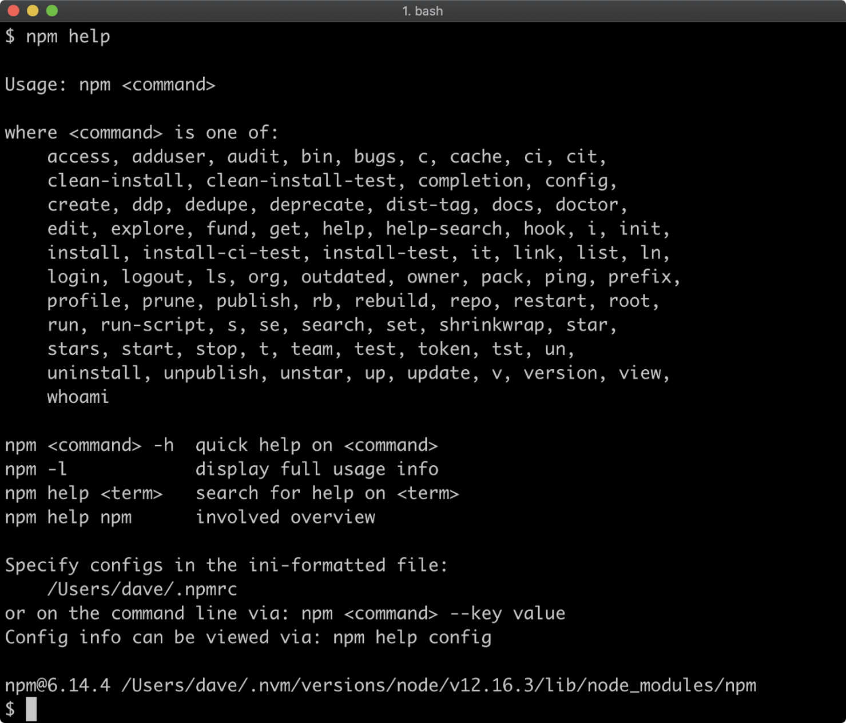

A quick help output for a particular command can be viewed using the **-h** flag with that command:

**npm install -h**

