**Installing Dependencies (Cont.)**

Now that we have the dependency we can use it:

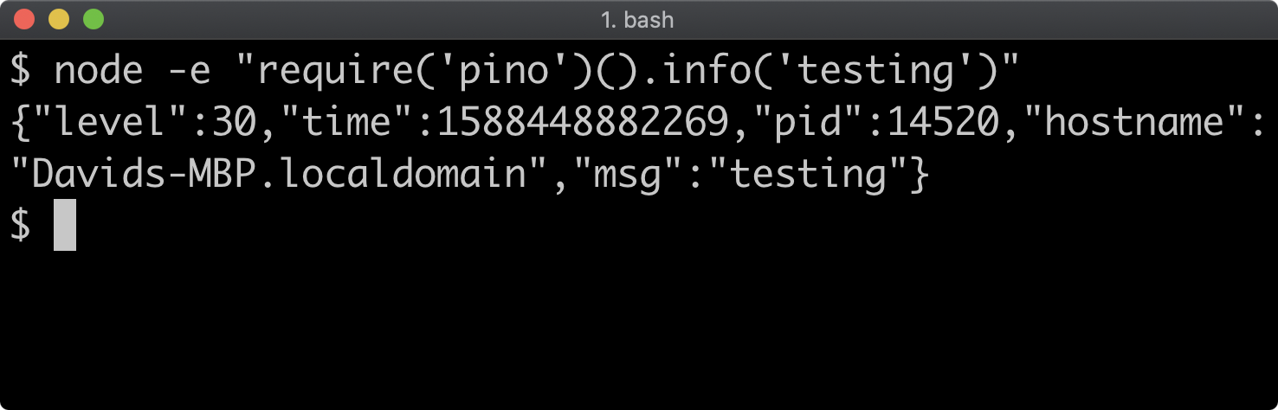

Loading dependencies will be covered comprehensively in *Section 7: "Node's Module System"*.

A primary reason for adding the installed dependency to the **package.json** file is to make the **node_modules** folder disposable.

Let's delete the **node_modules** folder:

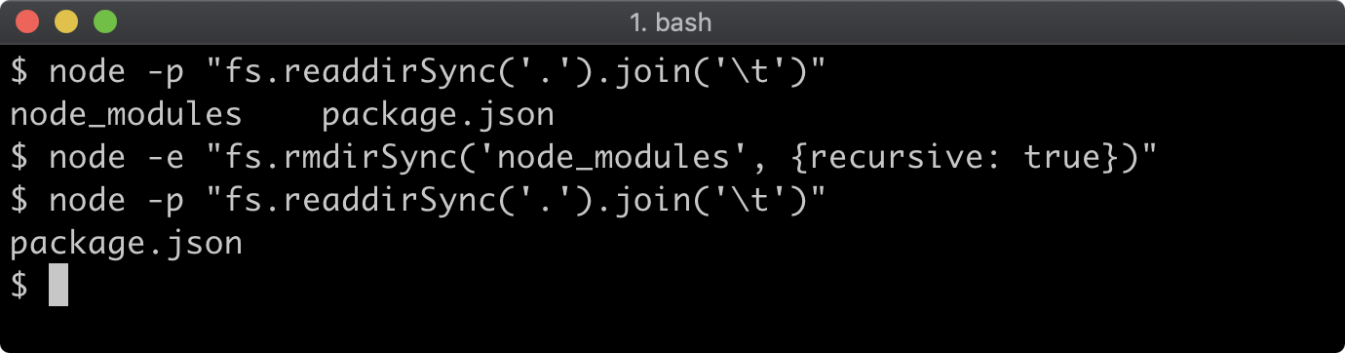

If we run **npm ls** it won't print out the same tree any more because the dependency isn't installed, but it will warn that the dependency should be installed:

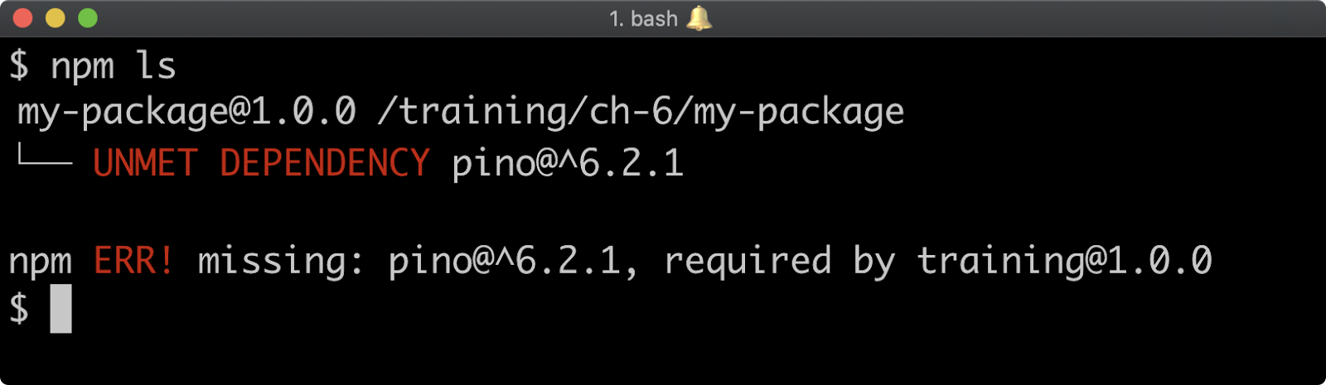

To install the dependencies in the **package.json** file, run **npm install** without specifying a dependency namespace:

**npm install**

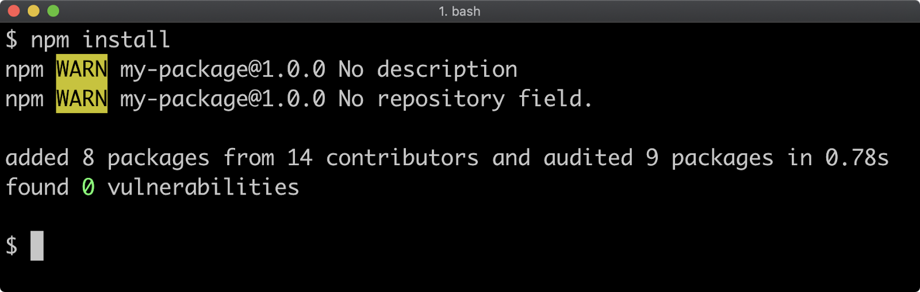

Running **npm ls** now will show that the logger has been installed again:

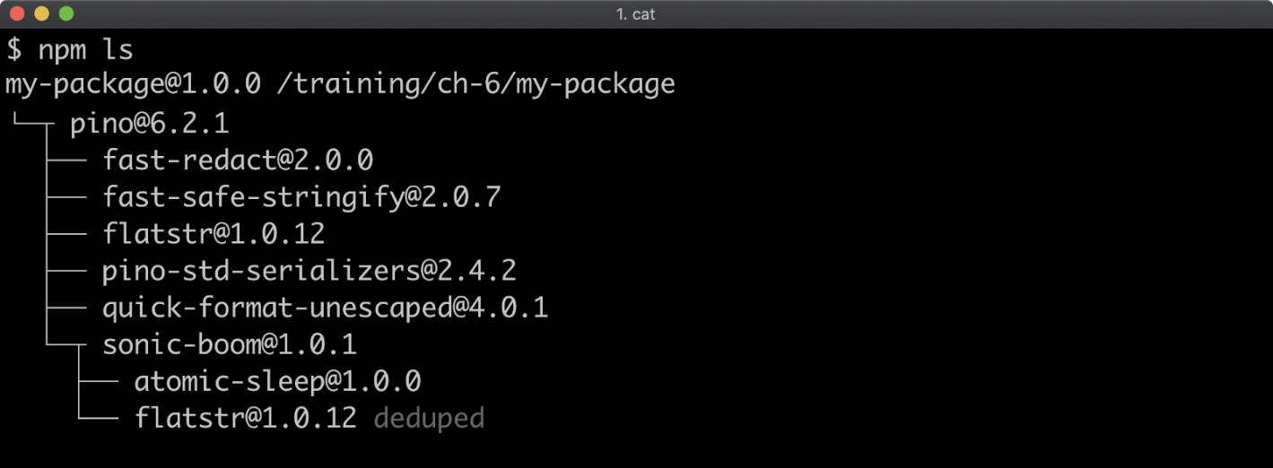

The **node_modules** folder should not be checked into git, the **package.json** should be the source of truth.