**Development Dependencies**

Running **npm install** without any flags will automatically save the dependency to the **package.json** file's **"dependencies"** field. Not all dependencies are required for production, some are tools to support the development process. These types of dependencies are called development dependencies.

An important characteristic of development dependencies is that only top level development dependencies are installed. The development dependencies of sub-dependencies will not be installed.

Dependencies and development dependencies can be viewed in the Dependency tab of any given package on npmjs.com, for **pino** that can be accessed at [Pino's Dependencies Documentation](https://www.npmjs.com/package/pino?activeTab=dependencies" \t "_blank).

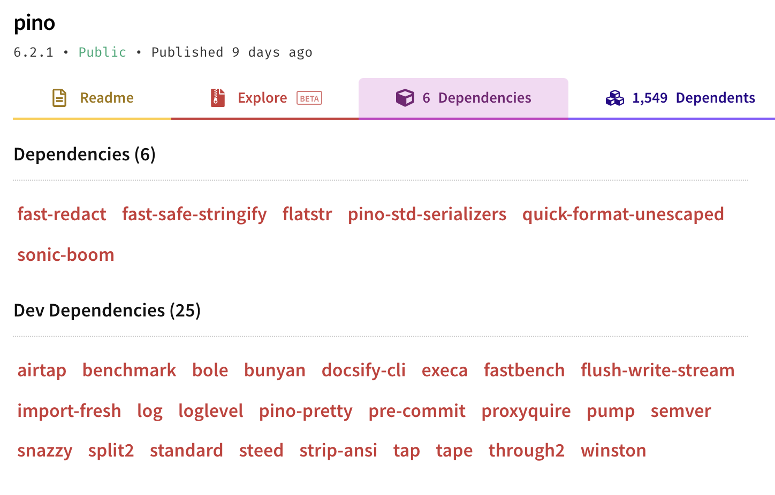

When we **run npm** ls we only see the production dependencies in the tree, none of the development dependencies are installed, because the development dependencies of installed packages are never installed.

**npm ls**

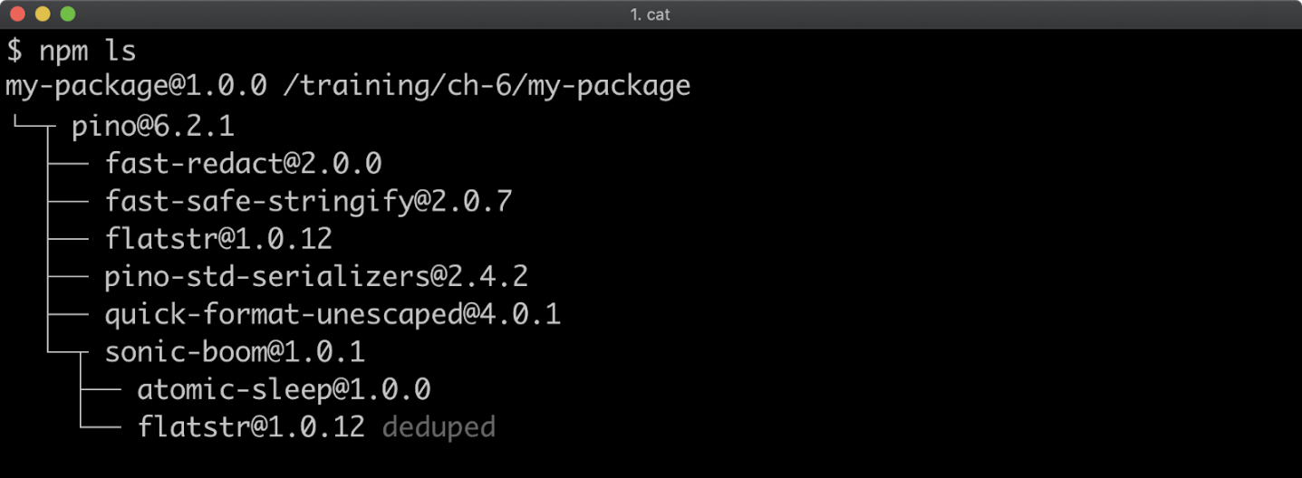

Let's install a linter as a development dependency into **my-package**:

**npm install --save-dev standard**

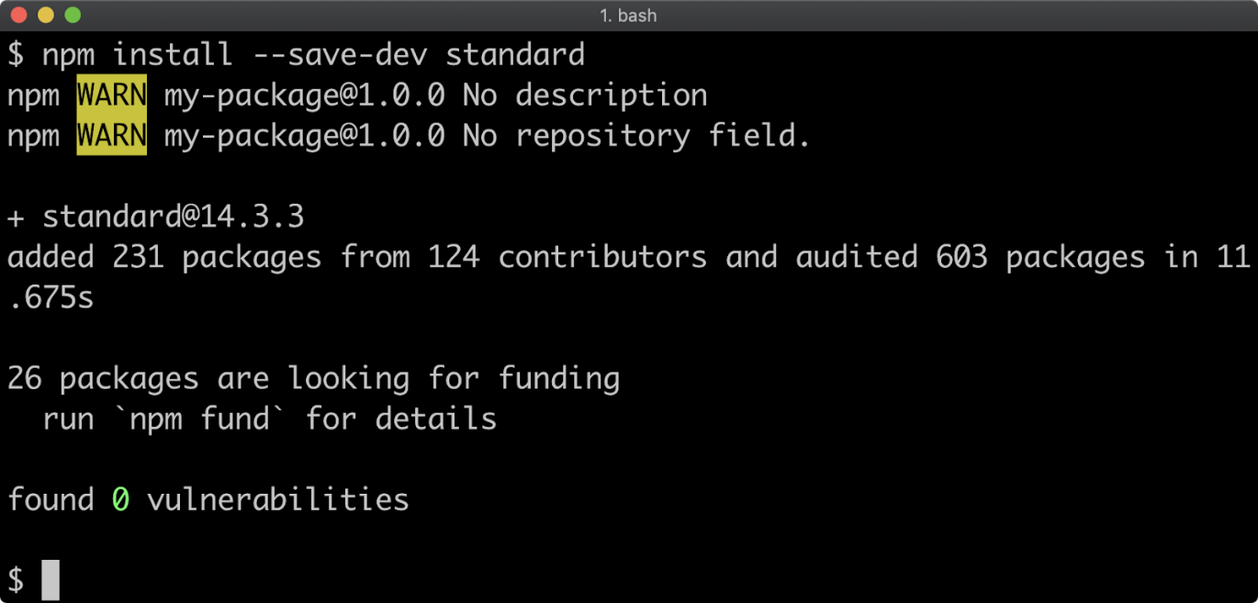

 Now let's take a look at the **package.json** file:

**{  
  "name": "my-package",  
  "version": "1.0.0",  
  "description": "",  
  "main": "index.js",  
  "scripts": {  
    "test": "echo \"Error: no test specified\" && exit 1"  
  },  
  "keywords": [],  
  "author": "",  
  "license": "ISC",  
  "dependencies": {  
    "pino": "^6.2.1"  
  },  
  "devDependencies": {  
    "standard": "^14.3.3"  
  }  
}**

*Cont'd on the next page.*