**Development Dependencies (Cont.)**

In addition to the **"dependencies"** field there is now a **"devDependencies"** field.

Running **npm ls** now reveals a much larger dependency tree:

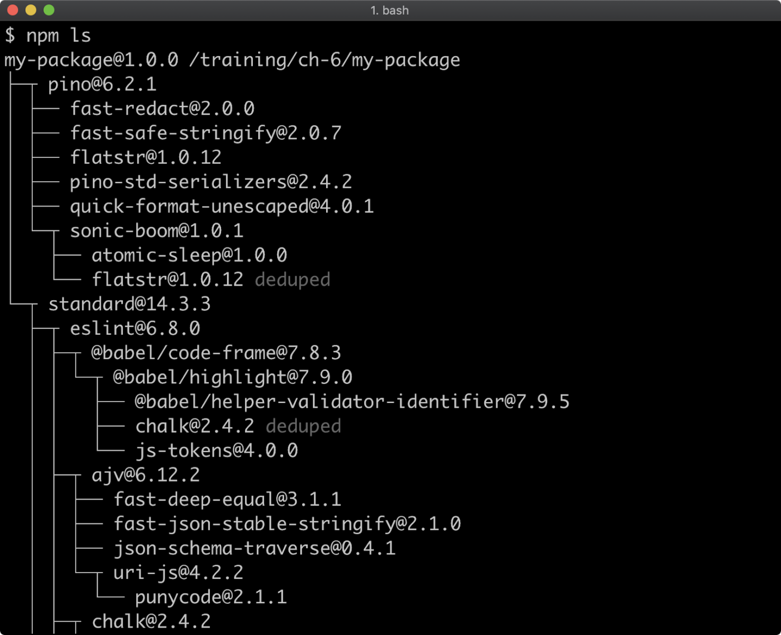

When deploying a service or application for production use, we don't want to install any dependencies that aren't needed in production.

A **--production** flag can be used with **npm install** so that development dependencies are ignored

Let's remove the **node_modules** folder:

**node -e "fs.rmdirSync('node_modules', {recursive: true})"**

Node is being used here to remove the **node_modules** folder because this command is platform independent, but we can use any approach to remove the folder as desired.

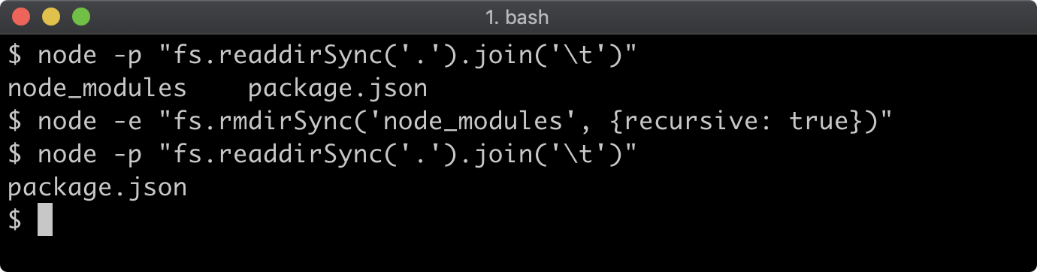

Now let's run **npm install** with the **--production** flag:

**npm install --production**

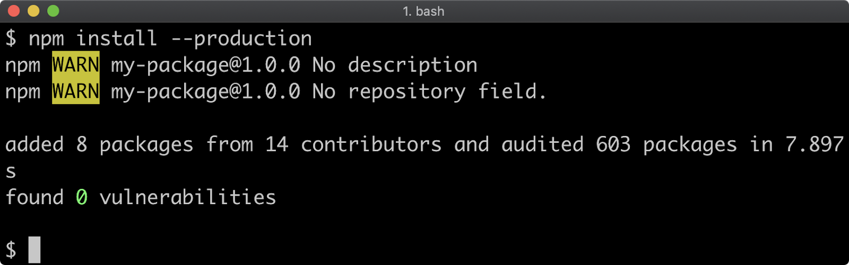

While **pino** and **standard** are both dependencies of **my-package**, only **pino** will be installed when **--production** is used because **standard** is specified as a development dependency in the **package.json**. This can be verified:

**npm ls**

