**Package Scripts (Cont.)**

As a result the **index.js** was altered according to the lint rules, and saved.

There are two package scripts namespaces that have dedicated **npm** commands: **npm test** and **npm start**.

The **package.json** already has a **"test"** field, let's run **npm test**:

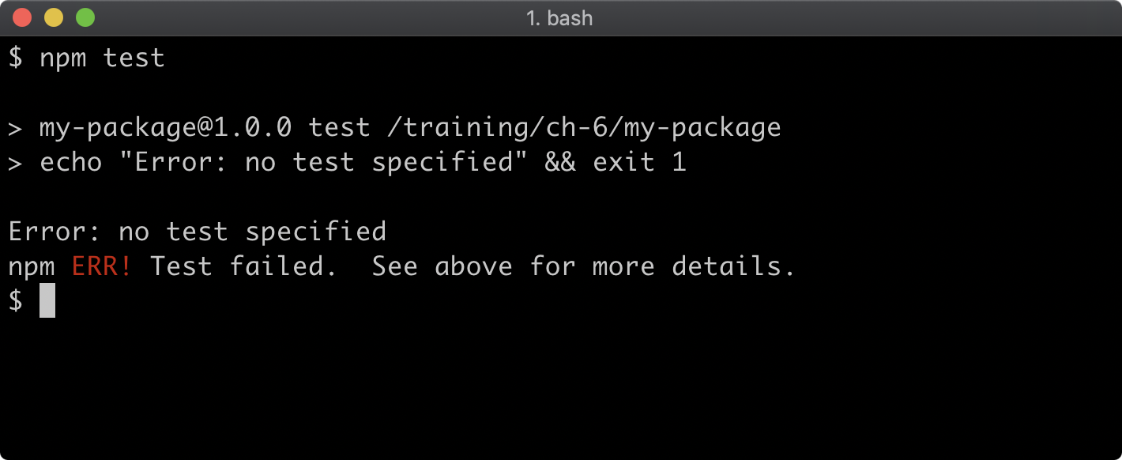

The **"test"** field in package scripts is as follows:

**"test": "echo \"Error: no test specified\" && exit 1"**

The output is as expected. Testing will be explored in full in *Section 16 - "Writing Unit Tests"*.

Note that we did not have to use **npm run test**, the **npm test** command is an alias for **npm run test**. This aliasing only applies to **test** and **start**. Our **npm run lint** command cannot be executed using **npm lint** for example.

Let's add one more script, a **"start"** script, edit the package.json scripts field to match the following:

**"scripts": {  
    "start": "node index.js",  
    "test": "echo \"Error: no test specified\" && exit 1",  
    "lint": "standard"  
  },**

Now let's run **npm start**:

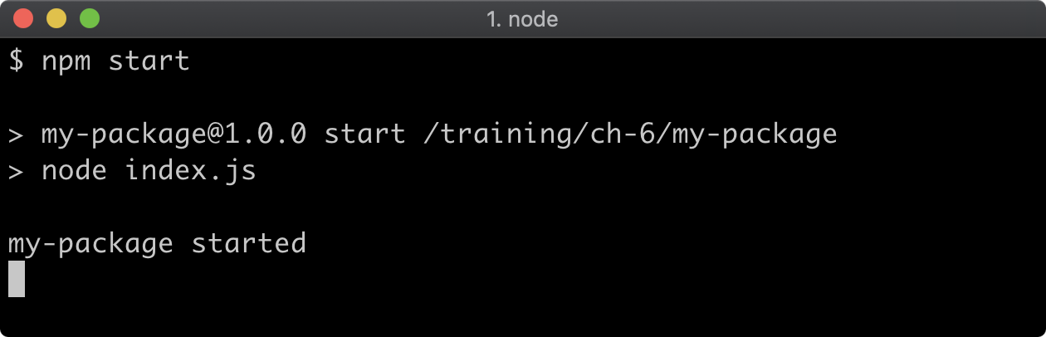

To exit the process, hit CTRL-C.