
Dong Ethnic Drum Tower Damage Detection Using UAV Images and YOLOv8n
June 2, 2026

Abstract
Dong ethnic drum towers are traditional wooden structures with distinctive regional characteristics and significant cultural value. As landmark buildings in Dong villages, they serve as public spaces for community gatherings, social communication, and traditional performances. These towers are exposed to long-term environmental conditions, which can cause visible damage such as material loss, weathering, cracks, and surface detachment. Traditional manual inspection methods are limited by accessibility, subjectivity, and difficulty in producing reproducible quantitative records [1][2][3].
This study proposes an automated detection framework using UAV imagery and YOLOv8n to identify visible damage regions in Dong drum towers. UAV images from three drum towers—Zengchong, Chaoli, and Congjiang—were collected and annotated into YOLO-format datasets containing both positive and negative samples. Three single-case YOLOv8n models were trained to evaluate detection performance for individual towers, and a fusion model was trained on the combined dataset to assess multi-case adaptability. Additional experiments compared YOLOv8n with YOLOv9t, YOLOv10n, and YOLO11n to investigate the applicability of different YOLO versions for this task.
Experimental results demonstrate that the proposed approach can efficiently detect visible damage regions across different drum towers, with the fusion model improving cross-case performance. This framework provides a reproducible and scalable solution for digital monitoring of heritage wooden structures, supporting preservation and maintenance planning.
Keywords: Dong drum tower; damage detection; UAV imagery; YOLOv8n; object detection

Table of Contents
1 Introduction ........................................................................................................ 1
2 Theoretical Background ..................................................................................... 2
2.1 Damage Detection in Historic Buildings ........................................................ 2
2.2 Deep Learning-based Object Detection ......................................................... 3
3 Dataset Construction ......................................................................................... 4
3.1 Data Sources and Splits ................................................................................ 4
3.2 Data Annotation ............................................................................................ 5
4 Method and Experiments .................................................................................. 6
4.1 Experimental Environment and Design ......................................................... 6
4.2 YOLOv8n Model ......................................................................................... 9
4.3 Comparison between Single-case and Fusion Models ................................ 10
4.4 Comparison of Different YOLO Versions .................................................. 13
5 Conclusions and Discussion ............................................................................ 14
5.1 Main Findings ............................................................................................. 14
5.2 Limitations and Future Work ...................................................................... 15
References ......................................................................................................... 16
Acknowledgements ............................................................................................ 17

1 Introduction
Dong ethnic drum towers are traditional wooden architectural structures with distinctive regional characteristics and important cultural value. As landmark buildings in Dong villages, they are closely related to village gatherings, public discussion, social communication, traditional performances, fire-warning functions, and other community activities. Previous studies on Dong drum towers and Dong villages have emphasized their cultural significance and the necessity of digital documentation and preservation, including the use of UAV photography, point clouds, and BIM-based reconstruction for endangered drum tower heritage[1] [2] .
Because drum towers are exposed to long-term natural environments, their roofs, eaves, facade components, wooden members, and exterior decorations may develop visible damage such as local material loss, weathering, cracks, and surface detachment. Traditional manual inspection mainly depends on field experience and visual judgment. It is often affected by observation angle, site accessibility, lighting conditions, and subjective interpretation, making it difficult to establish stable and reproducible quantitative records. Related studies on historic building pathology detection and cultural heritage visual inspection have also pointed out that manual inspection usually faces limitations such as subjectivity, limited visible areas, high labor cost, difficulty in damage quantification, and insufficient consistency for long-term monitoring [3] [4] [5] .
With the development of UAV image acquisition and deep learning methods, image-based damage detection has gradually become an important technical route for historic building conservation. Existing studies have applied computer vision and deep learning models to architectural pathology detection, including cracks, material loss, surface spalling, discoloration, and other visible deterioration phenomena. For example, Chen et al. integrated UAV images and deep learning models to detect and analyze pathologies in historic masonry buildings of Suzhou, providing a useful reference for the workflow design and experimental expression of this study [3] . Unlike that work, which focuses on pathology detection and analysis for masonry buildings and includes segmentation-based outputs, this study focuses on object detection for visible damage regions on wooden Dong drum towers. The model outputs bounding boxes, confidence scores, and class information, but does not perform mask-level segmentation.
This study conducts experiments on three drum tower cases: Zengchong, Chaoli, and Congjiang. The main work includes four aspects. First, UAV image data from the three drum towers are organized into YOLO-format datasets with both positive and negative samples. Second, three single-case YOLOv8n models are trained to analyze detection performance within each individual case. Third, a three-case fusion YOLOv8n model is trained using merged data to evaluate the influence of multi-case data on model adaptability. Fourth, YOLOv9t, YOLOv10n, and YOLO11n are additionally trained on the fusion dataset and compared with YOLOv8n to examine the applicability of different YOLO versions to this task.

2 Theoretical Background

2.1 Damage Detection in Historic Buildings
Damage detection in historic buildings aims to identify visible deterioration on building surfaces and components, including cracks, material loss, spalling, discoloration, biological invasion, and other forms of degradation. In cultural heritage conservation, such detection provides basic information for condition assessment, repair planning, and periodic monitoring. Manual inspection remains important because it allows experts to interpret damage in relation to material, structure, and conservation context. However, it also has limitations, including subjectivity, restricted access to high or hidden areas, difficulty in quantitative comparison, and high time cost [3,4].
Recent research has increasingly integrated UAV imagery, computer vision, and deep learning into heritage inspection. UAVs can collect images from high and complex building parts, while detection models can automatically locate potential damaged regions in large image sets. For Dong drum towers, digital technologies have already been applied to architectural documentation and reconstruction, but automated visible damage detection still requires further exploration. Therefore, this study treats drum tower damage detection as a single-class object detection problem and focuses on whether visible damage regions can be found and localized in UAV images.

2.2 Deep Learning-based Object Detection
Deep learning-based object detection has been widely used in image interpretation tasks. In cultural heritage inspection, convolutional neural networks, two-stage detection models, single-stage detection models, and segmentation networks have been applied to cracks, spalling, weathering, tile defects, and other damage forms [3,5]. Among them, YOLO-series models are single-stage detectors that predict object classes and bounding boxes in one forward pass. This design reduces the need for a separate region proposal stage and provides advantages in detection speed and computational efficiency.
This study adopts YOLOv8n as the main model. YOLOv8n is a lightweight version of the YOLOv8 family and is suitable for experiments conducted under limited GPU resources. Since the current dataset uses bounding-box annotations rather than polygon masks, the task is formulated as object detection instead of instance segmentation. The goal is to identify the approximate location of visible damage regions. This setting is appropriate for preliminary screening and localization, although it cannot provide precise contour or area information for irregular damage boundaries.

3 Dataset Construction

3.1 Data Sources and Splits
The experimental data are derived from UAV image materials of the Zengchong, Chaoli, and Congjiang drum towers. After frame extraction and image screening, Labelme was used to manually annotate visible damage regions, and the category name was unified as damage. To ensure that the training data include scenes without obvious damage, negative samples were also organized and included in the dataset with empty label files. The positive and negative samples were divided into training, validation, and test sets using a consistent procedure. The dataset statistics are shown in Table 3-1.
Table 3-1 Statistics of the three drum tower datasets
Dataset | Images | Positive | Negative | Boxes | Positive ratio
Zengchong | 236 | 170 | 66 | 735 | 72.03%
Chaoli | 228 | 164 | 64 | 376 | 71.93%
Congjiang | 268 | 193 | 75 | 769 | 72.01%
Three-case fusion dataset | 732 | 527 | 205 | 1880 | 71.99%
As shown in Table 3-1, the positive sample ratios of the three single-case datasets are all approximately 72%, indicating that the positive and negative sample proportions are generally consistent. The Chaoli dataset contains 376 annotated boxes, fewer than the Zengchong and Congjiang datasets. This difference is mainly because each positive image in the Chaoli dataset contains fewer visible damage regions, rather than because of insufficient image quantity. The fusion dataset contains 732 images and 1880 annotated boxes, providing a unified data basis for cross-case model training.
Table 3-2 Split statistics of the three-case fusion dataset
Split | Images | Positive | Negative | Boxes
train | 576 | 417 | 159 | 1491
val | 78 | 55 | 23 | 208
test | 78 | 55 | 23 | 181
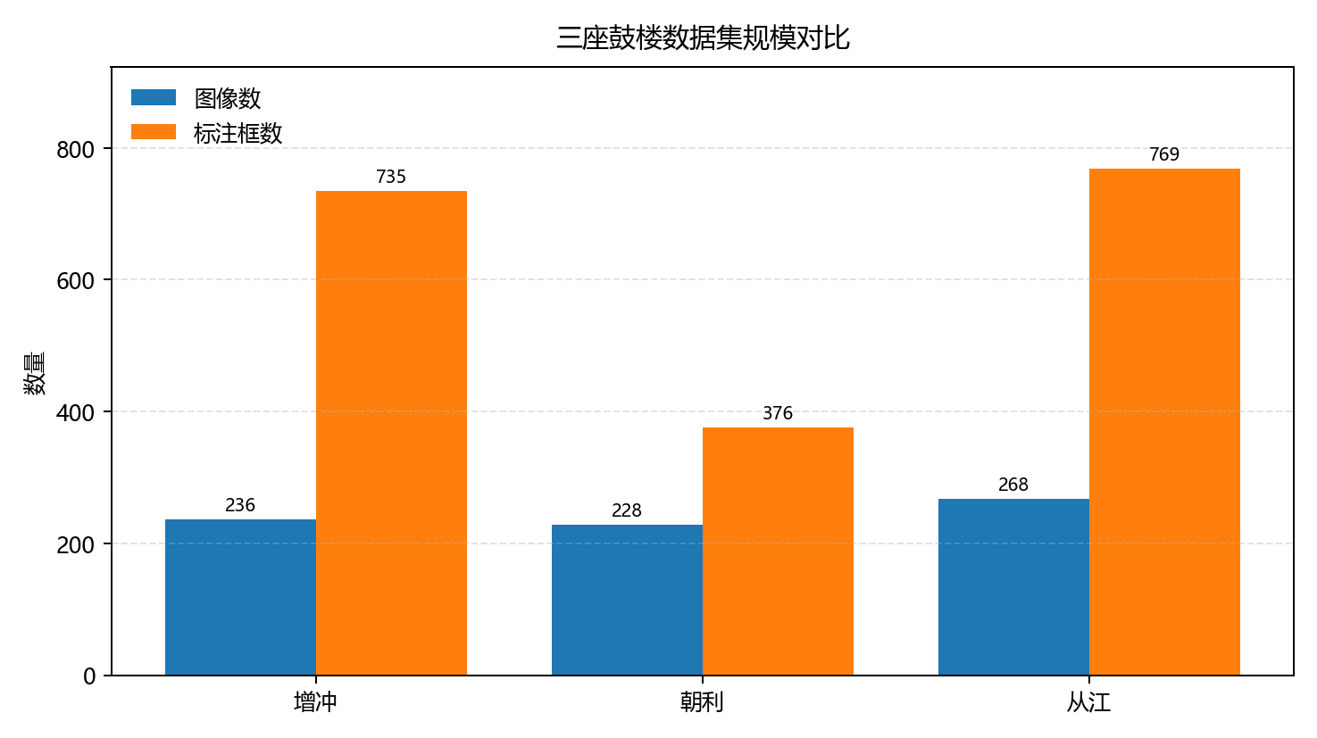
Figure 3-1 Dataset statistics of the three drum towers

3.2 Data Annotation
All image samples were manually annotated using bounding boxes. Each visible damage region was labeled as the unified category damage. During annotation, the visible damaged region was taken as the basic object, and each bounding box was drawn to cover the damaged area as closely as possible while avoiding unnecessary background. This annotation strategy can efficiently cover visible damage regions in drum tower UAV images, accommodate targets of different scales and positions, and facilitate conversion into YOLO-format labels for YOLOv8n training and validation.
Images without obvious damage after manual checking were included as negative samples and participated in training with empty label files. The use of negative samples helps the model distinguish between real damage and complex background patterns such as wooden texture, roof-tile structures, shadows, and edges. This design aims to reduce false detections in complicated heritage-building scenes. Examples of the original UAV image and bounding-box annotation are shown in Figure 3-2 and Figure 3-3.
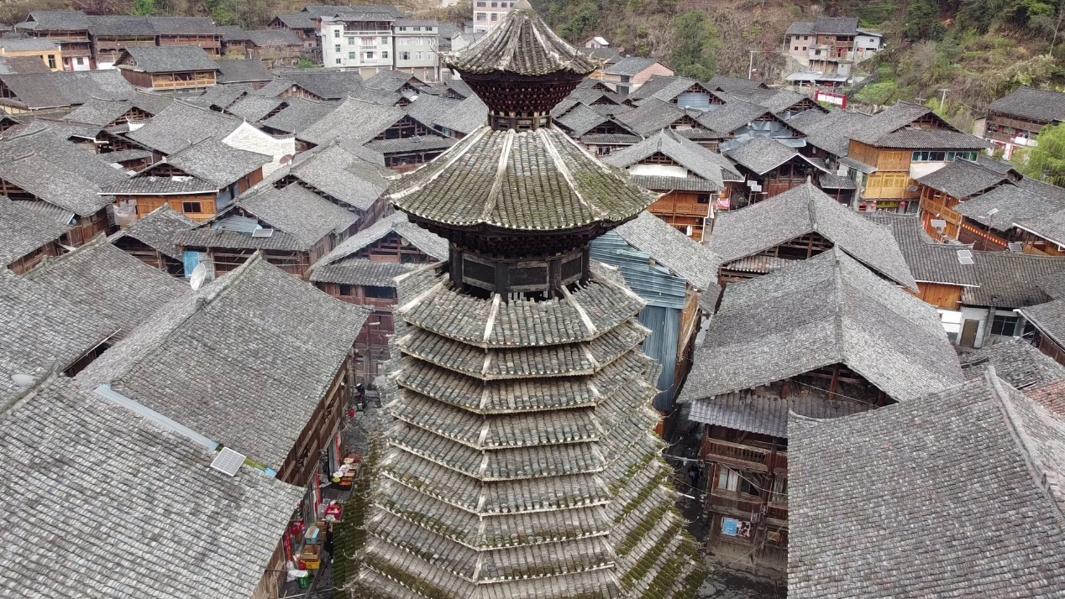
Figure 3-2 Example of an original UAV image of a drum tower
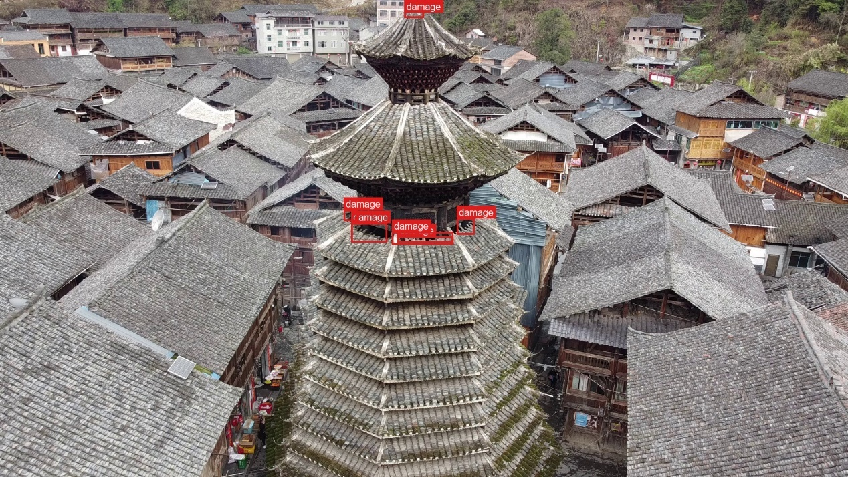
Figure 3-3 Example of bounding-box annotation for visible damage

4 Method and Experiments

4.1 Experimental Environment and Design
The experiments were conducted in a local computing environment, including data organization, label conversion, model training, test evaluation, and visualization output. To ensure reproducibility, the hardware platform, software environment, and training parameters were recorded. The hardware environment is shown in Table 4-1.
Table 4-1 Experimental hardware environment
Item | Configuration | Purpose
Operating system | Windows Pro 22H2, Build 22621 | Data processing, model training, and document preparation
CPU | 12th Gen Intel(R) Core(TM) i5-12500H | Data preprocessing, label conversion, and auxiliary computation
Memory | 31.67 GB | Image loading, data caching, and auxiliary training computation
GPU | NVIDIA GeForce RTX 3050 Ti Laptop GPU | YOLO model training and test inference
GPU memory | 4096 MiB | GPU memory allocation for model training
GPU driver | 512.78 | Used with the current CUDA runtime environment
CUDA environment | CUDA 11.8 | CUDA version corresponding to PyTorch cu118
Table 4-2 Experimental software environment
Software or dependency | Version | Purpose
Python | 3.11.0 | Runtime environment for experimental scripts
Ultralytics | 8.4.52 | YOLO model training, validation, and inference
PyTorch | 2.0.1+cu118 | Model training and GPU computation framework
torchvision | 0.15.2+cu118 | Image processing and model-related dependencies
OpenCV | 4.13.0.92 | Video frame extraction, image reading, and result processing
Labelme | 6.3.0 | Manual annotation of damage regions
Pillow | 12.2.0 | Image reading, drawing, and visualization output
NumPy | 1.26.4 | Array computation and experimental statistics
To ensure comparability among the three drum tower cases, all single-case models and the three-case fusion model used consistent training parameters. The fusion model used the merged dataset of the three drum towers as the training source, while each single-case model was trained on the corresponding drum tower dataset. During testing, each model was evaluated on an independent test set. Test images were not used for model training or parameter selection.
Table 4-3 Unified training parameters
Parameter | Configuration
Detection task | Single-class drum tower damage object detection
Base model | YOLOv8n
Initial weights | yolov8n.pt
Annotation category | damage
Input size | 640 x 640
Batch size | 8
Maximum epochs | 150
Early stopping patience | 30
Optimizer | optimizer=auto (configured by Ultralytics according to model and task)
Learning rate | lr0=0.01 and lrf=0.01; adjusted by the default YOLO strategy under auto optimizer
Momentum | momentum=0.937
Weight decay | weight_decay=0.0005
Warm-up epochs | warmup_epochs=3.0
Random seed | seed=0
Deterministic training | deterministic=True
Mixed precision | AMP=True
Mosaic closing epoch | close_mosaic=10
Data augmentation | Mosaic, HSV perturbation, random flipping, scaling, translation, and random erasing
Test-set evaluation | Precision, Recall, mAP50, and mAP50-95
Confidence threshold for examples | 0.4
Data loading workers | workers=0
Training device | NVIDIA GeForce RTX 3050 Ti Laptop GPU
The overall experimental workflow is as follows: image organization, manual annotation, YOLO-format dataset construction, model training, test-set evaluation, and detection result output. Single-case models are trained separately, and the three-case fusion model is trained on the merged dataset. The results are evaluated using Precision, Recall, mAP50, and mAP50-95. The detailed workflow is shown in Figure 4-1.
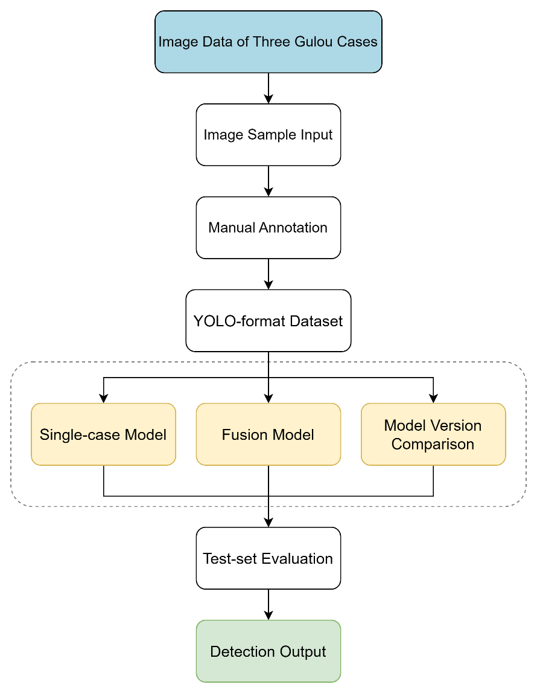
Figure 4-1 Experimental workflow for drum tower damage detection

4.2 YOLOv8n Model
The YOLOv8n model used in this study consists mainly of Input, Backbone, Neck, Detection Head, post-processing, and output modules. The input image is resized and normalized before entering the network. The Backbone extracts visual features such as edges, textures, and local structural patterns. The Neck performs multi-scale feature fusion, which helps the model detect damage targets of different sizes. The Detection Head outputs bounding boxes and class confidence scores. In the post-processing stage, confidence filtering and non-maximum suppression (NMS) are used to remove low-confidence and duplicate boxes, producing the final detection results. The model structure is shown in Figure 4-2.
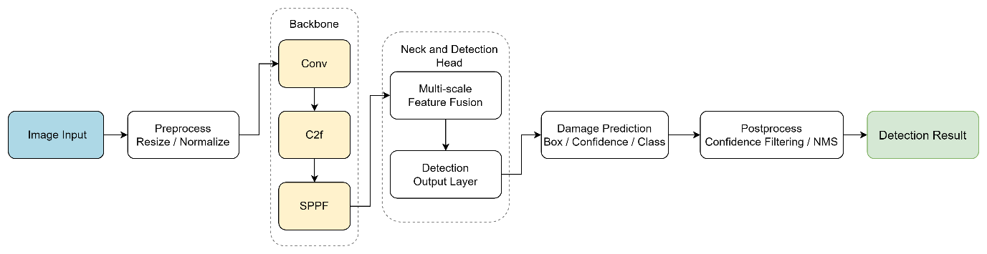
Figure 4-2 Schematic structure of the YOLOv8n network

4.3 Comparison between Single-case and Fusion Models
Using the unified experimental parameters described in Section 4.1, this study first trained three single-case models for the Zengchong, Chaoli, and Congjiang drum towers. The models were evaluated on their corresponding independent test sets. The experimental results are shown in Table 4-4 and Figure 4-3.
Table 4-4 Test metrics of the three single-case models
Case | Precision | Recall | mAP50 | mAP50-95
Zengchong | 0.867 | 0.873 | 0.89 | 0.394
Chaoli | 0.75 | 0.468 | 0.545 | 0.261
Congjiang | 0.719 | 0.595 | 0.612 | 0.186
The single-case results show that the Zengchong model performs best on its corresponding test set, with an mAP50 of 0.890 and both Precision and Recall exceeding 0.86. The Chaoli model achieves a Precision of 0.750 but a Recall of 0.468, indicating that it maintains a certain level of detection correctness while still missing some real damage targets. The Congjiang model obtains an mAP50 of 0.612 and a Recall of 0.595, with overall performance between Zengchong and Chaoli. However, its mAP50-95 is only 0.186, suggesting that its localization accuracy still needs improvement under stricter IoU thresholds.
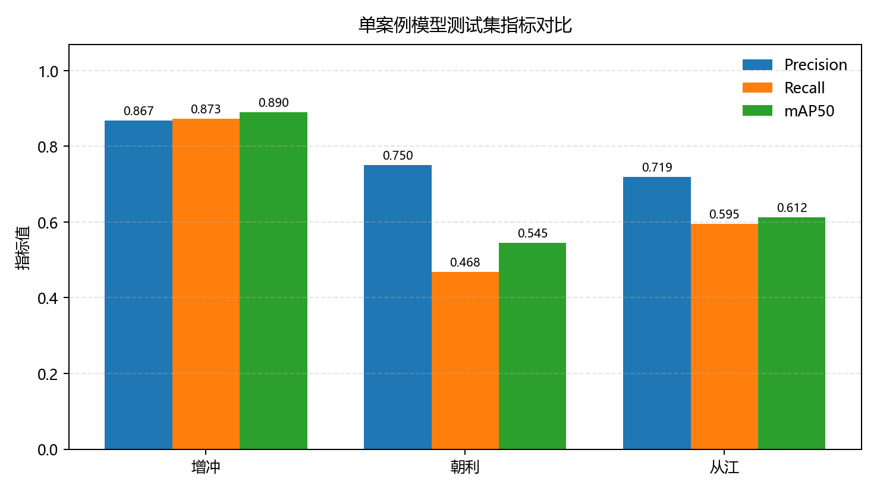
Figure 4-3 Comparison of the single-case models
The test results of the three-case fusion model are shown in Table 4-5, Figure 4-4, and Figure 4-5.
Table 4-5 Test metrics of the three-case fusion model
Test set | Precision | Recall | mAP50 | mAP50-95
Combined test set | 0.855 | 0.691 | 0.755 | 0.317
Zengchong test set | 0.924 | 0.88 | 0.887 | 0.433
Chaoli test set | 0.802 | 0.656 | 0.702 | 0.311
Congjiang test set | 0.815 | 0.527 | 0.618 | 0.213
The fusion model achieves a Precision of 0.855, Recall of 0.691, mAP50 of 0.755, and mAP50-95 of 0.317 on the combined test set. In the separate test sets, the fusion model obtains an mAP50 of 0.887 on Zengchong, which is close to the Zengchong single-case model. On the Chaoli test set, its mAP50 increases to 0.702, higher than the 0.545 achieved by the Chaoli single-case model. On the Congjiang test set, its mAP50 is 0.618, which is close to the Congjiang single-case model. These results indicate that fusion training improves the performance on the Chaoli test set without significantly weakening the detection performance on Zengchong.
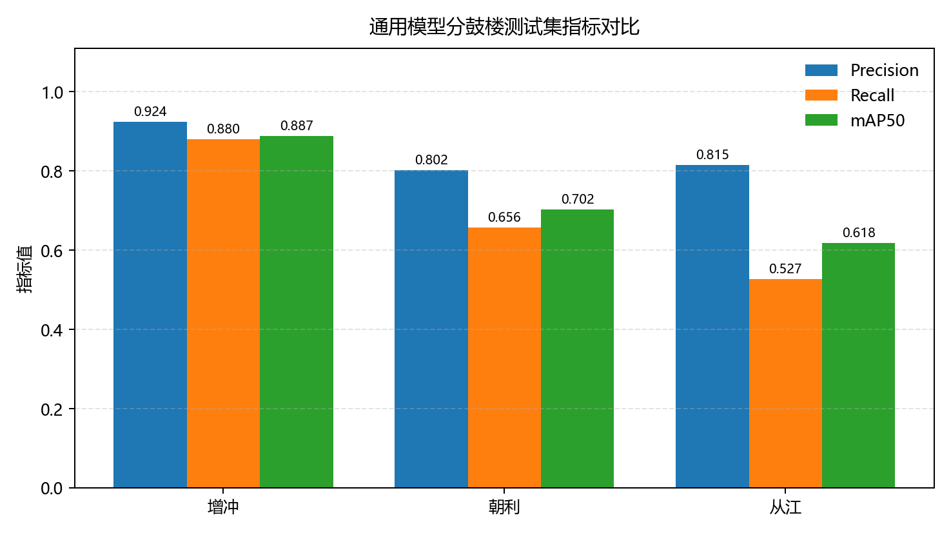
Figure 4-4 Test results of the fusion model on separate drum tower test sets
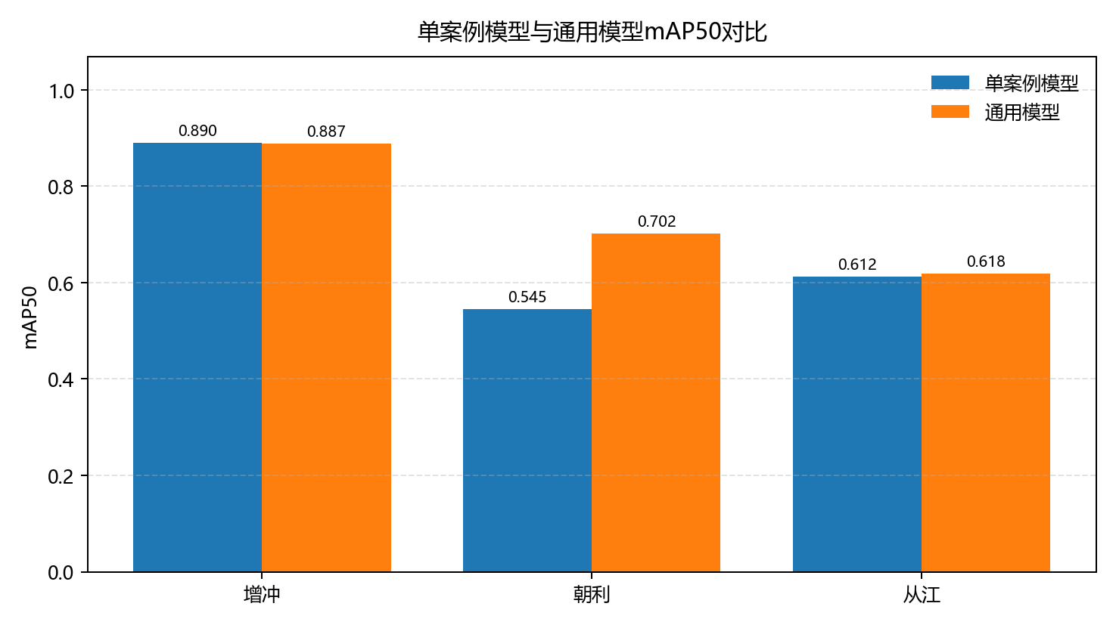
Figure 4-5 Comparison between single-case and fusion models
To supplement quantitative metrics, representative test samples with manual annotations and predicted boxes were selected from the three drum towers to show the detection results of the single-case models. In each comparison image, the left side shows the original test image, and the right side shows the result after overlaying predicted bounding boxes.
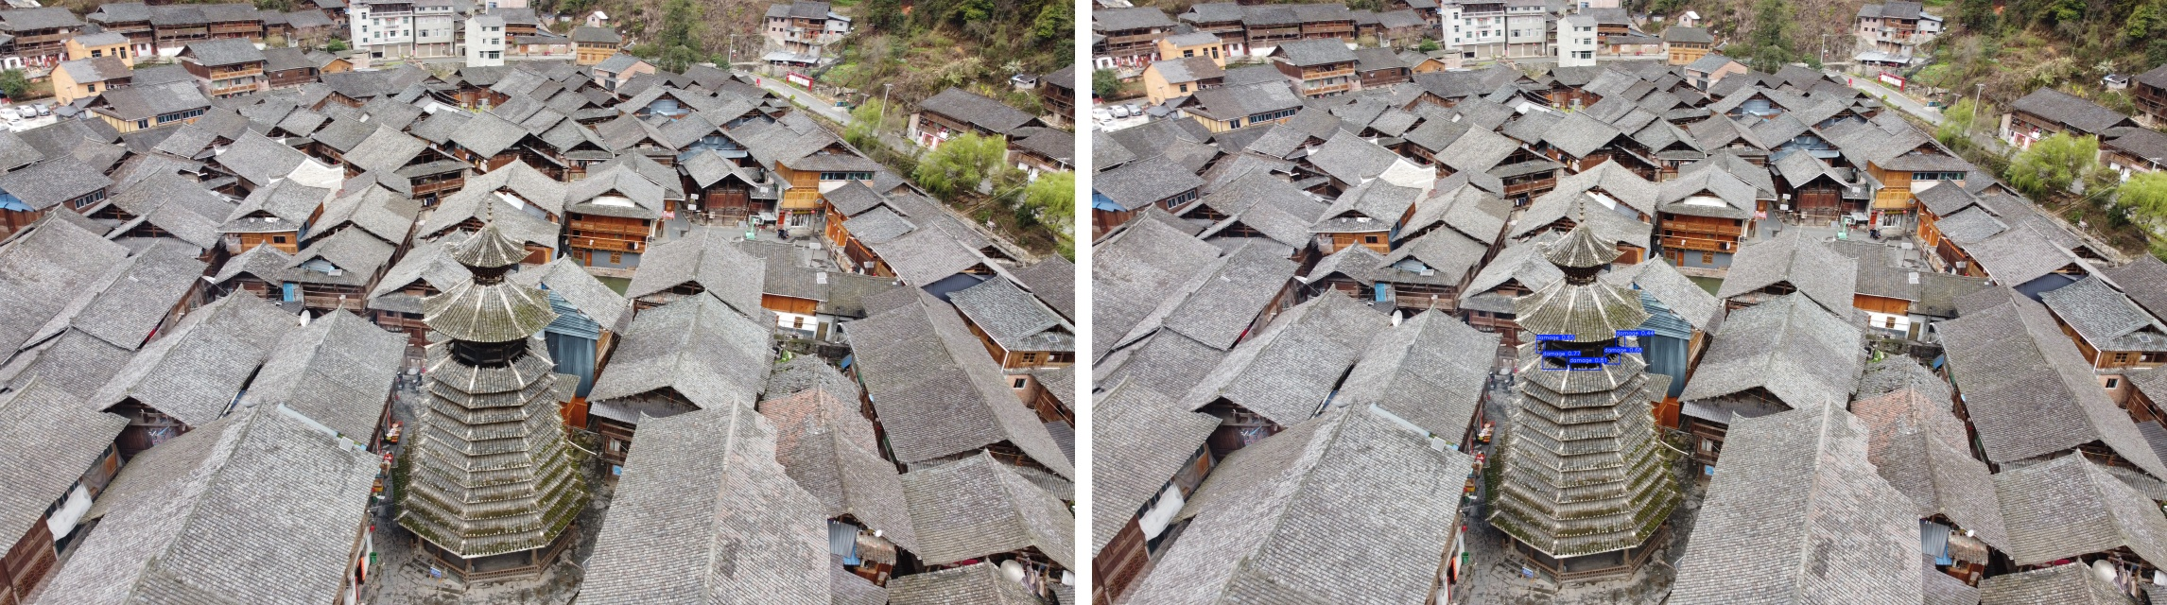
Figure 4-6 Detection comparison for the Zengchong single-case model (left: original image; right: detection result)
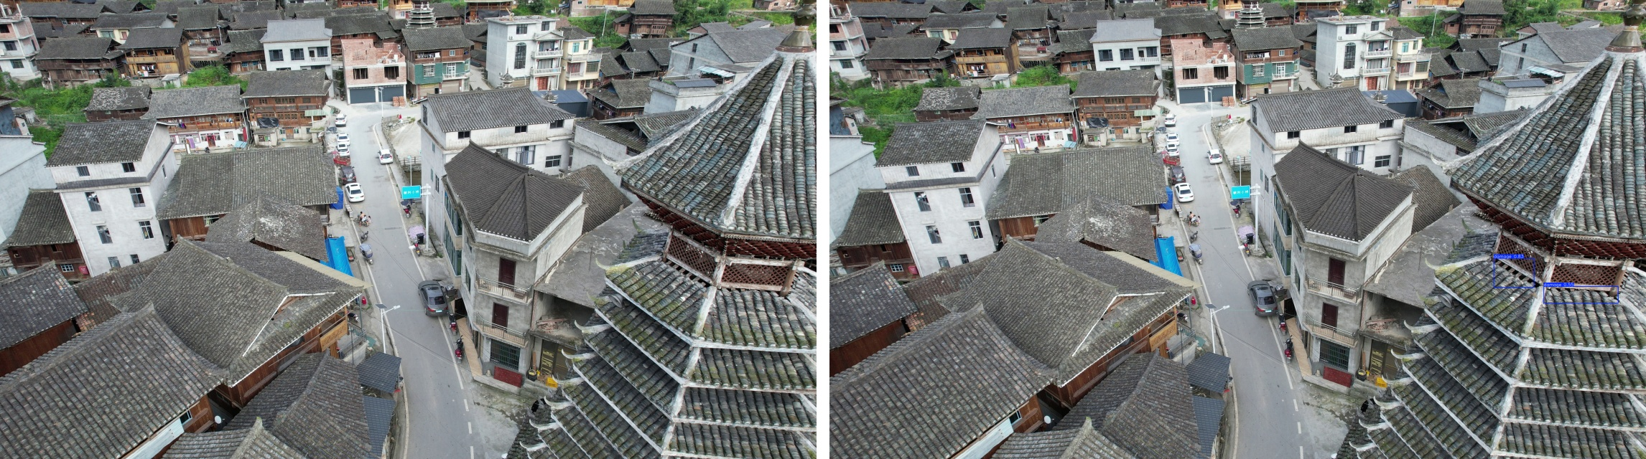
Figure 4-7 Detection comparison for the Chaoli single-case model (left: original image; right: detection result)
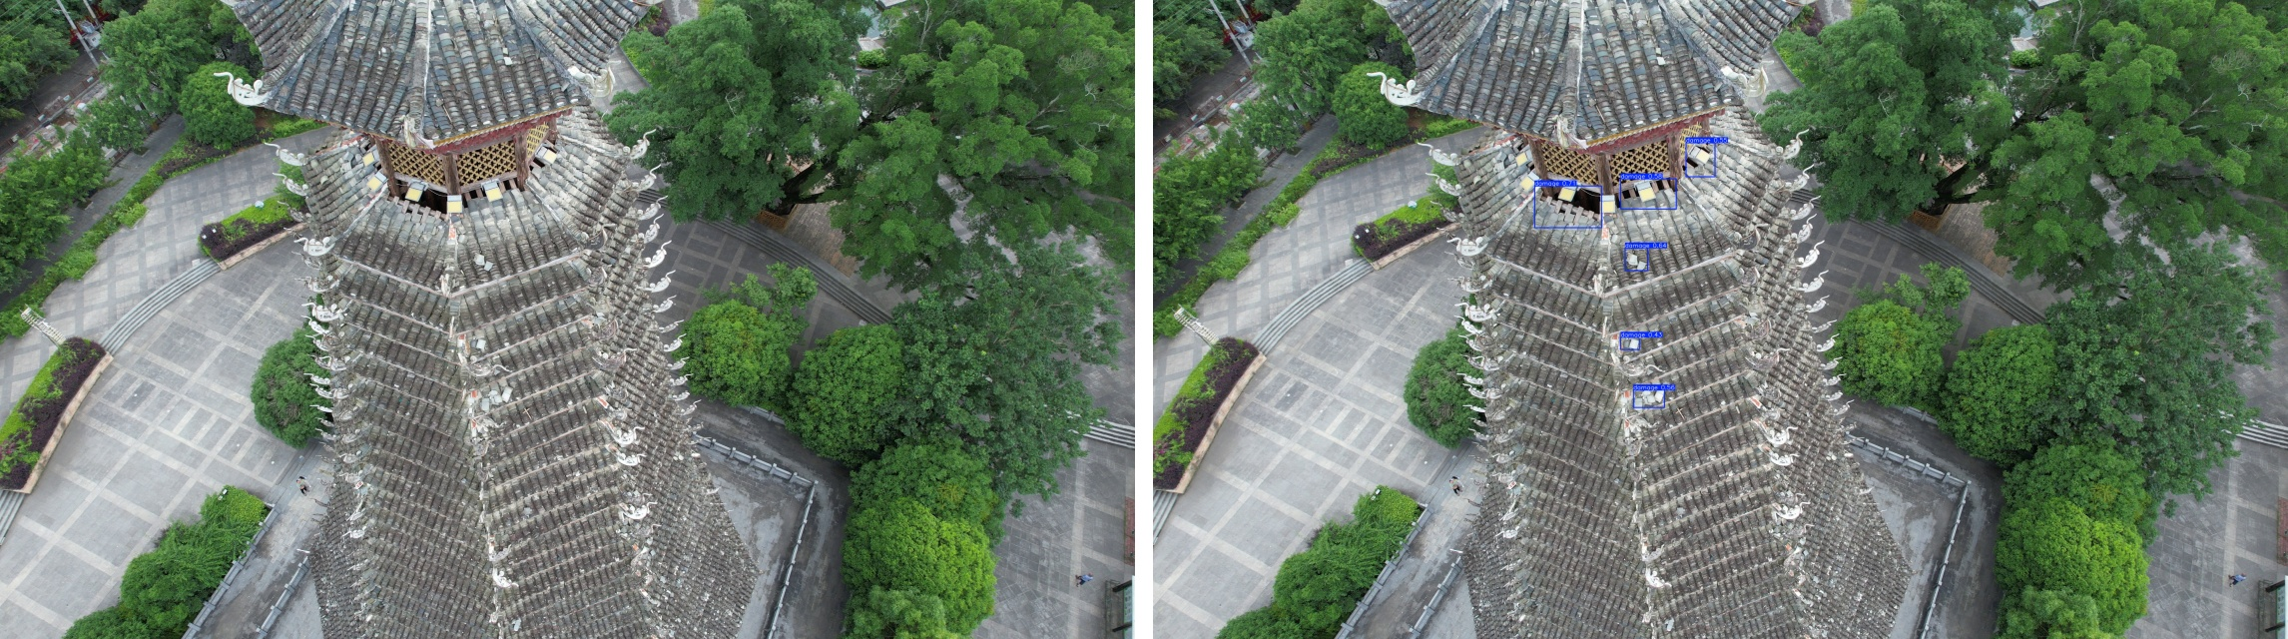
Figure 4-8 Detection comparison for the Congjiang single-case model (left: original image; right: detection result)
From the test metrics, both the Zengchong single-case model and the fusion model perform stably, suggesting that this case contains relatively clear visible damage features and consistent annotation quality. In the Chaoli and Congjiang cases, the fusion model improves mAP50 compared with the corresponding single-case models, indicating that multi-case data fusion can enhance adaptability to different roof textures, viewing angles, and damage appearances. However, the mAP50-95 values still leave room for improvement, showing that precise localization is affected by small targets, occlusion, complex texture, and irregular damage boundaries.
This pattern is consistent with general observations in historic building damage detection: when damage shapes are irregular and background material textures are visually similar to damaged regions, models may perform reasonably well in discovering targets but face greater difficulty in precise boundary localization. The bounding-box object detection method used in this study is therefore suitable for preliminary screening and regional localization, while more precise analysis may require segmentation-based methods in future work.

4.4 Comparison of Different YOLO Versions
To further examine the applicability of different YOLO versions to drum tower damage detection, this study additionally trained YOLOv9t, YOLOv10n, and YOLO11n on the three-case fusion dataset and compared them with the main YOLOv8n model. All models used the same training, validation, and test sets, and the input size, batch size, maximum epochs, early stopping strategy, and data augmentation methods were kept consistent. Since the dataset uses bounding-box annotations, only object-detection metrics were used for evaluation, including Precision, Recall, mAP50, mAP50-95, and inference time. The results are shown in Table 4-6 and Figure 4-9.
Table 4-6 Comparison of different YOLO models on the combined test set
Model | Precision | Recall | mAP50 | mAP50-95 | Inference time (ms/img)
YOLOv8n | 0.855 | 0.691 | 0.755 | 0.317 | 4.38
YOLOv9t | 0.801 | 0.711 | 0.753 | 0.322 | 7.5
YOLOv10n | 0.766 | 0.591 | 0.649 | 0.251 | 5.44
YOLO11n | 0.871 | 0.608 | 0.725 | 0.304 | 5.85
On the combined test set, YOLOv8n achieves the highest mAP50 of 0.755 and the shortest inference time of 4.38 ms/img, indicating a good balance between accuracy and efficiency. YOLOv9t obtains a Recall of 0.711 and an mAP50-95 of 0.322, slightly outperforming YOLOv8n in recall and stricter localization metrics, but its inference time increases to 7.50 ms/img. YOLO11n achieves the highest Precision of 0.871, but its Recall is lower than those of YOLOv8n and YOLOv9t. YOLOv10n performs relatively weakly under the current data setting and is not selected as the preferred model for this task.
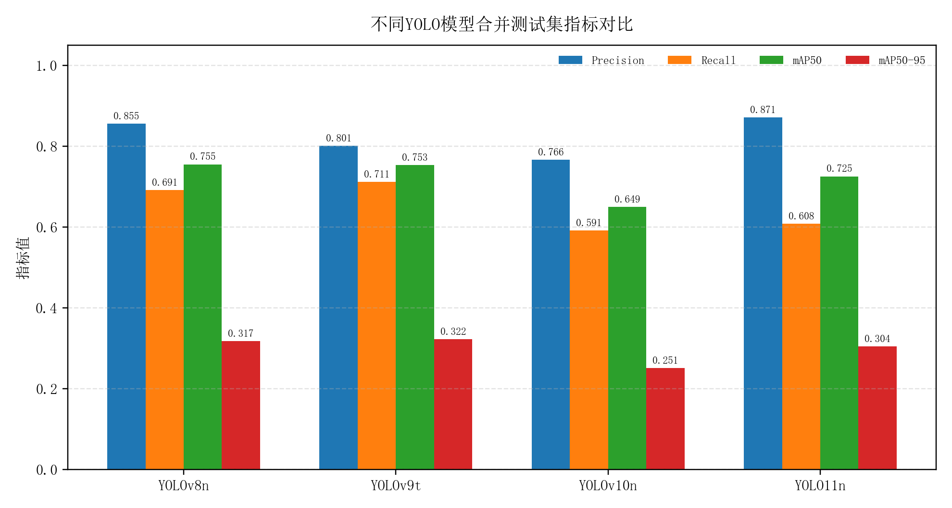
Figure 4-9 Comparison of different YOLO models on the combined test set

5 Conclusions and Discussion

5.1 Main Findings
The experimental results show that the Zengchong dataset performs well in both the single-case model and the fusion model, suggesting that the visible damage regions in this case have relatively stable features and sufficient annotated boxes. The positive sample ratio of the Chaoli dataset is close to those of the other two datasets, but its total number of annotated boxes is smaller, and each positive image contains fewer damage regions. This may lead to insufficient recall in the single-case model. After fusion training, the mAP50 of the Chaoli test set increases from 0.545 to 0.702, indicating that samples from other drum towers help supplement damage appearance features and improve detection ability for this case.
The Congjiang dataset contains many annotated boxes, but its mAP50-95 is relatively low, indicating that the model can identify a certain number of damage targets under a loose overlap threshold but still has boundary deviations under stricter localization requirements. This may be related to irregular damage shapes, complex architectural textures, local occlusion, and variations in shooting angles. Future improvements may include increasing high-quality annotated samples, refining boundary annotation rules, using higher-resolution inputs, or combining detection with segmentation.
The model-version comparison indicates that different YOLO versions have different strengths in this task. YOLOv8n provides a relatively balanced performance in mAP50 and inference efficiency and is suitable as the main model for the current drum tower damage detection experiment. YOLOv9t has certain advantages in Recall and mAP50-95 and may be considered when reducing missed detections is prioritized. YOLO11n shows higher Precision but lower Recall, while YOLOv10n does not show obvious advantages under the current dataset size and training settings. Because the dataset size is still limited, these model-version conclusions should be interpreted as results under the current experimental setting rather than general conclusions about all YOLO versions.

5.2 Limitations and Future Work
This study constructs a single-class detection dataset for visible surface damage in Dong wooden drum towers using UAV images from Zengchong, Chaoli, and Congjiang. YOLOv8n is used to conduct single-case training, three-case fusion training, and model-version comparison experiments. The results show that YOLOv8n can effectively localize visible damage regions on drum tower surfaces. The single-case model achieves high detection accuracy on the Zengchong test set, and the fusion model performs stably on both the combined test set and separate drum tower test sets. Compared with single-case training, fusion training clearly improves the detection performance on Chaoli and maintains basic applicability to Zengchong and Congjiang.
Several limitations remain. First, the dataset is relatively small, and the number and morphology of damage regions differ among drum towers. Second, the model describes damage regions using bounding boxes, which limits fine-grained representation of irregular boundaries and small damage areas. Third, cross-case generalization is still affected by shooting angle, architectural texture, lighting condition, and background complexity. Future work can expand the dataset with more drum tower cases, improve annotation standards, introduce fine-grained damage categories, and explore detection-segmentation hybrid methods to improve the precision of damage recognition for historic wooden architecture.

References
- Huang, W.; Gao, X.; Lu, J. Digital Construction Preservation Techniques of Endangered Heritage Architecture: A Detailed Reconstruction Process of the Dong Ethnicity Drum Tower (China). Drones 2024, 8, 502.
- Deng, Z.; Dong, K.; Bai, D.; Tong, K.; Liu, A. A Case Study on Soundscape Analysis for the Historical and Ethnic Village of Dong Nationality in Zhaoxing County. Acoustics 2021, 3, 221–234.
- Chen, X.; He, J.; Wang, S. Deep Learning-Driven Pathology Detection and Analysis in Historic Masonry Buildings of Suzhou. npj Heritage Science 2025, 13, 197.
- Soleymani, A.; Jahangir, H.; Nehdi, M. L. Damage Detection and Monitoring in Heritage Masonry Structures: Systematic Review. Construction and Building Materials 2023, 397, 132402.
- Mishra, M.; Lourenço, P. B. Artificial Intelligence-Assisted Visual Inspection for Cultural Heritage: State-of-the-Art Review. Journal of Cultural Heritage 2024, 66, 536–550.

