**Fall 2023 SYS 390**

**Business Proposal**

**Team ZEST_ID**

1. **Introduction**
2. **Customer Details**
   1. The Customer
   2. Non-Customer Stakeholders
   3. Motivation
   4. KT Situation Appraisal
3. **Alternative Solutions**
   1. Quizxpress (Buy)
      1. Quizxpress KTDA
      2. Quizxpress Estimated Budget
      3. Quizxpress NPV Analysis
      4. Quizxpress Intangible Benefits
      5. Quizxpress Adverse Consequences
      6. Buy Option Research Notes
   2. Building a Software
      1. Building a Software KTDA
      2. Building a Software Estimated Budget
      3. Building a Software NPV Analysis
      4. Building a Software Intangible Benefits
      5. Building a Software Adverse Consequences
4. **Recommendation**

**1 – Introduction**

The purpose of this Business Proposal is to document how we have thought about securing the optimal solution for the client organization as it relates to the specific challenges and nuances of Bible Quizzing. We recommend our **build** option (see **section 4**) as the best fit solution after considering a wide range of needs. This solution accounts for functional as well as non-functional requirements. The rest of the document outlines the specific reasoning behind why building a custom solution is the optimal solution for our client.

**2 – Customer Details**

2.1 - The Customer

Our customer is the leadership Grace Morton Church, and by extension, the Fellowship of Evangelical Churches. Grace Morton’s leadership team is involved in their denomination’s Bible Quizzing program, where churches across the Midwest compete against one another at quizzing competitions called Quiz-offs.

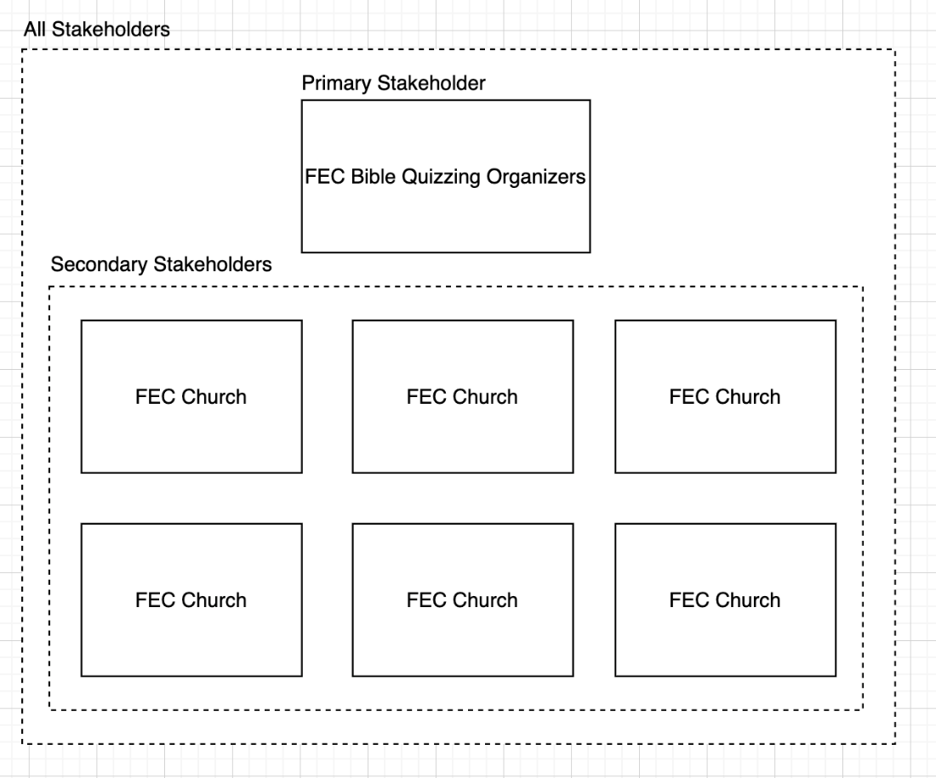

2.2 - Non-Customer Stakeholders

Non-Customer stakeholders include the FEC Bible Quizzing planning cabinet, the quizzers who participate in the Bible Quizzes, and the volunteers who help to organize the Bible Quizzes (quizmasters, administrators, organizers).

2.3 - Motivation

Three times per year, several churches from the Fellowship of Evangelical Churches send quiz teams to quiz-offs to compete in Bible trivia. While at a quiz-off, quiz teams consisting of at least four quizzers, go head-to-head against other teams to try to accumulate as many points as possible by answering different types of questions. After an initial seeding round in which quiz teams play four matches against randomly assigned opponent teams, the eight quiz teams with the highest score from the seeding matches are placed in a bracket-style competition. A separate bracket is created for middle school and high school students. The winner of the final bracket is declared the winner of the quiz-off for that division.

There are a few problems with the existing system that we would like to address: human error, centralization of knowledge, and inefficient quiz-off operation.

The competitions are held based on a paper and pencil system. This means that there are physical scorecards for every quiz that happens in each quiz-off. This is a huge problem, because there could be up to 100 separate quizzes that happen at any given quiz-off. To make matters worse, the scoring logic for each quiz is not trivial, and humans have been shown to produce significant errors in calculating these final scores. Since the scorecards are physical, it takes a significant amount of time to sort through the scoresheets to make the bracket style competition.

Lastly, each quiz is scheduled in a different room in the venue that is hosting the quiz-off. This means that at every quiz-off, depending on the number of teams that will be attending as well as the number of rooms that are available in the venue, an organizer must calculate a new schedule for each quiz off.

Each of these tedious tasks can be automated and optimized to reduce human input errors.

2.4 - KT Situation Appraisal

Grace Morton Church found there were numerous challenges without any software to run their quizzes. Here is a list below:

|  |  |  |
| --- | --- | --- |
| Issues | Clarify issues | Severity (1-10) |
| Human error | The quiz master's would manually enter the scores, but with the complexity of the scoring system human error is high | 9 |
| No centralized information management | They like to keep track of statistics, for both individuals and teams. Manually entering them is tedious and erroneous. | 6 |
| No practice quizzing for players | No players can have any type of account with the software to log in from their own device and practice a quiz | 5 |
| Efficiency | Turn-arounds to determine brackets is very slow when analyzed manually | 7 |

**3 – Alternative Solutions**

With the challenges mentioned above, we will examine some alternative solutions for quizzing software. An analysis of each potential alternative will include a cost-benefit analysis, and a KTDA (Kepner Tregoe Decision Analysis).

The KTDA will be used to analyze various wants and needs, based on customer requirements. They will be separated into 2 charts. One will be a needs chart on top for essential system requirements and one will be a wants chart with weights to analyze which non-requirements are most significant, and how the proposed alternative measures up.

The cost-benefit analysis will include an overall cost analysis, an analysis of the NPV (net present value), intangible benefits, and adverse consequences. The overall cost analysis will give overviews of the forecasted expenses for the software, and the NPV will discount those costs with adjustments for inflation to calculate how much those costs will equate in today's dollars. The intangible benefits section will outline certain software benefits that can be understood but are not empirical or calculable, while the adverse consequences will give an analysis to the greatest drawbacks and how they impact the viability of the alternative.

3.1 Quizxpress (Buy)

Our first alternative would be to buy a yearly subscription for Quizxpress. It is a high-end, professional gameshow program which includes a mobile app, software, and multiple bonus games. Something that stands out on their homepage ([https://www.quizxpress.com](https://www.quizxpress.com/quizxpress-live/#director)) is that there is a “QuizXpress director” feature that allows 1 moderator to run an entire game, or quiz, at a time. All of the hardware needed would come with the yearly subscription. The students in Information Systems Design would learn how to navigate and manage the software, then would pass that knowledge onto a staff member at Grace Morton.

3.1.1 - Quizxpress KTDA

|  |  |
| --- | --- |
| Quizxpress | |
| Musts | Y/N |
| Run by one moderator | Y |
| Database storage | Y |
| Custom rules | Y |
| Can be played w/o player phones | N |
| Team/player statistics | Y |
| Includes user logins | N |

|  |  |  |  |  |
| --- | --- | --- | --- | --- |
| Quizxpress | | | | |
| Wants | Weight | Comments | Score (1-10) | Weighted score |
| Supported on mobile phones and desktop | 10% | Mobile app or mobile website works | 10 | 10 |
|  | 15% | Does not offer user logins | 0 | 0 |
| Affordable | 10% | Is pricey on a yearly basis | 2 | 5 |
| Real time updates | 20% | Does not offer any bracket tournament options | 0 | 0 |
| Customizable branding | 15% | The church may want to brand the quizzes to represent their organization | 10 | 15 |
| Minimal maintenance needs | 15% | We would want it to be easily understood by Grace | 0 | 0 |
| **Totals** |  |  |  | **30/100** |

3.1.2 - Quizxpress Estimated Budget

We would like to accommodate many players for large tournaments. However, on the website it is important to note that prices scale with the number of mobile devices supported, which as mentioned earlier is not what we’re looking for in software. Below is the general pricing for the Quizxpress mobile license:

|  |  |
| --- | --- |
| **Quizxpress mobile licensing** | |
| Capacity | Price |
| Up to 50 players | $389.82 |
| Up to 100 players | $589.82 |
| Up to 400 players | $889.82 |
| Up to 1000 players | $1,539.82 |
| Up to 2000 players | $2,289.82 |

The estimated budget for using Quizxpress is as follows:

|  |  |  |  |
| --- | --- | --- | --- |
| **Quizxpress budget** | | | |
| Item | Description | Comments | Price |
| Yearly subscription fee |  | Would include licensing, software, and quality support | $889.82 |
| Staffing cost for setup | The cost to employ people for setup | We can utilize an Information Systems Design student to set it up for free. | $0 |
| **Total** |  |  | $889.82 |

3.1.3 - Quizxpress NPV Analysis

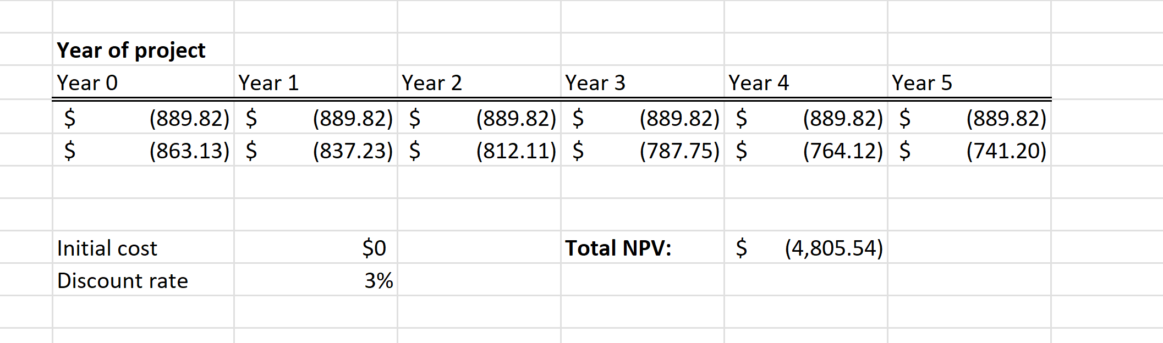 This is the total NPV (Net Present Value) of the costs of the project, discounted with projections for how the cost will equate to more value for the dollar than it will in the future due to inflation. $4,805.54 is the expected value cost of this project over the next 5 years. Understandably, the net present value calculated is negative because this project is an expense.

3.1.4 - Quizxpress Intangible Benefits

One of the strongest intangible benefits that Quizxpress can offer is the ability to sell or make practice quizzes available online anywhere. Using their “Quiz Center” feature, the quiz itself, not just the questions, can be made available for a chosen price. That could help the church organization expand by easily offering the quizzes to other churches.

3.1.5 - Quizxpress Adverse Consequences

The first adverse consequence of Quizxpress is the cost. Our team is quite confident that there are viable alternatives which are much more affordable, especially for a for non-profit organizations such as churches.

The second adverse consequence is the need for player phones during live quizzes. The Bible quizzing program does not utilize phones for players during quizzes. Quizxpress never mentions alternatives to phones or other electronic devices as mediums for players.

The third adverse consequence is that there is no login except for administrators. Players must be able to create accounts with the software to login and practice their quizzes, see their quizzing stats, and other helpful information.

3.1.6 Buy Option Research Notes

Because Quizxpress falls short of the functional requirements, we investigated other buyable software's and none of them come even close to the requirements. There are so many musts that the system has. We also investigated Mytrivialive, Triviahub, and Sporlce.com. No viable trivia software that we investigated offers user accounts and access from any device, and complex logic for scorekeeping. It seems that the needs that the customer has would be best met by building a program.

3.2 Building a Software

We will build a quizzing app that will meet the needs of our customer. The app will be secure with user logins to review data and take practice quizzes. The scoring system will be designed to process the complex scoring logic of the tournaments. This one software will be the “all-in-one" package for Bible quizzing, which will store the quiz questions, practice quizzes, and statistics for both players and teams. It will also be used extensively to run tournaments.

The personnel would start off as the developers but would be given to the FEC administration for maintenance. The needed infrastructure would include clerk.com for user authentication and logins, planetscale.com for data storage, a Javascript based development platform, and vercel.com for deployment costs and API hosting.

3.2.1 - Building a Software KTDA

|  |  |
| --- | --- |
| Building a software | |
| Musts | Y/N |
| Quiz is run by one moderator | Y |
| Database storage | Y |
| Custom rules | Y |
| Can be played w/o player phones | Y |
| Team/player statistics | Y |
| Includes user logins | Y |

|  |  |  |  |  |
| --- | --- | --- | --- | --- |
| Building a software | | | | |
| Wants | Weight | Comments | Score (1-10) | Weighted score |
| Supported on mobile phones | 10% | Will be compatible with mobile devices | 10 | 10 |
| User logins | 15% | Industry standard verification | 10 | 15 |
| Affordable | 25% | Will cost $12 per year | 10 | 25 |
| Can create brackets | 20% | Will offer bracket verifications | 10 | 20 |
| Customizable branding | 15% | The church may want to brand the quizzes to represent their organization | 10 | 15 |
| Handles room scheduling | 15% | That may be added but not definitely | 6 | 9 |
| **Total** |  |  |  | **96/100** |

3.2.2 - Building a Software Estimated Budget

Below is a detailed estimation of the cost needed to build a software:

|  |  |  |  |
| --- | --- | --- | --- |
| Building a software | | | |
| Item | Description | Comments | Cost |
| Authentication | Service for managing user logins using clerk.com | Free for up 5000 users | $0 |
| Database storage | Information storage using planetscale.com | Includes 5 GB storage and plenty of row reading | $0 |
| Deployment costs | To transition a system from “in development” to “ready”, the system needs to be deployed. |  | $0 |
| API hosting | The backend service needs to be always online so users can access the system. |  | $0 |
| Maintenance | The system will need maintenance once it is built to ensure optimal quality | Is roughly the same as the development cost | $0 |
| Domain | The yearly cost of the website domain |  | $12 |
| **Total** |  |  | $12 |

3.2.3 - Building a Software NPV Analysis

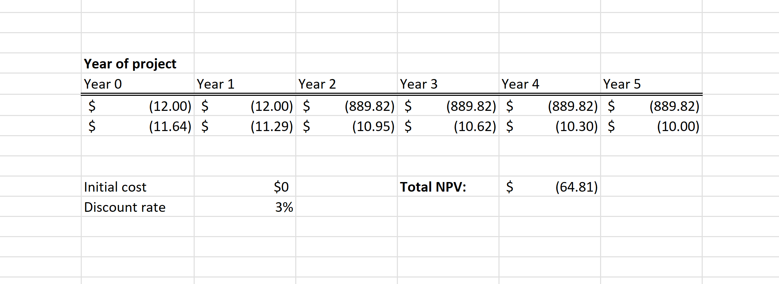 This is the total NPV (net present value) of the cost of building the software, discounted with projections for how the cost will equate to cheaper than it will be in the future due to inflation. $64.81 is the expected value cost of this project over the next 5 years. Understandably, the net present value calculated is negative because this project is an expense.

3.2.4 - Building a Software Intangible Benefits

* The customizability of the software. The customer has very specified needs and a built program will have the ability to adapt the software.
* The elegance and simplicity of the software will be less distracting for teams, as other programs such as Quizxpress are flashy for marketing purposes.

3.2.5 - Building a Software Adverse Consequences

* The limited programming knowledge of the developers, most if not all of whom will be completing their undergraduate degree. The software will take more time to build (around 3 months) and may take trial and error for less experienced programmers.
* The time taken to train the staff in the new software would require a centralized transition of the way the quizzing organization is run.
* The developers will not be available for maintenance questions and support when the class is over.

**4 –** Recommendation

After careful examination, our team concluded that building custom software is by far the most feasible option considering the factors above. We would strongly recommend building custom software, as opposed to buying, for the following reasons:

* **Customizability:** The unique rules and scoring logic must be custom-made. Building it will offer the rule specification flexibility needed to be an “all-in one” software for Bible quizzing. Customizability can also stretch to organizing rooms for the quiz-offs and other potential needs.
* **Price:** As shown in the Cost-benefit analysis as well as the NPV analysis, the cost of building will be dirt cheap if not free.
* **Data storage:** A custom-built program will offer storage of data for statistics, questions, teams, practice quizzes and more.

We believe that the positives greatly outweigh the negatives.