Student Name : Abhishek Kumar Gupta
Student ID : 11710423
Email Address : abhishekonly125@gmail.com
GitHub Link : https://github.com/itrare/Scheduling_Algo_OS_CA
Description :
Problem1: Three students (a, b, c) are arriving in the mess at the same time. The id numbers of these students are 2132, 2102, 2453 and the food taken time from the mess table is 2, 4 and 8 minutes. If the two students have same remaining time so it is broken by giving priority to the students with the lowest id number. Consider the longest remaining time first (LRTF) scheduling algorithm and calculate the average turnaround time and waiting time.
Solution1:
Code Snippet 1:
#include<iostream>
#include<stdlib.h>
#include<conio.h>
#include <windows.h>
#include <iomanip> // std::setprecision
#define MAX 500
COORD = {0, 0};
COORD max_res,cursor_size;
void gotoxy (int x, int y)
{
coord.X = x; coord.Y = y; // X and Y coordinates
SetConsoleCursorPosition(GetStdHandle(STD_OUTPUT_HANDLE), coord);
}
using namespace std;
int cc;
struct process{
int PID,at,bt,btt,wt,ct,tat,PR;
};
process *ProcessQueue = new process[MAX];
int sizeBTQueue(process *Array[]){
int isThere=0;
for(int i=0;i<cc;i++){
if(Array[i]->bt>0){
isThere+=1;
}
}
return isThere;
}
int isNullQueue(process *Array[]){
int isThere=0;
for(int i=0;i<cc;i++){
if(Array[i]->bt>0){
isThere=1;
}
}
return isThere;
}
int allDone(){
int isThere=0;
for(int i=0;i<cc;i++){
if(ProcessQueue[i].bt>0){
isThere+=ProcessQueue[i].bt;
}
}
return isThere;
}
int x=1,m=1,d;
void madeGanttChar(int id[],int ct[],int z){
int i=0;
d=0;
ct[0]=0;
for( m =1,x=1;m<=z;m++,x++){
if(m%15==0){
d+=5;
x=1;
gotoxy(x*7,d+2);
}
gotoxy(x*7,1+d);
cout<<" ______";
gotoxy(x*7,1+d);
cout<<""<<ct[m-1]<<endl;
gotoxy(x*7,2+d);
i=m-1;
cout<<"|P"<<id[i];
gotoxy(x*7+7,2+d);
cout<<"|"<<endl;
gotoxy(x*7,3+d);
cout<<"|______|"<<endl;
}
gotoxy(x*7,1+d);
cout<<""<<ct[m-1]<<endl;
}
process &priorityScheduling(process *longAssump, process *CompV){
if(longAssump->PID < CompV->PID){
return *longAssump;
}
else{
return *CompV;
}
return *longAssump;
}
void lRTFScheduling(){
process *ReadyQueue[MAX];
int m=0,i=0,ctGlobal=0;
int id[MAX],ct[MAX];
do{
if(m<cc){
for(int j= 0 ;j<cc;j++){
if(ProcessQueue[j].at==i &&ProcessQueue[j].bt>0){
ReadyQueue[m++] = &ProcessQueue[j];
}
}
}
process *longRProc = *(&ReadyQueue[0]);
for(int k= 0 ;k<m;k++){
if(longRProc->bt < ReadyQueue[k]->bt && ReadyQueue[k]->bt>0){
longRProc = *(&ReadyQueue[k]);
}else if(longRProc->bt == ReadyQueue[k]->bt && ReadyQueue[k]->bt>0 ){
longRProc = (&priorityScheduling(longRProc,ReadyQueue[k]));
}
if(ReadyQueue[k]->bt<0){
delete ReadyQueue[k];
}
}
ctGlobal++;
longRProc->bt-=1;
longRProc->ct=ctGlobal;
longRProc->tat = longRProc->ct - longRProc->at;
longRProc->wt = longRProc->tat - longRProc->btt;
cout<<"Long ID:"<<longRProc->PID<<"Long Prcs bt:- and ct:-"<<longRProc->bt<<" " <<longRProc->ct<<endl;
system("cls");
id[i]=longRProc->PID;
ct[1+i]=longRProc->ct;
madeGanttChar(id,ct,i+1);
i++;
}while( i<allDone()||isNullQueue(ReadyQueue)==1 );
}
void getStudents(){
cout<<"How many student are coming to the mess"<<endl;
cin>>cc;
cout<<"PID\t\t ARRIVAL TIME\t\t FOOD TAKEN"<<endl;
for(int i = 0 ; i<cc;i++){
cin>>ProcessQueue[i].PID;
cin>>ProcessQueue[i].at;
cin>>ProcessQueue[i].bt;
ProcessQueue[i].btt= ProcessQueue[i].bt;
cout<<endl;
}
}
void display(){
cout<<"\t+_______________________________________________________________________________________________+\n";
cout<<"\t|ProcessID \t|ArrivalTime \t|BurstTime\t|CompletionTime\t|TurnAroundTime\t|WaitingTime\t|\n";
cout<<"\t+_______________________________________________________________________________________________+\n";
float avgWt=0,avgTAT=0;
for(int i =0 ;i<cc;i++){
cout<<"\t| "<<ProcessQueue[i].PID<<"\t\t| "<<ProcessQueue[i].at<<"\t\t| "<<ProcessQueue[i].btt<<"\t\t| "<<ProcessQueue[i].ct<<"\t\t| "<<ProcessQueue[i].tat<<"\t\t| "<<ProcessQueue[i].wt<<"\t\t|"<<endl;
avgTAT+=ProcessQueue[i].tat;
avgWt+=ProcessQueue[i].wt;
}
cout<<"\t+_______________________________________________________________________________________________+\n\n";
cout<<"\t\t\t\t+_____________________________________________+\n";
cout<<"\t\t\t\t|\t\t Average TAT "<<fixed<<std::setprecision(1)<<(double)avgTAT/cc<<"\t |"<<endl;
cout<<"\t\t\t\t|\t\t Average WT "<<fixed<<setprecision(1)<<(float)avgWt/cc<<"\t |"<<endl;
cout<<"\t\t\t\t+_____________________________________________+\n";
}
int main(){
getStudents();
lRTFScheduling();
gotoxy(0,8+d);
display();
}

Explanation 1:
- In the above code there is Array declared which is of process type which contains all the process info, of size MAX (threshold value for cpu to manage process)
- First it continues with input of the test case by getting all the value of the related process and storing them to array.
- The lRFT() function contains the main scheduling algorithm, in which there is readyqueue of process type for containing all the process according to their arrival times.
- The prioritySheduling() function priorities the process according to the process id.
- The madeGanttChar() function design the Gantt chart for the scheduling for every second which uses the array uses to store the status of the process at every second.
Algorithm 1:
- Make a structure for a process which contains all the attributes of the process.
- Declare the process array ProcessQueue[MAX] where MAX will be the threshold value for maximum value of processes can be there.
- Getting the required value like id, arrival time and burst time for every process n from a loop within function()
- In lrtf() :
Define a readyQueue[MAX] //for process arrived at time t_{n}
Initialize i=0 //per second timer.
- In do while loop:
- Take the process into the readyQueue[] which arrive on time i_{n} and having burst time greater than 0.
- Then sort the process which is in the readyQueue[] according to their burst time descending and take a variable of process type for taking reference of the that longest burst time process.
- If two process having same longest burst time then sort them using priority of their process ids.
- Then decrease the burst time of the longest burst time process by 1
- Then calculate the waiting time and turn around time by their completion time at every second.
- Then print the Gantt chart for every second in the loop.
- Increase i++.
- After the scheduling algorithm display the respective data of every process.
Complexity:
- Declaring every array and variable will be O(1).
- Getting the values for the process will be of O(N).
- In the lrtf() there is do while loop and inside it there is loop for sorting the process by burst time the it will be O(N²).
OVERALL COMPLEXITY : O(N²)
Constraints:
- Burst Time should be greater than 0
- Processes should contain ids.
- MAX value should be less than 1000
Test Cases:
Test Case #1:
+____________________________________________+
|ProcessID |BurstTime |ArrivalTime | +____________________________________________+
| 2132 | 2 | 0 |
| 2102 | 4 | 0 |
| 2453 | 8 | 0 |
+____________________________________________+
Result #1:
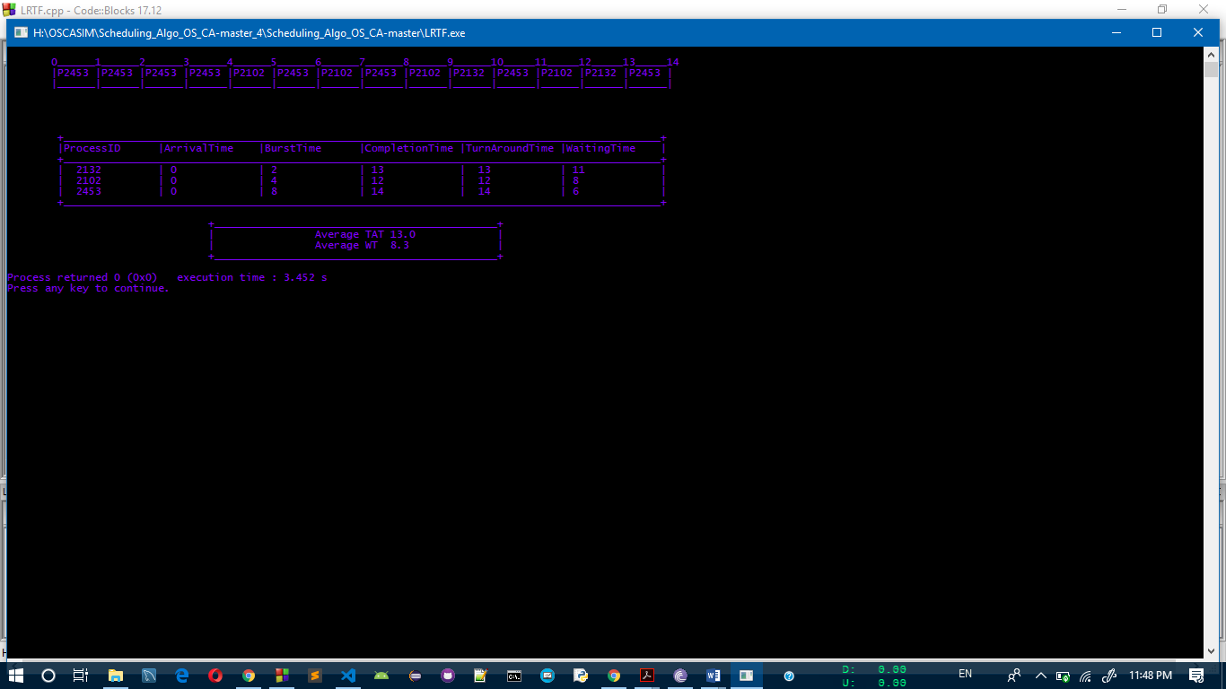
Test case passed successfully and gave expected result.

Test Case #2:
+____________________________________________+
|ProcessID |BurstTime |ArrivalTime | +____________________________________________+
| 1 | 2 | 1 |
| 2 | 4 | 2 |
| 3 | 6 | 3 |
| 4 | 8 | 4 |
+____________________________________________+

Result #2:
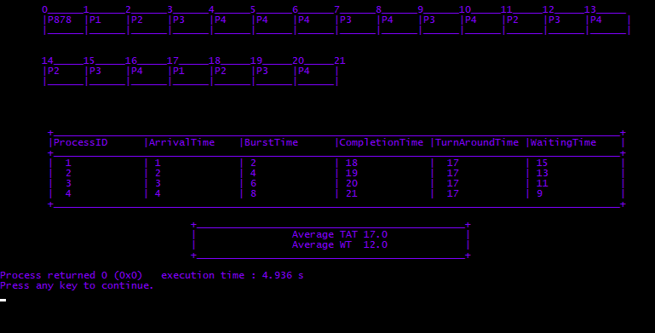
Test case passed successfully and gave expected result.

Problem2: There are five processes in the system. All five processes arrive at time 0, in the order given, with the length of the CPU burst given in milliseconds:
Process Arrival Time Burst Time
P1 0 10
P2 0 29
P3 0 3
Pi 0 7
P5 0 12
Write a C program which will incorporate SJF scheduling and print the ending time of process Pi.
Solution 2:
Code Snippet 2:
#include<stdlib.h>
#include<conio.h>
#include <windows.h>
#define MAX 1000
COORD coord = {0, 0};
COORD max_res,cursor_size;
void gotoxy (int x, int y)
{
coord.X = x; coord.Y = y;
SetConsoleCursorPosition(GetStdHandle(STD_OUTPUT_HANDLE), coord);
}
using namespace std;
int noProcess,aTs,ttB=0;

struct process{
int iD,bT,bbT,aT,cT,tAT,wT;
};
process * pArray= new process[MAX];
int x=1,m=1,d;
void madeGanttChar(int id[],int ct[],int z){
int i=0,L=1;
d=0;
ct[0]=0;
for( m =1,x=1;m<=z;m++,x++){
if(m%20==0){
d+=5;
x=1;
gotoxy(x*7,d+2);
}
gotoxy(x*7,1+d);
cout<<" ______";
gotoxy(x*7,1+d);
cout<<""<<ct[m-1]<<endl;
gotoxy(x*7,2+d);
i=m-1;
cout<<"| P"<<id[i];
gotoxy(x*7+7,2+d);
cout<<"|"<<endl;
gotoxy(x*7,3+d);
cout<<"|______|"<<endl;
}
gotoxy(x*7,1+d);
cout<<""<<ct[m-1]<<endl;
}
void schedule(int noProcess){
process *ReadyQueue[MAX];
int length = noProcess;
int m=0,i=0;
int id[MAX],ct[MAX];
int cTValue = 0;
do{
cout<<"Executed "<<i+1<<endl;
if(m<MAX){
for(int j= 0 ;j<noProcess;j++){
if(pArray[j].aT==i &&pArray[j].bT>0){
ReadyQueue[m++] = &pArray[j];
}
}
}
int minIndex = 0;
for(int x = 0 ;x<m;x++){
if(ReadyQueue[x]->bT>0){
minIndex = x;
}
}
int min=ReadyQueue[minIndex]->bT;
process *minProcess = *(&ReadyQueue[minIndex]);
int minPid;
for(int k=0 ; k<m;k++){
if(ReadyQueue[k]->bT <= min && ReadyQueue[k]->bT>0){
minProcess = *(&ReadyQueue[k]);
minPid = ReadyQueue[k]->iD;
min = minProcess->bT;
}
}
cout<<minProcess->iD<<endl;
cTValue++;
minProcess->cT = cTValue;
minProcess->bT -=1;
minProcess->tAT = minProcess->cT - minProcess->aT;
minProcess->wT = minProcess->tAT - minProcess->bbT;
system("cls");
id[i]= minProcess->iD;
ct[1+i]= minProcess->cT;
madeGanttChar(id,ct,i+1);
gotoxy(0,2);
i++;
}while(i<ttB );
}
int main(){
cout<<"How many Process are there: \n";
cin>>noProcess;
process *n;
cout<<"ProcessID \t\tArrivalTime \t\tBurstTime\t\t\n";
for(int i=0;i<noProcess;++i){
n = new process;
cin>>n->iD;
int bt;
cin>>n->aT;
cin>>bt;
n->bT = bt;
ttB+=bt;
n->bbT = bt;
pArray[i]= (*n);
}
cin.ignore();
schedule(noProcess);
gotoxy(0,8+d-2);
cout<<"\t+_______________________________________________________________________________________________+";
gotoxy(8,8+d-1);
cout<<"|ProcessID \t|BurstTime \t|ArrivalTime\t|CompletionTime\t|TurnAroundTime\t|WaitingTime\t|\n";
cout<<"\t+_______________________________________________________________________________________________+";
for(int i=0;i<noProcess;++i){
gotoxy(8,9+d+i);
cout<<"| "<<pArray[i].iD<<"\t\t| "<<pArray[i].bbT<<"\t\t| "<<pArray[i].aT<<"\t\t| "<<pArray[i].cT<<"\t\t| "<<pArray[i].tAT<<"\t\t| "<<pArray[i].wT<<"\t\t|"<<endl;
}
cout<<"\t+_______________________________________________________________________________________________+\n";
{
cout<<"\t\t\t\t+_____________________________________________+\n";
cout<<"\t\t\t\t| The Ending time of Pi(i=4) : "<<pArray[3].cT<<" \t |"<<endl;
cout<<"\t\t\t\t+_____________________________________________+\n";
}
}
Explanation 1:
- In the code there is struct of process type which contained all the attribute for the process.
- An array of process type defined above to store all the processes in the array.
- Then in schedule function we defined a readyQueue of length MAX.
- And two integer variable i=0 timer and m=0 (used in readyqueue to get its size) initialized.
- Then in do while loop readyqueue fills with process which having the arrival time equals to timer.
- Then after getting all the process in the readyqueue according to the arrival time we short the readyqueue according to the shortest burst time process and store it in variable.
- Then it decreases its burst time by 1 and stores all the information in the process’s attributes.
- Then after doing the scheduling part it displays the respective values of the processes.
Algorithm 1:
- Get the total number of the processes.
- Declare the structure of name process which will contains all the attribute of the process.
- Declare a pArray[MAX]; // for storing processes.
- Get the all required attribute for every process in a loop which continues up to total number of process.
- Define a function scheduling():
- Declare a readyQueue[MAX].
- Declare i=0,m=0;
- Define do{}while loop
- In do while loop{
- In loop up to total number of process:
  - Get the process[_{i}] which having arrival time = i burst time >0
    - Add process[_{i}] into the readyQueue[m++];
- Sort the process in ascending order by the burst time from readyQueue[]
- Decrease the burst time of the process by 1
- Change the value of ct, tat and wt at every i.
- Increase i++.
- }
- Display the info of every process in a loop.
Complexity:
- Declaring every array and variable will be O(1).
- Getting the values for the process will be of O(N).
- In the scheduling() there is do while loop and inside it there is loop for sorting the process by burst time the it will be O(N²).
OVERALL COMPLEXITY : O(N²)
Constraint:
- Burst Time should be greater than 0
- Processes should contain ids.
- MAX value should be less than 1000
Test Cases:
Test Case #1:
+____________________________________________+
|ProcessID |BurstTime |ArrivalTime | +____________________________________________+
| 1 | 10 | 0 |
| 2 | 29 | 1 |
| 3 | 3 | 1 |
| 4 | 7 | 2 |
| 5 | 12 | 2 |
+____________________________________________+
Result #1:
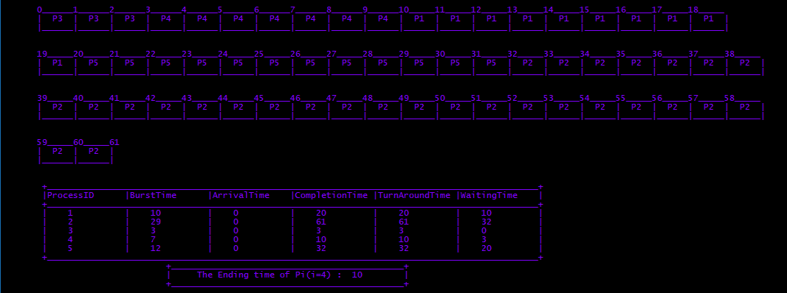
Test case passed successfully and gave expected result.

Test Case #2:
+____________________________________________+
|ProcessID |BurstTime |ArrivalTime | +____________________________________________+
| 1 | 7 | 0 |
| 2 | 4 | 2 |
| 3 | 1 | 4 |
| 4 | 4 | 5 |
+____________________________________________+

Result #2:
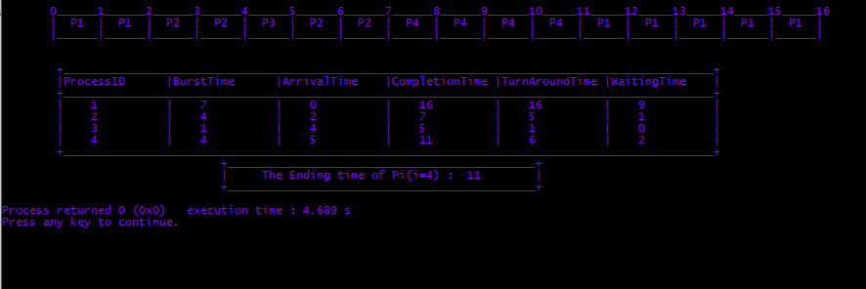
Test case passed successfully and gave expected result.
GitHub Link : https://github.com/itrare/Scheduling_Algo_OS_CA
I have done more than 5 revision in the GitHub repository.

