Functional Design Specification (FDS) Template

Persona-Specific Technical Notes
This section defines the security, encryption, and database behaviors specific to each persona in the CYBHI platform. These include access control, data encryption, and database interaction constraints for each persona's specific actions. All rules are aligned with FERPA, HIPAA, and CYBHI compliance requirements, ensuring privacy and security.

1.1.1 Classified Staff

Persona-Specific Security & Encryption Notes
Access Scope
- Can only create and edit incident reports.
- Cannot create, submit, or bill counseling sessions.
- Cannot decrypt Student PII.
- Cannot access or modify billing information.
Encryption & PII Handling
- All incident data entered by Classified Staff is encrypted before submission.
- PII is redacted before AI processing and is never stored in plaintext.
- Incident narrative and SOAP fields are processed and redacted before being passed to the AI model.
- Role-restricted access: Only those with the proper keys (Admins and Counselors) can decrypt student identities.
- No access to encrypted student roster data or private keys.
- Cannot approve student mappings or billing data.

Persona-Specific Database Notes (Classified Staff)
Collections Accessed
- incidents: Read/write access for incident creation.
- cybhi_sessions: No access for Classified Staff.
Data Rules
- Can only edit incidents they have created.
- Cannot submit or finalize any incident reports.
- Cannot modify data related to counseling sessions or billing.
- No direct access to any student-specific encrypted data.
- Only access anonymized placeholders for student data in the system.
Constraints
- Cannot edit incident data once submitted.
- Cannot access or update cybhi_sessions (counseling data).
- Cannot approve any student ID mappings or billing entries.

1.1.2 Counselors / Certified Health Workers (CHWs)

Persona-Specific Security & Encryption Notes
Access Scope
- Can view and edit assigned incident reports.
- Can create and manage counseling sessions.
- Can bill for counseling services.
- Can decrypt Student PII locally (via private keys stored on their device).
Encryption & PII Handling
- Student identities are decrypted locally using private keys stored in secure device enclaves (e.g., iOS Keychain or Android Keystore).
- No plaintext PII ever transmitted or stored on the backend.
- Counseling data is redacted before being processed by the AI, ensuring no direct PII exposure.
- Role-based access ensures counselors only decrypt the sessions assigned to them.

Persona-Specific Database Notes (Counselors / CHWs)
Collections Accessed
- incidents: Read-only for assigned incidents.
- cybhi_sessions: Read/write for managing and editing counseling sessions.
Data Rules
- Can create counseling sessions and store counseling notes.
- Can view and approve mappings for student IDs but only after manual approval.
- Cannot access incident data beyond their role-specific sessions.
- Can generate and edit SOAP notes for their counseling sessions.
Constraints
- One active counseling session per student per incident.
- Cannot modify billing or finalize payment without Admin approval.
- No direct write access to encrypted student identity data; only placeholders are available in the system.

1.1.3 Admins

Persona-Specific Security & Encryption Notes
Access Scope
- Can approve/reject sessions.
- Can upload and review encrypted student rosters.
- Can generate one-time encrypted roster upload links for onboarding students.
- Can decrypt PII locally using recovery keys (if needed for troubleshooting).
- Can reset passwords and revoke access in case of lost keys or device compromises.
Encryption & PII Handling
- Admins generate one-time secure links for encrypted roster uploads, which are valid for only 15 minutes.
- All encryption keys are stored in secure vaults, with private keys never transmitted or stored in plaintext on the backend.
- Decryption occurs locally on the Admin’s device when needed to confirm student identity, but never on the backend.
- Admins cannot bypass redaction, and PII is stripped before LLM processing.

Persona-Specific Database Notes (Admins)
Collections Accessed
- incidents: Read and update all incidents.
- cybhi_sessions: Approve/reject sessions but no edit access to session data.
- encrypted_rosters: Full access for encrypted student data (during upload).
Data Rules
- Can approve session data and ensure compliance before finalization.
- Can upload student rosters using a one-time, digitally-signed link.
- Can edit and approve mappings for student IDs, but cannot auto-generate mappings.
- Can reset passwords and revoke device access in case of compromise.
Constraints
- Cannot modify incident narratives or SOAP notes.
- Cannot access raw encrypted student data beyond what is required for decryption and upload approval.
- Audit logs track all actions for accountability.

1.1.4 Backend Services & Developers (Non-Persona – Explicitly Restricted)

Persona-Specific Security & Encryption Notes
Access Scope
- Cannot access or decrypt any Student PII.
- Cannot interact directly with LLM’s output that contains PII.
- Cannot approve any mappings or billing data.
- Cannot access or modify session data unless it is anonymized.
Encryption & PII Handling
- All encryption and decryption are handled on the client side (Admin, Counselor).
- Backend services only store encrypted data (no plaintext PII or sensitive student data).
- Encryption keys are never accessible by backend services or developers.

Persona-Specific Database Notes (Backend Services / Developers)
Collections Accessed
- incidents: Read-only access for logs, metadata, and anonymized reports.
- cybhi_sessions: Read-only access for logs, metadata, and anonymized session data.
- Cannot read/write encrypted student data.
Data Rules
- No direct access to student names, identifiers, or any encrypted PII.
- Only anonymized placeholders are used in logs, and all PII is redacted before passing through AI systems.
- No writes to sensitive tables or encrypted roster data.
Constraints
- Cannot approve student mappings or finalize billing data.
- All developer actions are logged and auditable.
- No direct access to personal data in the backend.

2. Security & Encryption (Detailed Technical Section)

This section defines the end-to-end security, encryption, access control, and privacy guarantees implemented across the CYBHI Incident & Counseling platform. The system is designed with a zero-knowledge architecture, ensuring that no backend service, AI system, or developer ever has access to decrypted Student PII at any point in the data lifecycle.

2.1 Security Design Objectives
The security architecture ensures:
- Zero-knowledge backend (no plaintext Student PII)
- End-to-end encryption (client → storage → retrieval)
- Role-based decryption (human-only)
- PII-safe AI processing
- Human-in-the-loop approvals
- FERPA, HIPAA, and CYBHI compliance by design

2.2 Zero-Knowledge Architecture Model

Core Principle
Evolo AI backend services, AI models, infrastructure, and developers cannot decrypt or reconstruct Student PII, even with full database or server access.

Enforcement Mechanisms
Layer | Enforcement
Client | Local encryption & decryption only
Backend | Stores encrypted blobs only
AI / LLM | Receives anonymized placeholders
Database | Encrypted fields + no private keys
Developers | No access to private keys
This guarantees that data breaches, insider threats, or misconfigurations cannot expose Student identities
CYBHI Security Flow
.

2.3 Key Management & Cryptographic Model

2.3.1 Key Types
Key | Purpose | Storage
Public Key (AES-256) | Encrypt Student & roster data | Encrypted in backend
Private Key (Passphrase-Derived) | Decrypt Public Key | Client device only
- Private keys are derived using PBKDF2
- Private keys are never transmitted
- Keys are stored in OS secure enclave / keychain

2.3.2 Roster Encryption & Upload Flow
- Admin generates a digitally-signed, one-time upload link
- Link expires after 15 minutes or one successful upload
- Roster is:
  - Parsed locally
  - Encrypted on the client
- Backend stores:
  - Encrypted roster blobs only
- Upload link becomes invalid immediately
Backend never receives:
- Student names
- Student IDs
- Medical record numbers
CYBHI Security Flow

2.4 PII Redaction & AI Isolation

2.4.1 Mandatory Redaction Layer
Before any LLM processing:
User Input → Presidio Redaction → Placeholder Text → LLM

Detected entities include:
- PERSON
- PHONE
- EMAIL
- ID numbers
- Addresses
Redaction replaces identities with placeholders:
<PERSON_1>, <PERSON_2>

2.4.2 AI Processing Rules
The LLM:
- Receives no real names
- Receives no student IDs
- Returns JSON-only structured output
- Cannot access or infer real identities
The AI cannot leak what it never receives.

2.5 Role-Based Access & Decryption Boundaries

Classified Staff
- Cannot decrypt PII
- Can submit incidents
- Can select student placeholders
- Cannot approve billing
- Cannot access counseling encryption keys

Counselors / CHWs
- Can decrypt locally (client-side)
- Can create counseling documentation
- Can approve student mappings
- Can generate billing drafts

Admin
- Generates secure upload links
- Holds recovery keys
- Approves/rejects sessions
- Can revoke access
- Cannot decrypt backend-stored data

Backend / Developers
- Cannot decrypt anything
- Cannot approve mappings
- Cannot access real identities
CYBHI Security Flow

2.6 Threat Model & Risk Mitigation
Threat Scenario | Outcome
Database breach | Encrypted data unusable
Backend compromise | No private keys
Developer access | Zero PII visibility
Stolen device | Requires account + private key
Lost private key | Data unrecoverable without admin recovery
LLM misuse | No PII available
This ensures defense-in-depth and zero-trust enforcement.

2.7 Network & Infrastructure Security

Edge Protection
- DDoS mitigation
- Rate limiting
- WAF rules
- User-agent filtering
- Fail2ban (SSH)

API Layer
- Private VPC
- No public IPs
- HTTPS only (TLS 1.3)
- NGINX hardening
- Secret Manager for credentials

Database Layer
- MongoDB Atlas (VPC-peered)
- TLS in transit
- Encryption at rest
- Daily backups
- Audit logs enabled
Updated CYBHI (FDS)

2.8 Auditability & Compliance
- All decryptions logged
- All mapping approvals logged
- All submissions tracked
- Admin actions auditable
- Logs retained per policy
- Compliance evidence preserved
Supports:
- FERPA
- HIPAA
- CYBHI billing audits

2.9 Security Guarantees Summary
Guarantee | Status
Zero-knowledge backend | ✅
End-to-end encryption | ✅
PII-safe AI | ✅
Human approval required | ✅
Role-based decryption | ✅
Audit-ready | ✅

2.10 Security Flow
The CYBHI platform enforces privacy-first AI through:
- Cryptographic isolation
- Redaction-before-intelligence
- Human-controlled decryption
- Strict RBAC enforcement
This design ensures maximum security with minimum trust, while still enabling compliant AI-assisted incident and counseling workflows.
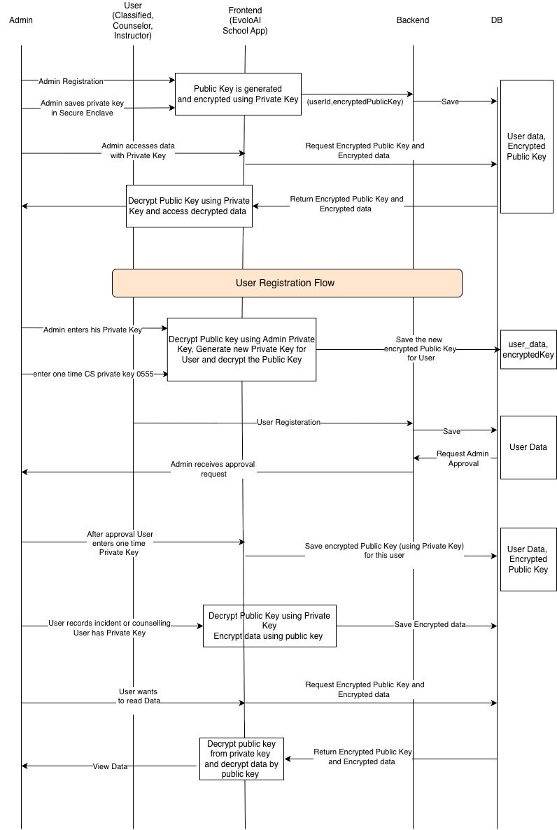

3. Database Schema (Detailed Technical Section)
This section defines the complete database schema used for the CYBHI Incident & Counseling Management platform. It includes all collections, relationships, constraints, ER diagrams, and technical workflows linked to the database interactions.

3.1 Database Design Principles
- Database Technology: MongoDB Atlas (NoSQL, document-based)
- Schema Validation: MongoDB built-in validation with application-level enforcement
- Encryption:
  - Encrypted-at-rest via MongoDB Atlas
  - TLS encryption in transit
  - Client-side encryption for Personally Identifiable Information (PII)
- Zero-Knowledge Architecture: No plaintext PII ever stored or processed on the backend.
- Role-based Access Control (RBAC) ensures secure data access.

3.2 Complete Database Schema
This section includes the full schema for CYBHI-related collections and all platform-related data.

3.2.1 incidents Collection
Purpose: Stores incident reports, including description, messages, and finalized reports.

Key Fields
Field | Type | Description | Constraints
_id | ObjectId | MongoDB primary key | Auto-generated
session_id | string (UUID) | Unique identifier for each incident session | Unique
title | string | Title or description of the incident | Required
date | string (ISO-8601) | Date of the incident | Required
time | string (HH:mm) | Time of the incident | Required
datetime | string | Combined date and time | Auto-generated
location | string | Location where the incident occurred | Required
description.raw | string | Raw incident description | Required
description.soap.subjective | string | Subjective section of SOAP notes | Required
description.soap.objective | string | Objective section of SOAP notes | Required
description.soap.assessment | string | Assessment section of SOAP notes | Required
description.soap.plan | string | Plan section of SOAP notes | Required
messages | array | Full chat history for the incident | Append-only
redaction_map | object | Maps original data to placeholders | Auto-generated
entity_counters | object | Tracks PII entities (e.g., PERSON_1) | Auto-generated
pii_detected | boolean | Flag indicating if PII was detected | Auto-generated
is_report_complete | boolean | Flag indicating if the report is complete | Auto-generated
ready_for_submission | boolean | Flag for submission readiness | Auto-generated
generate_report | boolean | Flag for generating report | Auto-generated
updated_at | datetime | Timestamp for the last update | Auto-generated

Constraints
- session_id must be unique.
- Read-only after submission.
- PII redacted before AI processing.
- No plaintext PII stored after finalization.

3.2.2 cybhi_sessions Collection
Purpose: Stores counseling and coaching sessions linked to incidents.

Composite Identity (Enforced)
incident_id + session_id + session_type + person_identifier

Key Fields
Field | Type | Description | Constraints
_id | ObjectId | MongoDB primary key | Auto-generated
incident_id | ObjectId | Reference to incidents | Foreign Key
session_id | string (UUID) | Unique session identifier | Unique
session_type | string | Type of session (e.g., counseling, coaching) | Required
role | string | Role of participant (e.g., counselor, coach) | Required
person_identifier | string | Placeholder for person | Required
messages | array | Full chat history | Append-only
assistance_response | string | AI response | Optional
billing_code | string | Billing code (e.g., H2014 for counseling) | Optional
units | number | Billing units (e.g., total duration in minutes) | Optional
status | string | Session status (e.g., draft, submitted, approved) | Required
created_at | datetime | Timestamp for session creation | Auto-generated
updated_at | datetime | Timestamp for last session update | Auto-generated

Constraints
- Composite key: incident_id + session_id + session_type + person_identifier must be unique.
- One active session per student per incident and session type.
- Immutable after submission.

3.2.3 Encrypted Roster & Identity Collections
Purpose: Store encrypted student identities and other PII-related data.

Characteristics
- Only encrypted blobs: No plaintext data in any field.
- No access to decrypted PII except on the client-side by authorized roles (Admin and Counselor).
- Encryption keys are stored securely (e.g., in a secure vault or keychain).

3.3 Platform Collections
These collections store data related to platform management, such as users, events, and organizational data.

3.3.1 users Collection
Purpose: Stores platform user accounts (e.g., admins, counselors).

Key Fields
Field | Type | Description | Constraints
_id | ObjectId | MongoDB primary key | Auto-generated
email | string | User's email address | Required
role | array | User's roles (e.g., admin, counselor) | Required
encryptedPublicKey | string | Public encryption key for the user | Required
auth_provider_id | string | ID for authentication provider (e.g., Firebase) | Required
createdAt | datetime | Timestamp when the account was created | Auto-generated
updatedAt | datetime | Timestamp of last account update | Auto-generated

3.3.2 branches Collection
Purpose: Stores data about organizational units (e.g., schools or districts).

Key Fields
Field | Type | Description | Constraints
_id | ObjectId | MongoDB primary key | Auto-generated
name | string | Name of the branch | Required
district_id | string | District to which the branch belongs | Optional

3.3.3 events Collection
Purpose: Stores data about events within an organization.

Key Fields
Field | Type | Description | Constraints
_id | ObjectId | MongoDB primary key | Auto-generated
branch_id | ObjectId | Reference to branches collection | Foreign Key
name | string | Event name | Required
start_date | datetime | Event start date | Required
end_date | datetime | Event end date | Required

3.3.4 messages Collection
Purpose: Stores messages exchanged during chat-based interactions.

Key Fields
Field | Type | Description | Constraints
_id | ObjectId | MongoDB primary key | Auto-generated
chat_id | ObjectId | Reference to the chats collection | Foreign Key
sender | string | Sender of the message (admin, counselor, student) | Required
message | string | Content of the message | Required
timestamp | datetime | Timestamp when the message was sent | Required

3.4 Relationships Summary (ERD)
From Collection | To Collection | Relationship Type
incidents | cybhi_sessions | 1 → N
branches | events | 1 → N
chats | messages | 1 → N
chats | participants | 1 → N
ERD reference confirmed via schema snapshot.

3.5 Constraints & Invariants
- No hard deletes (soft delete only)
- All writes are timestamped for auditability
- PII is never stored in plaintext
- All sensitive actions are logged and auditable
- Role-based access control ensures data is only visible to authorized users
- Placeholder data used in AI workflows to prevent exposure of PII

3.6 Technical Workflows Linked to Database Interactions

3.6.1 Incident Reporting Workflow
- User submits an incident via the app or web interface.
- Backend validates required fields (date, time, location).
- PII Redaction is applied before AI processing.
- AI response generation: Incident is processed to generate an initial report.
- Final report generation: When the incident is complete, it is flagged for submission.
- Database Update: Data is inserted or updated in incidents collection.

3.6.2 Counseling/Coaching Workflow
- Session creation: A session is initialized based on the incident.
- PII redaction & analysis: Any sensitive data is redacted before AI processing.
- Session updates: AI helps in generating SOAP/BIRP notes.
- Billing generation: After session completion, billing units are calculated.
- Database Update: Data is inserted into the cybhi_sessions collection.

3.7 ER Diagrams and Visual Schema
Here are the ER Diagrams based on the JSON schema and generated by MONGO ATLAS and the corresponding relationships:

ERD Visual

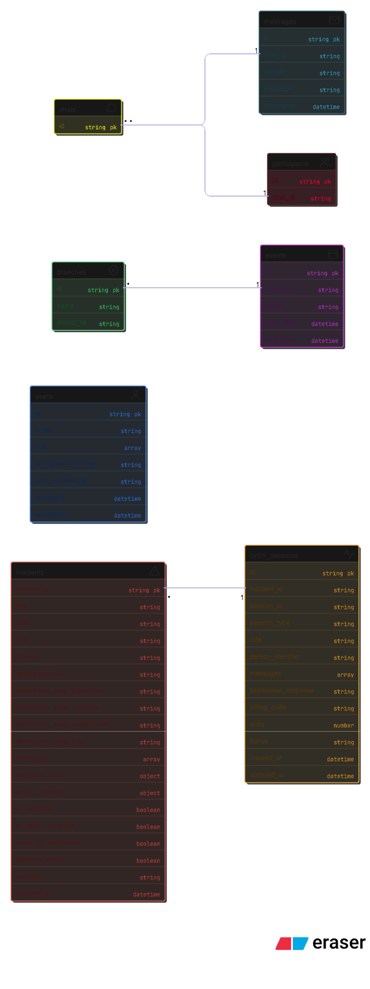

4. BOT Technical Workflow

This section describes the technical architecture, execution flow, and decision logic of the unified CYBHI AI Bot responsible for:
- Incident Reporting
- Incident-Triggered Coaching / Counseling
- Standalone Coaching / Counseling Sessions
The workflow ensures FERPA, HIPAA, and CYBHI compliance, zero-knowledge guarantees, and human-in-the-loop validation at every stage.

4.1 High-Level Architecture Overview
The CYBHI AI system is implemented as a single backend intelligence layer that dynamically adapts behavior based on role, session type, and conversation state.

Core Components
Component | Responsibility
React Native Client | User input, encryption, local decryption
CYBHI_Bot (Backend) | AI orchestration, redaction, validation, persistence
OpenAI LLM | Structured JSON generation (no PII)
MongoDB Atlas | Session persistence (anonymized)
Presidio Engine | PII detection & redaction
Mapping Layer | LLM ↔ Session schema translation
Key Architectural Rule:
The LLM never receives real student identities — only anonymized placeholders.

4.2 Session Types & Responsibilities
The bot supports three distinct workflows, handled by the same backend class.

1️ Incident Session
- Created via start_chat()
- Stores:
  - Incident metadata
  - SOAP description
  - Conversation history
- No counseling logic applied

2️ Incident + Coaching/Counseling
- Incident session + one or more CYBHI sessions
- Coaching drafts auto-generated per participant
- Used by Counselors / CHWs

3️ Coaching/Counseling Only
- Created via start_coaching_counseling_chat()
- Independent of incident creation
- Uses BIRP / counseling schemas

4.3 Incident Reporting Flow (Sequence)

Step-by-Step Execution

1. Session Initialization
start_chat(role)

- Generates session_id
- Initializes incident_session_schema
- Persists draft session (localhost / prod)

2. User Input Received
chat(incident_session, user_message, role)

3. PII Redaction (MANDATORY PRE-LLM)
redact_pii(session, user_message)

What Happens
- Presidio detects allowed entity types
- Real identities replaced with <PERSON_1>, <PHONE_1>, etc.
- Redaction map stored only in session memory
- Backend never reconstructs identities
Enforces zero-knowledge guarantee
CYBHI Security Flow

4. LLM Prompt Construction
Depending on role:
- Incident only → get_incident_prompt()
- Incident + counseling → get_incident_coaching_counseling_prompt()
Prompt Includes
- Current system time (ISO-8601)
- Structured JSON snapshot (read-only)
- Conversation history
- Role-specific instructions
Prompt explicitly forbids mentioning system JSON or placeholders.

5. LLM Execution
generate_llm_response(...)

Constraints
- response_format = json_object
- No free-text output
- No PII
- No future dates allowed

6. LLM → Session Mapping
mapLLMOutputToIncidentSessionDetails()

Responsibilities
- Merge structured fields
- Preserve prior user-confirmed data
- Normalize SOAP sections
- Update completion flags

7. Validation & Readiness Check
is_report_complete
ready_for_submission
generate_report

Blocked unless:
- Date present
- Time present
- Location present
- SOAP (S/O/A/P) complete
- No unreplaced placeholders

8. Persistence
save_incident_session_to_db()

- Entire session object stored
- No decrypted PII
- Timestamped updates
- Draft-safe

4.4 Incident → Coaching / Counseling Flow
Triggered when role supports counseling.

Additional Steps

9. CYBHI Session Mapping
mapLLMOutputToCYBHISessionDetails()

- One session per participant
- Linked via incident_id
- Uses composite upsert key:
incident_id + session_id + session_type + person_identifier

10. CYBHI Persistence
save_cybhi_coaching_counseling_sessions_to_db()

- Draft-safe
- Human-approved billing only
- Role-restricted access

4.5 Standalone Coaching / Counseling Flow
Used when counseling is not incident-triggered.

Execution Path
start_coaching_counseling_chat()
→ coaching_counseling_chat()
→ generate_coaching_counseling_llm_response()
→ mapCoachingCounselingLLMOutputToCYBHISessionDetails()
→ save_cybhi_coaching_counseling_sessions_to_db()

No incident schema involved.

4.6 Bot Decision Logic (State Machine)

Core States
State | Description
Draft | Missing required fields
Assisted | Bot prompting for missing data
Complete | All validation rules satisfied
Locked | Submitted / Approved
Read-Only | Admin or post-submission

Transition Rules
- Draft → Assisted: missing fields detected
- Assisted → Complete: all required data collected
- Complete → Locked: user submits
- Locked → Read-Only: admin approval

4.7 Compliance & Security Guarantees
Guarantee | Enforcement
Zero-Knowledge | PII redacted before LLM
Human Approval | Student ID selection required
No Backend Decryption | Keys never transmitted
Auditability | All actions logged
Role Isolation | Prompt + access controlled
Aligned with Security Architecture
CYBHI Security Flow

4.8 Summary
The unified CYBHI_Bot provides:
- A single, extensible AI backend
- Strict separation of identity and intelligence
- Role-aware, schema-driven workflows
- Fully compliant incident and counseling documentation

4.9 High-Level Architecture Diagram
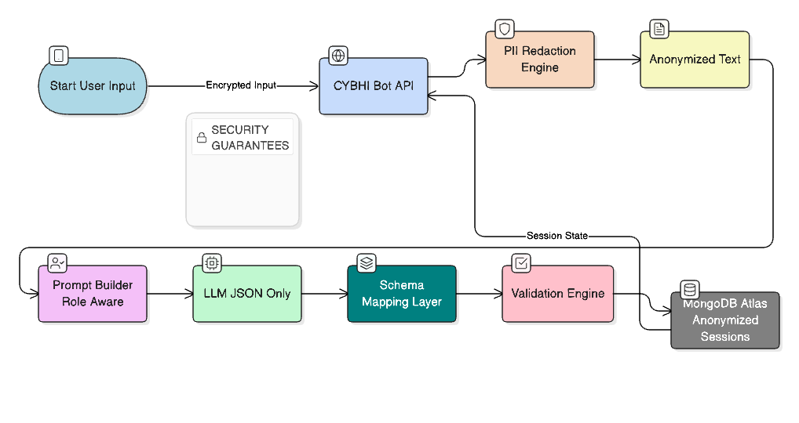

4.10 - Sequence Diagrams

Sequence Diagram — Incident Reporting Flow
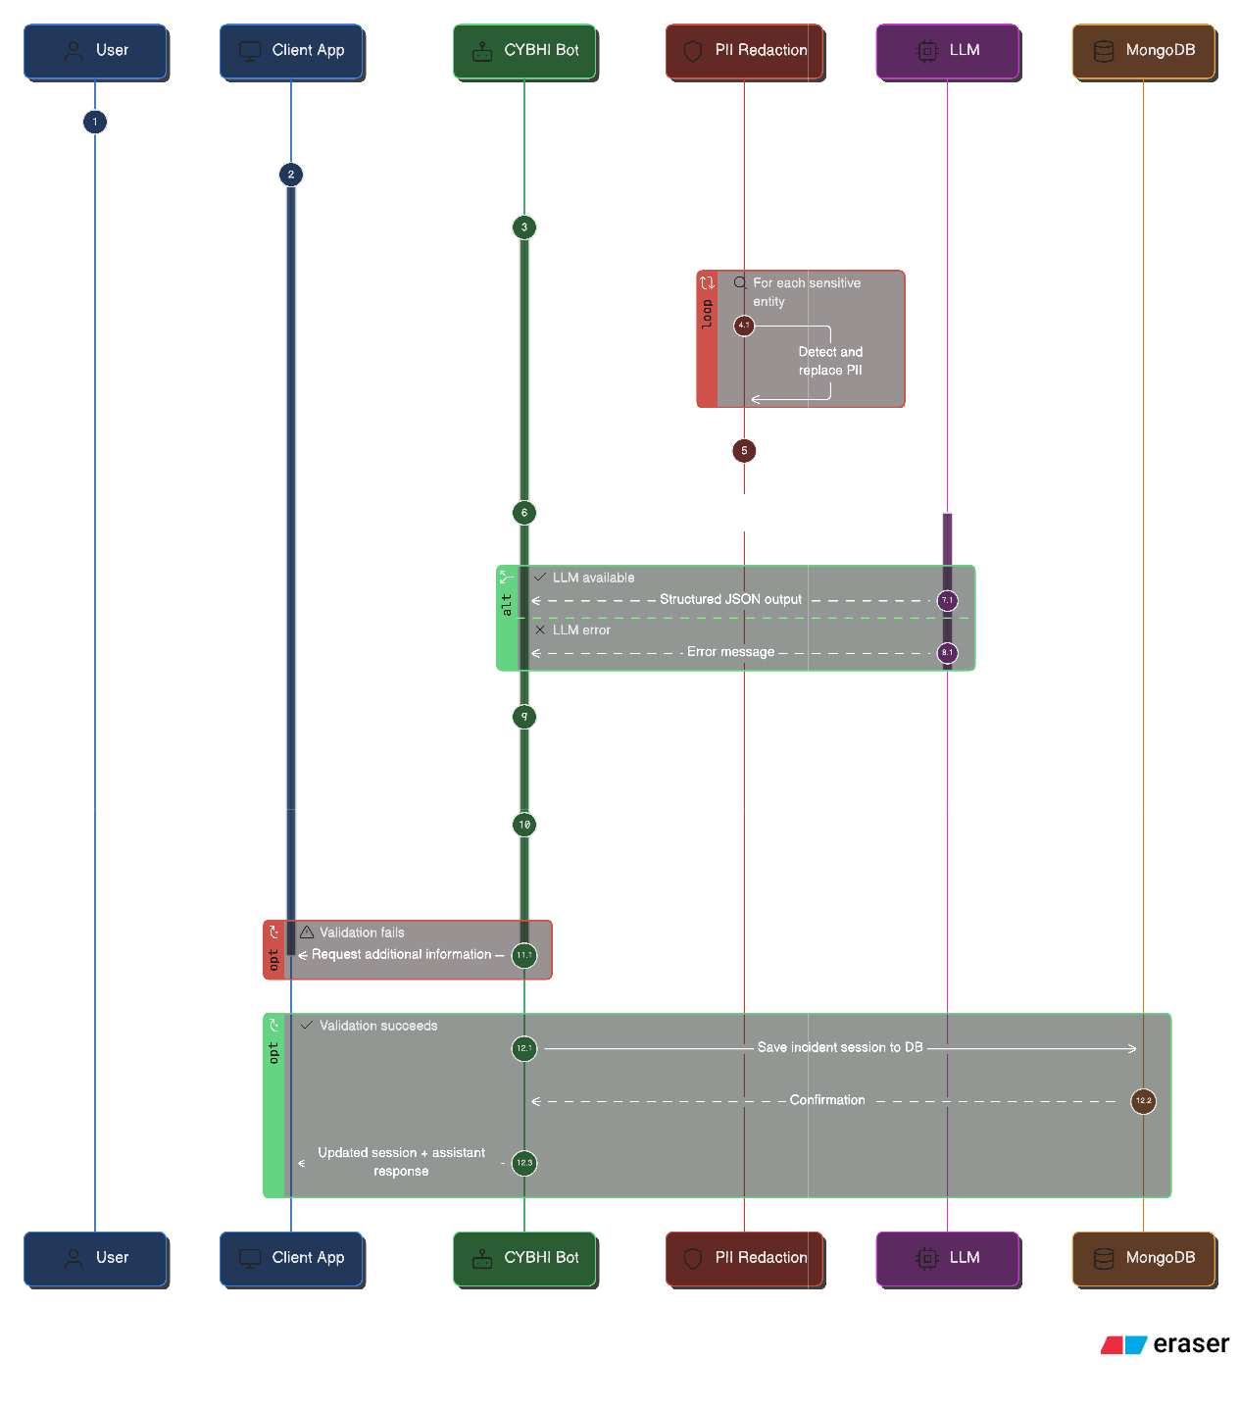

Sequence Diagram — Incident → Coaching / Counseling
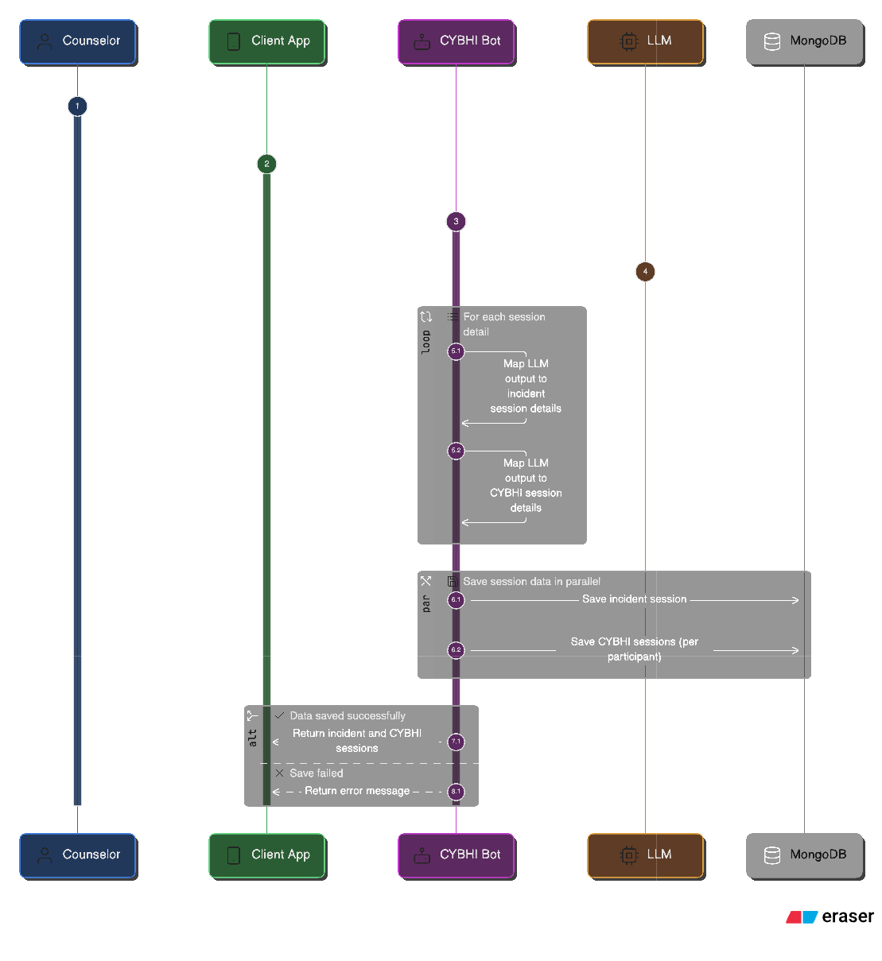

Sequence Diagram — Standalone Coaching / Counseling
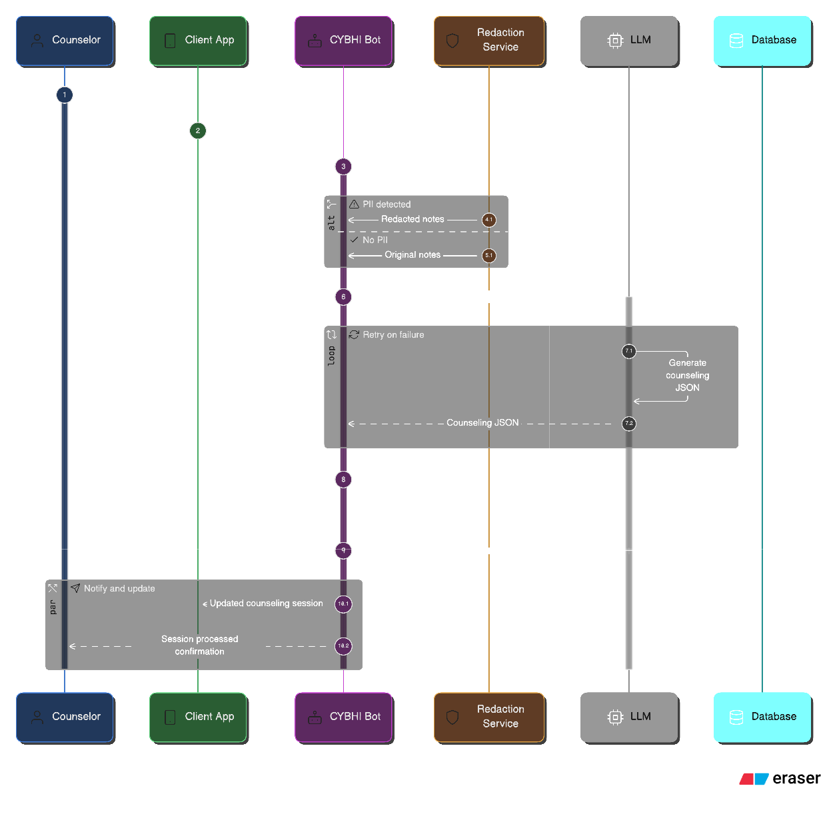
- Bot Decision Logic / Intelligence Flow

5. Integration Notes
- Each section should be finalized individually before integration.
- Planned integration date: ___________________________

