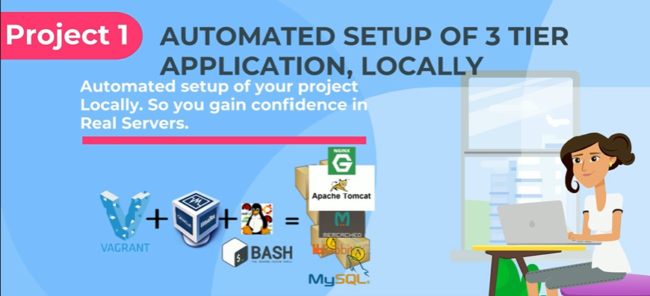

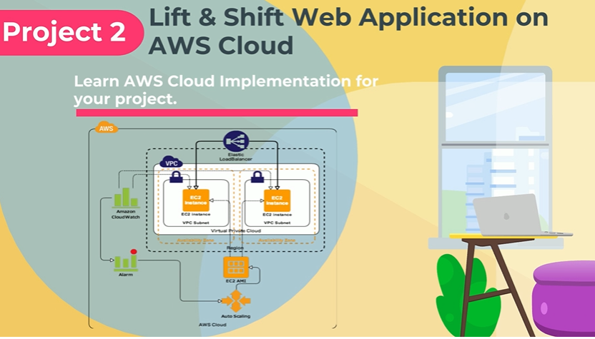

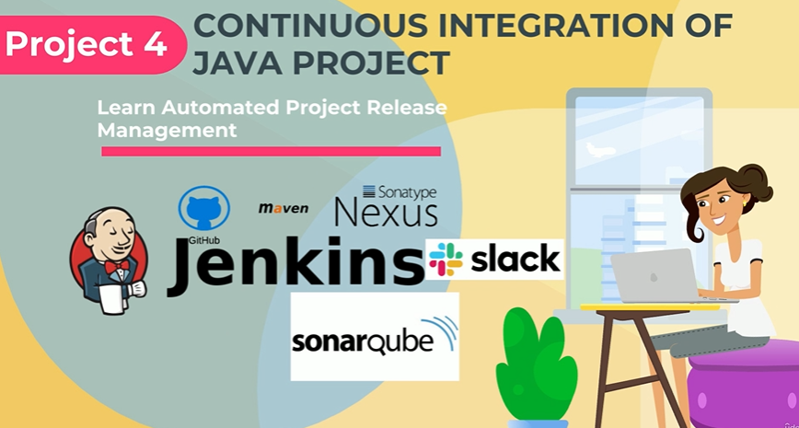

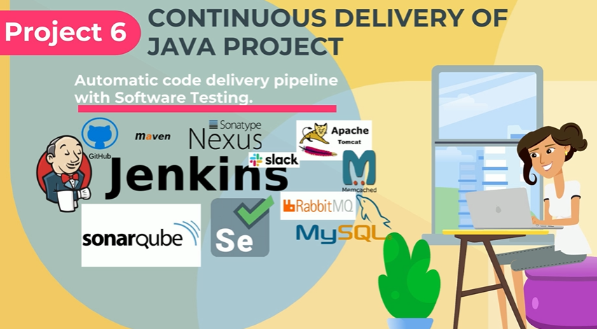

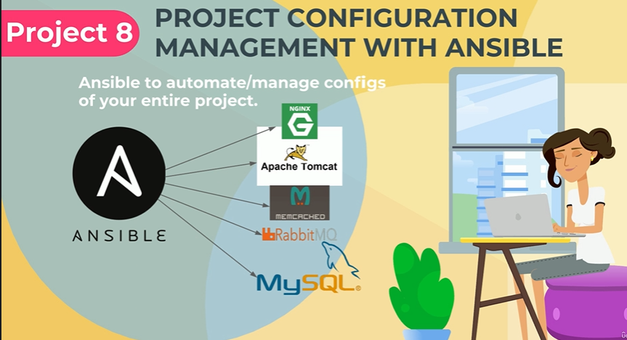

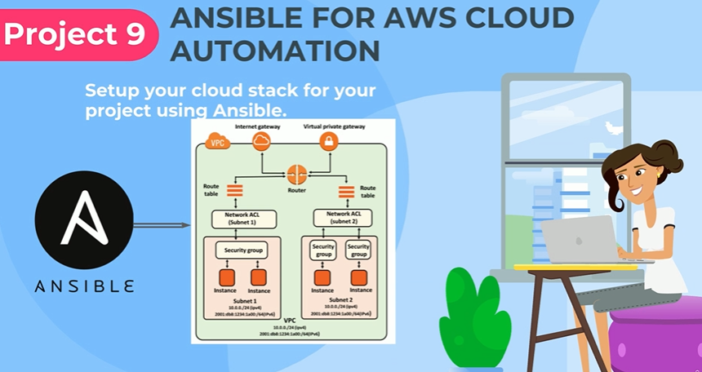

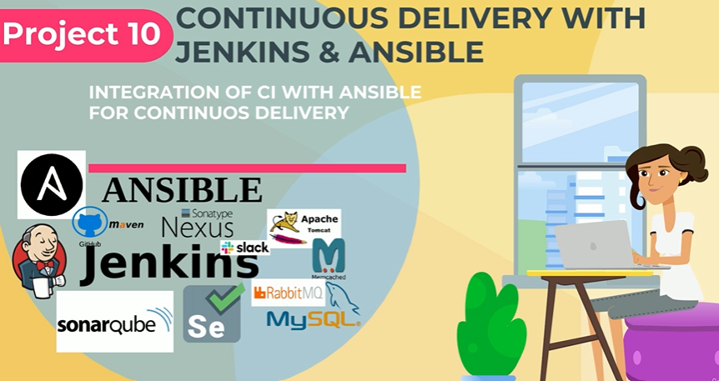

**PROJECT 1 PART 1/2**

Must use LOCAL-SETUP branch

Follow the step here

<https://github.com/itresolve/pani-devops-project/blob/local-setup/vagrant/Manual_provisioning/PaniProjectSetup.MD>

**PROJECT 1 PART 2/2**

Destroy PROJECT 1

Still in LOCAL-SETUP branch

<https://github.com/itresolve/pani-devops-project/tree/local-setup/vagrant/Automated_provisioning>

Check Vagrantfile file, make sure everything is good and that all IPs, Usernames and Password matches what is in application.properties file

# cd pani-devops-project/vagrant/Automated_provisioning/

# vagrant up (To deploy the whole STACK)

**PROJECT 2**

Follow step here (Download)

<https://github.com/itresolve/pani-devops-project/blob/aws-LiftAndShift/Project%202%20Lift%20and%20Shift.docx>

**PROJECT 3**

**PROJECT 4**

**PROJECT 5**

**PROJECT 6**