1. **Structure Geometry Drawing**

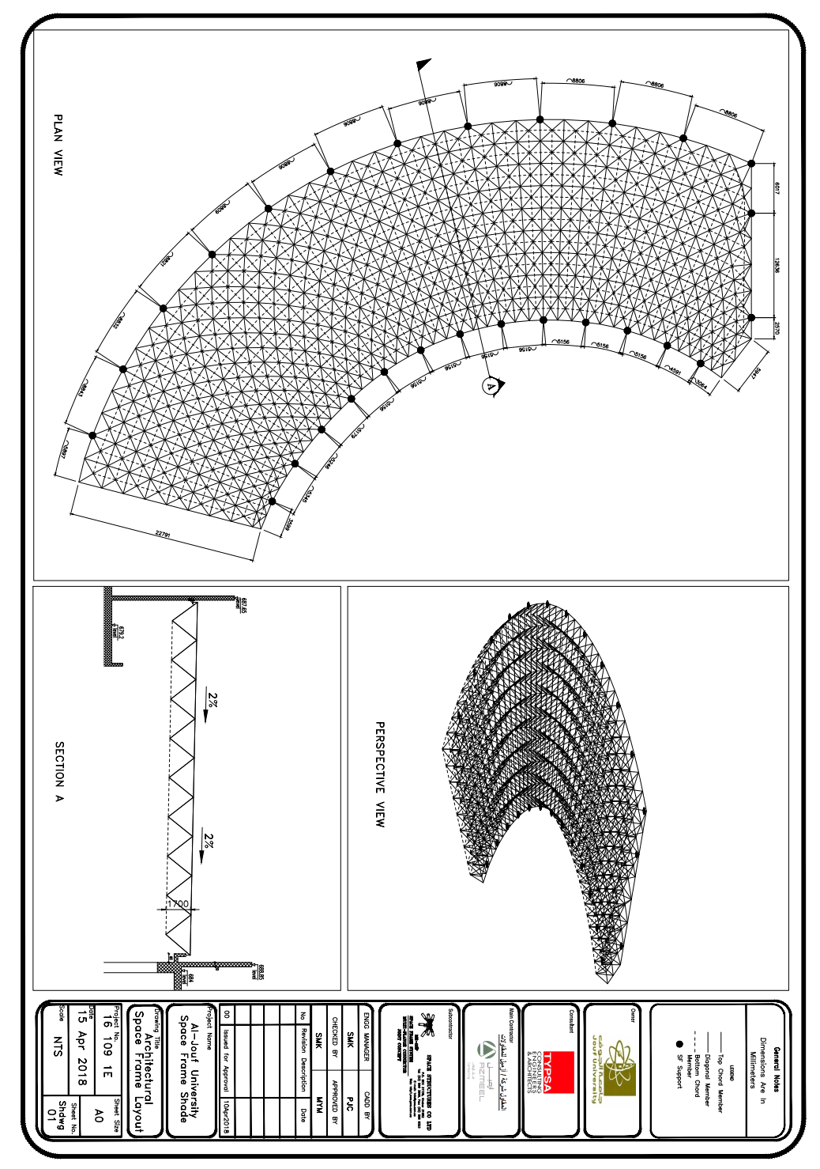

1. **General Description**
   1. **Introduction**

The following report presents the structural analysis & design of the “Al-Jouf University, General Administration Building SF Shade, Job Id 16 109 1E”. The design is according to ASCE STANDARD ASCE-SEI 7-10, as executed in the STAAD.Pro V8i-SS6 Structural Analysis and Design software package.

* 1. **Description of the Structure**

The Space frame represents a semicircular double layer structure, supported by twenty seven short steel columns. The Geometric line sketch illustrates the over-all geometry of the structure. Covering is to consist of sandwich panels supported over purlins connected to purlin stools at each top chord joint.

* 1. **Design Philosophy**

The space frame structure itself is made up of pipes (members) joined to each other using the propriety Multi-Flange™ connecting concept, that is unique to the ME-SSP® Space frame system. This concept allows certain favorable partial fixity to members’ ends, but the design shall be based on the basis of pinned-pinned three-dimensional truss as stipulated in the STAAD.Pro v8i software package. Design of the space frame structure is prepared and made in compliance with the AISC design requirements and scope of other project approved standards.

* 1. **Technical References**
* ASCE/ SEI 7-10: Minimum design loads for buildings and other structures.
* IBC: International building code of international code council (ICC).
* SBC 301: Saudi building code requirements; loading and forces.
* ANSI/AISC 360-05: Specification for Structural Steel Buildings.
* AISC 2005: Steel construction manual.
* ACI-318/318M-08: Building code requirements for structural concrete.
* ASTM A36/A36M: Standard specification for carbon structural steel.
* ASTM A53/A53M: Standard specification for pipe (welded and seamless).
* SAES-A-112: Saudi Aramco Engineering Standard (metrological Data)
* RCSC-04: Specification for structural joints using ASTM A325 or A490 Bolts.
  1. **Design Load Criteria**

The space frame structure is designed considering project specifications and relevant code provision for the following loading conditions:

* + 1. **Dead Loads**

|  |  |  |
| --- | --- | --- |
| **Reference** | **Calculation** | **Output** |
|  | The self-weight is automatically generated during the design analysis iterations | ***Sw*** |
| Client provided Dwgs & Specs | Roof Dead Loads (Sandwich Panels roofing and purlins) [Zone:801] | ***Rl*** = 0.10 kN/m2 |
| Services [Zone:802] | ***Ds*** = 0.05 kN/m2 |

* + 1. **Roof Live Loads**

|  |  |  |
| --- | --- | --- |
| **Reference** | **Calculation** | **Output** |
| Client provided specs. | Ordinary flat, pitched, and curved roofs [Zone:803] | ***Lo*** = 0.6 kN/m2 |

* + 1. **Wind Loads**

|  |  |  |
| --- | --- | --- |
| **Reference** | **Calculation** | **Output** |
| ASCE 7-10  Table 1.5-1 | Risk Category III |  |
| SAES A-112 | Basic wind speed, 3-sec gust at 10m above ground level,  Wind speed ***V*** = 165 km/hr (For Al-Jauf as per client specs) | ***V*** = 165 km/hr  = 45.83m/s |
| ASCE 7-10  Sec 26.1.1  Table 26.6-1 | Buildings – Main Wind Force Resisting System  Directionality Factor **Kd** = 0.85 | ***Kd*** = 0.85 |
| Sec. 26.7.2  Sec. 26.7.3 | Structure is in unobstructed area. | Exposure Category C |
| Sec. 26.8.2  Table 26.8-1 | No hills, ridges or escarpments exist in the area | Topographic Factor  ***Kzt*** = 1.00 |
| ASCE 7-10  Sec. 26.9.1 | Structure is low rise | Gust Effect Factor  ***G*** = 0.85 |
| ASCE 7-10  Sec. 26.10 | Structure considered Open | Enclosure Specification is Open |
| ASCE 7-10  Table 26.11-1  pg. 258 | Internal Pressure Coefficients for Enclosed Buildings | **(*GCpi*)** = ±0.00 |
| ASCE 7-10  Table 27.3-1 | Height above ground 10m | Velocity Pressure Coefficient, ***Kz*** = 0.877 |

|  |  |  |
| --- | --- | --- |
| **Reference** | **Calculation** | **Output** |
| As per Client Specs | ***qh*** *=**0.613****Kz Kzt Kd V2***  = 0.613 x 0.877 x 1.00 x 0.85 x (45.83)2  = 1094.41 N/m2 | ***qh****=*1.0944kN/m2 |

|  |  |  |
| --- | --- | --- |
| Fig. 27.4-1  pg. 264 | Open Building; h = 7.10m; θ = 0˚    Enter x wind zones here  Enter y wind zones here |  |
| **Reference** | **Calculation** | **Output** |
| Fig. 27.4-1  pg. 264 | Open Building; h = 7.10m; θ = 0˚  Enter x wind zones calculations here  Enter y wind zones calculations here |  |

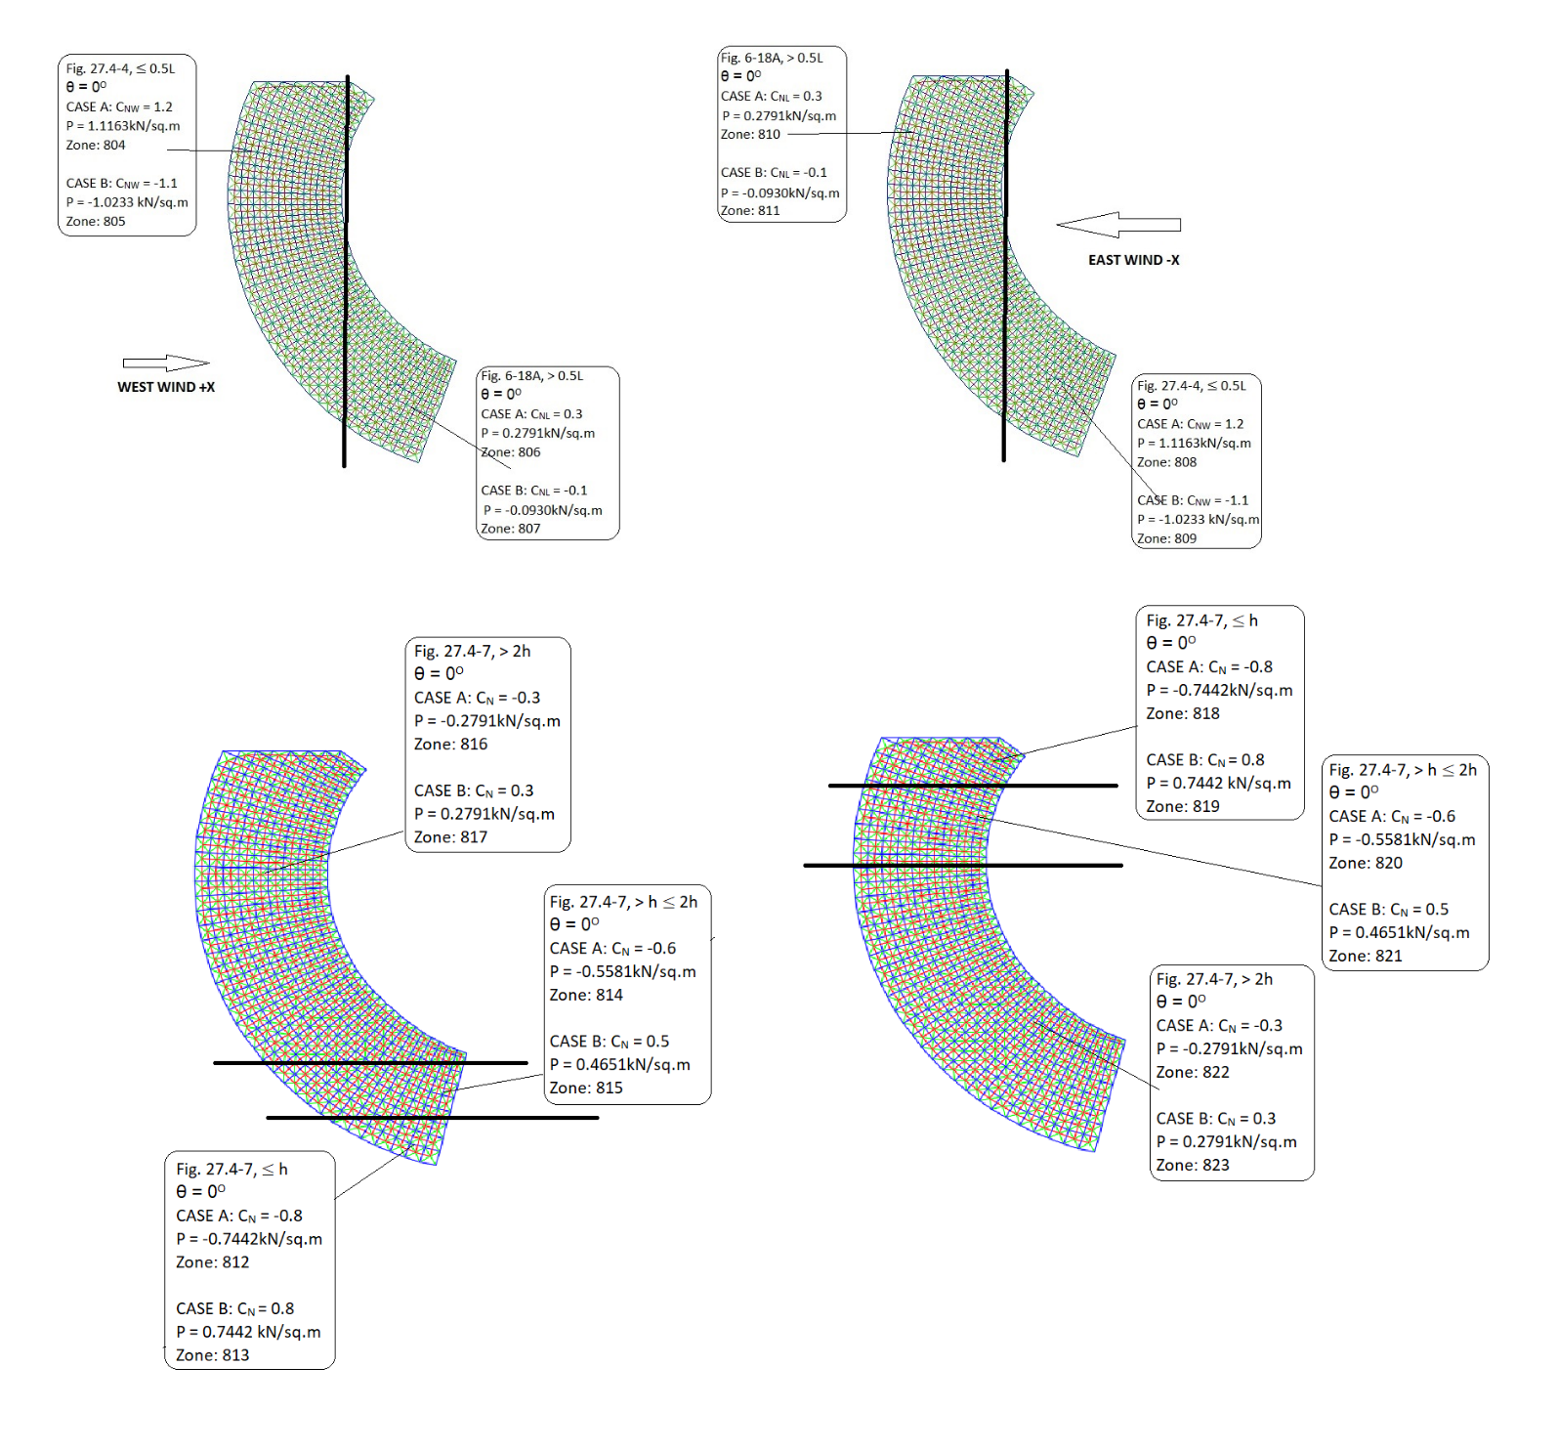

* + 1. **Temperature Loading**

|  |  |  |
| --- | --- | --- |
| **Reference** | **Calculation** | **Output** |
| As per client Specs | The temperature loading is obtained as the difference between the highest and lowest one-day mean. For Al Jauf, as per client specs | ΔT = ± 24ºC |

* 1. **Description of the Primary Load Cases**

|  |  |  |  |  |  |  |
| --- | --- | --- | --- | --- | --- | --- |
| LC1 | ***Sw*** | Self-Weight |  | LC2 | ***Rl*** | Roof Dead Loads = 0.10 kN/m2 |
| LC3 | ***Ds*** | Services = 0.05 kN/m2 |  | LC4 | ***Lr*** | Roof Live Load = 0.60 kN/m2 |
| LC5 | *W+x* | Wind along +X Direction (A) |  | LC6 | *W-x* | Wind along +X Direction (B) |
| LC7 | *W+y* | Wind along -X Direction (A) |  | LC8 | *W-y* | Wind along -X Direction (B) |
| LC9 | *W+y* | Wind along +Y Direction(A) |  | LC10 | *W+y* | Wind along +Y Direction (B) |
| LC11 | *W+y* | Wind along -Y Direction(A) |  | LC12 | *W+y* | Wind along -Y Direction (B) |
| LC13 | *T* | Temperature Loading ±24 ˚C |  |  |  |  |

* 1. **Load Combination Factors**

To achieve basic combination employed in designing the space frame structure, table of load combination factors is generated using the load cases described above and in accordance with “combining nominal loads using allowable stress design” required by ASCE 7-10 as follows:

|  |  |  |  |  |  |  |
| --- | --- | --- | --- | --- | --- | --- |
| No. | Description | Combination |  | No. | Description | Combination |
| 101 | ***Sw*** + ***Rl*** + ***Ds*** | D |  | 217 | ***Sw*** + ***Rl*** + ***Ds*** + 0.75 ***Lr*** +0.45*W+x* (**A**) | D + 0.75Lr + 0.45W |
| 102 | ***Sw*** + ***Rl*** + ***Ds*** + ***Lr*** | D + Lr |  | 218 | ***Sw*** + ***Rl*** + ***Ds*** + 0.75 ***Lr*** + 0.45 *W+x* (**B**) |
| 103 | ***Sw*** + ***Rl*** + ***Ds*** +*T* | D + T |  | 219 | ***Sw*** + ***Rl*** + ***Ds*** + 0.75 ***Lr*** +0.45 *W-x* (**A**) |
| 104 | ***Sw*** + ***Rl*** + ***Ds*** + 0.75 ***Lr*** +*T* | D + 0.75Lr + T |  | 220 | ***Sw*** + ***Rl*** + ***Ds*** + 0.75 ***Lr*** +0.45 *W-x* (**A**) |
| 105 | ***Sw*** + ***Rl*** + ***Ds*** –*T* | D - T |  | 221 | ***Sw*** + ***Rl*** + ***Ds*** + 0.75 ***Lr*** +0.45 *W+y* (**A**) |
| 106 | ***Sw*** + ***Rl*** + ***Ds*** + 0.75 ***Lr*** –*T* | D + 0.75Lr - T |  | 222 | ***Sw*** + ***Rl*** + ***Ds***+ 0.75 ***Lr*** + 0.45 *W+y* (**B**) |
| 201 | ***Sw*** + ***Rl*** + ***Ds*** +0.6 *W+x* (**A**) | D + 0.6W |  | 223 | ***Sw*** + ***Rl*** + ***Ds*** + 0.75 ***Lr*** +0.45 *W-y* (**A**) |
| 202 | ***Sw*** + ***Rl*** + ***Ds*** + 0.6 *W+x* (**B**) |  | 224 | ***Sw*** + ***Rl*** + ***Ds*** + 0.75 ***Lr*** +0.45*W-y* (**B**) |
| 203 | ***Sw*** + ***Rl*** + ***Ds*** +0.6 *W-x* (**A**) |  |  |  |  |
| 204 | ***Sw*** + ***Rl*** + ***Ds*** +0.6 *W-x* (**B**) |  |  |  |  |
| 205 | ***Sw*** + ***Rl*** + ***Ds*** +0.6 *W+y* (**A**) |  |  |  |  |
| 206 | ***Sw*** + ***Rl*** + ***Ds*** + 0.6 *W+y* (**B**) |  |  |  |  |
| 207 | ***Sw*** + ***Rl*** + ***Ds*** +0.6 *W-y* (**A**) |  |  |  |  |
| 208 | ***Sw*** + ***Rl*** + ***Ds*** +0.6 *W-y* (**B**) |  |  |  |
| 209 | ***Sw*** +0.6(***Rl*** + ***Ds***) +0.6 *W+x (***A**) | 0.6D + 0.6W |  |  |  |
| 210 | ***Sw*** +0.6(***Rl*** + ***Ds***) ***+*** 0.6 *W+x (***B**) |  |  |  |
| 211 | ***Sw*** + ***0.6***(***Rl*** + ***Ds***) +0.6 *W-x* (**A**) |  |  |  |  |
| 212 | ***Sw*** +0.6(***Rl*** + ***Ds***) ***+*** 0.6 *W-x* (**B**) |  |  |  |  |
| 213 | ***Sw*** +0.6(***Rl*** + ***Ds***) ***+*** 0.6 *W+y* (**A**) |  |  |  |  |
| 214 | ***Sw*** +0.6(***Rl*** + ***Ds***) ***+*** 0.6 *W+y* (**B**) |  |  |  |  |
| 215 | ***Sw*** +0.6(***Rl*** + ***Ds***) +0.6 *W-y* (**A**) |  |  |  |  |
| 216 | ***Sw*** +0.6(***Rl*** + ***Ds***) ***+*** 0.6 *W-y* (**B**) |  |  |  |  |