Domain Model

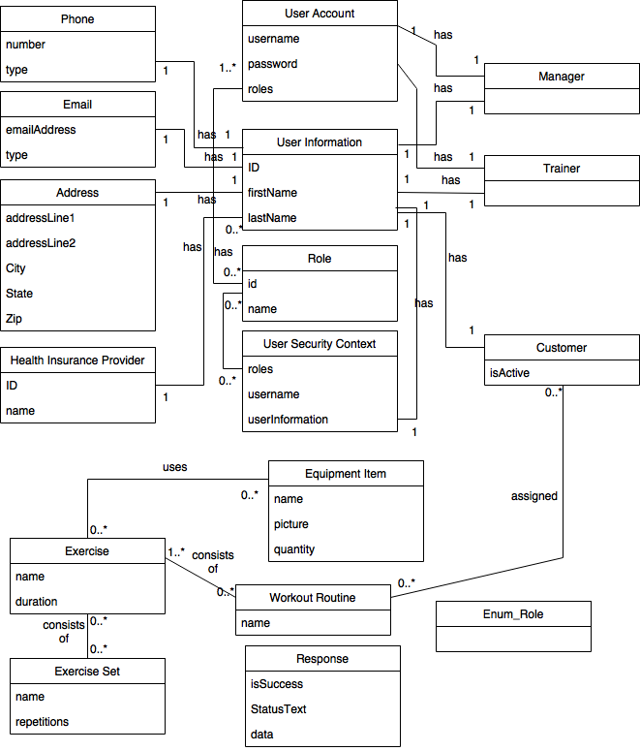Note: Please see P2_UML.png in GitHub if image resolution is not readable

Glossary

1. Address

Object to represent an address within the application

* 1. Attributes:
     1. **addressLine1**: Attribute to store the first line of the address
     2. **addressLine2**: Attribute to store the second line of the address
     3. **City**: Attribute to store the City of the address
     4. **State**: Attribute to store the State of the address
     5. **Zip**: Attribute to store the zip code of the address
  2. Associations:
     1. **User Information**: Each addressobject is associated with exactly one User Information object

1. Customer

Object to represent a customer entity within the application

* 1. Attributes:
     1. **IsActive**: Attribute to denote if this customer is active / not active within the application
  2. Associations:
     1. **User Information**: Each customer entity is associated with exactly one User Information entity
     2. **Assigned Workout Routine**: Each customer entity is assigned 0 to many workout routines

1. Email

Object to represent an email address within the application

* 1. Attributes:
     1. **EmailAddress**: Attribute to store the actual email address
     2. **Type**: Attribute to store the type of email. E.g. School, Work, Personal
  2. Associations:
     1. **User Information**: Each email object is associated with exactly one User Information object

1. Equipment Item

Object to represent an item of equipment within the gym. E.g. treadmill, weight bench, barbells

* 1. Attributes:
     1. **Name**: Attribute to store the name of the equipment item
     2. **Picture**: Attribute to store a picture of the equipment item
     3. **Quantity**: Attribute to store the quantity of the equipment item within the gym
  2. Associations:
     1. **Exercise**: Each equipment item may be used in 0 to many exercises within the application

1. Exercise

Object to represent an exercise within the application

* 1. Attributes:
     1. **Name**: Attribute to store the name of the exercise
     2. **Duration**: Attribute to store the duration of the exercise
  2. Associations:
     1. **Exercise Set**: An exercise may consist of 0 to many exercise sets
     2. **Equipment Item**: An exercise may make us of 0 to many equipment item entities

1. Exercise Set

Object to represent an exercise set within the application.

* 1. Attributes:
     1. **Name**: Attribute to store the name of the exercise set
     2. **Repetitions**: Attribute to store the number of repetitions the exercise set requires
  2. Associations:
     1. **Exercise**: An exercise set may be used in 0 to many exercises

1. Health Insurance Provider

Object to represent a health insurance provider entity within the application

* 1. Attributes:
     1. **ID**: Attribute to store the unique identifier for the health insurance provider
     2. **Name**: Attribute to store the name of the health insurance provider
  2. Associations:
     1. **User Information**: Health insurance providers can be associated with many user information entities

1. Manager

Object to represent a manager entity within the application

* 1. Attributes: None
  2. Associations:
     1. **User Information**: Each manager entity is associated with exactly one User Information entity
     2. **User Account**: Each manager entity is associated with exactly one user account in order to log into the system

1. Phone

Object to represent a phone number within the application

* 1. Attributes:
     1. **Number**: Attribute to store the actual phone number
     2. **Type**: Attribute to store type of phone. E.g. Cell, Home, Work
  2. Associations:
     1. **User Information**: Each phone object is associated with exactly one User Information object

1. Response

Object to represent a response from a controller.

* 1. Attributes:
     1. **isSuccess**: denotes if action was successful
     2. **StatusText**: Text message to display to user
     3. **data**: Additional data to pass to UI for presentation
  2. Associations:
     1. None

1. Roles

Object to represent a user’s role in the system. Many to many relationship with User Account

* 1. Attributes:
     1. **Id**: Role identifier
     2. **Name**: Name of the role
  2. Associations:
     1. **User Account**: Many roles to many user accounts

1. Trainer

Object to represent a trainer entity within the application

* 1. Attributes: None
  2. Associations:
     1. **User Information**: Each trainer entity is associated with exactly one User Information entity
     2. **User Account**: Each trainer entity is associated with exactly one user account in order to log into the system

1. User Account

Object to represent a user account entity within the application in order to allow a user to log into the application

* 1. Attributes:
     1. **Username**: Attribute to store the username to be used to into the application
     2. **Password**: Attribute to store the password to allow a user to log into the application
  2. Associations:
     1. **Manager**: User account must be associated with at most one manager entity and no trainer entity

OR

* + 1. **Trainer**: User account must be associated with at most one trainer entity and no manager entity

1. User Information

Object to hold all common user information data for Managers, Trainers, and Customers

* 1. Attributes:
     1. **ID**: Unique identifier
     2. **FirstName:** Attribute to store first name
     3. **LastName:** Attribute to store last name
  2. Associations:
     1. **Phone**: Association of a phone object to this object. This User Information object can only have one associated phone
     2. **Email**: Association of an email address object to this object. This User Information Object can only have one associated email
     3. **Address**: Association of an Address object to this object. This User Information object can only have one associated address
     4. **Health Insurance Provider**: Association of a Health Insurance Provider object to this object. This User Information object can only have one Health Insurance Provider

1. User Security Context

Object to represent a user’s security context in the system.

* 1. Attributes:
     1. **roles**: user roles
     2. **username**: User’s username
     3. **userInformation:** user’s userInformation object
  2. Associations:
     1. **Roles**: 0 to many association with Roles object

1. Workout Routine

Object to represent a workout routine entity within the application

* 1. Attributes:
     1. **Name**: Attribute to store the name of the workout routine
  2. Associations:
     1. **Customer**: Each workout routine can be assigned to 0 to many customers
     2. **Exercise**: Each workout routine entity consists of 1 to many exercises