|  |
| --- |
|  |
| ARIANA GDPR users |
| Cloud Cybersecurity Fortress of Open Resources and Tools for Resilience (CyFORT) |
| ARIANA User guide for the  Record of Processing Activities  (GDPRUserGuide) |

General information

|  |  |
| --- | --- |
| Reference | 5ADPUG |
| Version | 1.1 |
| State | Final |
| Owner | R. Santos |
| Application date | 30/06/2025 |
| Classification | Internal |

Document history

|  |  |  |  |
| --- | --- | --- | --- |
| Version | Date | Author | Modifications |
| 0.1 | 27/12/2024 | R. Santos | Document creation |
| 1.0 | 30/12/2024 | R. Santos | Document publication |
| 1.0.3 | 23/06/2025 | R. Santos | Added more information to section 3 detailing the initial lines of the Excel worksheet file.  Reviewed references |
| 1.1 | 23/06/2025 | C. Harpes | Revision |

Working group

|  |  |
| --- | --- |
| Name | Organization |
| R. Santos | itrust Consulting |
| C. Harpes | itrust Consulting |
| A. Chezganova | itrust Consulting |
| R. Pande | itrust Consulting |
| E. Omar | itrust Consulting |

Approval

|  |  |  |  |
| --- | --- | --- | --- |
| Name | Role | Responsibility | Signature |
| Carlo Harpes | Managing  Director | Applicability |  |
| Ricardo Santos | Author | Content |  |

Summary

This document details how to create GDPR processing records with ARIANA starting from the GDPR record of processing Word template and the GDPR record of processing Excel file.

**Table of contents**

1 Introduction 5

1.1 Context 5

1.2 Objectives 5

1.3 Document structure 5

1.4 References 5

1.5 Acronyms 5

1.6 Glossary 5

2 GDPR document structure 7

3 The GDPR record of processing data 8

4 The GDPR Record of Processing Template 9

5 Generating the records of processing 10

List of figures

Figure 1: The Record of processing workbook layout. 8

Figure 2: Record of Processing Template table example. 9

Figure 3: The GDPR-Processing Record Ribbon menu section. 10

Figure 4: The PRORecPara button. 10

Figure 5: The document generation settings window. 10

Figure 6: The PRExportInDoc button. 11

Figure 7: Selecting records of processing to be generated. 11

# Introduction

## Context

The ARIANA GDPR document creation tool aims to produce a set of records of processing for a given client. These records are based in a Word-format template and an Excel-based set of processing records information.

The creation of such documents is performed in an automated manner using ARIANA tools and

## Objectives

This document aims to provide instructions on how to generate the GDPR records of processing based on the data in the Excel-format data.

## Document structure

The structure of the document is the following:

* Chapter 2 describes how the documents in the GDPR tool interact with each other to create the records of processing;
* Chapter 3 describes the structure of the Excel document and how to include data in it;
* Chapter 4 describes the record of processing template Word file;
* Chapter 5, finally, describes the process to generate a set of processing records using the Word template and the Excel data file.

## References

1. itrust consulting, ISMS, Information Security policy (ITR-InfoSec), #0.
2. itrust consulting, ISMS, List of documents (ITR-ListDoc), #01.
3. Itrust Consulting, Cloud Cybersecurity Fortress of Open Resources and Tools for Resilience (CyFORT) -- Registre des traitements de DCP (ITR-RegistreDCP) [#2R]
4. Itrust Consulting, Protection des données à caractère personnel (PDCP) -- Registre de traitements de DCP —Modèle (ITR-FTModèle) [#2FT]
5. REGULATION (EU) 2016/679 OF THE EUROPEAN PARLIAMENT AND OF THE COUNCIL of 27 April 2016 on the protection of natural persons with regard to the processing of personal data and on the free movement of such data, and repealing Directive 95/46/EC (General Data Protection Regulation)

# Overview of functions and documents

The ARIANA GDPR module takes two files as input to produce a folder containing a word docucment for eac h(selected) processing activities containing all relevant information for the record in an easy readable form. The two inputs are. :

1. The Record of Processing Excel workbook (#2R): holds all the information about the records of processing, including name, the record fields and approval;
2. The Record of Processing Template File (#2FT): contains the formatted version of one specific record of processing.

These two files serve distinct functionalities in the creation of the records of processing, while the Excel file contains the data to be used in the generation of the records of processing, the Record of Processing template defines the structure and layout of the documents.

# The GDPR record of processing activities

All data for the GDPR records of processing activities are contained in the Excel Workbook for any given customer (generally referred to as #2R). The key data are stored in the worksheet “Registre”. See figure 1.

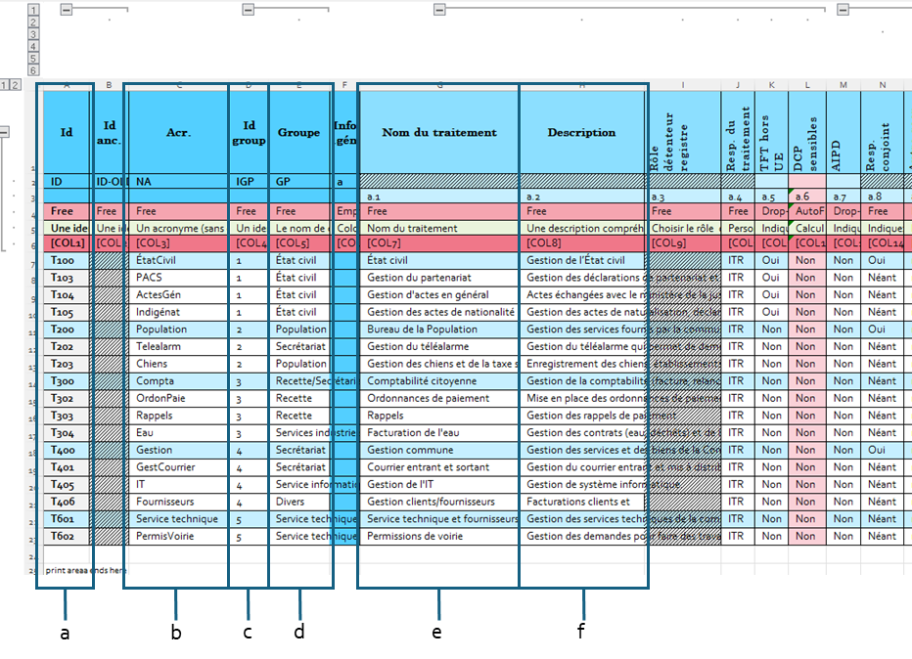

Figure 1: The Record of processing workbook layout.

Each line of this workbook corresponds to one Processing activity (and thus one Word document). The columns of this tables are as follows:

1. The ID of the Record of Processing, composed by a letter, followed by the number of the ID group and then, the sequence number of the record;
2. The Record of Processing name acronym, used in the generation of the Record of Processing file name;
3. Id group, used to separate the Records of Processing in sections according to any given criteria (company sector that deals with the data, similar data types, outsourced and in-house data handling, etc.);
4. Name of the identification of the group. Normally, for one group all the entries should have the same name, but it may make sense to give a few records within the same group a different name;
5. The name of the processing activity, which must be unique and descriptive;
6. The description of the record, detailing in one sentence the purpose and concept of the record.

The remaining Excel columns in the file contain values that ARIANA uses to fill the processing records template file. This correspondence if shown in figure 2 below.

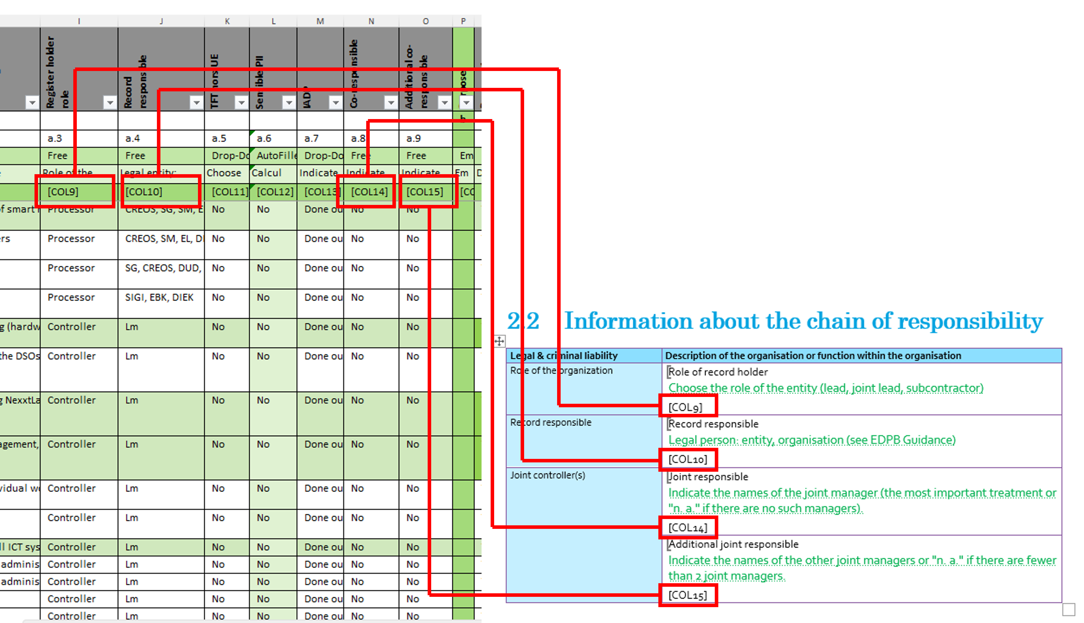

Figure 2: Example of correspondence between the Excel worksheet and the Word template file.

The format of the Excel worksheet is important, as records should begin at line 7, the above lines should always contain the preliminary fields, namely:

1. Line 1: Full name of the data field;
2. Line 2: Abbreviated name of the data field;
3. Line 3: Section and subsection of the data field;
4. Line 4: Completion instructions for the data field, either:
   1. Empty: The column should stay empty;
   2. Free: The user can input anything they want;
   3. AutoFilled: The Excel worksheet calculates the value automatically;
   4. Drop-down: There is a fixed set of possible values, and selecting one excludes any other of them
5. Line 5: The explanation of the field and how it should be filled;
6. Line 6: The column code, as shown in the Word template file.

In conclusion, each line will generate a record of processing Word file and each column is the contents of said Word file. The Excel worksheet should follow the defined format for ARIANA, with the preliminary lines at the top.

# The GDPR Record of Processing Template

## Model history table

Different from other documents, the record of processing template has two history tables; one for the record of processing template itself and the other for the record of processing.

ARIANA treats both automatically, but the model history table should meet two requirements:

1. The HistoryModelTab bookmark should be inside the “Model History” table;
2. The last line should have, at least, the version number already filled.

An example of the table is shown in figure 2 below.

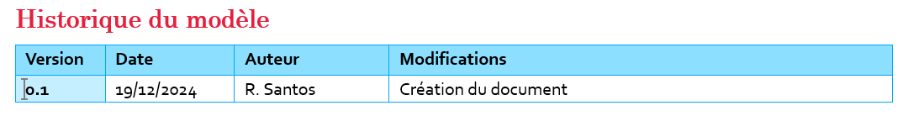

Figure 3: Model history table example.

In case of adding a new version to the record of processing template, a new line should be added to the table and the version number should be already filled, as shown in figure 3.

Figure 4: Adding a new line to the template history table.

## Record tables

When generating the Records of Processing, it is necessary to provide ARIANA with the template of a record of processing (#2FM). The main purpose of this file is to define the document layout for all the Records of Processing generated.

The Record of processing Template is composed of several tables, each with the fields which will be replaced by the information in the Excel Record of Processing Workbook, indicated by the bookmarks, as shown in figure 2.

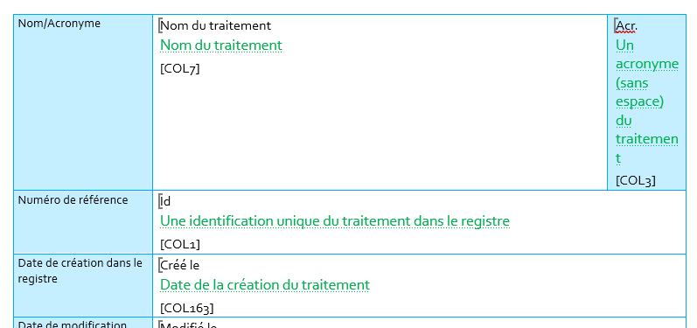

Figure 5: Record of Processing Template table example.

# Generating the records of processing

To generate the records of processing for the GDPR activities, ARIANA should be installed in Word, and its buttons should be available from the ribbon menu.

Before beginning the export procedure, review the Word template document and make sure that the bookmarks are in the correct place and that all the tables are complete.

In the ribbon menu, begin by selecting the “ARIANA-Doc Mgt” ribbon menu and navigate to the “GDPR-Processing Record” section, shown in figure 1:

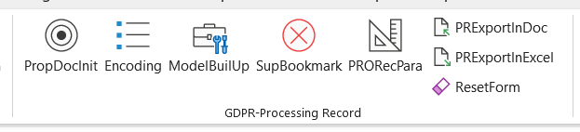

Figure 6: The GDPR-Processing Record Ribbon menu section.

To prepare the document for creation, click on the “PRORecPara” (shown in figure 2) button. Some informative dialog boxes may appear and display messages for your information, but it is safe to dismiss them and



Figure 7: The PRORecPara button.

This will cause the window shown in figure 3 to appear.

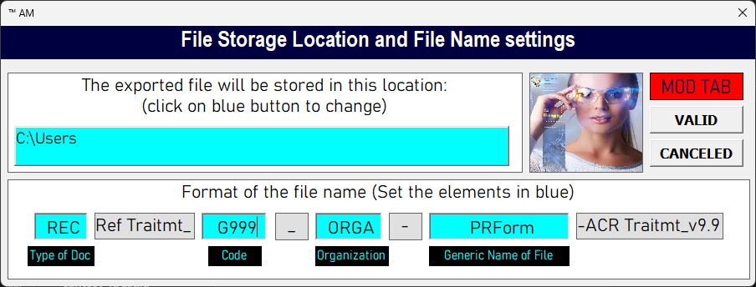

Figure 8: The document generation settings window.

Record of processing generation is a procedure executed in batch, as many documents are generated sequentially by ARIANA. Hence, the filename definition should have information taken from the Excel file in order to organize the documents.

In this window, click on the upper blue area for selecting the directory which will receive the generated records of processing. A folder selection window will appear for selecting the destination directory.

After selecting the directory, it is necessary to define the general name of the record file. The default record of processing name is composed of four parts:

1. Type of Doc: The reference prefix of the record of processing. This will combine with the record of processing ID (COL1 in #2R) to generate the reference of the file;
2. Code: The type of document, usually, the Record of Processing has code STA (Standard)
3. Organization: The acronym of the organization, used to identify for which organization the record was generated.
4. PRForm: The term displayed before the record of processing acronym, as shown in the Excel data file, COL3.

By editing these fields, it is possible to define the rules through which the record files will be generated.

After configuring this step, click on the “PRExportInDoc” button, shown in figure 4, to begin the creatin of processing records documents.

Figure 9: The PRExportInDoc button.

After that, ARIANA will prompt for selecting the Excel file that contains the data which will be used in the records of processing. Make sure that the Excel file is in a valid form and a window such as the one below should appear.

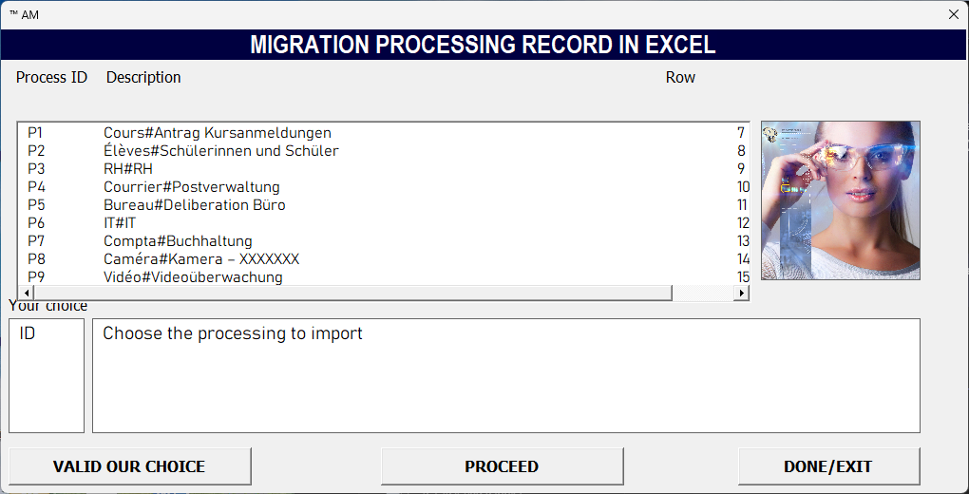

Figure 10: Selecting records of processing to be generated.

To define the records of processing to be generated, select the ones in the list and click on the button “Valid our Choice”. The name of the records of processing should appear in the lower box. Finally, click on the “Proceed” button and wait for the Word documents to be created automatically.