|  |
| --- |
|  |
|  |
| Cloud Cybersecurity Fortress of Open Resources and Tools for Resilience  (CyFORT) |
| DocList Management Tool – UserGuide (DocListManager-UserGuide) |
|  |

General information

|  |  |
| --- | --- |
| Name of the company | itrust consulting s. à r. l.  itrust Abstractions Lab s. à r.l.  IAL : ITR + ALab |
| Project title | Cloud Cybersecurity Fortress of Open Resources and Tools for Resilience (CyFORT) |
| Type | Standard (STA) |
| Reference | #5DCU |
| Version | 1.0 |
| State | Final |
| Owner | Carlo Harpes |
| Application date | 19/06/2025 |
| Classification | Public (PU) |

Document history

|  |  |  |  |
| --- | --- | --- | --- |
| Version | Date | Author | Modifications |
| 0.1 | 02/04/2025 | R. Pande | Initial Version + vwe |
| 0.2 | 07/04/2025 | R. Pande | Version reviewed for validation by Carlo |
| 0.2.7 | 22/04/2025 | R. Pande | Accepted track changes updated section 2.1.3 for review by CHA next before finalizing |
| 0.2.7.2 | 06/06/2025 | R. Pande | Updated the color as Blue from Green of existing entries in section 4.1 and minor other corrections. |
| 0.3 | 14/06/2025 | C. Harpes | Quality review before publication |
| 0.4 | 19/06/2025 | R. Pande | Taking care of review comments. |
| 1.0 | 19/06/2025 | R. Pande | Finalized document for publishing (accepting all track changes) |

Approval

|  |  |  |  |
| --- | --- | --- | --- |
| Name | Role | Responsibility | Signature |
| R. Pande | Product Owner | Content agreement |  |
| A. Chezganova | Project Manager | Release agreement |  |
| C. Harpes | Managing Director (MD) | Project Leader |  |

Table of contents

1 Introduction 5

1.1 Context 5

1.2 Objectives 5

1.3 Scope 5

1.4 Enforcement and reading instructions 5

1.5 Audience 5

1.6 Document structure 5

1.7 References 6

1.8 Acronyms 6

1.9 Glossary 6

2 Prerequisite of using the tool 8

2.1 ISMS Directory structure and File Name convention 8

2.1.2 Folder name structure 9

2.1.3 File distribution mechanism 10

3 Creating a DocList 12

3.1 Additional Installed files 12

3.2 Command line arguments 12

3.3 XML config File 13

3.3.1 XML Configuration Schema 13

3.4 Template File 15

3.4.1 Explanation of all sheets 16

3.5 Debug the generated Doclist Excel file to check for errors 18

3.5.1 Debugging the DocListSheet 18

3.5.2 Misc sheet 21

4 Updating a DocList 22

4.1 Using an existing Doclist to create a new DocList 22

4.2 Example 22

5 Other guidance 24

5.1 Error Handling 24

5.2 Useful hints while working with the tool 24

Table of figures

Figure 1: File naming convention assumed to be followed by the document repository 8

Figure 2: Folder naming convention type 1 or 3 9

Figure 3: Folder naming convention type 3 9

Figure 4: ISMS management/working directory 11

Figure 5: ISMS internal/distribution directory 11

Figure 6: Processing steps 13

Figure 7: Schema of XMLConfigFile 14

Figure 8: Sample XML config file 14

Figure 9: DocList generated for example test without an existing doclist 23

List of tables

Table 1:Example of sorting of files 10

Table 2: Explanation of XML config file elements 15

Table 3: Explanation of DocList Sheet 17

Table 4: Explanation of Tables of Parameters sheet 18

Table 5: Result when using an existing DocList 22

# Introduction

## Context

This document provides the user guide for the DocListManager tool version 1.2, a work package of the CS-GRAM subproject of CyFORT.

## Objectives

The user guide is aimed to help the user in creating an ISMS repository aligned with ISO 27001-2022 structure and create a DocList for the repository while reporting any errors to help maintain and manage the repository in an efficient manner.

## Scope

This document summarizes the user guide of the DocListManager tool.

## Enforcement and reading instructions

This document will come into effect after approval and distribution to interested parties. It shall be respected and/or formally updated by all active contributors.

The use of the SIMPLE PRESENT tense or the terms ‘MUST’, ‘MANDATORY’, ‘REQUIRED’, or ‘SHALL’ in a statement means that the statement is considered a formal requirement. The use of words such as ‘SHOULD’ or the adjective ‘RECOMMENDED’ means that there may be legitimate reasons for disregarding the statement, but that the implications of such an exception shall be assessed and fully understood.

The terminology ‘MAY’ or the adjective ‘OPTIONAL’ means that the implementation of the statement is at the discretion of the implementer. Text marked in red refers to laws or regulations that must be obeyed.

## Audience

This document shall be read and applied by users of the DocListManager tool.

## Document structure

The remainder of this document is structured as follows:

* Chapter 2: Prerequisites of using the tool
* Chapter 3: Creating a DocList
* Chapter 4: Updating a DocList
* Chapter 5: Error Handling
* Chapter 6 provided error handling help and useful hints.

## References

1. itrust consulting, ISMS, Standard, List of documents (ITR-DocList), #0D.
2. itrust consulting, ISMS, Procedure, Document management (ITR-DocMgt), #175.
3. itrust consulting, CyFORT, CS-GRAM, DocListManager – Installation Guide, DocListManager-UserGuide), #5DCU. (this document)
4. itrust consulting, CyFORT, CS-GRAM, DocListManager – Installer (tool internal installer), #5DD.
5. Itrust consulting, github repository, <https://github.com/itrust-consulting/DocListManager>
6. Itrust consulting, test-example, <https://github.com/itrust-consulting/DocListManager/test-example>

## Acronyms

|  |  |
| --- | --- |
| CISO | Chief Information Security Officer |
| CyFORT | Cloud Cybersecurity Fortress of Open Resources and Tools for Resilience |
| CS-GRAM | Cloud services: Governance, Risk management, Audit, Monitoring |
| ISMS | Information Security Management System |
| ISO/IEC | International Organization for Standardization / International Electrotechnical Commission |

## Glossary

|  |  |
| --- | --- |
| Asset | Anything that has value to the organization. |
| Availability | The property of being accessible and usable upon demand by an authorized entity (cf. ISO/IEC 27002). |
| Chief Information Security Officer (CISO) | The CISO is the senior-level executive within an organization responsible for establishing and maintaining the enterprise vision, strategy, and program to ensure information assets are adequately protected. |
| Confidentiality | The property that information is not made available or disclosed to unauthorized individuals, entities, or processes (cf. ISO/IEC 27002). |
| Control | Security measure |
| Information | Element of knowledge that may be transmitted. |
| Information Security | preservation of confidentiality, integrity and availability of information  Note 1: In addition, other properties, such as authenticity, accountability, non-repudiation, and reliability can also be involved. |
| Integrity | property of accuracy and completeness. |
| Management system | set of interrelated or interacting elements of an organization to establish policies and objectives and processes to achieve those objectives  Note 1: A management system can address a single discipline or several disciplines.  Note 2: The system elements include the structure of the organization, roles and responsibilities, planning and operation.  Note 3: The scope of a management system may include the whole of the organization, specific and identified functions of the organization, specific and identified sections of the organization, or one or more functions across a group of organizations. |
| Policy | Overall intention and direction as formally expressed by management. |
| Reliability | Property of consistent intended behaviour and results |

# Prerequisite of using the tool

The tool assumes that the documents for which the tool is creating the DocList are part of the ISMS of an organization and follow a specific naming convention and are sorted in the folder structure in a specific manner.

The naming convention and directory structure is detailed in the sections below.

## ISMS Directory structure and File Name convention

The document naming convention used for creating ISMS documents is depicted below. Any documents not adhering to the DOC naming convention will be flagged as errors.

Figure 1: File naming convention assumed to be followed by the document repository

The name of a file is assumed to be made up of 4 elements separated by an underscore:

1. XXX(T) where the document identifier is a sequence of digits and capital letters, that should be read in a sequential way, i.e. #5 refers to a high-level document, here a policy, whereas the document #502 refers to another document related to this policy;
2. TTT is the acronym, in general three letters, for the document Type, e.g. POL, PLA, PRO, STA, REC. These are the most commonly used ones. Refer to the template used by the tool 3.4.1.5 (Parameters sheet, TableType table);
3. ACR-DocAcr is the acronym of the document, where ACR stands for the acronym of the company or the activity, and TitleAcr is an acronym of the title of the document:
   1. ACR stands for the entity acronym. Refer to the template used by the tool section 3.4.1.5 specifically the TableOrg table;
   2. TitleAcr is the acronym of the document chosen by the author of the document. It reflects the content of the document (e.g. DocList for the standard list of documents). In addition, hyphens may also be used to add clarity to the titles (e.g. Risk -analysis-for-2023);
4. vX.X is the version number of the document, with X generally being a one-digit number or exceptionally two-digit number. Draft versions may contain a third position and fourth position, followed by the acronym of the person who changed the document and, optionally, by a date. Refer the template used by the tool section 3.4.1.5 specifically the TableStatus table.

Finally, the name of a computer file ends with the document type (always lowercase), for example, .docx, .pdf, .xls.

##### Classification of documents (parameter sheet)

All ISMS documents must be classified according to a specific access level. This defines who has access to the specific document. Refer the template used by the tool section 3.4.1.5 specifically the TableClassif table.

### Folder name structure

Files are assumed to be sorted into appropriate folders based on their identifier (ID). Folder names can be structured in three ways.

* The first one is the simplest one, composed of only two components, folders reference number and folder acronym separated by an underscore, used when a folder contains different types of documents. Eg. 6_PeopleControl.
* The second convention is also two components, but the second component will also contain the acronym of the organization. Eg. 6_ITR-PeopleControl

Figure 2: Folder naming convention type 1 or 3

* The third convention is composed of three components: folder reference number, type of document, and organization and folder acronym, separated by two underscores in total, as illustrated below. This can be used in case the folder contains only one type of document. Eg. 6_POL_ITR-PeopleControl.

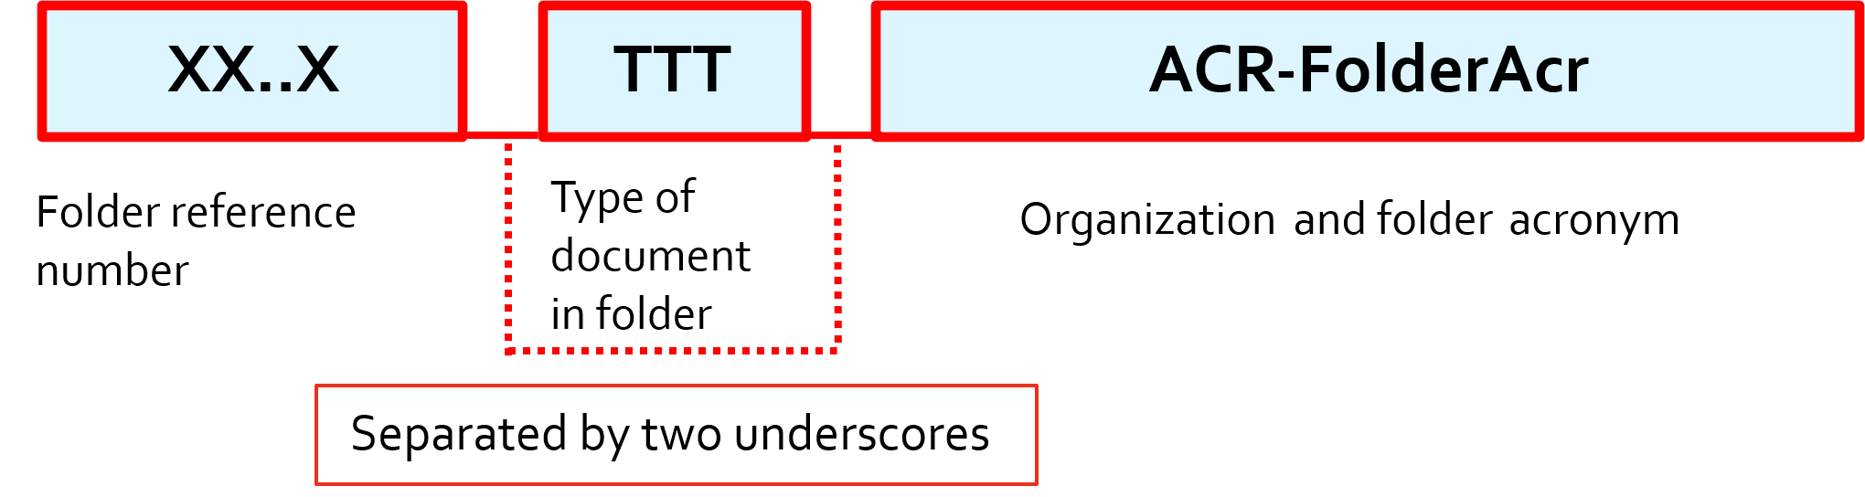

Figure 3: Folder naming convention type 3

**XX..X**: Implies the folder identifier is a sequence of digits and capital letters, that should be read in a sequential way. Only the documents whose identifiers are prefixed with XX..X can be sorted in their folder. Eg. 0D_STA_ITR-DocList_v0.1.1-jdo can be sorted in 0D_ITR-DocList. It follows that 0D_STA_ITR-DocList_v0.1.1-jdo cannot be sorted into 1_ISMS.

**FolderAcr** is the TitleAcr of the first document (usually policy or procedure) in the folder.

**TTT** is an indicator which is sometimes added if the folder contains only one specific type of document with a single identifier. TTT in this case represents the type of document present within the corresponding folder. For example, 3_POL_ITR-CodeConduct represents that the document contained in the given folder will only be a Policy document with identifier 3.

**ACR** represents the organization or project acronym and is an optional prefix to the FolderAcr (separated by a hyphen).

#### Examples of sorting of files and folders.

|  |  |  |  |  |
| --- | --- | --- | --- | --- |
| No | FileName | ParentFolder | Grand Parent | Valid |
| 1. | 0D_ITR-DocList | 0_InfoSec | 0_InfoSec | Yes |
| 2. | 1D_ITR-DocList | 0_InfoSec | 1_ISMS | No |
| 3. | 1D_ITR-DocList | 1_ISMS | 1_ISMS | Yes |
| 4. | 72_PRO_ITR’PhysicalEntry | 702_PhysicalEntry | 7_PhysControls | No |
| 5. | 702_PRO_ITR’PhysicalEntry | 702_PhysicalEntry | 7_PhysControls | Yes |
| 6. | 702_PRO_ITR’PhysicalEntry | 702_PhysicalEntry. | 6_PeopleControl | No |

Table 1:Example of sorting of files

Example 2. Doesn’t represent a valid case because even though the file name is valid (id = 1D) it is not correctly sorted in the parent folder (ID=0) and will thus be flagged as an error by the tool.

Example 4. Doesn’t represent a valid case because the ID of the file which is 72 is not a subset of ID of parent (702).

Example 6. Doesn’t represent a valid case since even though the ID (702) of the file is a valid ID of the ParentFolder(702), the ID of the parent folder (702) is not a subset of the ID of grandparent (6).

### File distribution mechanism

Validated and signed files that are ready to be distributed are sorted into folders according to their IDs.

During the document distribution process, a member of the ISMS team is responsible for the following actions:

1. generate a PDF file of the signed document in ISMS Working dir (see 3.3.1 ISMSWorkDir element);
2. move the signed document and the signed PDF to the _distributed directory in if the document is classified as Internal or Public and copy it to the distribution folder (see 3.3.1 ISMSPublishDir element);
3. move the signed document and the signed PDF to the _approved directory if the document is classified as Restricted or Confidential and DO NOT copy it to the distribution folder (see 3.3.1 ISMSPublishDir element);

**Example**: Refer the directory structure of the ISMS working directory in test_example shared in the tool repository. Following picture shows the path of the recently distributed file 175_PRO_ITR-DocMgt_v4.4.pdf.

Figure 4: ISMS management/working directory

The same file should be copied and made available for access within the organization’s Internal repository

Test_example/ISMS_internal in this case:

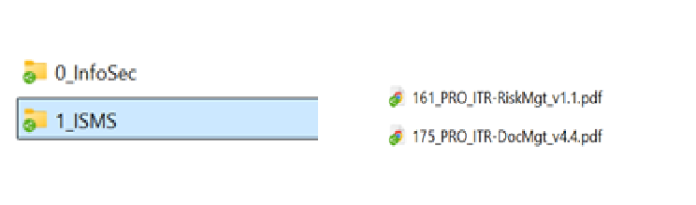

Figure 5: ISMS internal/distribution directory

# Creating a DocList

For build and installation guide refer to Installation guide [3].

## Additional Installed files

During installation, the following helper files are installed in an _input directory:

* **DirToMonitor.xml:** This defines the configuration of the doclist generation, eg. working directory, DocList save path, overwriting and existing DocList etc. It also contains the excludeList element which can be used to exclude some specific files or folders during processing. For more details refer to 3.3.
* **DirToMonitorSchema.xsd:** This specifies the schema of the DirToMonitor.xml file supported by the tool. For more details refer to 3.3.
* **DocListTemplate.xlsm**: This is the template used for creating a new DocList. The columns defined in the Template DocList or Misc sheet should not be changed or altered. For more details refer to 3.4.
* **DocListTemplate-FR.xlsm**: This is the French template which can be used for creating a new DocList. The columns defined in the Template DocList or Misc sheet should not be changed or altered. For more details refer to 3.4.
* **run.bat**: This file can be used as a script to run the executable instead of running the exe from the command line. It contains the path to the XML, Template used, as well as the directory for the log that will be generated along with the DocList.

If using this script, set up the paths of the config file and template as well as the log directory path correctly.

XML_CONFIG_FILE=${Env:ProgramFiles}\ITR\DocListHandler\input\DirToMonitor.xml

DOC_LIST_TEMPLATE=${Env:ProgramFiles}\ITR\DocListHandler\input\DocListTemplate.

LOG_DIR=$Env:USERPROFILE\Desktop\

## Command line arguments

* Input Arguments:--xmlConfigFilePath

Specifies the path to the XML configuration file.

This XML file contains the configuration for directory monitoring, including which directories to scan, file exclusions, and other settings. The tool uses this configuration to determine where to look for files and how to process them. Refer to **DirToMonitor.xml file installed with the tool.** For further details refer to 3.3**.**

* --docListTemplate

Specifies the path to the Excel template file.

The Excel template defines the structure and formatting of the output document. The tool will populate this template with data from the monitored directories. Ensure that the template file is correctly set up with the necessary sheets and formatting. Refer to **DocListTemplate.xlsm file installed with the tool.** For more information refer to 3.4.

**Note:** The default template can be customized in terms of design, but it is important to maintain the same sheet names and column structure as those in the sample template provided with the tool. This ensures that the tool can properly populate and process the data according to its expected format.

* --logdir

Specifies the path to the log file where the tool’s operations and any issues encountered will be recorded.

The log file will capture details about the tool’s execution, including any errors, warnings, and general activity. This helps in troubleshooting and reviewing the tool’s performance.

Tip: Before running the tool ensure to close all files present in the repository so they are not locked.

For more details refer 5.

Output:

At the end of processing the tool generates a DocList file at the path specified by docListSavePath in the XML configuration file and also generates a log file ‘log_DD-MM-YYY.txt’

Note: During the processing the tool generates a message ‘File is currently locked. Please close the file.’ this is normal as the Template file is locked for processing.

In case of any errors the log file can be viewed to debug the source of the problem.

Screen shot of the processing window is as below:

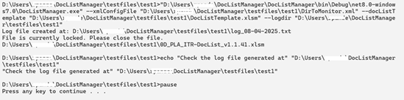

Figure 6: Processing steps

## XML config File

The XML file specified with the --xmlConfigFile option contains the configuration for directory monitoring. It defines the directories to scan, file exclusions, and other settings. The tool uses this configuration to determine which files to search for and how to process them. Once set up for a project, this file typically does not need to be modified for each subsequent run.

The schema supported by the tool is as below:

### XML Configuration Schema

Figure 7: Schema of XMLConfigFile

Figure 8: Sample XML config file

Config file should be opened by a notepad to save changes.

|  |  |  |  |
| --- | --- | --- | --- |
|  | Element Name | Description | Example |
| 1 | DirList |  |  |
| 2 | Directory |  |  |
| 3 | active |  | true |
| 4 | activityName | Name of the activity | Information Security Management System |
| 5 | activityAcronym | Acronym of the name of the activity | ISMS |
| 6 | ISMSWorkDir | This defines the root directory for the ISMS, corresponding to which the tool generates the DocList. It includes folders containing both draft and final versions of files. Access to this directory is restricted to the ISMS team and top management. The files here may be classified as Internal or Restricted or Confidential(with passwords or restricted access). | N:\MG\ISMS |
| 7 | ISMSPublishDir | This defines the root folder that contains the files that have been published in the shared folder which is accessible to all employees in the organization. These files are classified as Internal or Public. | N:\_INternal\ISMS |
| 8 | docListSavePath | This specifies the path where the newly generated DocList will be saved. | N:\MG\ISMS\0_ITR-InfoSec\0D_PLA_ITR-DocList\_input |
| 9 | docListName | The filename must adhere to the document naming convention outlined in section 2.1. The document reference number may be either 0D, 1D etc, document type could be specified as PLA. The version number for the file will be generated automatically. | 0D_PLA_ITR-DocList |
| 10 | docListOverwrite | This decides whether an existing DocList will be overwritten or not. | false |
| 11 | templateDoclistSheet | This element specifies the name of DocList sheet in the Template DocList (specified using ‘docListTemplate’ argument of the tool). | DocList |
| 12 | templateMiscSheet | This element specifies the name of Misc sheet in the Template DocList (specified using ‘docListTemplate’ argument of the tool). | Misc |
| 13 | TemplateMappingSheet | This element specifies the name of Parameter or Mapping sheet in the Template DocList (specified using ‘docListTemplate’ argument of the tool). | Parameters |
| 14 | useExistingDocListEntries | This element (optional) specifies the name of the existing DocList which may be used to create an updated DocList: This option is in Beta version. | N:\MG\ISMS\0_ITR-InfoSec\0D_PLA_ITR-DocList\_distributed\0D_PLA_ITR-DocList_v1.7.xlsm |
| 15 | existingDocListSheet | This element (optional) specifies the name of DocList sheet in the existing DocList (if useExistingDocListEntries used): This option is in Beta version. | ISMS-DocList |
| 16 | excludeList | This element provides a list of files or folders that the tool will ignore while processing the ISMS files. |  |
| 17 | excludeName | The names of the folders to be excluded. | _* (specifies that any folder or file starting with _ will be excluded from processing) |

Table 2: Explanation of XML config file elements

## Template File

This Excel file serves as the template for the new DocList. The generated file will follow its structure. While the template’s design can be customized, it’s crucial to retain the same sheet names and column structure as the sample template provided with the tool. This ensures the tool can correctly populate and process the data in the expected format.

### Explanation of all sheets

The DocList template includes a generic DocList template with five sheets, of which three are modified during document processing: the ‘Hist,’ ‘Misc,’ and ‘DocList’ sheets. The ‘DocList’ and ‘Misc’ sheets are populated with files info from the ISMS repository, along with any errors if present. The ‘Parameter’ sheet remains read-only and is used by the tool to determine conventions followed in the ISMS repository for the organization.

#### Hist

The History sheet contains the document title, general information and document history. The ‘Hist’ sheet is always the first sheet, and cells A1 and A2 are updated with the activity name and activity acronym using information from the XML config file.

#### Guide

The ‘Guide’ sheet provides a brief explanation of the File Naming Convention, common domains, possible types and IDs, along with a table displaying the status classification based on the document’s version number. While this information can be modified if needed, the tool does not utilize any data from this sheet.

#### DocList

This sheet provides the metadata and naming conventions used to organize and manage documents within the system. The key attributes listed here define each document’s structure, status, and associated metadata. These columns should remain unchanged.

**NOTE:** The first row contains headers, and the second row includes a dummy entry—please do not delete this row. Additionally, the first row includes formulas that can be copied down once the DocList sheet is populated by the tool.

|  |  |  |  |  |
| --- | --- | --- | --- | --- |
| # | Column  Name | Description | ToolGen | Example |
| 1 | ID | Represented by Document reference number in the naming convention image. It is a concatenation of i,j,k,l columns. It is a unique identifier for the document. | Yes | 175G |
| 2 | Old ID | The previous identifier for the document before any migration. This can be used for version tracking. | No | 175F |
| 3 | I | The domain in ISMS the document belongs to. (1 for ISMS, 2 for PII etc.) | No | 8 |
| 4 | J | The sub section in the domain the document belongs to. | No | 32 |
| 5 | K | Additional classification of the document could be an integer or a number. | No | A |
| 6 | L | Additional classification of the document could be an integer or a number. | No | B |
| 7 | Type | The type or category of the document. The acronym of these types must be defined in Table ‘TableType’ in a Parameter sheet in DoclistTemplate. This table is used by the tool to recognize types and in future to report errors based on types. | Yes | Policy,  Record,  Procedure,  Standard,  Plan. |
| 8 | Title | The full title of the document.  This information is retrieved from the DocProperty for Word documents from ‘Subject’ property. | Yes | Information Security Policy |
| 9 | Acr. | The acronym or short title used to identify the document.  This is retrieved from the FileName (see the naming convention image). | Yes | ChangeMgmt,  ISMS |
| 10 | Ver. (opt.) | The version of the document, typically in the format vX.X.X.X. This version is determined from the version of the document in the working directory.  See the DocListTemplate parameters sheet ‘TableStatus’ to see how status is generated by the tool using file version. | Yes | v1.0 |
| 11 | Ext. | The file extension represents the document’s format. | Yes | .docx, .pdf |
| 12 | Filename | The complete file name, excluding the path.  It is a concatenation of elements determined from file name. | Yes | 0_POL_ISMS_Security_v1.0.docx |
| 13 | Organisation | The organization responsible for the document. | Yes | itrust consulting |
| 14 | OrgAcr | The acronym of the organization. A mapping for mapping OrgAcr with Organization should be present in ‘TableOrg’ in DoclistTemplate.xlsm Parameter sheet. The acronym is derived from the filename. | Yes | ITR |
| 15 | Ref. | A complete reference of the file which gives detailed information on the file. This text may be inserted in the References section of another document which refers to the current document. | Yes | itrust consulting, ISMS, Policy, InfoSec (ITR-InfoSec), #0 |
| 16 | Status | The status of the document. A list of valid status of files based on version numbers can be described in the Parameters sheet in TableStatus in the DoclistTemplate.xlsm. | Yes | 0.1 – InitialDraft,  1.0 – Distributed etc. |
| 17 | Classif. | The classification or confidentiality level of the document. This is defined in TableClassif in the Parameters sheet in DoclistTemplate.xlsm. This information is derived from the Comments DocProperty of a word document. For Excel and other document types it can presently not be derived. | Yes for Word | IN-Internal,  CO-Confidential,  PU-Public |
| 18 | Manager | The person or team managing the document lifecycle. | Yes for Word/Excel | John Smith, Document Control Team |
| 19 | Owner | The person or team responsible for the document’s content and updates.  This information is derived from Author document property of Word or Excel documents. | Yes | Jane Doe, Security Team |
| 20 | Published | The publication date of the document is added by the tool to the corresponding document entry for the latest document in the _distrib* or _approv* folder, using the document’s update date. | Yes | 05/11/2024 |
| 21 | Folder | The directory or folder where the document can be found. | Yes | \\Server\Docs\Policies\ |
| 22 | Last CC | The last Conformity check made. | No | CISO – 24/10/2024 |
| 23 | Next Reviewer | The person who will review the document next. | No | John Doe, CISO |
| 24 | Ticket or Deadline | A reference to a ticket or deadline related to the document’s review or approval process. | No | #12345, 10/11/2024 |
| 25 | Confirm Date | The date on which the document was confirmed or reviewed. | No | 05/11/2025 |
| 26 | Next Review Plan | The schedule for the next review of the document. | No | 05/11/2025 |
| 27 | Month to Next Revision | The number of months until the document’s next revision is due. | No | 6, 11 |
| 28 | Changed On | The last modification date of the document. This is generated by the tool. | Yes | 12/06/2024 |
| 29 | By | The person who last modified the document entry. | No | John Doe, Jane Smith |
| 30 | Comments | Additional comments or feedback regarding the document. | No | Reviewed and approved by Security Team |
| 31 | Pending Action | Any actions that need to be taken before the document can be finalized. | No | Approval needed, Pending review |
| 32 | Error | Any errors or issues with the document, if applicable. | Yes | These errors are generated by the DocListHandler tool for the given entry in a row and should be fixed in ISMS see 0 for the type of errors and their resolution. |

Table 3: Explanation of DocList Sheet

#### Misc

The table in the Misc sheet mirrors the categories in the DocList sheet. After generating the DocList, any files that appear here are due to possible errors, as these files were not categorized in the DocList sheet. **Note**: Do not alter the columns in the table in this sheet.

#### Parameters

The parameter sheet is used for organization and specific configuration in terms of acronyms, classification, types of documents, etc. There are various tables in this sheet which can be adapted to the needs of the organization and are used by the tool to populate/verify doc list entries.

**Example**

If the Organization acronym is ‘ABC’ then an entry for this acronym could be added in TableOrg so that the Organization column in the DocList can be filled up.

|  |  |
| --- | --- |
| Table | Explanation |
| TableType | Explains the different acronyms used to classify the type of a document. Most commonly used are STA, POL, PLA, and PRO. These acronyms are part of the document naming convention. |
| TableOrg | References some of the acronyms used for specific organizations. These remain unchanged throughout all of the ISMS documents and are also part of the file naming convention. |
| TableStatus | Explains the status displayed in the DocList based on the version number of a file. The same table can be found in the Guide sheet. It specifies the distribution status of a document based on the status, which is derived from the version number in the title. |
| TableClassif | This table lists the possible classification levels of a document. |

Table 4: Explanation of Tables of Parameters sheet

#### KPI

This sheet contains a pivot table sourced from the DocList sheet that provides an overview of the number of documents in specific states, categorized by their status. After generating the DocList sheet, refresh the pivot table to update it with the latest status of the DocList entries.

## Debug the generated Doclist Excel file to check for errors

### Debugging the DocListSheet

#### DocList Sheet - ‘ID column’ (Duplicates)

Ensure that all IDs in the rows are appropriate. If any ID looks incorrect or duplicated, there is a potential problem with the IDs in the FileName.

**Examples:**

N:\ISMS\6_ITR-PeopleControls\7_POL_ITR-PolicyInfoSec_v1.0.docx

N:\ISMS\7_ITR-PhysControls\7_POL_ITR-PolicyInfoSecRE_v1.0.docx

For these two files ID 7 will be used to indicate the two locations of Policy 7.

#### DocList Sheet - Error Column

Review the error column to identify and address potential issues. Refer to the ‘Folder’ column entry to locate the corresponding file and follow the guidance below for resolution.

##### Types of Errors

1. Please archive the old entries in this folder (title, version, ext is the same):
   * **Issue:** Multiple files in the same folder with different versions present.
   * **Resolution:** Sort these files and move older versions to an _old directory for a cleaner ISMS. Ideally only the latest file should be present in the working directory.
   * **Example:**
     + N:\ISMS\5_ORG-OrgControls\5_POL_ORG-OrgControls_v1.0.1.docx
     + N:\ISMS\5_ORG-OrgControls\5_POL_ORG-OrgControls_v1.0.2.docx
   * **Resolution, for example:**
     + Move 5_POL_ORG-OrgControls_v1.0.1.docx to N:\ISMS\5_ORG-OrgControls\_old directory.
2. Duplicate values for this entry (id, title, version, extension is same):
   * **Issue**: Multiple files with the same ID, title, version, and extension.
   * **Resolution**: This indicates accidental duplication. Verify if one of the files is named incorrectly or should be moved to a subdirectory.
   * **Example**:
     + N:\ISMS\5_ORG-OrgControls\5_POL_ORG-OrgControls_v1.0.1.docx
     + N:\ISMS\5_ORG-OrgControls\5_POL_ORG-OrgControls_v1.0.1-abc.docx
   * **Resolution for example:**
     + Rename N:\ISMS\5_ORG-OrgControls\5_POL_ORG-OrgControls_v1.0.1-abc.docx to N:\ISMS\5_ORG-OrgControls\5_POL_ORG-OrgControls_v1.0.2.docx if this file was created later. In case of merge conflict resolve the same manually.
3. Duplicate values for this entry (id, domain, type, extension is same but title = is different):
   * **Issue**: Two or more files with the same ID, domain, type, and extension but different titles.
   * **Resolution**: Move one of the files to another ID or integrate the content of files into one.
   * **Example**:
     + N:\ISMS\5_ORG-OrgControls\5_POL_ORG-OrgControlsRev_v1.0.1.docx
     + N:\ISMS\5_ORG-OrgControls\5_POL_ORG-OrgControls_v1.0.2.docx
   * **Resolution for example**: Move one of the files 5_POL_ORG-OrgControlsRev_v1.0.1.docx to another ID say 5R_POL_ORG-OrgControlsRev_v1.0.1.docx or integrate the content of the two files into one file with ID 5.
4. Classification of Document in _appr* Folder Should Be Restricted:
   * **Issue**: Finalized files moved to an ISMS folder within a subfolder named _approved should be classified as Restricted since they cannot be shared within the organization.
   * **Resolution**: Fix the classification of the document to either internal or public or rename the _approved folder to _distributed and distribute the file in the shared repository see 2.1.3.
   * **Example**:
     + N:\ISMS\5_ORG-OrgControls\_approved\5_POL_ORG-OrgControls_v1.0.docx
   * **Resolution, for example:**
     + Rename N:\ISMS\5_ORG-OrgControls\_approved to N:\ISMS\5_ORG-OrgControls\_distributed OR change classification of N:\ISMS\5_ORG-OrgControls\5_POL_ORG-OrgControls_v1.1.docx to restricted (in next revision of doc).
   * **Note**: This error check currently applies only to files with.docx extensions.
5. File XYZ Not Found in Published Folder:
   * **Issue**: A file classified as Internal is not found in the published folder, meaning it’s not distributed as read-only at the organizational level.
   * **Resolution**: Distribute the file XYZ in shared folder. Inform CISO of this error to take corrective action or documentation.
   * **Example**:
     + N:\ISMS\5_ORG-OrgControls\_distributed\5_POL_ORG-OrgControls_v1.0.pdf is not present in N:\ISMS-Internal\5_ORG-OrgControls
   * **Resolution of example:** 
     + Copy N:\ISMS\5_ORG-OrgControls\_distributed\5_POL_ORG-OrgControls_v1.0.pdf to N:\ISMS-Internal\5_ORG-OrgControls and inform CISO.
6. Classification of Document File in _distributed Folder Should Be Internal or Public:
   * **Issue**: Finalized files moved to a _distributed folder should be classified as Internal since they are distributed within the organization.
   * **Resolution**: Either rename the folder to _approved and remove file from published folder or correct the file classification to internal. Inform CISO of this error to take corrective action.
   * **Example**:
     + N:\ISMS\5_ORG-OrgControls\_distributed\5_POL_ORG-OrgControls_v1.0.docx where policy is classified as Resticted.
   * **Resolution for example:**
     + Rename N:\ISMS\5_ORG-OrgControls\_distributed to N:\ISMS\5_ORG-OrgControls\_approved OR change classification of N:\ISMS\5_ORG-OrgControls\5_POL_ORG-OrgControls_v1.1.docx to internal (in next revision of policy).
   * **Note**: This error check currently applies only to files with.docx extensions.
7. ID of the parent directory is not a subset of ID of the file:
   * **Issue:** The IDs of the folder and the file do not match up.
   * **Resolution:** Move the file to the correct directory or rename it appropriately as per the sorting of files in 2.1.2.
   * **Example**:
     + File N:\ISMS\ 1_ITR-ISMS\175_DocMgt\17-5G_AssessmtTempl\_distributed\017G_STA_ITR-AssessmtTempl_v1.0.xlsm is the latest file distributed and has no later version it implies an ID change is needed.
     + Error reported: ID of the parent directory (17-5G) is not a subset of ID of the file = (017G).
   * **Resolution, for example:**
     + Revise N:\ISMS\1_ITR-ISMS\175_DocMgt\17-5G_AssessmtTempl\17G_STA_ITR-AssessmtTempl_v1.1.xlsm (create a new document with correct ID and publish it).

**NOTE: There may be more errors generated by tool not listed above.**

1. Invalid target of shortcut:
   1. **Issue:** The target of shortcut is not valid. It may be possible the target has been renamed or removed from its initial location.
   2. **Resolution:** Correct the target of the shortcut.
   3. **Example**:
      1. File 1R_REP_CyFORT-DRAW-TestReport_v0.2-ABC.docx.lnk
      2. Error reported: Invalid target of shortcut.
   4. **Resolution, for example:**
      1. Revise Correct the target of the shortcut to a valid accessible path.

### Misc sheet

The Misc sheet lists all the files that are not parsed by the tool and which do not follow the file naming convention as expected by the tool. In certain cases the file names should be corrected. In some other cases, the files are not expected to be parsed by the tool.

**Examples:**

1. This dot after ‘v’ in the following file name may cause it to be incorrectly recognized by the tool.

N:\ISMS\7_ITR-PhysControls\7_POL_ITR-PolicyInfoSecRE_v.1.0.docx

1. The following file is missing a type and is hence not correctly recognized by the tool. The file can be renamed as 7_POL_ORG-PolicyInfoSecRE_v1.0.docx.

N:\ISMS\7_ITR-PhysControls\7_ITR-PolicyInfoSecRE_v1.0.docx

1. Some files may not be parsed by the tool and therefore won’t appear in the DocList, but will be listed in the Misc sheet because they do not follow the naming convention outlined in section 2.1.

These files, if expected to be excluded could be added to the exclude list (see excludeList/excludeName element in Section 3.3).

# Updating a DocList

## Using an existing Doclist to create a new DocList

The tool enables a user to keep the DocList up to date by adding Column Entries in the DocList which are not filled up automatically by the tool. The behavior of the tool to generate the DocList when an existing DocList is provided is as below:

|  |  |  |
| --- | --- | --- |
| ID Status in existing Doc List | ID status in ISMS Repository | Resultant generated DocList |
| Exists | Exists | Entries from the ISMS repository are incorporated alongside any additional columns from the existing DocList that share the same ID. The values from the ISMS repository take precedence over any existing entries in the DocList.  **Note**: For performance reasons, changes in cell values corresponding to existing DocList entries for a given ID are not highlighted. This feature may be considered for future implementation based on user requirements. |
| Exists | Does Not Exist | Removed from the generated DocList, marked in **RED row.**  These entries could be removed from the DocList or marked withdrawn on case-by-case basis. |
| Does not exist | Exists | Added to the generated DocList marked with a **BLUE** **row** for the ID entry. All such entries should be reviewed by the user before finalizing the DocList. |

Table 5: Result when using an existing DocList

## Example

A working example of the tool is available in the git repository [5] in ‘test-example’ directory [6]. Refer the README file in the example for details about the test. There are two scripts to run the test.

1. Running the example without using an existing doc list. After executing run.bat the expected generated doc list is as below:

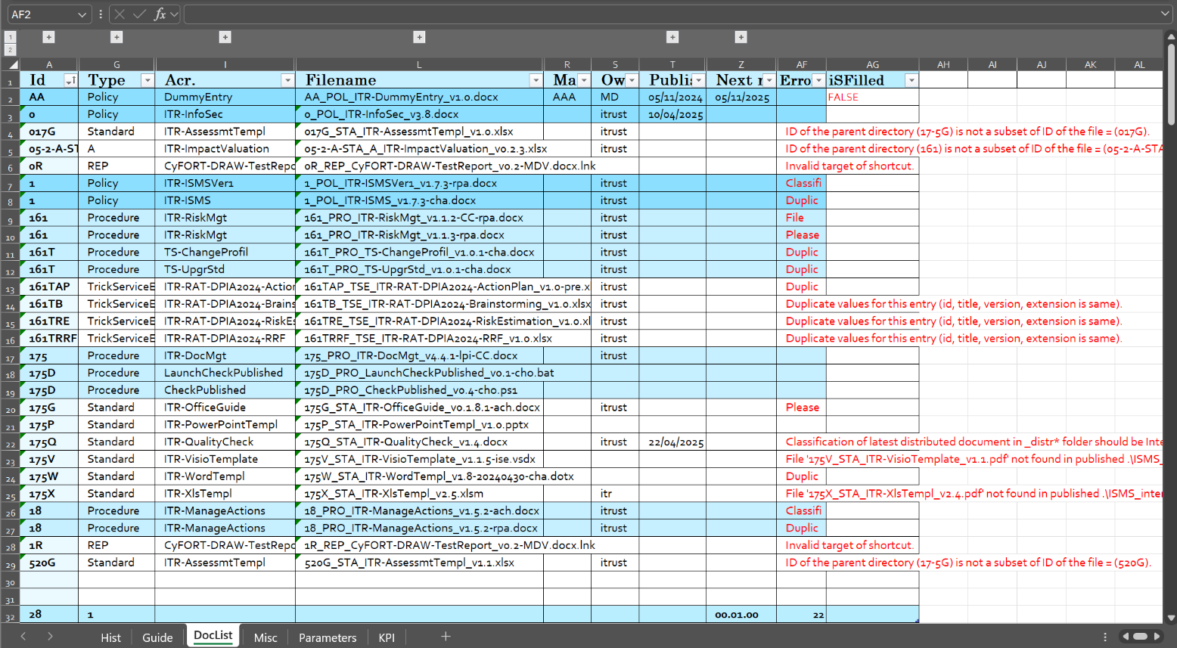

Figure 9: DocList generated for example test without an existing doclist

1. Running the example using an existing doc list. After executing runUseExistingDocList.bat the expected generated doc list is as below:

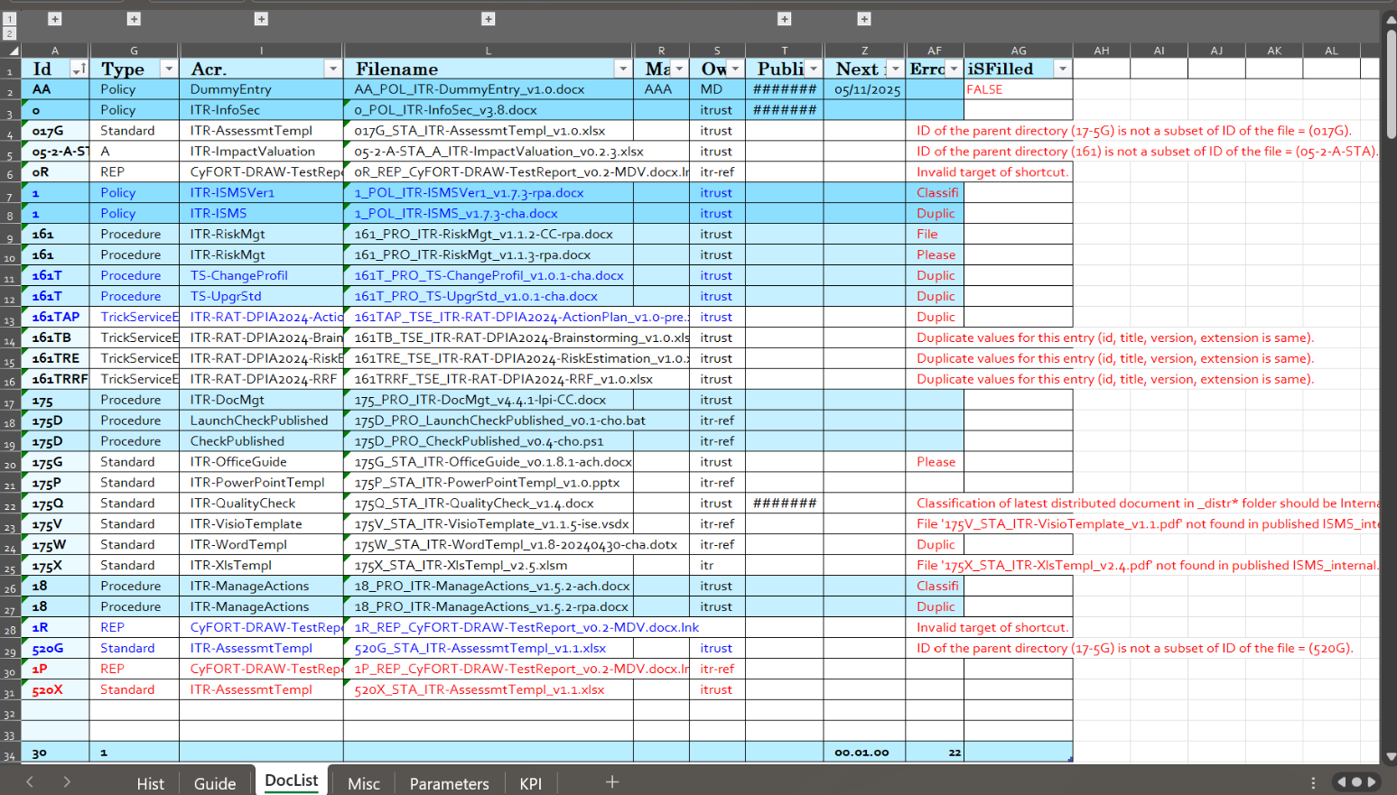

# Other guidance

## Error Handling

In case of tool-related errors specific to arguments, environment, or other issues, the tool generates a log file at the path specified by the --logdir command-line option. The log file is named log_DD-MM-YYYY.txt, and logs for the same day are appended to the same. Expert users can use the log file to debug the tool’s processing steps.

## Useful hints while working with the tool

* When using the DocList template provided with the installation (in the input folder) drag the formulas from first the rows in the DocList entry to fill in specific columns. Do not delete the first row of this sheet as this stores the formulas used for the next revision.
  + ID only if you have setup I, j, k, l correctly.
  + FileName.
  + Ref.
  + Next Review Plan.
  + Month to next revision.

This formula can be computed once the DocList has been generated.

* If the process is interrupted before it finishes, gracefully an Excel process could be running in the background which may cause problems while running the tool again. In this case it is recommended to kill the running excel process.