


Open Assistance for Reporting on Information system Audits
with Normative Assessment
(OpenARIANA)
  - Use Case
(OpenARIANA-UseCase)
General information
Type | Report (REP)
Version | 1.0
State | Final version
Owner
Application date | 02/02/2024
Classification | Internal (IN)

Document history
Version | Date | Author | Modifications
1.0 | 02/02/2024 | Author | Created template

Approval
Name | Role | Responsibility | Signature

Introduction

Objectives
This guide is a use case of OpenARIANA.
The purpose of this document is to provide a use case of different tags of OpenARIANA

Scope
The scope and the content of this document is fully in line with the OpenARIANA project.

Document structure
The remainder of the document is structured as follows:
2: Tags and related styles

Use case 1 test
- Install OpenARIANA.
- Put the cursor in this document at the end of document (where you like to insert new text).
- Select Load for select the file: 5OC4U1X_CyFORT-CS-GRAM-OpenARIANA-UseCas1-input_1.0.xls (which come with the installation).
Chose the following parameters: itrust Processor, press Load.

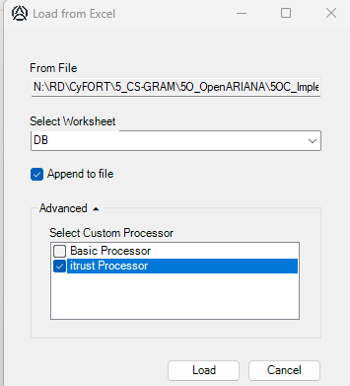
- You now should find in this document the next Chapter added a second time. If both chapters are identical (except for the Word From Excel), the test was successful.
- Now feel free to changes Excel and create your own document from structured Excel text.

From Excel: Chapter 1 title

Level 2 Title 1

Section title
Add here your normal text.
Add here text to be marked as Specific (or important).

Level 2 Title: Test of adidtional formatings

Section title AAA
This is an example of an multilevel bullet list:
- Bullet point list, item on level 1.
  - Bullet point list, item on level 2.
    - Bullet point list, item on level 3
      - Bullet point list, item on level 4
      - ...
For optional reasons, we suggest adding an small empty paragraph to show the end of an enumeration.
- Enumeration L1
  - Enumeration L2
    - Enumeration L3
      - Enumeration L4
- Enumeration L1
- @s With the TAG @s you can restart an enumeration.

When you want to add figures that should be linked to a caption, please use this style:

Caption style for lists and images.

SP-QuoteText style for adding quotes to text.
Text not shown when printing the document
Highlight a few words in a text, or put them in Din bold font.&D1Ed like this.
The following text if for a paragraph marked as being less important.
You can also add enumerations here:
- SP-OtherInfoBulletText style for inserting additional information to the text

An the following is for hidden text inside a paragraph: SECRET INFO.

This style is planned to be highlighted.
You can also add bullet and enumeration lists here:
- SP-Bullet point to be added in a table at level 1.
  - SP-Bullet point to be added in a table at level 2
    - SP-Bullet point to be added in a table at level 3
For optional reasons, we suggest adding an small empty paragraph to show the end of an enumeration.

