1. **Resources:**These are resources like equipment, material, human resources that have been allocated to the work package. Click resources in main menu. You will see following acr

In the following screen.

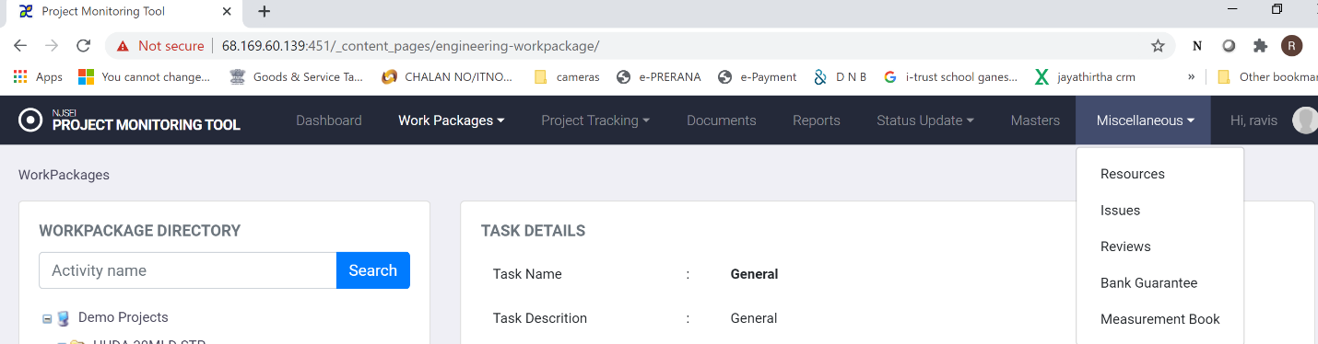

Click resources in main menu.

**8.1 Viewing resources configured.**

1. Choose “Miscellaneous” in main menu.
2. Click on “Resources”.
3. You will see following screen.

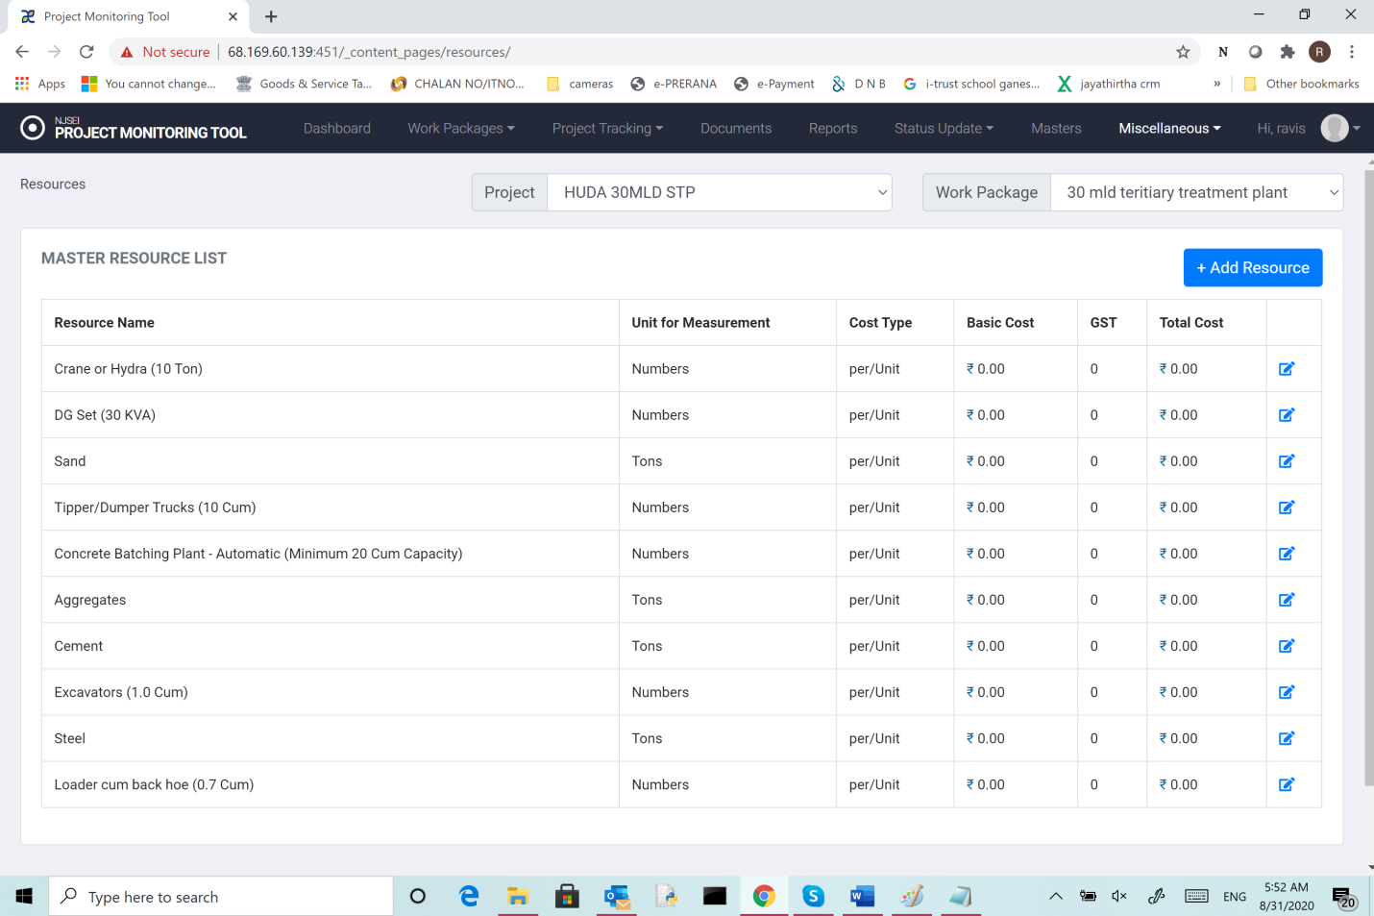

1. Choose project of interest from drop down.
2. Choose work package of interest from drop down.
3. You will see list of resources with following details.
4. Resource name
5. Unit of measurement
6. Cost type
7. Basic cost
8. GST
9. Total cost

**8.2Addning resources.**

1. Choose “Miscellaneous” in main menu.
2. Click on “Resources”.
3. In Displayed screen shown above, Click “Add resources”.

You will see following screen.

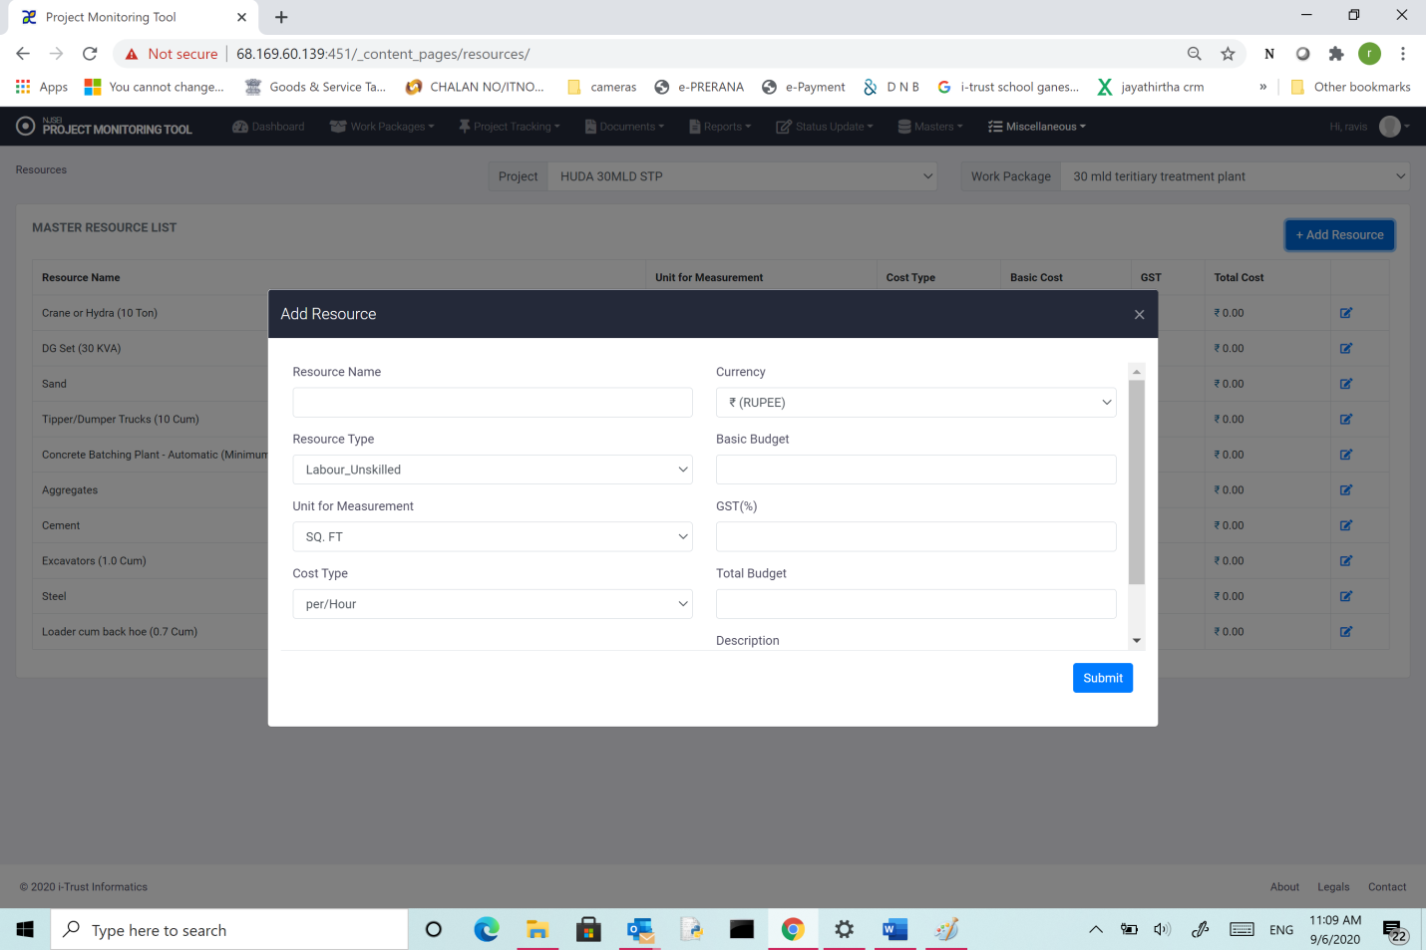

Enter

1. Resource name
2. Choose resource type.
3. Choose Unit of measurement
4. Choose Cost type
5. Choose currency
6. Basic cost
7. GST
8. Total cost
9. Enter description
10. Press “Submit”

**8.2 Editing resources.**

1. Choose “Miscellaneous” in main menu.
2. Click on “Resources”.
3. In Displayed screen choose the resource you want to edit.
4. Click “Edit” (Scribe symbol) for the resource.

You will see following screen.

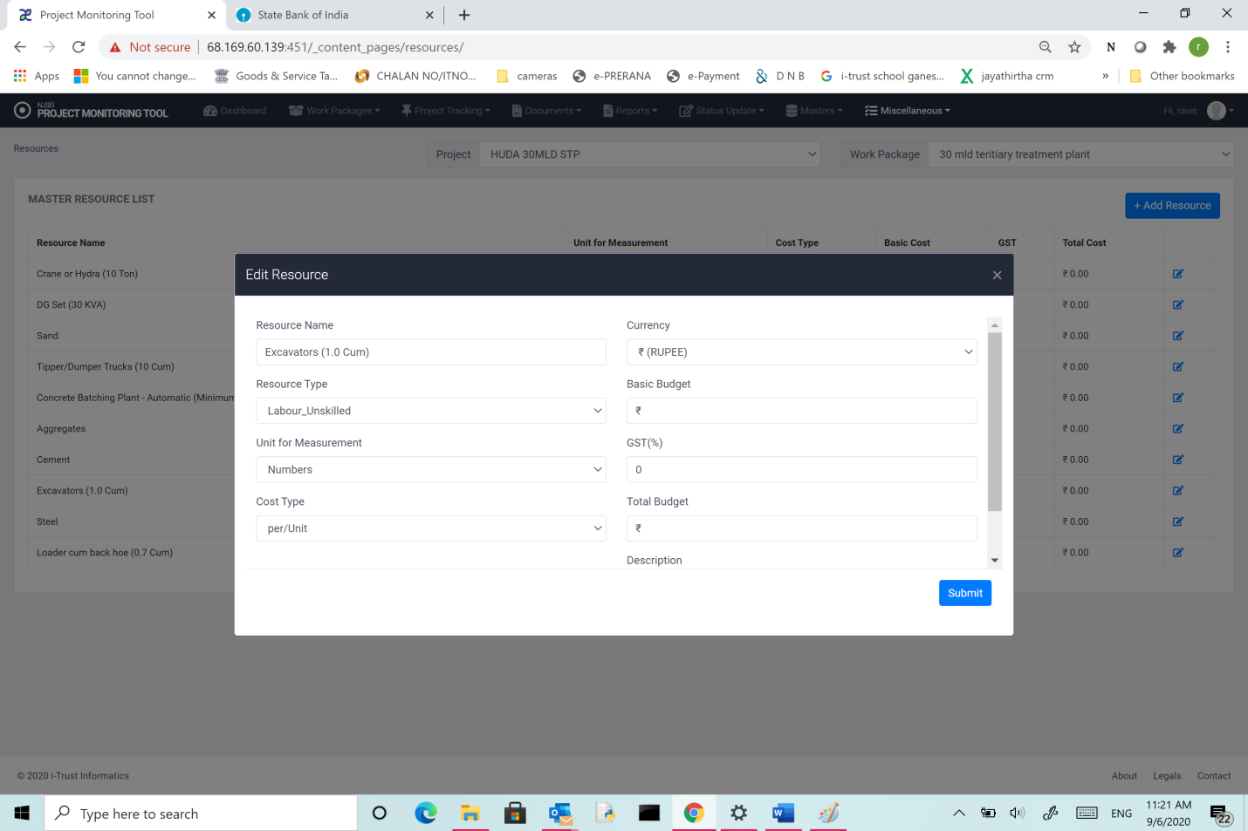

It shows configured values for various parameters. Edit whatever you want to change.

Click “Submit”