1. **Dashb****oard:** This is the landing page.

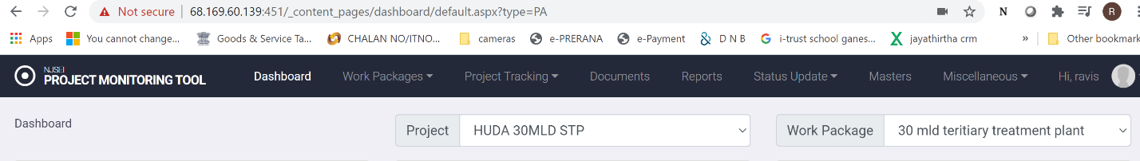

1. From Project dropdown, select project of interest.
2. From Workpackage drop down select work package of interest.

**Six panels will be displayed as shown below** (information customized for different user classes)

1. **IP camera feed**: Can be configured to show feed from any field camera
2. **Document Summary**: Summary of document management information
3. **Alerts**: Alerts from the system configured for this user.(scrolling up)
4. **Activity**: Summary of activity status of major tasks
5. **Progress**: Summary of progress of major tasks
6. **Resource**: Information about critical resources

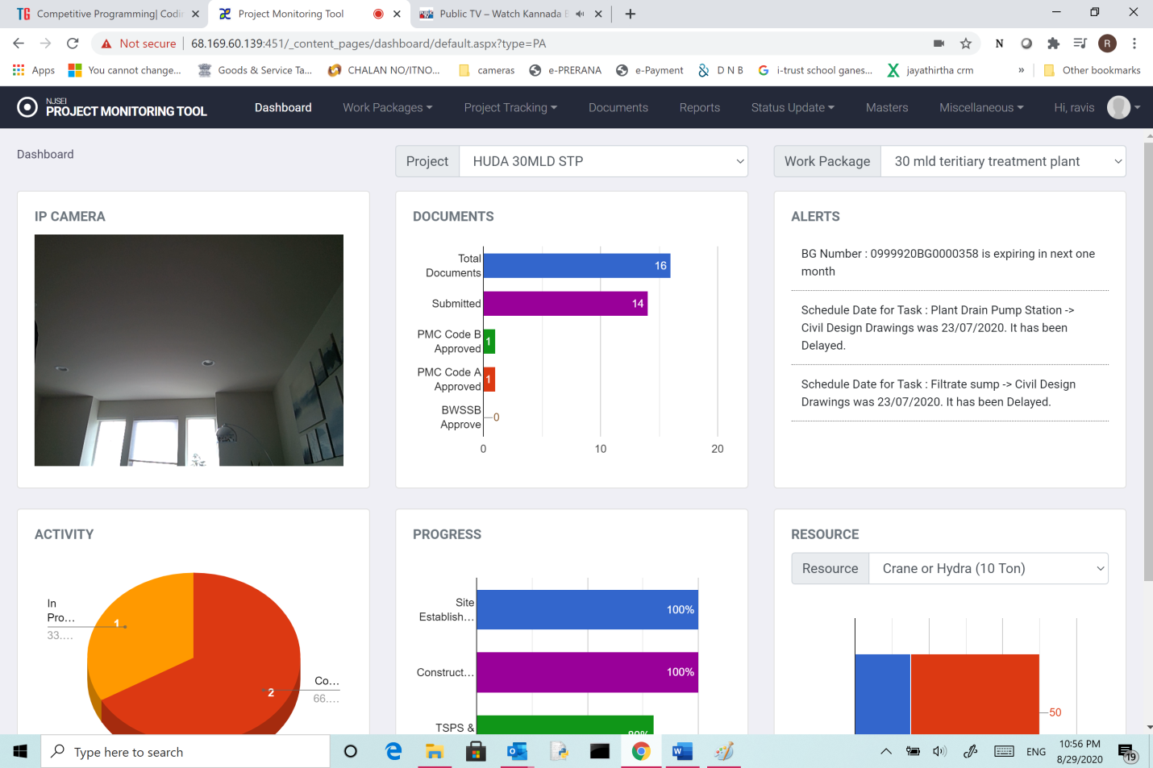

Fig: 1