Data Organization and terms:

Project category: This is highest level in classification to group projects of similar natureThis is class of projects Ex: Water supply, STP, etc.

Projects: These are projects under a project category classified as required by customer (Ex: Bangalore projects, Madhurai Projects).

Work Package: This is typically to show work packages awarded to various suppliers under a project. This is the main monitoring entiry. Ex : 100 mld STP , Hebbal etc.

Tasks/subtasks: These are activities/tasks under a work package:

All entities in the hierarchy are represented as a tree. They are all represented as nodes of a tree. The schedules. Status of the task, milestones and resources are all treated like properties of the node.

At the root is “Project” . Multiple work packages can be created under a project.

The project can only be created by the site administrator. Other users can only create “work package” (if required we can make it “contract package”).Contract package is main monitoring entity.

Tasks can be created under contract package. Each task can have schedule (star/end dates), resources as well as milestones. Optionally documents can also be associated with tasks.

1. **Masters:.**

**Masters are master information which will be added to the system to be used in subsequent stages to create projects/workpackagesetc…**This is to view/update master data about contractors, work packages etc...Creation of masters is first step to configuring the application. **This is restricted to Application administrators.** Following paragraphs explain creation of masters.

Click on “Masters” in main menu.You will see following screen.

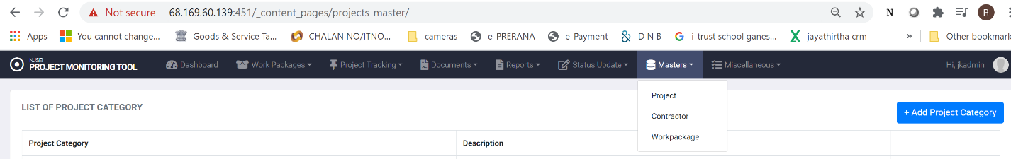

The options Projects, Contractors, Work packages help you add these details to the masters.

* + 1. **Adding Project Categories to the master.**

1. Click on “Masters” in main menu.
2. Click on “Projects”.
3. You will see following screen

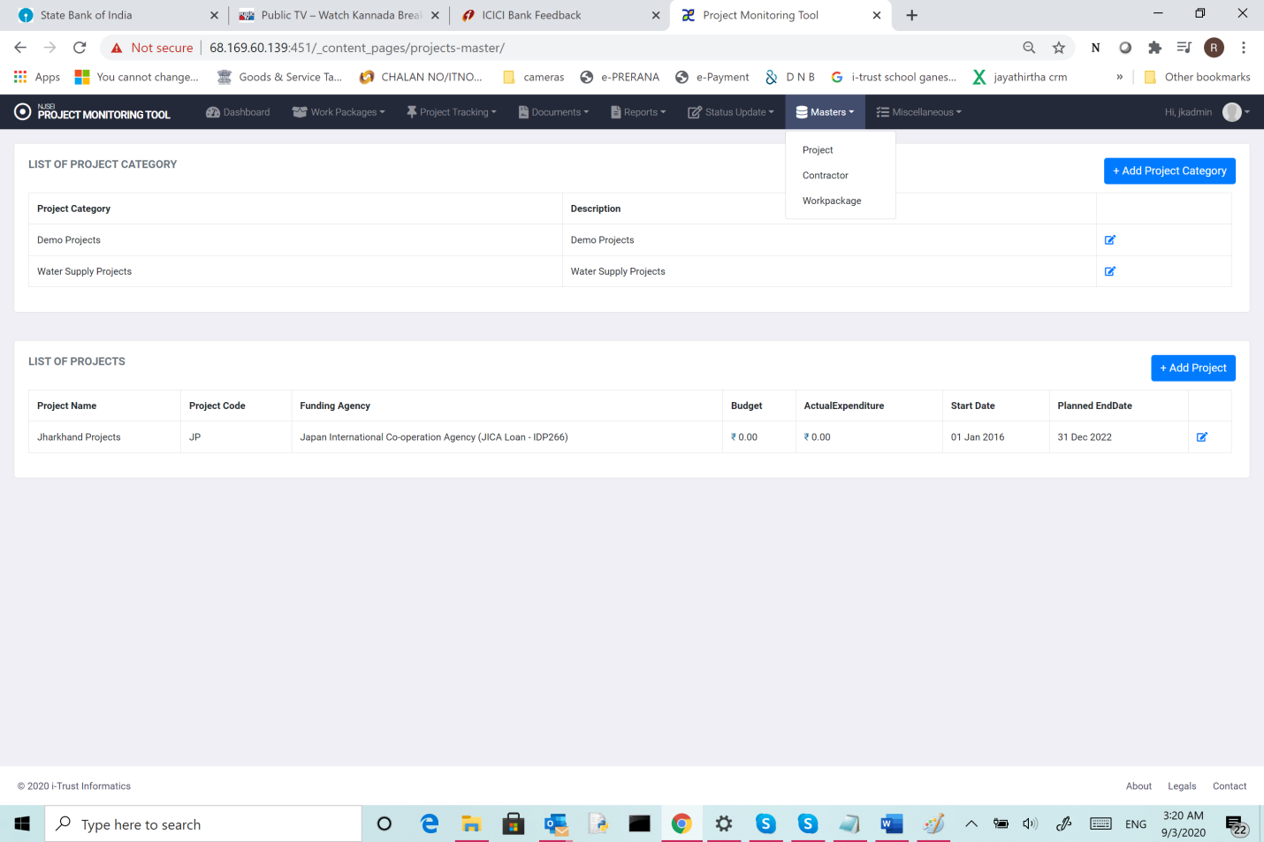

Click on “Add project categories”. You will see following screen.

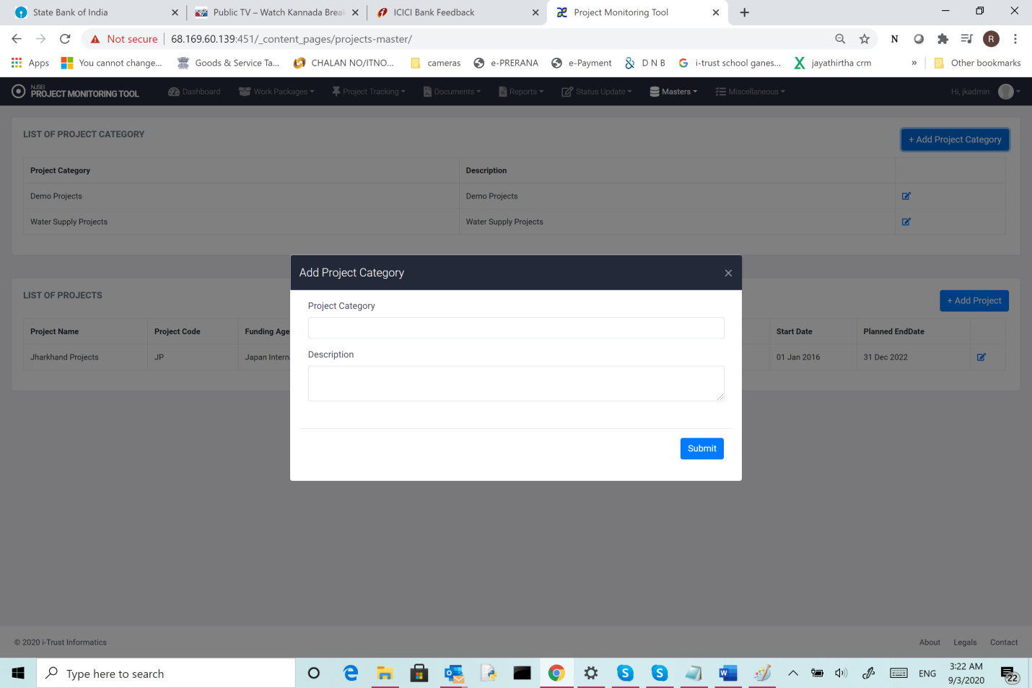

Enter

* 1. Project Category ,
  2. Description
  3. Click “submit”
     1. **Adding Projects to the master.**

1. Click on “Masters” in main menu.
2. Click on “Projects”.
3. Click on “Add projects”
4. You will see following screen

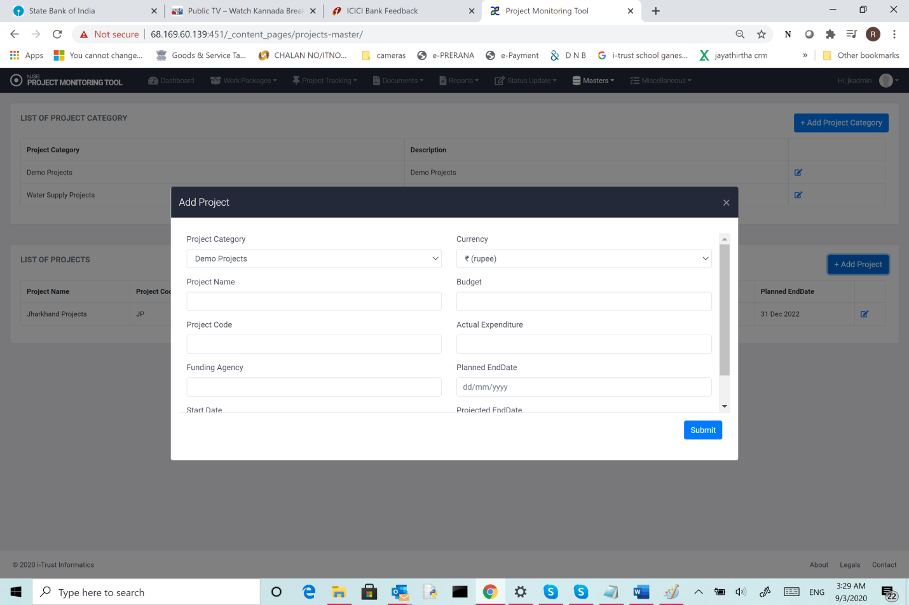

Enter

1. Select Project category,
2. Add project name,
3. Add Project code,
4. Add Funding Agency,
5. Add start date,
6. Select Currency (INR/USD/YEN)
7. Add Budget
8. Add Actual expenditure (if project has already started)
9. Add Planned end date,
10. Add Projected end date.

Click “Submit”

* 1. **Adding contractor.**

1. Click on “Masters” in main menu.
2. Click on “Contractors”.
3. You will see following screen

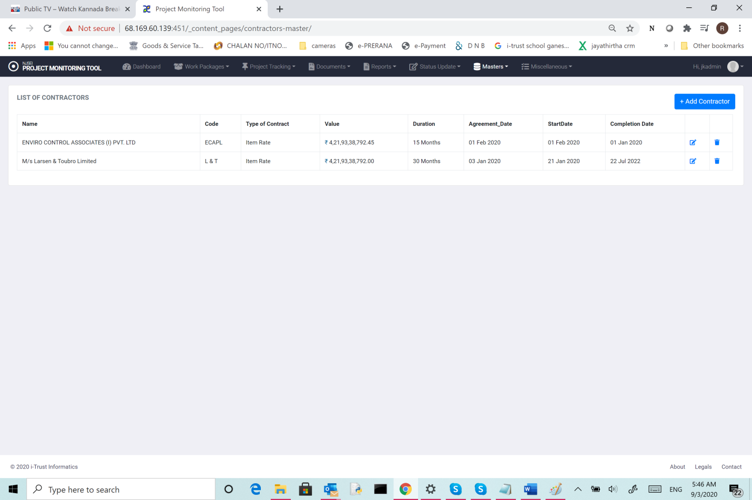

This shows the list of contractors already added.

Click on “Add contractor”. You will see following screen.

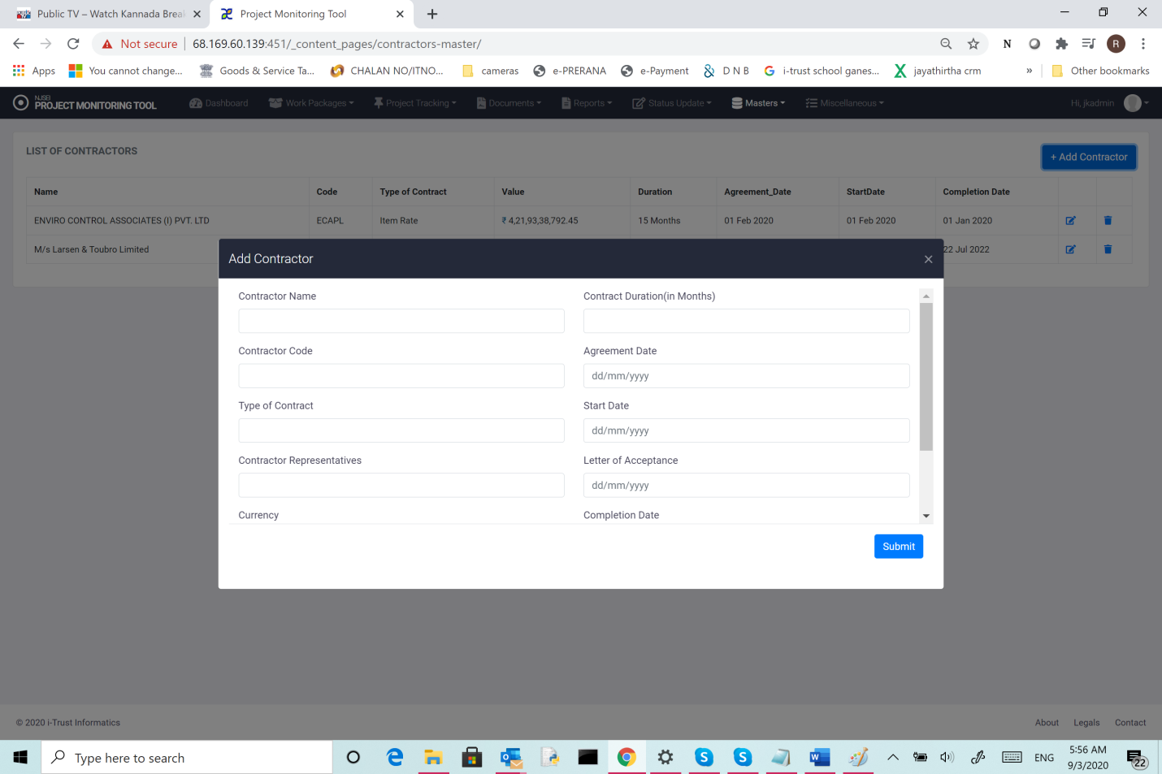

Add following details.

1. Name
2. Type of contract.
3. Contractor representative,
4. Contract value,
5. Contract duration,
6. Agreement date,
7. Start date,
8. Letter of acceptance date,
9. Completion date.
10. Click “submit”.

This will get added to the list of contractors.

* 1. **Adding Work packages related data to the master.**

Following lists are added under this class.

1. Work Packages,
2. Location master and
3. Client master.

You click on Masters,

Click on “work packages”

You will see following screen

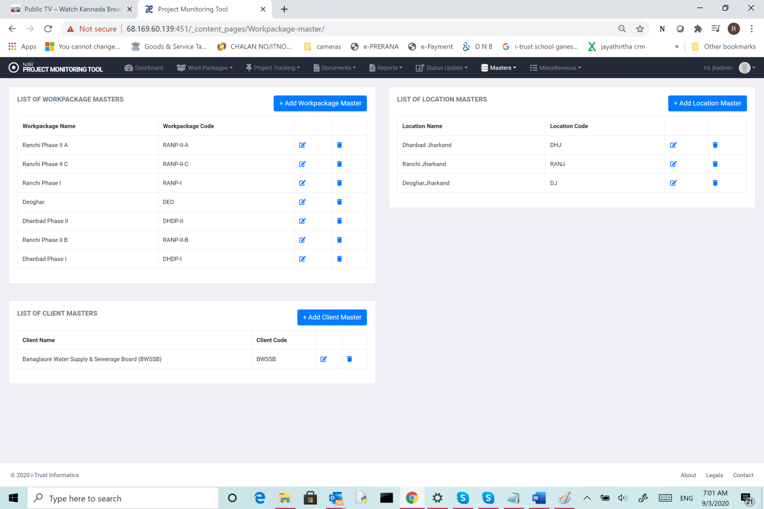

* + 1. **Adding Workpackages names to the master.**

Click on “Add workpackage master”

You will see following screen.

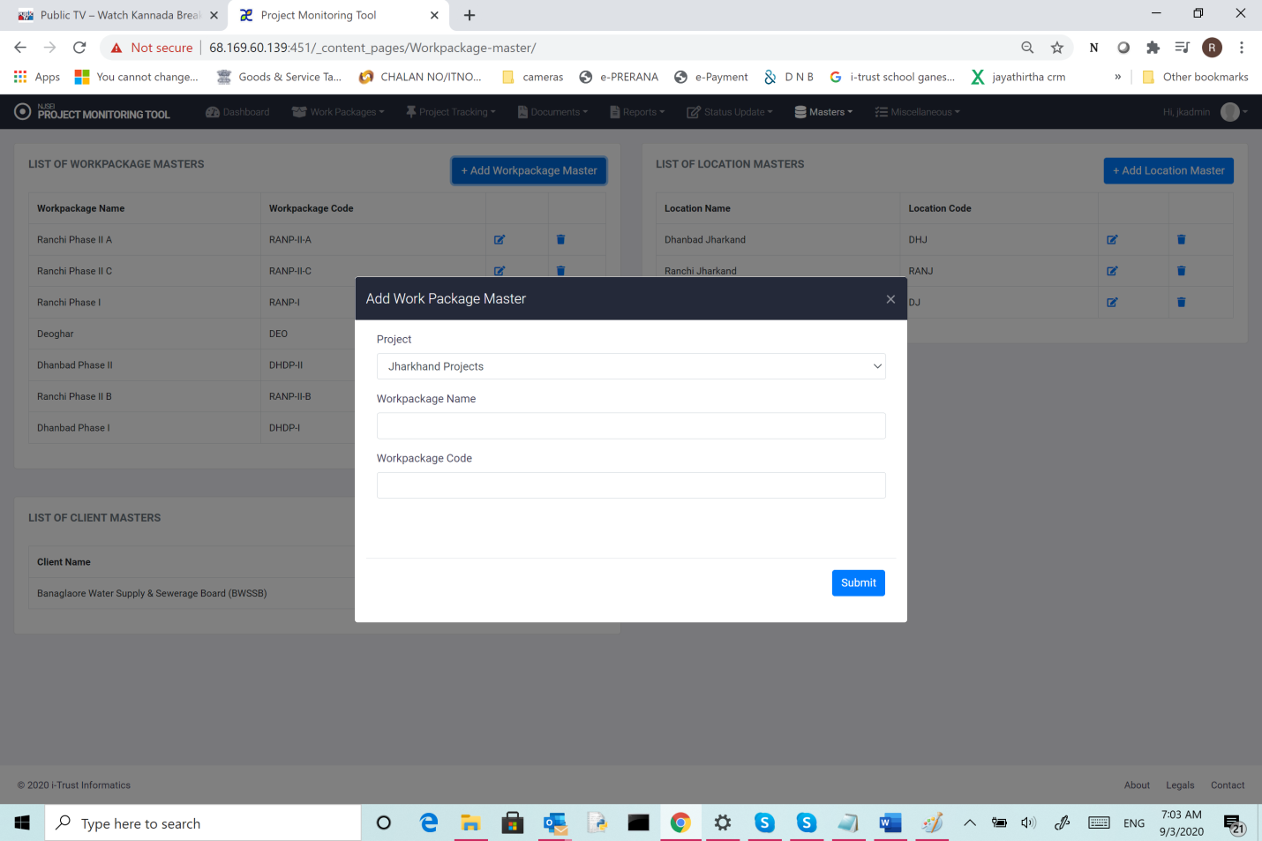

1. Choose the project of interest.
2. Enter work package name,
3. Enter Workpackage code.
4. Click “submit”. This will update the master record for work package.
   * 1. **Adding Location names to the master.**
5. Click on “Masters” in main menu.
6. Click on “Workpackages”
7. Click on “Add Location master”.

You will see following screen.

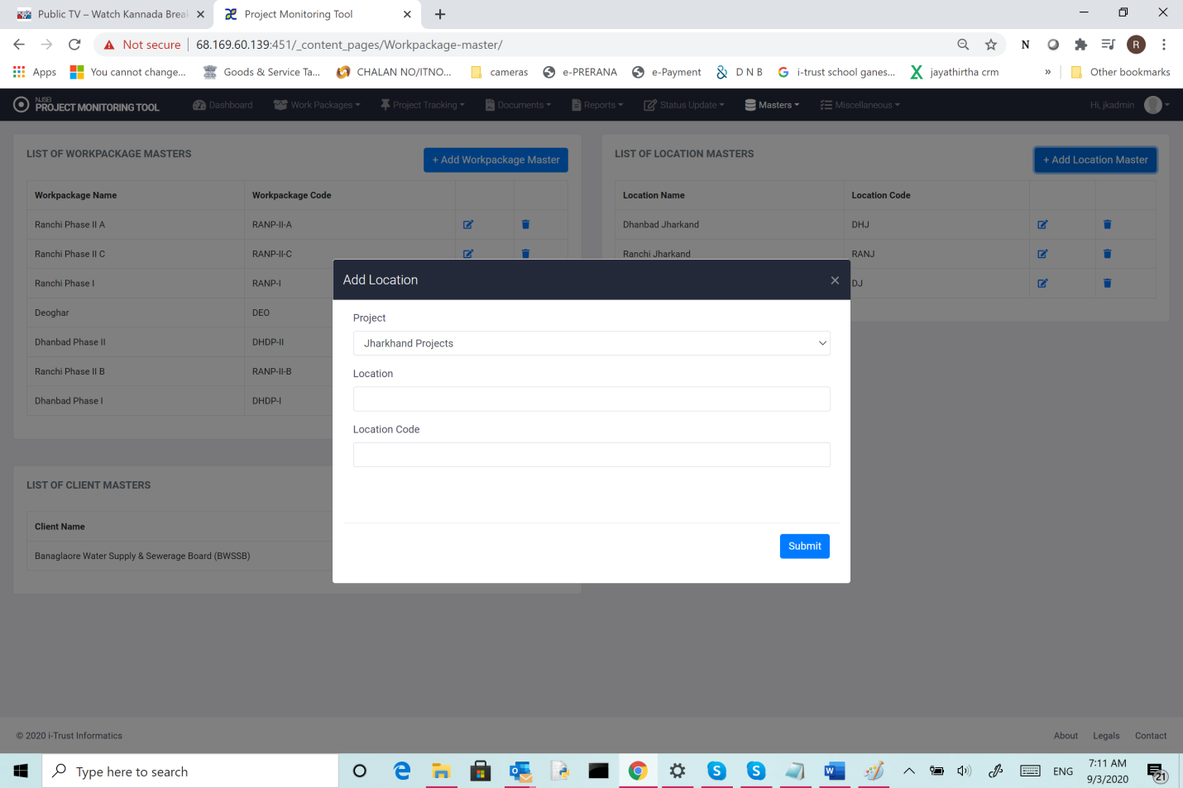

1. Choose the project,
2. Enter location,
3. Enter location code
4. Click “submit”
   1. **Adding Client names to the master.**
5. Click on “Masters” in main menu.
6. Click on “Workpackages”
7. Click on “Add Client master”.

You will see following screen.

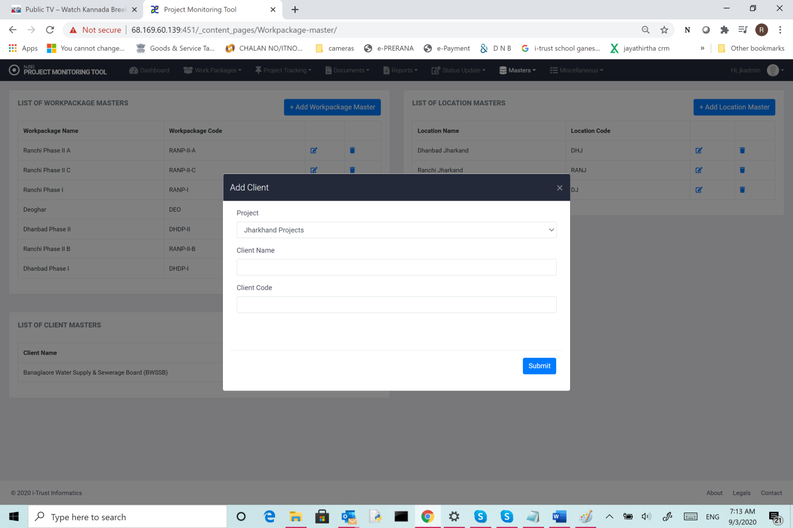

1. Choose the project,
2. Enter client,
3. Enterclient code
4. Click “submit”.