1. **Reports. This option is to access reports.**

In the main menu click on reports. You see following screen.

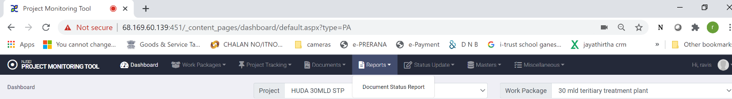

The list of reports is hsown as drop down Menu (Currently only one report is configured.

**6.1 Viewing report:**

1. Click on “reports” in main menu.
2. Click on the report you want o access.
3. In “projects drop down choose project of interest.
4. In “work package” drop down choose the work package of interest.
5. You have option to choose the ‘report’ by status or by date.
6. By date allows to get a report on status of document submissions in any date range
7. By status allows to get report by status.
8. Report by date give a screen shown below.

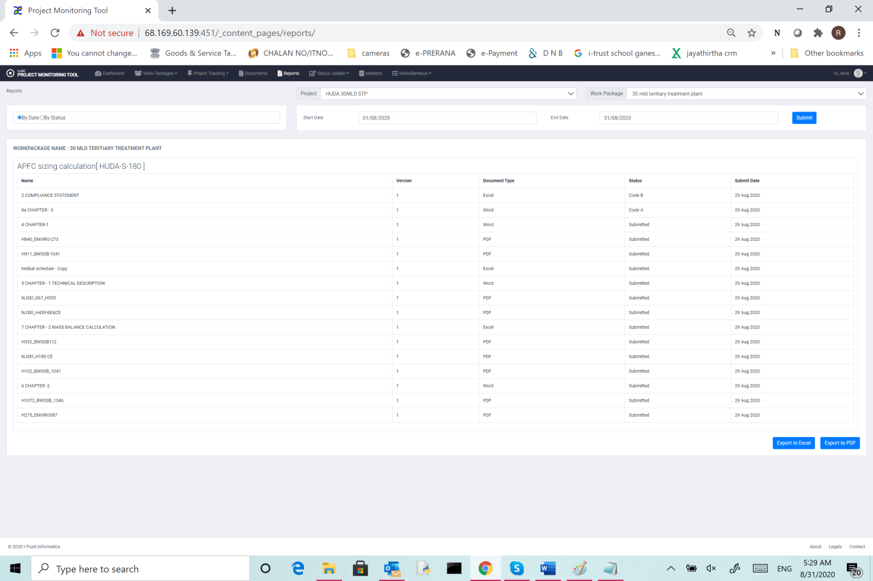

This shows list of documents and the status in chosen period. Show the

* 1. Work package name,
  2. Submittal name,
  3. document name,
  4. version of the document
  5. Document type
  6. Status
  7. Last update date.

You can use “Export to excel” or “Export to PDF” to export report in excel or pdf format.