1. **Revie****ws:**This is to schedule review meetings and follow ups of review meetings.

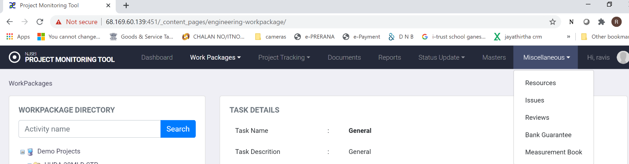

1. Choose “Miscellaneous” in main menu.
2. Click on “Reviews”.
3. You will see following screen.

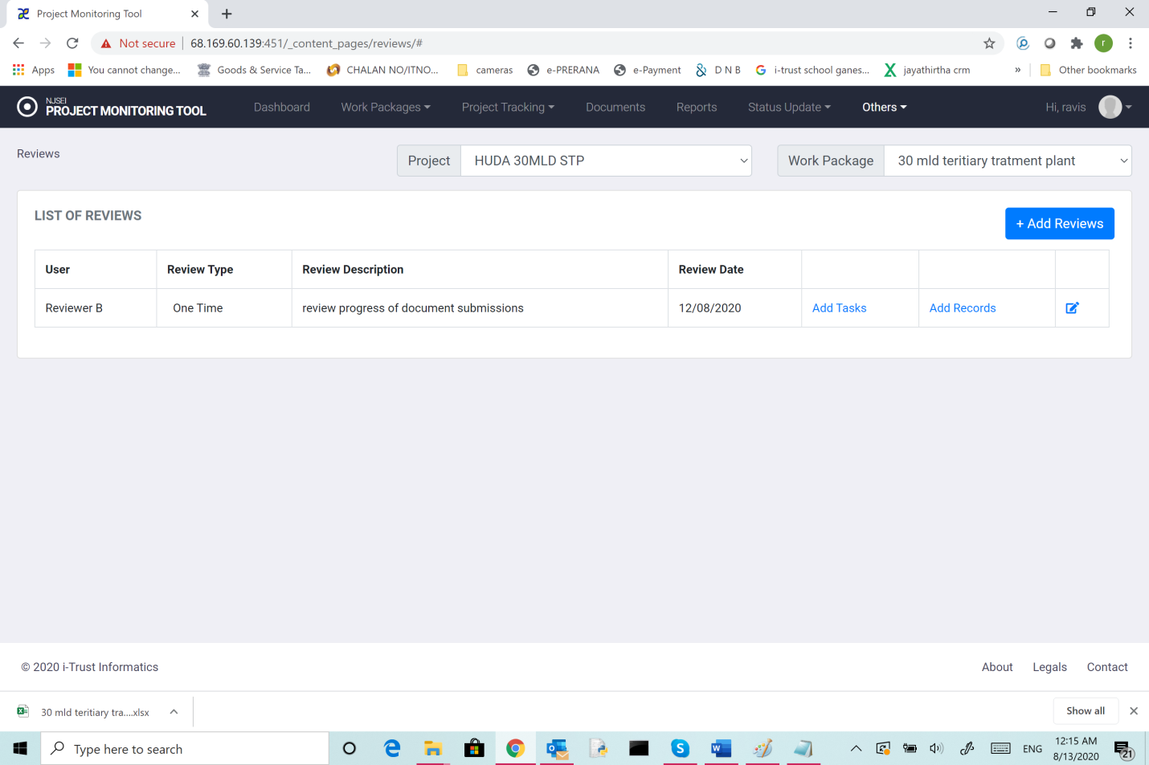

This shows details of reviews scheduled.

1. User who is the coordinator of the meeting.
2. Review type (one time or periodic)
3. Review date
4. Details of tasks that are being reviewed and
5. records of the review meetings

**10.1 Add Reviews:**

1. Choose “Miscellaneous” in main menu.
2. Click on “Reviews”.
3. In the screen you see (shown above), click “Add review”.
4. You will see following screen.

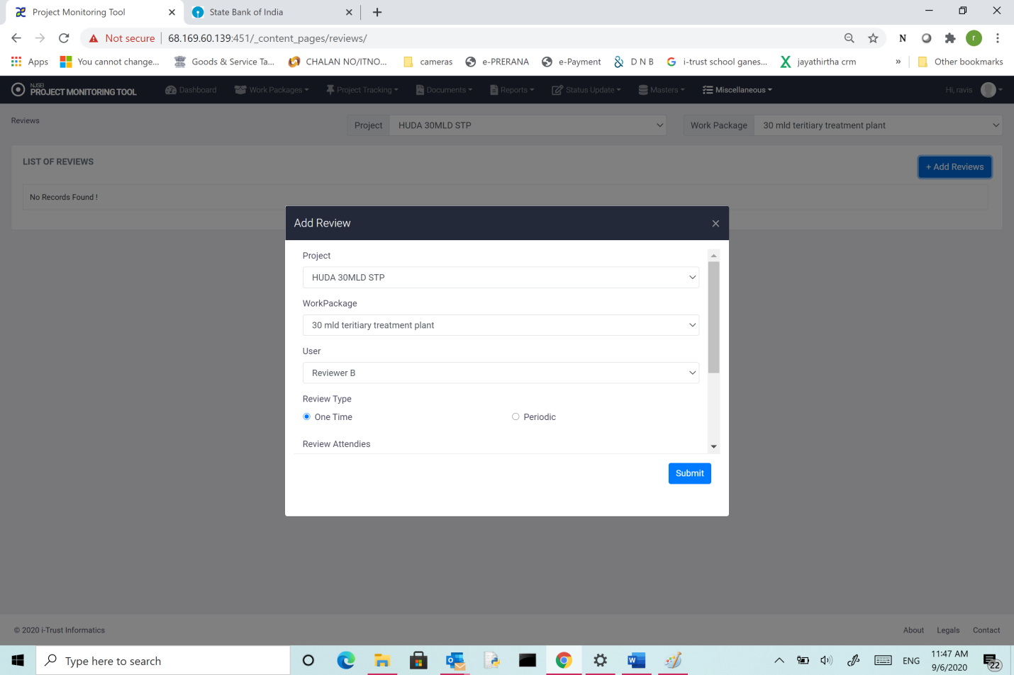

1. Choose the project.
2. Choose “Work package”,
3. Choose User who will the coordinator of the meeting.
4. Review type (one time or periodic)
5. Review date/Periodicity
6. Choose user names who will be attendees.
7. Add any desired description.
8. Click “Submit”