SOC Incident Investigation Report – SIEM-Based Threat Detection Lab

1. Executive Overview
This report presents a comprehensive investigation conducted within a simulated Security Operations Center (SOC) environment. The primary objective was to evaluate threat detection effectiveness using a SIEM-based monitoring setup and to analyze attacker behavior through log correlation.
The lab environment generated approximately 60,000 security events over a one-month observation period. The analysis focused on identifying brute-force intrusion attempts, understanding execution-level visibility, and assessing detection coverage gaps.
The findings indicate strong detection capability for authentication-based attacks, while highlighting limitations in identifying reconnaissance activities and advanced execution patterns without enhanced rule tuning.

2. Lab Architecture & Components
The simulated SOC environment was designed to mirror a real-world enterprise monitoring pipeline.

Infrastructure Components
- Wazuh SIEM Platform (Amazon Linux-based deployment)
- Monitored Endpoint: Windows 11 system with Sysmon and Wazuh Agent
- Adversary System: Kali Linux (attack simulation machine)

Data Flow Pipeline
Kali Attacker → Target System → Sysmon Logs → Wazuh Agent → Wazuh Manager → Dashboard → SOC Analysis
This architecture ensured centralized log aggregation and real-time alert visualization.
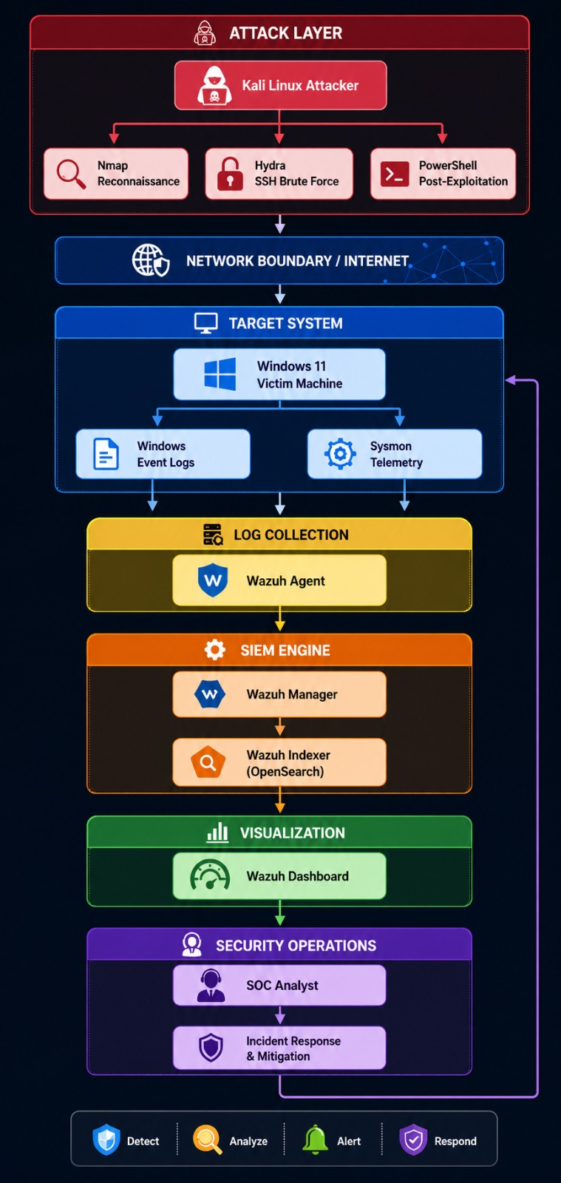

3. Scope & Methodology
- Monitoring Duration: ~30 days
- Total Events Processed: ~60,000
- Key Investigation Areas:
  - Authentication activity (login attempts)
  - Process execution monitoring
  - Network interaction visibility
  - Alert correlation patterns
The methodology followed a detection-driven approach, focusing on identifying abnormal patterns rather than isolated events.

4. Attack Lifecycle Timeline
The attack simulation followed a structured progression:
- Normal Activity Phase: Baseline system behavior with consistent logging
- Intrusion Attempt Phase: Brute-force attack using automated tools
- Execution Phase: Limited command execution activity
- Reconnaissance Phase: Network scanning attempts
- Post-Analysis Phase: No successful system compromise observed

5. Security Log Analysis

5.1 Event Volume & Behavioral Patterns
During the observation period, approximately 60,000 logs were collected. Under normal conditions, event generation remained stable. However, during attack execution, sharp spikes in log volume were observed.
These spikes directly correlate with malicious activity windows, demonstrating effective log ingestion and anomaly visibility.
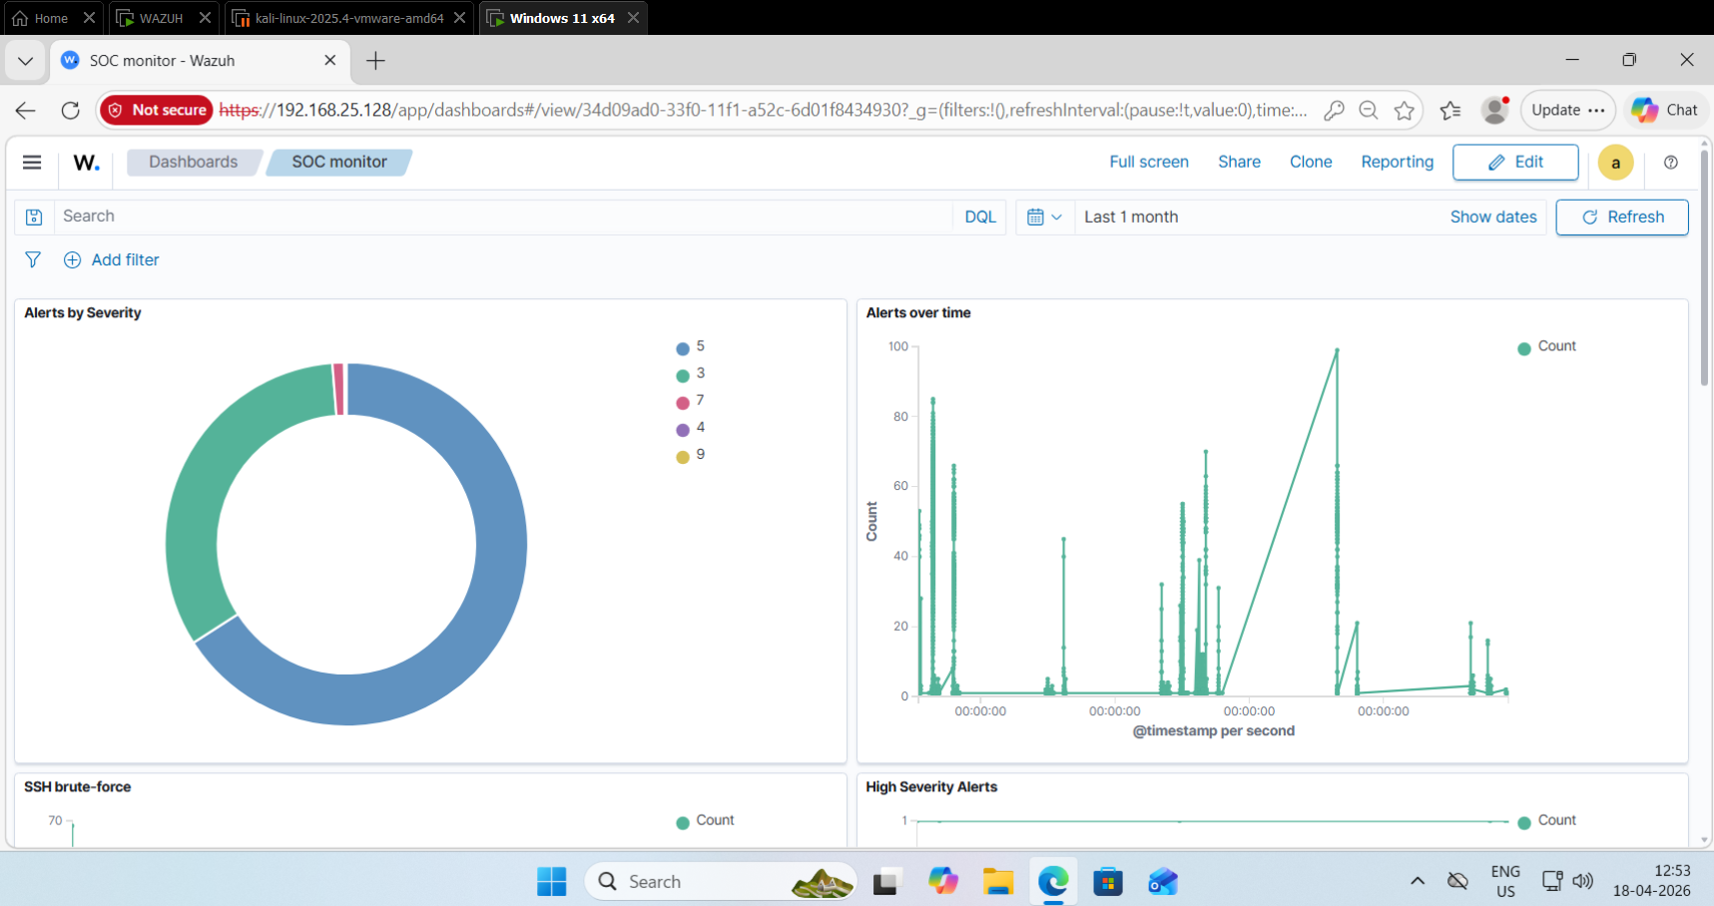

5.2 Authentication Activity Analysis
A significant number of failed login attempts (Event ID 4625) were recorded during attack phases.
Key observations:
- High-frequency login failures within short time intervals
- Attempts originating from a single consistent source IP
- Repetitive authentication patterns indicating automation
This behavior strongly aligns with credential brute-force attacks, confirming attacker persistence.
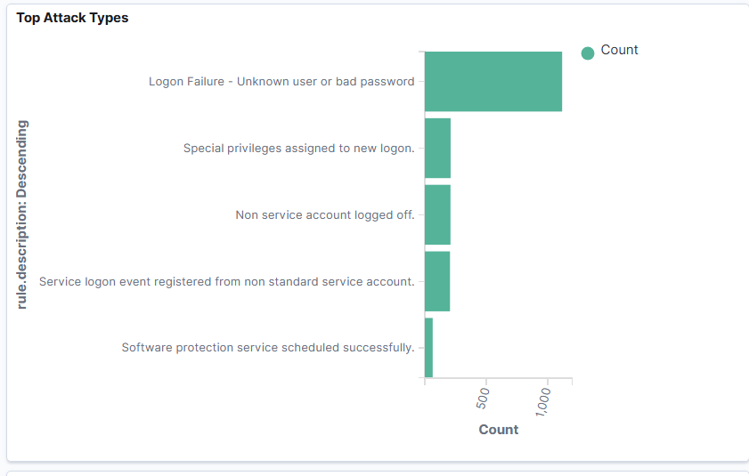
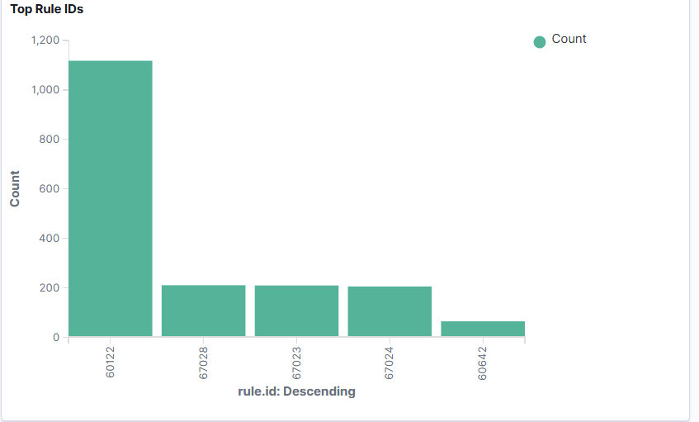

5.3 Process Monitoring & Execution Visibility
Sysmon logs provided insights into process creation events, including PowerShell activity.
Observations:
- Limited number of execution-related alerts
- Minimal correlation with high-risk behavior
- Lack of deeper detection for encoded or obfuscated commands
This indicates basic visibility exists, but detection logic requires enhancement for advanced threats.

5.4 Network Activity & Reconnaissance
Network scanning activity (e.g., port scanning) was performed during the simulation.
Findings:
- No significant alerts triggered for reconnaissance attempts
- Host-based logging failed to translate scanning behavior into actionable alerts
This highlights a visibility gap in network-level detection, common in SIEM setups lacking dedicated network monitoring tools.

5.5 Log Evidence Validation
Raw logs confirmed:
- Repeated Event ID 4625 entries
- Consistent timestamps during attack bursts
- Process execution logs from monitored endpoint
The frequency and repetition of these logs validate the presence of automated attack behavior.
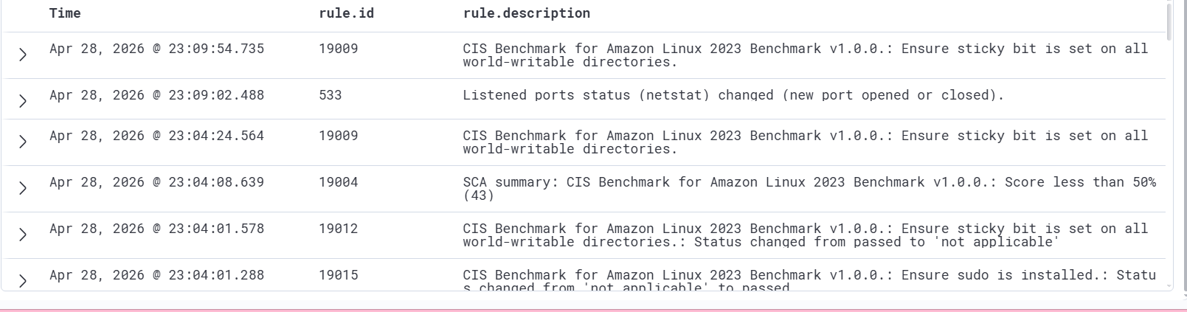
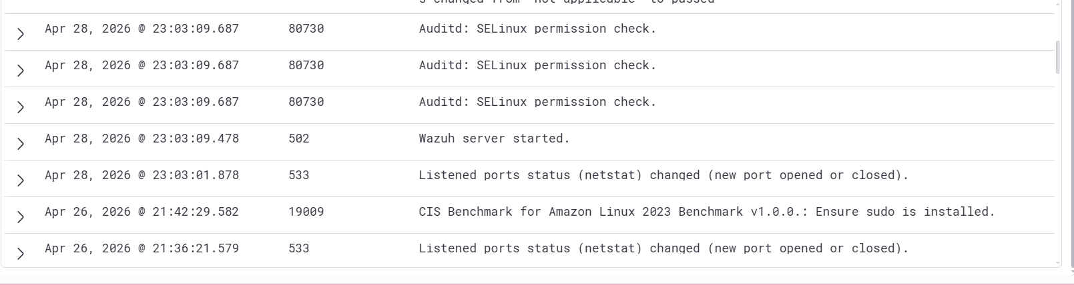
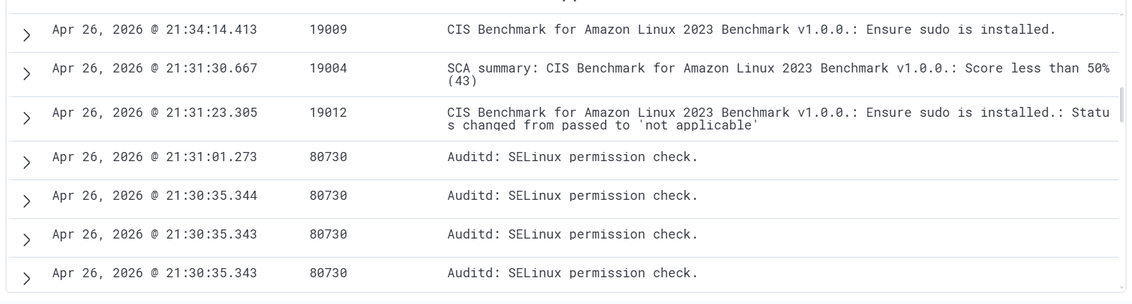

6. Event Correlation Analysis
By correlating logs across multiple data points, the following attack characteristics were identified:
- Rapid succession of authentication failures
- Concentration of activity within defined time windows
- Single-origin attack source
These indicators collectively confirm an automated brute-force attack pattern, differentiating it from legitimate user behavior.

7. Detection Capability Evaluation

Effectively Detected
- Brute-force login attempts
- Authentication anomalies

Partially Detected
- Process execution (limited depth)

Insufficiently Detected
- Network reconnaissance (port scanning)
This evaluation demonstrates that detection accuracy is heavily dependent on rule tuning and log enrichment.

8. MITRE ATT&CK Mapping
The observed attack activities align with the following techniques:
Technique | Description
T1110 | Brute Force
T1059 | Command Execution
T1046 | Network Service Discovery

9. Detection Gaps & Limitations
Several limitations were identified during analysis:
- Default SIEM rules lack advanced reconnaissance detection
- Insufficient PowerShell monitoring depth
- Absence of network-level telemetry integration
These gaps are typical in initial SOC deployments and emphasize the need for continuous improvement.

10. Analyst Insights
The investigation highlights that SIEM systems are highly effective for detecting pattern-based attacks, such as brute-force attempts.
However, sophisticated detection requires:
- Rule customization
- Behavioral analytics
- Integration of additional data sources
The absence of certain detections should be viewed as an opportunity for detection engineering enhancement, not system failure.

11. Conclusion
This SOC lab successfully demonstrates real-world threat detection workflows. The system effectively identified brute-force attacks while exposing realistic limitations in detecting reconnaissance and advanced execution techniques.
The project reflects a practical SOC scenario, emphasizing monitoring, correlation, and continuous improvement.

12. Recommendations for Improvement
To strengthen detection capabilities:
- Develop custom Wazuh rules for reconnaissance detection
- Enhance PowerShell logging and alerting mechanisms
- Integrate network monitoring tools such as Zeek
- Implement continuous rule tuning and testing

