

Hospital appointment

|  |  |
| --- | --- |
| Teams | |
| Ward Mousa | 201912099 |
| Rahaf bassit | 201812082 |
| Fatima Alfaraidy | 201912115 |

|  |
| --- |
| Supervisor |
| Ms. Layla albabtain |

**Problem statement**

Problem statement Online Hospital appointment System is Web-based that helps you to register appointment and Doctor's Choice online, It is ideal for every people.

**Proposed Solution**

**Functional Requirements**

• The system shall allow the user to login and register.

• The user shall be able to check the booking.

• The user shall be able to select a appointment and Doctor's Choice and cancel.

• The guest able to view a appointments and status.

**Tools and Framework**

• Language Used PHP

• Database Mysql

• Use Interface Design HTML, CSS

• Web Browser Google Chrome

• VScode editor

• Developer environment XAMPP

**Database design**

Entities

**user_account**

`**id**` int(11) NOT NULL,

`**username**` varchar(40) NOT NULL,

`**email**` varchar(40) NOT NULL,

`**password**` varchar(40) NOT NULL

**`appointments`**

`**Appointment_id**` int(11) NOT NULL,

`**date**` date NOT NULL,

`**time**` time NOT NULL,

`**doctor_name**` varchar(40) NOT NULL,

`**booking_status**` tinyint(1) NOT NULL

**`bookings`**

`**Appointment_id**` int(11) NOT NULL,

`**user_id**` int(11) NOT NULL

ER Diagram

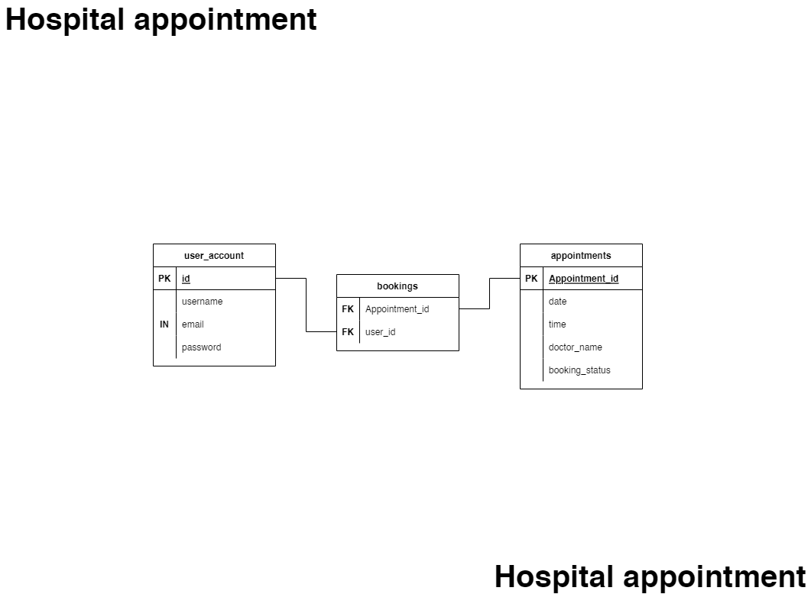

**Website structure**

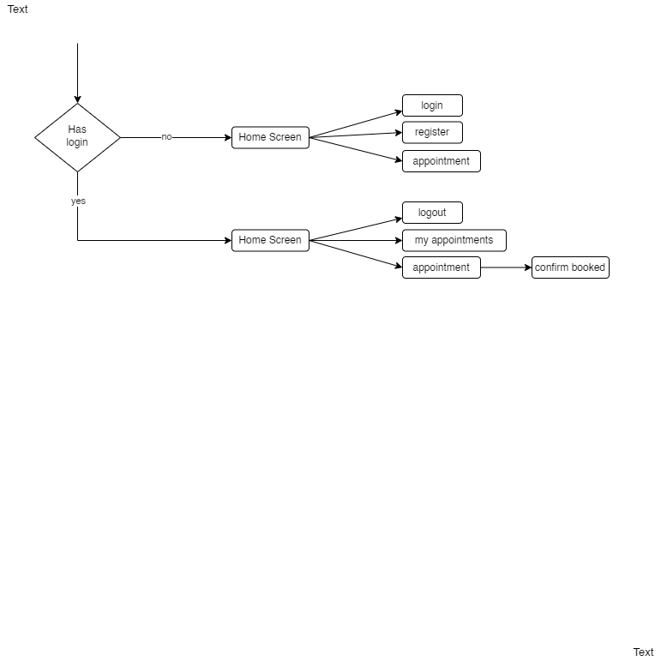

**UI Design**

color Scheme

|  |  |
| --- | --- |
| color | For use |
| #00d5dd | button |
| #f8faf7 | navbar in header and footer |
| #d5d5d5 | Button navbar in header, Button when hover |
| #454545 | font |

Layout of the website

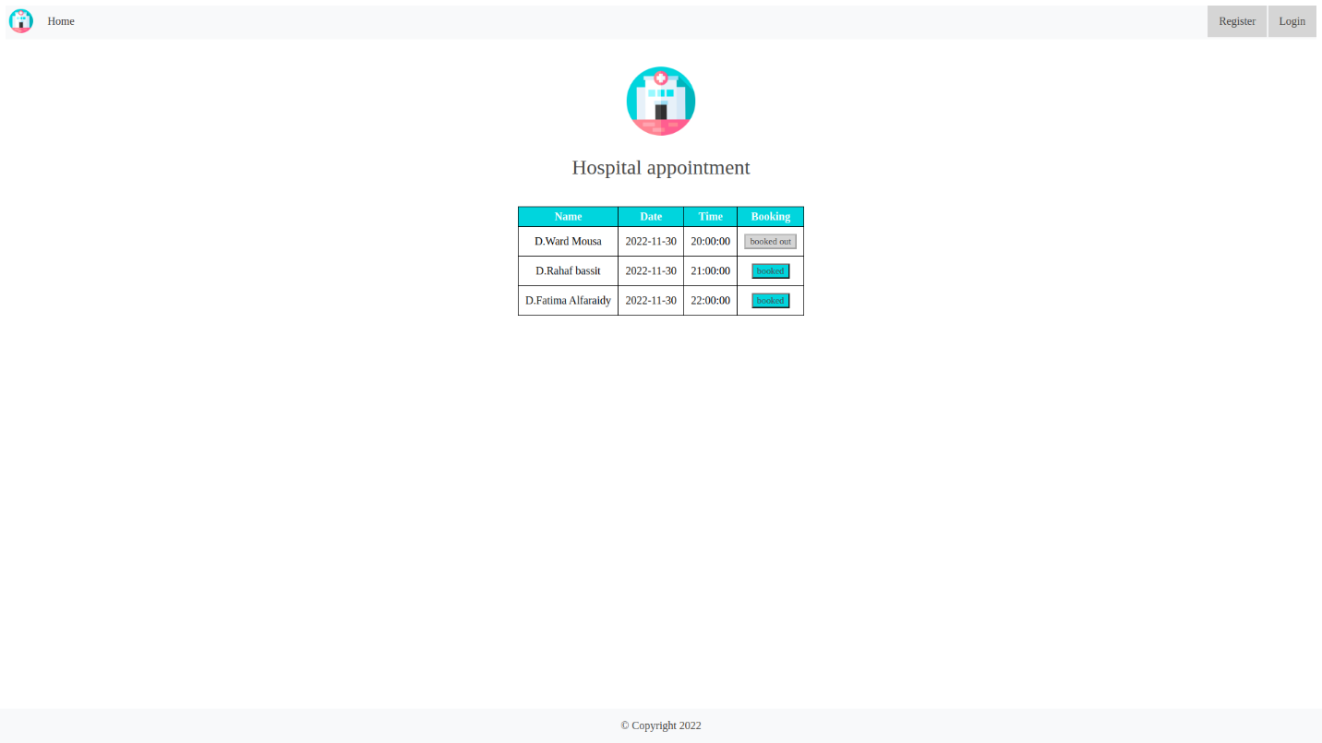

- home page

**References**

<https://www.w3schools.com/>

<https://code.visualstudio.com/>

<https://www.apachefriends.org/>

<https://app.diagrams.net/>

<https://www.php.net/>

<https://www.mysql.com/>