

Project Report

  - Financial investemnt recommender system

Submitted by: Aadra Khattri
Course: B. Tech CSE(AI-ML)
Reg. No.: 25BAI11012

Contents
- Introduction
- Problem Statement
- Functional Requirements
- Non-Functional Requirements
- System Architecture
- Design Approach
- Algorithm Development
- Design Decisions and Rationale
- Implementation Details
- Testing Approach/ Screenshots
- Challenges Faced
- Learnings & Key Takeaways
- Future Enhancements
- References

Introduction
Financial Planning is an essential life skill, yet may individuals- especially women often hesitate to explore investment opportunities due to lack of awareness, guidance or confidence. In today’s world, where financial independence is directly linked to personal security and empowerment, it is crucial for women to understand how to manage their income wisely and build long-term wealth.
This project aims to support the awareness by creating a simple and interactive Financial Investment Recommender System using Python. The program helps users, particularly young women and beginners, understand the 50-30-20 budgeting rule, calculate savings and explore investment options based on their risk comfort level. The system acts as a basic financial guide, encouraging women to take informed decisions about savings, expenses and investments without needing any prior financial knowledge.

PrOBlem Statement
Many women, especially students and young professionals, struggle to understand where and how to begin their financial journey. Limited exposure to financial planning leads to confusion about budgeting, investment safety and long-term wealth building.
The problem this project addresses is: How can we provide a simple, beginner-friendly system that guides women in understanding their salary distribution and suggests suitable investments based on their risk preference?
The goal is not to offer expert advice, but to make the first step toward financial independence easier and clearer.

Functional Requirements
- User Management
- The system should allow the user to interact through a simple menu-driven interface.
- It should validate the user’s monthly salary input.
- It should handle incorrect input (non-numeric, negative values) and prompt the user to re-enter data.
- The system should allow the user to request multiple recommendations in a loop until they choose to exit.

- Data Input and Processing
- The system should accept the user’s monthly salary as the primary input.
- It should process and calculate the 50-30-20 financial rule:
-50% Needs
-30% Wants
-20% Investments/Savings
- It should compute basic recommendations based on investment amount, such as:
-Emergency fund
-Fixed deposits
-SIPs / Mutual Funds
-PPF / NPS
- It must enter correct data validation at each step before processing.

- Reporting or Analytics
- The system should display a clear, structured breakdown of monthly budgeting based on the 50-30-20 rule.
- It should generate investment recommendations tailored to the user’s salary input.
- The system should show summary messages or formatted results to help the user interpret the output easily.
- It should report errors (if any) in a friendly and understandable manner.

non-Functional Requirements
- Performance
- The program should provide outputs instantly without any noticeable delay.
- It should Handle repeated user inputs efficiently in the recommendation loop.

- Security
- The system should ensure that no sensitive data is stored.
- User input should be validated to prevent crashes or malicious inputs.
- It should not expose any personal or financial information.

- Reliability
- The system should function consistently without errors during repeated usage.
- It should handle invalid inputs gracefully without terminating unexpectedly.
- The calculation logic must always produce accurate and predictable results.

- Scalability
- The system should be easy to expand in the future by adding:
-More Investment categories
-Graphical Dashboards
-File storage
-User Login
- The code structure should remain easy to maintain for future enhancements

System architecture
The Financial Investment Recommender follows a modular architecture consisting of four main components:
- User Interface Layer
- This layer interacts directly with the user.
- It collects user inputs such as monthly salary.
- It displays outputs like:
- 50-30-20 expense breakdown
- Investment recommendations
- Error messages (e.g., invalid salary input)
- Implemented through a console-based menu.

- Input Validation Module
- Ensures the user enters valid numeric salary values.
- Rejects invalid data such as:
-negative numbers
-alphabets
-symbols
- Uses try–except blocks to prevent program crashes.
- Enhances reliability and user experience.

- Processing & Calculation Engine
- This is the core logic of the system. It performs:
-50-30-20 Rule Calculation
- Calculates:
-50% – Needs
-30% – Wants
-20% – Savings

- Investment Recommendation Logic
- Based on the user’s savings amount, suggests:
-Emergency Fund Allocation
-SIPs / Mutual Funds
-FD/RD options
-Low-risk, medium-risk investment plans

- Repetition Logic
- Allows users to generate multiple recommendations without restarting the program.

- Output & Reporting Module
- Displays the processed results back to the user.
- Outputs include:
- Final calculated values
- Recommended investment plans
- Summary of financial breakdown
- Ensures clear, structured presentation.

- Data Storage (Optional / Minimal)
- Since this is a console program, no database is used.
- However, the architecture allows future integration of:
- CSV storage
- SQLite database
- Cloud-based storage

Design Approach
Modularization
- Main menu Module
- Shows menu options
- Handles user choices
- Recommendation Module
- Takes salary
- Validates numeric input
- Performs 50-30-20 calculation
- Asks for risk preference
- Displays recommended investments
3. Repetition Loop
Allows the user to get recommendations multiple times.

Algorithm Development
Step 1: Start
Step 2: Display menu -> (Get Recommendation/ About/ Exit)
Step 3: If user selects Get recommendation:
Step 3.1: Ask for monthly salary
Step 3.2: Validate Salary
Step 3.3: Apply 50-30-20 calculation
Step 3.4: Show expenses, savings, investable amount
Step 3.5: Ask for risk preference
Step 3.6: Map risk to suitable options
Step 3.7: Display recommended investments
Step 3.8: Ask if user wants another recommendation
Step 4: If user selects About, show program description
Step 5: If user selects Exit, display thank-you message
Step 6: Stop

Design decision and Rationale
1. Chose Python
- Because it's beginner-friendly, readable, and excellent for quick prototyping.

2. Used a Menu-Driven Structure
- Makes the tool easy to use
- Allows repeated recommendations
- Suitable for console-based apps

3. Applied 50-30-20 Model
- Standard financial budgeting framework
- Easy for users to understand
- Universally accepted financial rule

4. Used Simple Recommendation Ranges
- Ensures clarity for new users
- Easy to expand in future versions

5. Chose Console-Based Output
- Keeps the project simple
- Works in all environments (school labs, low-end devices)

Implementation details
- Programming Language
- Python (CLI-based application)

- Key Modules Used
- Input validation: using try–except
- Loops: while True for menu repetition
- Functions:
- get_recommendation() for core logic
- Main menu using conditional statements
- Arithmetic operations for 50-30-20 calculations

- Menu-Based Structure
- The program uses a menu system:
  - Get Recommendation
  - About for Users
  - Exit
- Each option triggers a separate block of code.

- Salary Processing Logic
- Convert input to integer
- Validate if salary is > 0
- If valid → calculate:
- needs = 0.5 * salary
- wants = 0.3 * salary
- invest = 0.2 * salary

- Recommendation Logic
- Based on investment amount:
- If investment < 3000 → RD, FD
- If investment 3000–7000 → SIP, index funds
- If investment > 7000 → PPF, NPS, mutual funds, SIP

- Error Handling
- Catches invalid inputs (letters, decimals, negatives)
- Ensures the program doesn’t crash
- Prompts user again until correct input is entered

- Output Formatting
- Prints clean, readable financial recommendation text
- Separates sections using dividers and spacing

Testing approach/ screenshots
- Test Case 1
Input: Salary = 30,000, Risk = Moderate
Output:
-Expenses = 15,000
-Savings = 9,000
-Investable amount = 6,000
-Recommended = Mutual Funds, Gold ETF
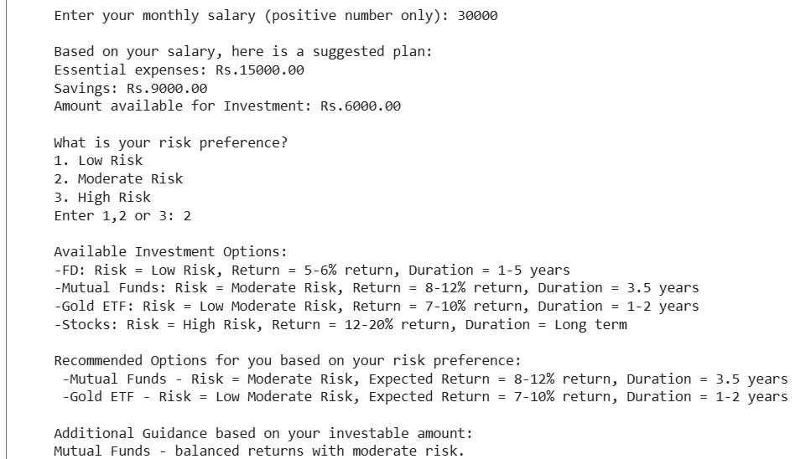

- Test Case 2
Input: Salary = -500
Output: “Salary must be greater than 0.”
- Test Case 3
Input: Risk= 3 (High Risk)
Output: Stocks + Mutual Funds


Challenges faced
- Handling invalid inputs like negative numbers, strings, or blank inputs.
- Ensuring the program does not crash during incorrect data entry.
- Designing a clean and user-friendly menu system.
- Creating a looping mechanism that asks the user if they want more recommendations.
- Formatting the program output to look professional.
- Learning to structure the code using functions.
- Adding documentation like README, diagrams, and screenshots.

Learnings and key takeaways
- Learned how to use Python for real-world financial calculations.
- Understood the importance of input validation and exception handling.
- Gained experience in designing user-friendly CLI interfaces.
- Understood the 50-30-20 budgeting principle and investment basics.
- Improved ability to structure code using functions and loops.
- Learned to create README.md and project documentation.
- Understood how software design requires both functional and non-functional thinking.
- Learned the importance of modular design for future scalability.

Future Enhancements
The project can be expanded in several ways to make it more interactive:
- Adding a database to store user profiles, salary history and recommendation logs.
- Integrating real-time financial data such as FD interest rates, mutual fund performance and stock market trends.
- Introducing goal-based planning- (ex- saving for education, travel, retirement).
- Building a graphical user interface (GUI) using Tkinter or a website version using HTML/CSS.
- Adding personalized alerts based on market conditions or salary updates.
- Providing Investment Calculators (SIP Calculator, FD Calculator, compound interest calculator).
- Developing a mobile-friendly app for easy access and user convenience.

References
- https://ankurwarikoo.com
- www.youtube.com
- https://colab.research.google.com

