Project Title:

TECH WORKSHOP

Group Members:
- HUMNA QAISER 208

- ABUZAR BHATTI 195

- HAMDA KHALID 224

- EMAAN SHEHZAD 199

- SAFFANA RIAZ 188

submitted to : ms.ramsha khalid
course :AICTL

Table of Contents
Introduction: 3
SUMMARY: 3
Objectives and Scope: 3
Website structure & navigation: 4
Top Navigation Bar: 4
Home Page: 4
Social Media Integration: 4
Left Sidebar Navigation System:- 4
Sidebar Menu Options: 4
Navigation Flow: 4
Project Background: 5
Design Choices: 6
Font Selection: 6
Colour Scheme: 6
Layout Design: 6
Code screenshots: 7
Assets used: 10
Reflection: 13
How to run/ publish the website: 13
LinkedIn links: 14

Introduction:

This report covers the topic of Tech Workshop.
Technology has become an essential part of modern life, and technical skills are important for personal and professional growth. Many people want to learn new technologies but often lack proper guidance and learning platforms.
The Tech Workshop project is created to provide a single platform where different technical courses are offered. This project focuses on basic understanding and practical learning of modern technologies. It is developed as part of the AICT course final project using HTML and CSS, along with proper documentation and presentations.

SUMMARY:

The Tech Workshop project is a group-based project developed by a team of five members. The main idea of this project is to create a simple and user-friendly website that represents a technology training workshop. The website provides information about different courses, their details, and the learning structure. Overall, the Tech Workshop project aims to promote technical education and skill development. It shows how digital tools can be used effectively to create an informative and professional project. This project also helps students understand teamwork, planning, and practical implementation of basic web technologies.

Objectives and Scope:

- To provide learners with clear information about available courses and their purpose.
- To help students choose suitable courses according to their interests.
- To promote awareness of modern technology education and training programs.
- Serving as an informational source for students interested in technical education.
- Supporting beginners who want to start learning technology-based skills.
- The project can be expanded in the future by adding more courses and advanced learning options.

Website structure & navigation:

Top Navigation Bar:
The website includes a clear and structured top navigation bar containing three primary sections: Prize Winners, Workshops, and Competitions. Among these, the Workshops section is set as the default home page, ensuring that users are immediately presented with the core offerings of the platform.

Home Page:
The Home Page (Workshops section) is designed to highlight key opportunities and learning areas. It features three main information blocks focusing on Internship Opportunities, Professional Growth, and Skill Development.
Additionally, the home page displays a well-organized list of technical courses and domains, including Artificial Intelligence (AI), Data Science, Machine Learning, Generative AI Expert, and other emerging technologies. This layout helps users quickly understand the educational scope and objectives of the website.

Social Media Integration:
A right-side social media panel is provided to enhance connectivity and communication. This panel includes icons for Instagram, LinkedIn, YouTube, Twitter, Facebook, and WhatsApp, allowing users to access updates, gather information, or contact the organization through multiple platforms.

Left Sidebar Navigation System:-

Sidebar Menu Options:
The website also features a left sidebar navigation menu for quick and efficient access to important sections. The sidebar includes Home, Events, Contact, About Us, Store, and Sponsors.

Navigation Flow:
- The Home option redirects users to the Workshops section, which functions as the main landing page.
- The Contact Us section provides detailed information about the website along with official contact details.
- The Events option redirects users to the official UET Lahore events page, as the website is a project of the Department of Computer Science, UET Lahore.
- Other options such as About Us, Store, and Sponsors provide additional supporting information.
- This sidebar-based navigation ensures smooth movement between pages and improves overall usability.

Project Background:
This website has been developed as an academic project by the Department of Computer Science, UET Lahore. The workshops and technical activities featured on the platform are organized by the same department to promote technical learning and professional development among students.

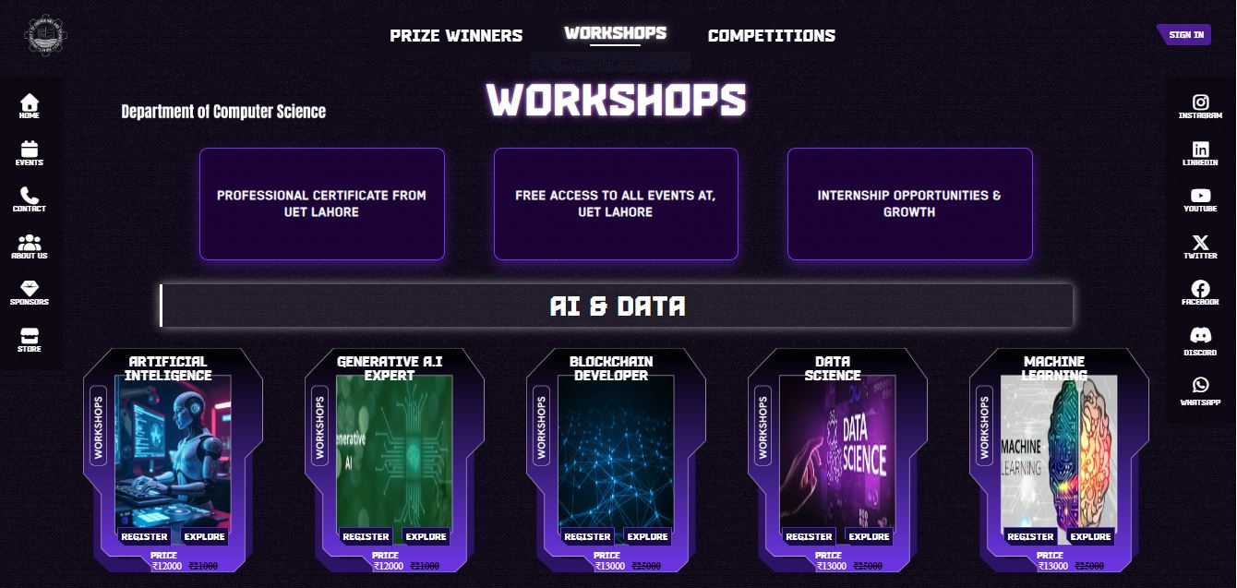

Design Choices:

Font Selection:
The website uses the KensMark 03 font style, which provides a modern, bold, and futuristic appearance. The font remains clear and readable while reinforcing the innovative nature of topics such as Artificial Intelligence, Data Science, and emerging technologies.

Colour Scheme:
The website uses a dark, thunder-inspired colour scheme featuring deep blue and purple tones with electric blue highlights. These colours create a dynamic and futuristic effect, reflecting energy, innovation, and advanced technology. Light text on dark backgrounds ensures clear contrast and good readability

Layout Design:
The website follows a structured and modern layout designed for ease of navigation. A top navigation bar is used to display the main sections, including Workshops, Competitions, and Prize Winners. A left sidebar provides quick access to secondary pages such as Home, Events, Contact, About Us, Store, and Sponsors.
The central content area uses a card-based layout to present workshops and learning domains, allowing users to easily browse and understand available options. This layout ensures a clean interface, logical content flow, and an improved user experience.

Code screenshots:

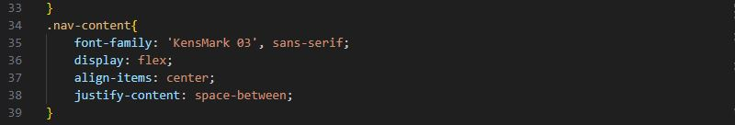
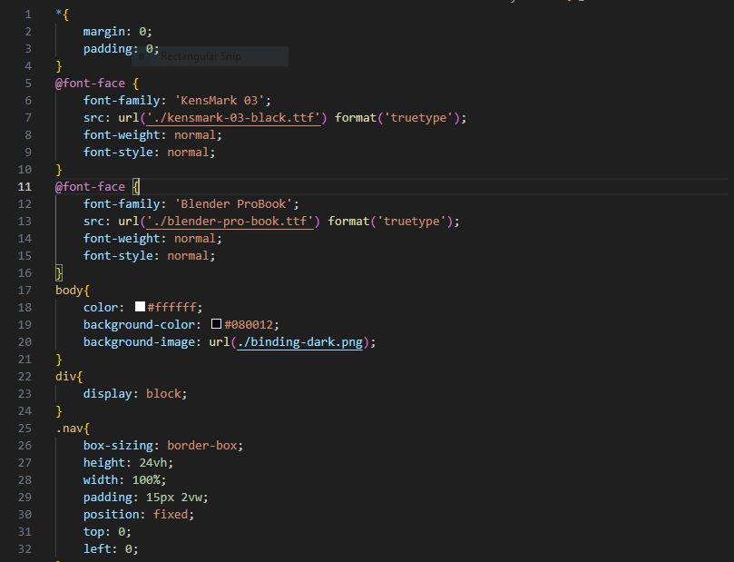
Style.css:

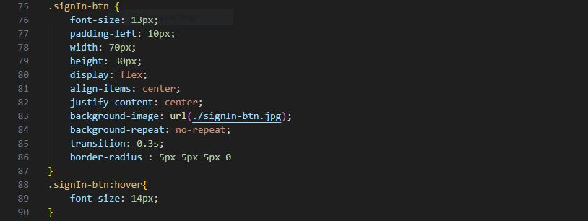

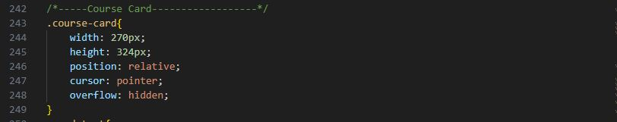
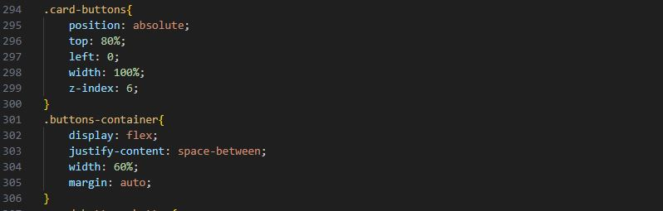
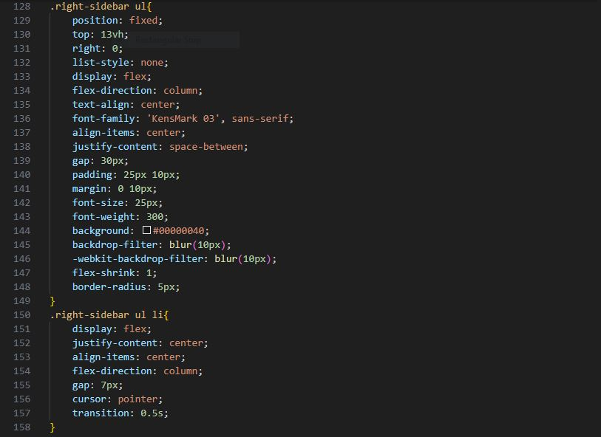
HTML:
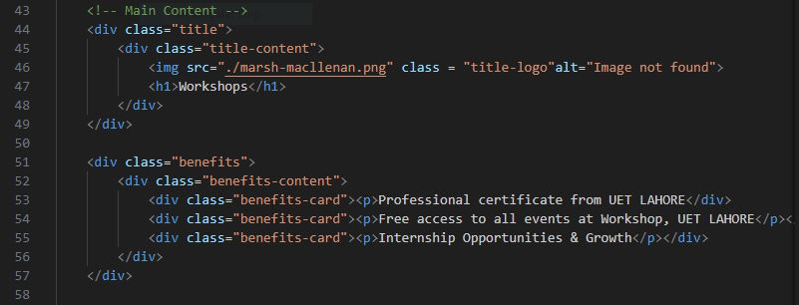
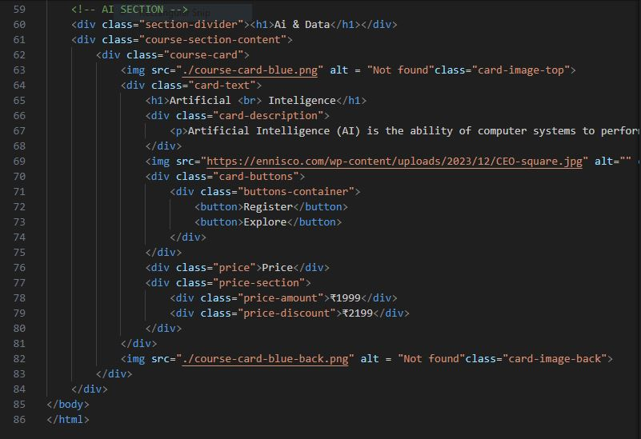

Assets used:

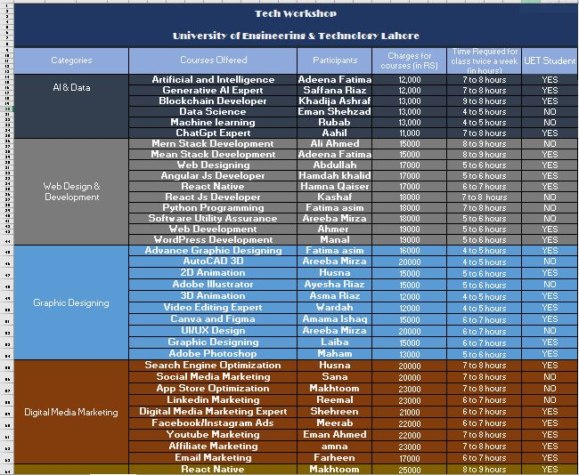

Data Analysis & visualization:
Table for the calculation of whether the participants are students of Uet

UET Students | DATA
UET Students | 28
Outsiders | 14
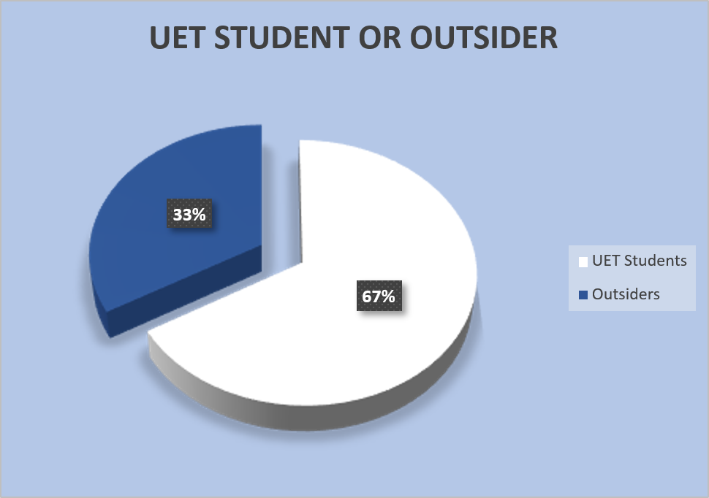

Key Statistics:
- ​Total Enrolments: 42 Participants
- ​UET Internal Talent: 28 Students (67%)
- ​External (Outsider) Participants: 14 Individuals (33%)

=

Categories and the number of courses under them

Categories | Courses Offered
AI & Data | 6
Web Design & Development | 10
Graphic Designing | 10
Digital Media Marketing | 9
Apps & Game Development | 4
Cyber Security | 3
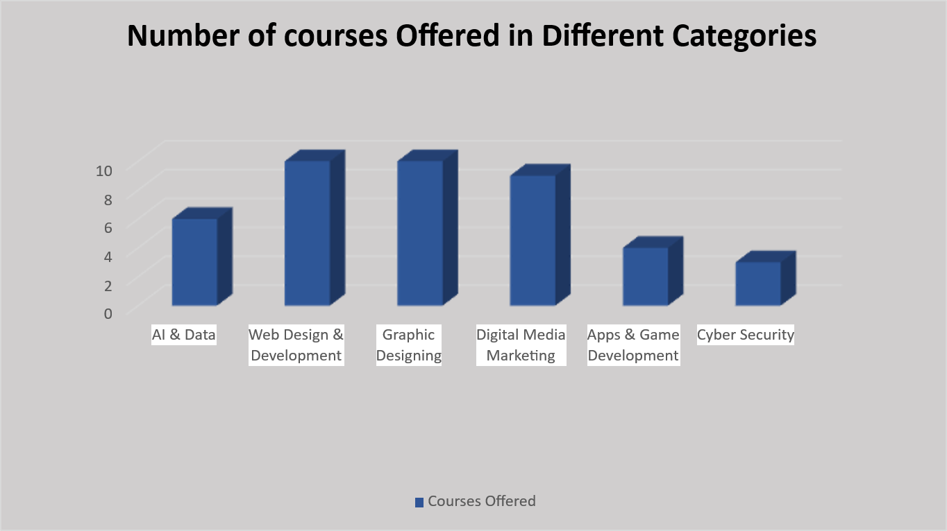
Key Statistics:
- ​Total Course Offerings: 42 Programs
- ​Primary Focus Areas: Web Design & Graphic Designing (10 courses each)
- ​Market Outreach: Digital Media Marketing (9 courses)
- ​Specialized Tracks: AI & Data (6), App Dev (4), and Cyber Security (3)

Reflection:
- Through this project, we learned how to design and organize a complete website, focusing on layout, navigation, and overall structure rather than only coding.
- We understood the importance of clear navigation and consistent design to improve user experience.
- Working with Excel tables and converting them into graphs helped us learn how to analyze data and present it in a visual and understandable form.
- We faced challenges such as maintaining layout consistency, selecting suitable colors, and aligning content, which improved our problem-solving skills.
- Team collaboration during the project enhanced our communication and coordination skills.
- If improvements are made in the future, the website can be enhanced by adding better responsiveness, interactive features, and dynamic content.
- Overall, this project helped us apply theoretical concepts practically and increased our confidence in web development and project documentation.

How to run/ publish the website:
- First, a GitHub account is created and a new public repository is set up for the project.
- All website files, including HTML, CSS, JavaScript, images, and assets, are uploaded to the repository.
- The main page of the website is saved as index.html, which is required for GitHub Pages to work properly.
- After uploading the files, the GitHub Pages option is enabled from the repository settings.
- The source branch (usually main) is selected, and GitHub automatically generates a live URL for the website.
- Once published, the website can be accessed through the provided GitHub Pages link using any web browser.
- For local testing, the website can also be run by simply opening the index.html file in a browser before publishing.

Live site URL:
https://its-abuzar.github.io/Tech-Workshop-Website/index.html

LinkedIn links:
Humna Qaiser (208):

Abuzar Bhatti (195):

Eman Shahzad (199):

Saffana Riaz (188):

Hamdah Khalid (224):

