Name:Agnishrota Chakraborty

Reg No. RA1811003010631

Assignment- Maintain Efficient Process Utilization on (Windows)

Problem Statement:

* Collect process information using the Task Viewer.
* Terminate a specific process using Windows PowerShell.
* Terminate multiple processes using Windows PowerShell.

Solution:

1. To open Task view manager > **Ctrl+Shift+Esc**
2. Go to > Details tab in the Task manager> to retrieve the PID of processes that you want terminate.

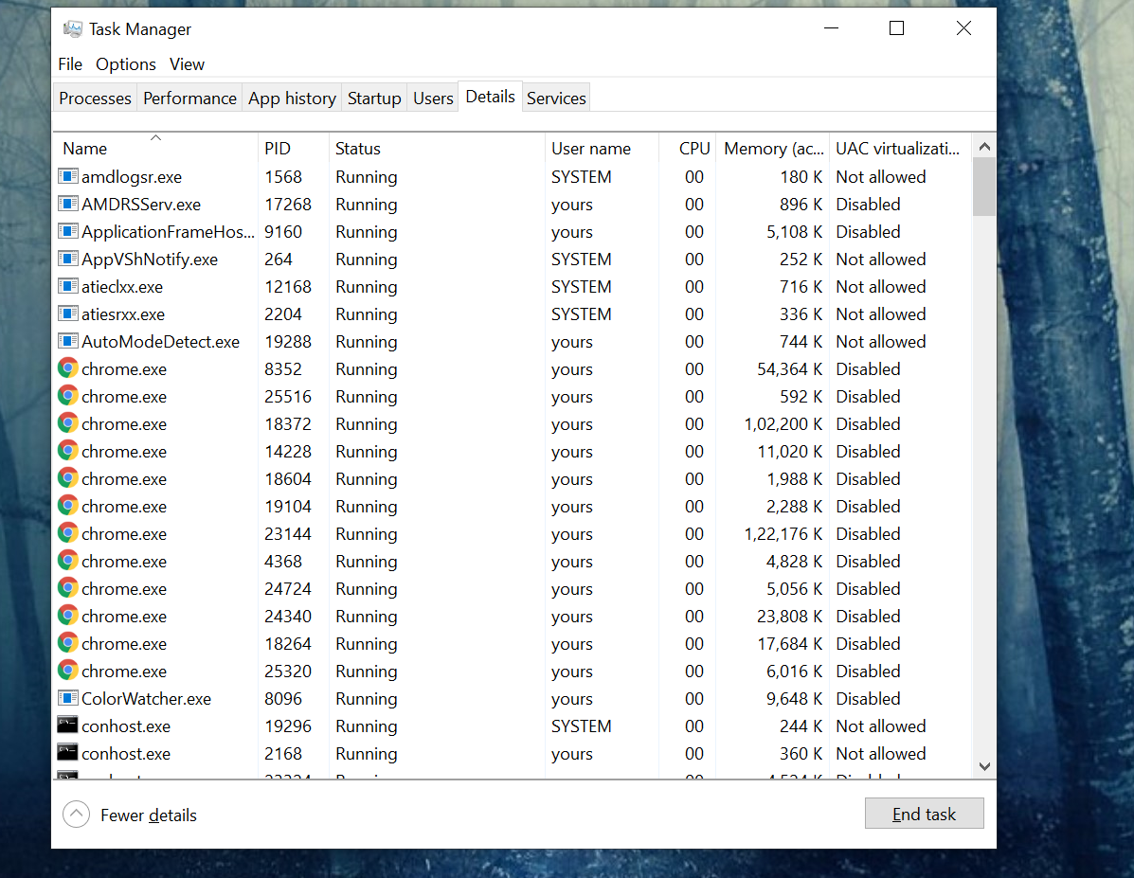

1. (Alternative) on windows PowerShell type> **Get-Process**> to retrieve all information of currently running processes.

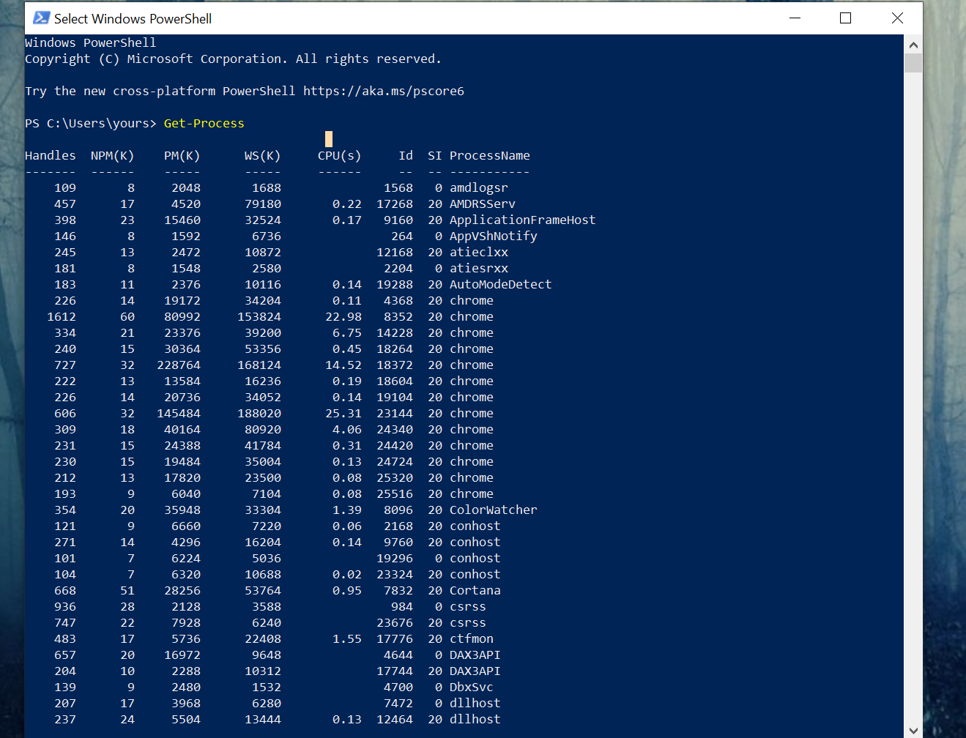

1. To terminate a process through window Powershell Type the following command:

> **TASKKILL / PID (#)**



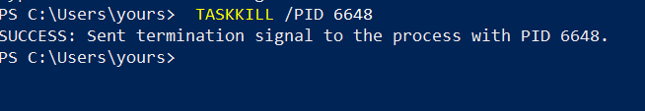

>**TASKKILL / PID (#) / PID (#) / PID (#)……(For terminating multiple processes)**

* explorer.exe >> 7336
* Mspaint.exe >> 15348
* SnippingTool.exe >>16700

