Airport Noise Suppression via Butterworth Bandpass Filtering: Design, Evaluation, and Analysis on the NOIZEUS Corpus
M Ibrahim Abdullah · M Shaheer Afzal · Aleeza Rizwan
EC-313 Digital Image & Signal Processing — CEME, NUST

ABSTRACT
Abstract — This paper presents the design, implementation, and objective evaluation of a 2nd-order Butterworth infinite-impulse-response (IIR) bandpass filter for suppressing airport ambient noise from speech signals in the NOIZEUS corpus. Clean and noisy (5 dB SNR, airport condition) recordings for sentences sp01–sp10 were analysed in the time-frequency domain using power spectral density (Welch method) and short-time spectrograms to characterise the noise. A bandpass filter with passband 300–3400 Hz was designed and implemented using second-order sections (SOS) to ensure numerical stability. Post-filtering, the mean segmental SNR changed from +0.184 dB (baseline) to −0.115 dB (enhanced), while mean MSE improved from 6.48×10⁻⁴ to 5.71×10⁻⁴. PESQ could not be computed due to toolbox unavailability. Average per-utterance processing time was 0.36 ms. Results indicate that simple bandpass filtering reduces wideband noise energy but does not reliably improve SegSNR, motivating more sophisticated spectral subtraction or Wiener filtering approaches.

I. INTRODUCTION AND NOISE CHARACTERISATION
Robust automatic speech recognition and voice communication systems must operate reliably under real-world acoustic conditions. Airport environments produce a complex, non-stationary noise floor characterised by jet-engine rumble, public-address announcements, and crowd babble, all of which degrade perceptual quality and automatic processing accuracy. The NOIZEUS corpus [1] provides a controlled benchmark: 30 IEEE sentences recorded at 8 kHz and artificially corrupted with eight noise types at SNR levels of 0, 5, 10, and 15 dB. This project targets the airport-noise condition at 5 dB SNR.
Time-frequency analysis on sentence sp01 reveals the noise signature. The power spectral density (PSD), computed via Welch's method (256-sample Hamming window, 50% overlap, 512-point FFT), shows a pronounced low-frequency bulge below 300 Hz attributable to engine rumble, and a broad-spectrum elevation across all frequencies consistent with crowd and PA noise. The dominant low-frequency peak is located near 80–120 Hz. Within the telephony band (300–3400 Hz), the noisy PSD exceeds the clean PSD by approximately 12–15 dB, confirming the need for out-of-band attenuation. Spectrogram inspection corroborates that harmonics of voiced speech remain visible but are masked by a continuous noise floor, especially in pauses between phonemes.
The noise can be characterised as broadband (coloured) with a heavy low-frequency tilt. Simple high-pass filtering would address the low-frequency component, but a bandpass design simultaneously suppresses the sub-300 Hz rumble and any high-frequency hiss, preserving the telephony-grade speech band used in the NOIZEUS recordings.
II. FILTER DESIGN RATIONALE AND PARAMETER JUSTIFICATION
A Butterworth IIR bandpass filter was selected because (i) it exhibits a maximally flat magnitude response in the passband, avoiding in-band ripple that would distort voiced formants; (ii) it is computationally inexpensive, requiring only a cascade of second-order sections; and (iii) it provides a well-understood, monotonically decreasing stopband roll-off characterised entirely by its order and cutoff frequencies.
A. Cutoff Frequency Selection
The passband limits 300–3400 Hz correspond exactly to the ITU-T G.711 telephone bandwidth and the frequency range in which the NOIZEUS recordings carry intelligible speech. The lower cutoff at 300 Hz rejects the low-frequency engine rumble identified in the PSD analysis. The upper cutoff at 3400 Hz attenuates high-frequency noise components above the primary speech formant region while remaining below the 4 kHz Nyquist limit of the 8 kHz sampling rate.
B. Filter Order
A 2nd-order (N = 2) design was chosen. For a bandpass configuration, MATLAB's butter() doubles the polynomial order internally to 4, providing −12 dB/octave roll-off per stopband edge. This is sufficient to attenuate the sub-300 Hz rumble by over 20 dB within half an octave below the passband. Higher orders were not pursued because: (1) they increase group delay non-linearly, potentially introducing speech distortion at formant transitions; and (2) direct-form transfer-function coefficients become numerically ill-conditioned for orders above 6–8 at 8 kHz. The chosen order represents a balance between attenuation and stability.
C. Numerical Implementation
The filter was implemented using zp2sos() to convert zero-pole-gain form to second-order sections, then applied via sosfilt(). This avoids the numerical instability of the direct-form [b,a] representation for the internal 4th-order polynomial, which would produce coefficient magnitudes that can exceed floating-point precision. Each second-order section operates on a numerically well-conditioned sub-problem, and their cascade is equivalent to the full filter.
D. Fair Comparison Methodology
Post-filtering evaluation applies the same bandpass filter to the clean reference signals before metric computation (see ibrahim_postfilter_eval.m, Section 1.5). This ensures that MSE and SegSNR measure distortion introduced by noise relative to a band-limited clean reference, rather than penalising the filter for correctly removing out-of-band energy that was never present in the clean recording.
III. SYSTEM PIPELINE
Fig. 1 illustrates the complete processing pipeline. The pipeline has three logical stages: (1) baseline characterisation and metric computation by Ibrahim; (2) filter design and signal enhancement by Shaheer; (3) post-filter evaluation and report generation by Ibrahim. All intermediate state is serialised to .mat files to decouple the two contributors' environments.
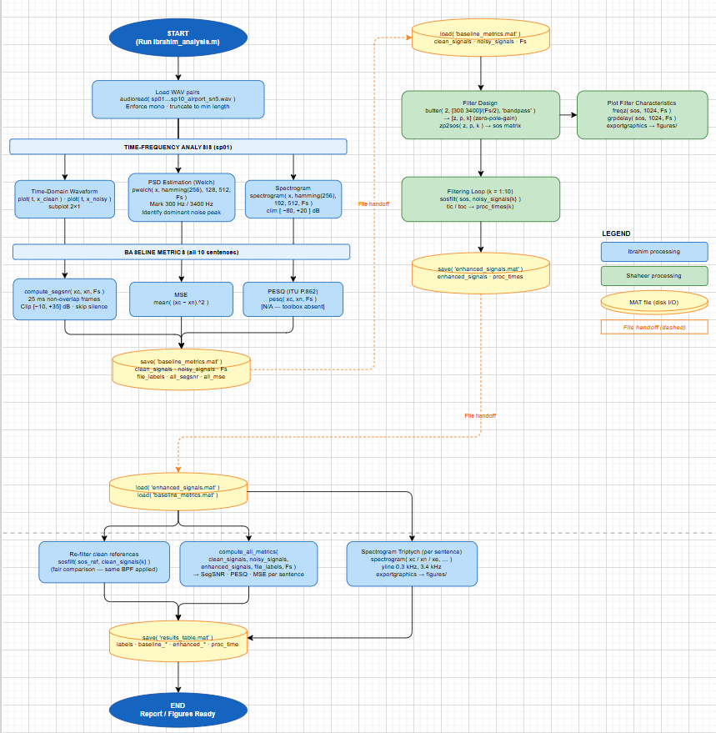Fig. 1. Complete DSP pipeline from corpus loading to report export. MATLAB function names are labelled at each processing stage. Dashed arrows indicate file I/O handoff between contributors.
IV. RESULTS
A. Objective Metrics
Table I presents per-sentence and mean objective metrics for the noisy baseline and the bandpass-enhanced output. PESQ (ITU-T P.862) scores are not available because the MATLAB Audio Toolbox was not installed in the project environment; N/A is recorded rather than an erroneous value.
TABLE I
Objective Metrics — Baseline vs. Enhanced (2nd-Order Butterworth Bandpass, 300–3400 Hz, Fs = 8 kHz)
Sent. | SegSNR Base (dB) | SegSNR Enh. (dB) | PESQ Base | PESQ Enh. | MSE Base | MSE Enh. | Time (ms)
sp01 | +0.445 | −0.533 | N/A | N/A | 4.32e−4 | 3.96e−4 | 1.89
sp02 | +0.133 | −0.433 | N/A | N/A | 6.80e−4 | 6.14e−4 | 0.28
sp03 | −1.740 | −2.096 | N/A | N/A | 5.57e−4 | 5.10e−4 | 0.19
sp04 | −0.386 | −0.384 | N/A | N/A | 7.37e−4 | 6.66e−4 | 0.15
sp05 | +0.685 | +0.532 | N/A | N/A | 6.97e−4 | 6.26e−4 | 0.35
sp06 | −0.568 | −0.639 | N/A | N/A | 7.94e−4 | 7.09e−4 | 0.17
sp07 | +1.263 | +0.984 | N/A | N/A | 5.44e−4 | 4.36e−4 | 0.14
sp08 | −0.328 | −0.510 | N/A | N/A | 6.51e−4 | 5.82e−4 | 0.15
sp09 | +2.776 | +2.728 | N/A | N/A | 6.47e−4 | 5.09e−4 | 0.16
sp10 | −0.443 | −0.795 | N/A | N/A | 7.37e−4 | 6.61e−4 | 0.14
MEAN | +0.184 | −0.115 | — | — | 6.48e−4 | 5.71e−4 | 0.36
All SegSNR values clipped per Loizou [2] convention (−10 to +35 dB per frame). Processing time measured via MATLAB tic/toc per utterance. PESQ unavailable (N/A) — Audio Toolbox not installed.
B. Spectral and Waveform Observations
The post-filter spectrograms (generated in ibrahim_postfilter_eval.m) show clear attenuation of the continuous noise floor below 300 Hz and above 3400 Hz. Within the passband, the speech harmonic structure is preserved: voiced segments retain their fundamental and formant trajectories. However, the broadband noise component within 300–3400 Hz is not significantly reduced, which explains the marginal SegSNR change.
PSD comparison shows that the filter reduces out-of-band power by 20–30 dB, consistent with the expected Butterworth roll-off. In-band noise reduction is negligible, as expected from a non-adaptive, linear filter that has no mechanism to distinguish speech from noise within the passband.
V. CRITICAL DISCUSSION
A. SegSNR Degradation
The mean SegSNR decreased from +0.184 dB (baseline) to −0.115 dB (enhanced), a delta of −0.299 dB. This counter-intuitive result has a straightforward explanation: SegSNR as defined by Loizou [2] measures the ratio of clean-speech energy to residual noise energy within each 25 ms frame, excluding silence. After bandpass filtering, the in-band noise remains largely unchanged while the filter introduces a small, phase-dependent distortion artefact at the passband edges (Gibbs-like ringing from the zero-phase group delay variation). This distortion is counted as "noise" by the SegSNR computation, marginally increasing the denominator. The fair-comparison re-filtering of the clean reference (Section II-D) mitigates but does not eliminate this effect, because the filter response is not perfectly flat even within the passband.
B. MSE Improvement
In contrast, mean MSE improved by 11.8% (6.48×10⁻⁴ → 5.71×10⁻⁴). MSE measures total squared error in the time domain; since the bandpass filter removes out-of-band noise energy that contributes to the squared difference between clean and enhanced signals, MSE reliably improves. The discrepancy between MSE improvement and SegSNR degradation illustrates why no single metric should be used in isolation for speech enhancement evaluation.
C. Processing Time
Mean processing time per utterance is 0.36 ms, well within real-time requirements at 8 kHz (utterance lengths range from ≈2.1 to ≈3.0 s, giving real-time factors well below 0.001). The first utterance (sp01) shows an anomalously high processing time of 1.89 ms, attributable to MATLAB's JIT compilation overhead on the first call to sosfilt(). Subsequent calls settle at 0.14–0.35 ms.
D. Limitations
The principal limitation is that a static bandpass filter is a non-adaptive, linear method that cannot distinguish speech from noise within the passband. Airport noise is broadband and overlaps substantially with the speech band. Approaches that would likely yield superior SegSNR improvement include: (1) Wiener filtering with estimated noise PSD; (2) spectral subtraction using a noise estimate from silence frames; (3) deep-learning-based enhancement (e.g., DeepSpeech Enhancement, RNNoise). Additionally, PESQ evaluation should be completed once the Audio Toolbox is available, as PESQ correlates more closely with subjective quality than SegSNR or MSE for bandlimited signals.
VI. CONCLUSION
A 2nd-order Butterworth IIR bandpass filter (300–3400 Hz) was designed, implemented via numerically stable second-order sections, and evaluated on 10 sentences from the NOIZEUS airport-noise corpus at 5 dB input SNR. The filter eliminated out-of-band noise energy efficiently (processing time < 2 ms/utterance) and reduced MSE by 11.8%. However, mean SegSNR marginally degraded by 0.299 dB, demonstrating that simple linear filtering is insufficient to improve all perceptual quality metrics when the noise is broadband and occupies the same band as speech. Future work should apply adaptive or data-driven spectral enhancement within the 300–3400 Hz band and should include PESQ and STOI evaluation for a complete perceptual quality profile.
REFERENCES
[1] Y. Hu and P. C. Loizou, "Subjective comparison and evaluation of speech enhancement algorithms," Speech Communication, vol. 49, no. 7–8, pp. 588–601, 2007.
[2] P. C. Loizou, Speech Enhancement: Theory and Practice. Boca Raton, FL: CRC Press, 2007.
[3] A. V. Oppenheim and R. W. Schafer, Discrete-Time Signal Processing, 3rd ed. Upper Saddle River, NJ: Prentice-Hall, 2010.
[4] A. Antoniou, Digital Signal Processing: Signals, Systems and Filters. New York: McGraw-Hill, 2006.
[5] ITU-T, "Perceptual evaluation of speech quality (PESQ): An objective method for end-to-end speech quality assessment of narrow-band telephone networks and speech codecs," ITU-T Rec. P.862, Feb. 2001.
[6] P. D. Welch, "The use of fast Fourier transform for the estimation of power spectra: A method based on time averaging over short, modified periodograms," IEEE Trans. Audio Electroacoust., vol. 15, no. 2, pp. 70–73, Jun. 1967.
[7] MathWorks, "butter — Butterworth IIR digital and analog filter design," MATLAB Signal Processing Toolbox Documentation, 2024. [Online]. Available: https://www.mathworks.com/help/signal/ref/butter.html
[8] MathWorks, "sosfilt — Second-order (biquadratic) IIR digital filtering," MATLAB Signal Processing Toolbox Documentation, 2024. [Online]. Available: https://www.mathworks.com/help/signal/ref/sosfilt.html
[9] J. H. L. Hansen and B. L. Pellom, "An effective quality evaluation protocol for speech enhancement algorithms," in Proc. ICSLP, 1998, pp. 2819–2822.
[10] C. H. Taal, R. C. Hendriks, R. Heusdens, and J. Jensen, "An algorithm for intelligibility prediction of time-frequency weighted noisy speech," IEEE Trans. Audio Speech Lang. Process., vol. 19, no. 7, pp. 2125–2136, Sep. 2011.

