**Mobilenet V2**

First I have used mobile net v2 pre trained model by doing by making changes in its layer which gave around 99% accuracy which shows that our model was overfitting

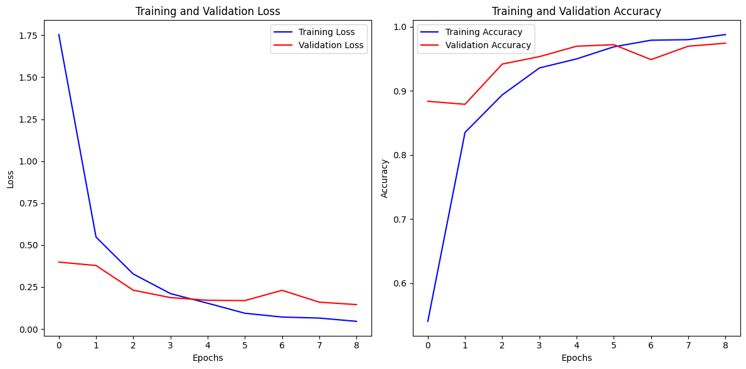

The above graph shows the training and validation accuracy over epochs, where training accuracy steadily improves, but the validation accuracy fluctuates, hinting at possible overfitting or poor generalization.

**InceptionV3**

After that we used the another pre trained model Inception v3 but that also gave the accuracy of around 97% accuracy showing early trends in overfitting.

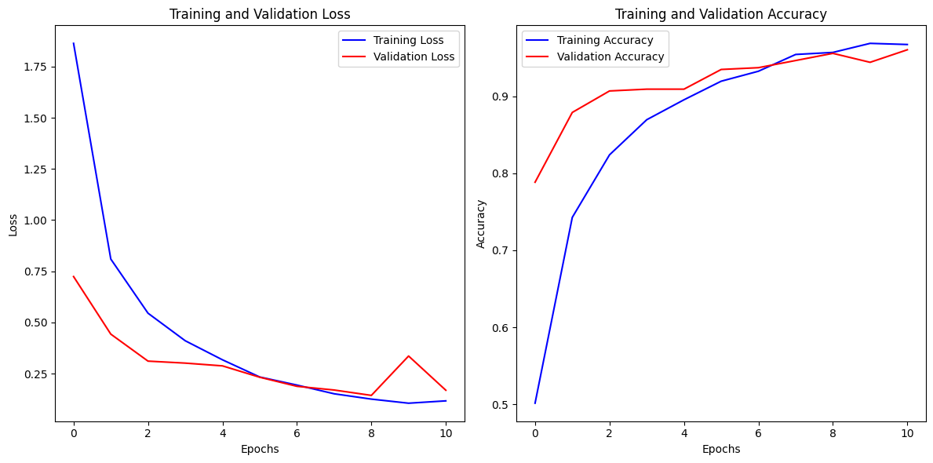

The above graph displays the training and validation loss over epochs, with a sharp decline in training loss and some fluctuation in validation loss, suggesting overfitting or inconsistency in validation performance.

**Again Mobilenet V2**

Overfitting occurs when your model learns the training data too well, including its noise, and fails to generalize to unseen data. To reduce overfitting we followed various strategies and made the changes in mobilenet V2 model:

* Increase Regularization
* Data Augmentation
* Use Weight Regularization
* Early Stopping
* Reduce Model Complexity

After applying these strategies, we re-trained our model and monitored its performance on the validation dataset. Though we attained a little bit less accuracy of around 92% but it results in better generalization (higher validation/test accuracy).

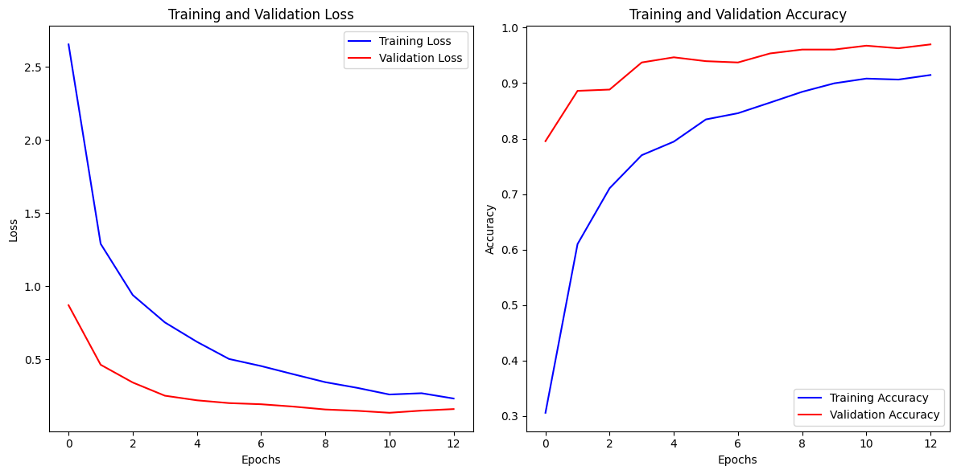

The above graphs depict the training and validation loss (left) and accuracy (right) over 12 epochs, illustrating model improvement and convergence during training.

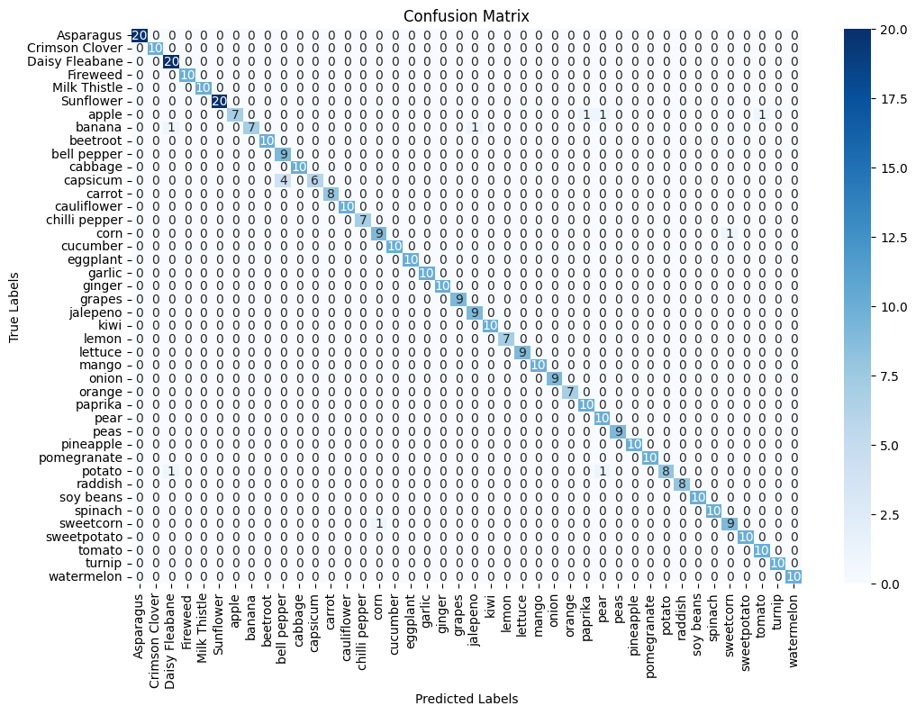

A confusion matrix visualizing the model's performance in classifying various plant categories, with a strong diagonal indicating accurate predictions for most classes.