


Manufacturing Operational Insights Report
IAC Provisioning for Telecomm System

Course Name: DevOps

Institution Name: Medicaps University – Datagami Skill Based Course

Student Name(s) & Enrolment Number(s):

Sr no | Student Name | Enrolment Number
01 | Aayushi Solanki | EN24CA5030003
02 | Ayushi Pal | EN24CA5030033
03 | Avdhesh Bhadoriya | EN22IT301026
04 | Kanak Kumari | EN24CA5030076
05 | Ramji Soni | EN22IT301078

Group Name: G01D12
Project Number: DO-39
Industry Mentor Name: Vaibhav
University Mentor Name: Akshay Saxena Academic Year: 2025-2026

1.Problem Statement & Objectives

1.1. Problem Statement
- Traditional manual infrastructure setup for telecom systems is prone to human error, leads to "environment drift" (where different servers have different configurations), and is extremely time-consuming. In a mission-critical industry like Telecomm, these delays and inconsistencies can lead to service downtime and security vulnerabilities.

1.2. Project Objectives
- Automation: To replace manual server configuration with script-based, automated deployments using Terraform.
- Consistency: To ensure that development and production environments are identical through Infrastructure as Code (IaC).
- Scalability: To enable dynamic scaling of telecom microservices using Kubernetes orchestration.
- Efficiency: To reduce the overall environment setup time from hours to a few minutes.

1.3. Scope of the Project
- The project covers the automation of local Docker environments and Kubernetes clusters specifically for hosting telecom services like Billing and Network Management. It includes building a Node.js-based management portal to control these deployments.

2. Proposed Solution

2.1. Key Features
- Automated Provisioning: One-click deployment of containers and K8s nodes via the Express backend.
- Secure Authentication: Admin access protected by bcrypt password hashing and jsonwebtoken (JWT).
- Real-time Monitoring: A dynamic dashboard built with EJS to visualize the current status of infrastructure resources.
- Zero-Downtime Deployment: Using CI/CD pipelines to update services without interrupting telecom operations.

2.2. Overall Architecture / Workflow
The system follows a modern DevOps workflow where infrastructure is treated exactly like application code.
- Code Commit: Developers push IaC scripts to the Git Repository.
- Automation Engine: GitHub Actions or Jenkins triggers a build, checking for syntax errors and security vulnerabilities.
- Infrastructure Provisioning: Terraform executes the plan to create or update Docker hosts and K8s nodes.
- Service Deployment: The updated Docker images for telecom microservices are pulled into the Kubernetes cluster.
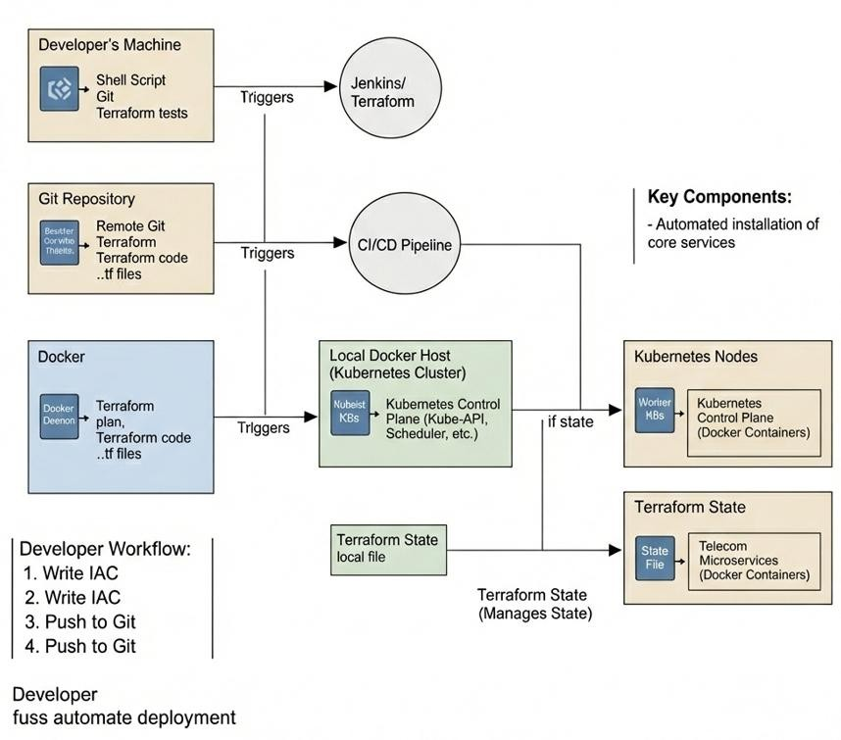

Figure 1: High-Level System Architecture

2.3. Tools & Technologies Used

IaC Tool: Terraform
Orchestration: Kubernetes (K8s) & Docker
CI/CD: GitHub Actions / Jenkins
Backend: Node.js & Express.js
Database: MongoDB (Mongoose)
Security: Bcrypt & JWT
3. Results & Output

3.1. Infrastructure Meta-Model
We developed an Infrastructure Meta-Model (ER Diagram) to track the lifecycle of every deployment. This ensures that we have a clear record of which Job_ID created which Infra_Resource.

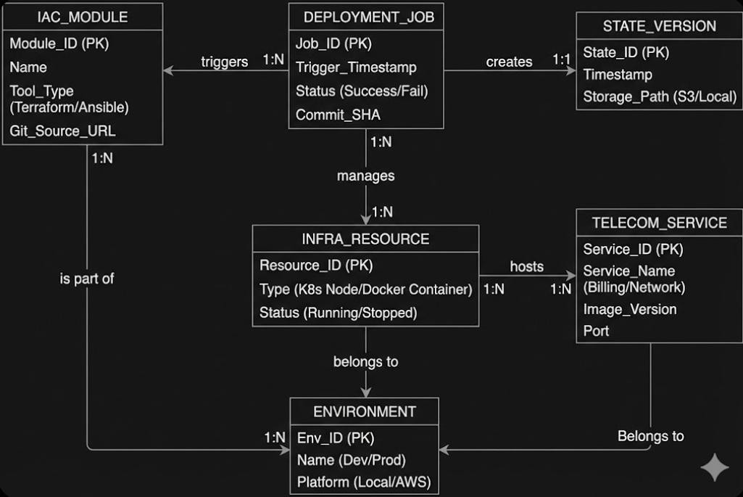

Figure 2: Infrastructure ER Diagram

3.2. Infrastructure Deployment Output

3.2.1. EC2 Instance Running:
- The screenshot displays the Amazon EC2 dashboard showcasing the running telecom-infra-backend instance along with its specific network configurations and instance metadata.

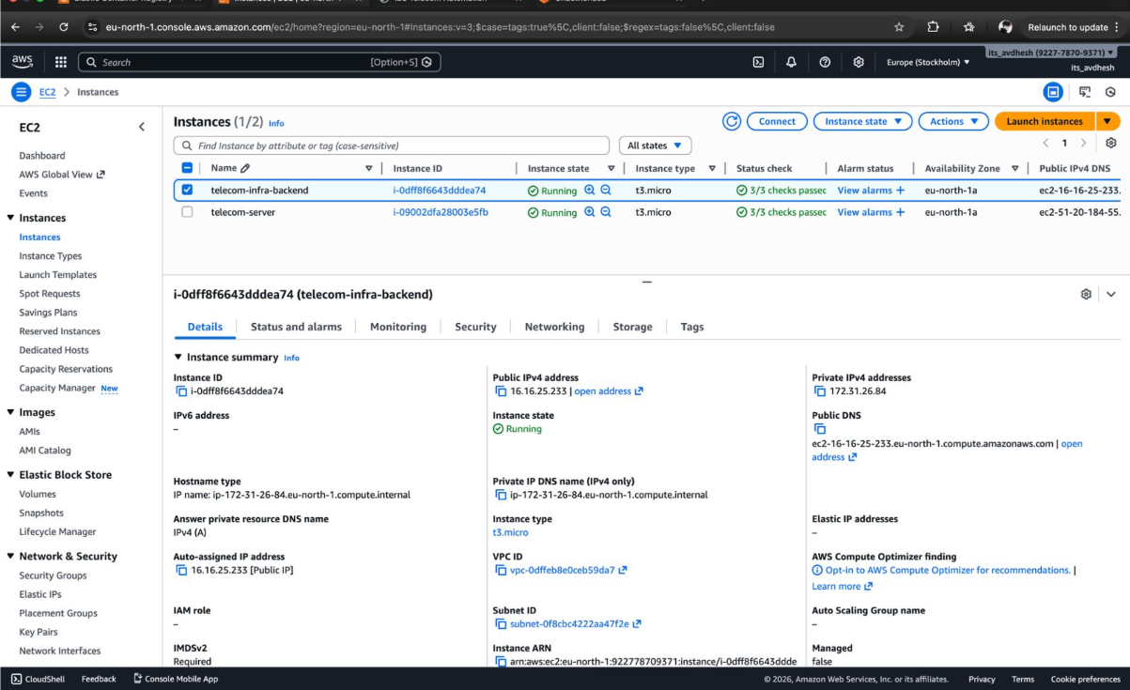

Figure 3: EC2 Instance in Running State

3.2.2. IAM Configuration:

- The screenshot shows the AWS Identity and Access Management (IAM) dashboard for the “telecom-cli-user.” It displays the attached permission policies and active access credentials used for infrastructure provisioning. These permissions allow the user to interact with AWS services such as EC2, ECR, and IAM during Terraform execution. This configuration ensures that infrastructure automation tasks are performed securely and with controlled access rights.
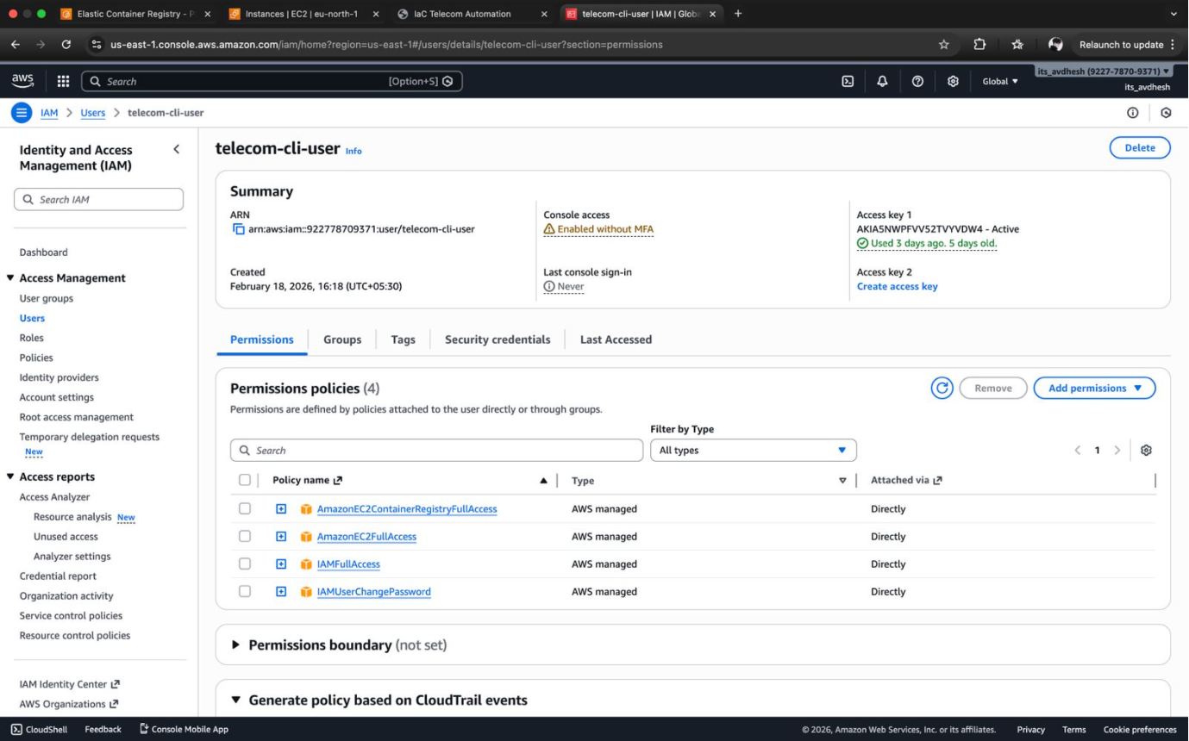

Figure 4: IAM User/Role Overview

3.3 Container Registry and CI/CD Execution

3.3.1. AWS ECR Repository:

- The screenshot displays the Amazon Elastic Container Registry (ECR) dashboard for the telecom-backend project. It shows the container image repository along with the available image versions (tags) and their respective push timestamps. This confirms that the Docker image was successfully built and pushed to AWS ECR as part of the CI/CD pipeline. The repository acts as a secure storage location from which the EC2 instance pulls the latest container image for deployment.
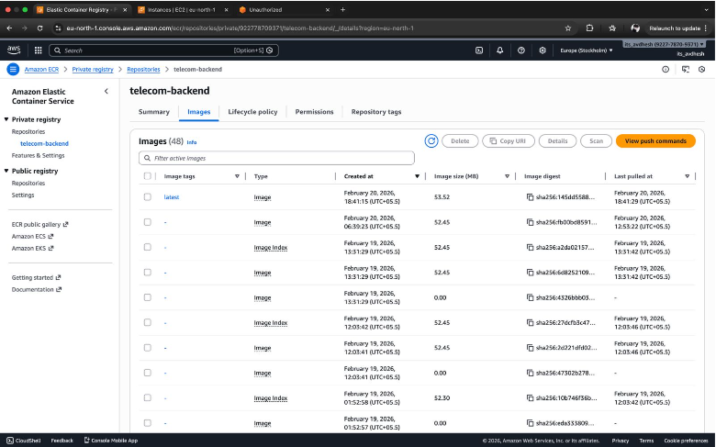

Figure 5: AWS ECR Repository

3.3.2. GitHub Actions Successful Workflow:

- The GitHub Actions dashboard illustrates the automated CI/CD workflow execution for the telecom-infra-automation project. It provides a complete history of workflow runs triggered automatically by commits pushed to the main branch. The dashboard clearly shows multiple successful (green) executions, confirming that the automation pipeline is functioning correctly.
- Each workflow run consists of sequential stages including source code checkout, Docker image build, image tagging, secure push to AWS Elastic Container Registry (ECR), and automated deployment to the EC2 instance. The successful completion status of each run demonstrates that the Continuous Integration and Continuous Deployment process is stable, reliable, and free from manual intervention.
- This confirms that infrastructure provisioning and application deployment are fully automated, ensuring consistency, faster releases, and reduced operational errors.

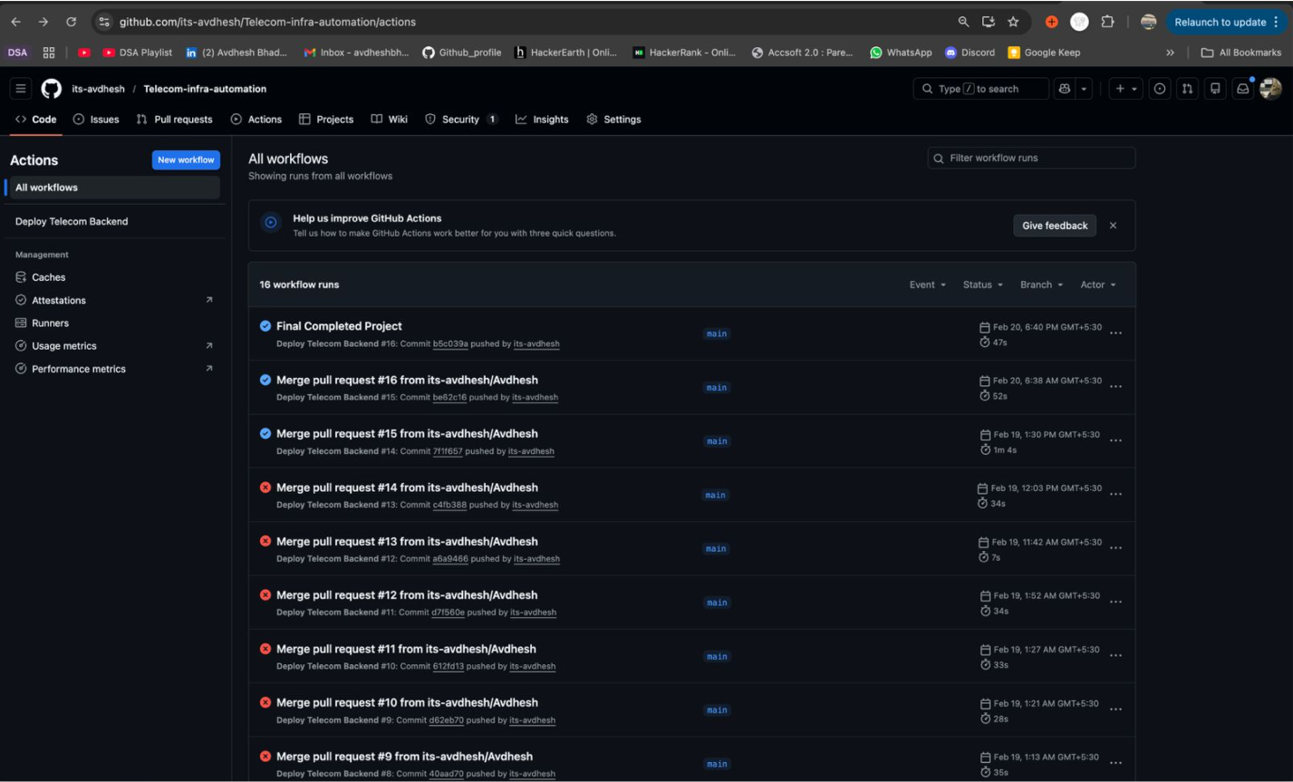

Figure 6: GitHub Actions Successful Workflow

3.4. Application Deployment Output

3.4.1. Home Page:

- The screenshot shows the “Overview” page of the IaC Telecom Automation portal, which explains the core objective of the project. It highlights the implementation of a repeatable and scalable backend deployment model using Docker containers, AWS Elastic Container Registry (ECR), and EC2 infrastructure. This page demonstrates how Infrastructure as Code (IaC) principles were applied to automate provisioning, containerization, and deployment processes, ensuring consistency and efficiency across environments.
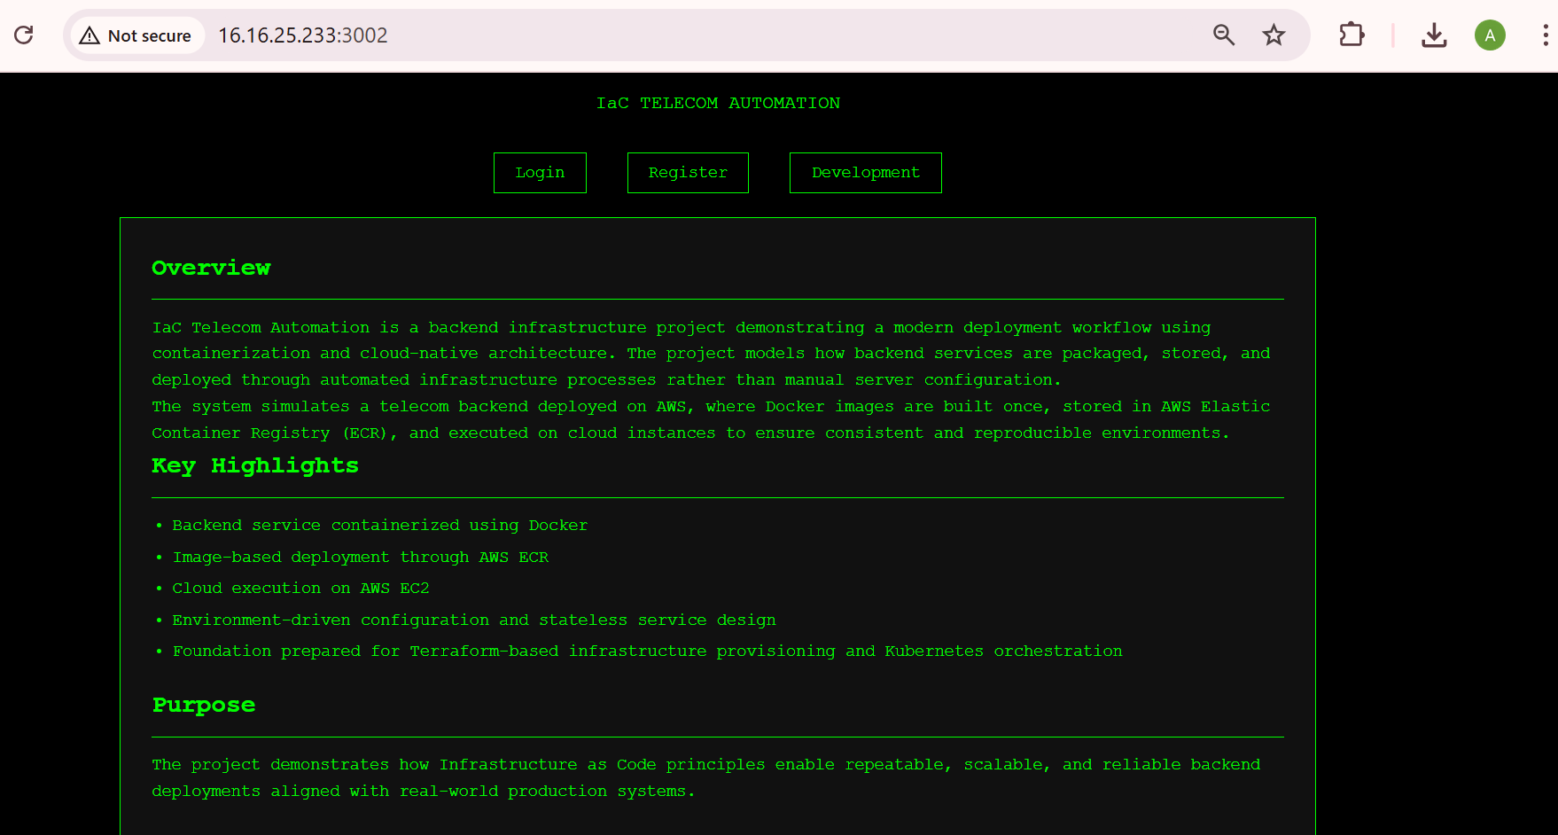

Figure 7: Home Page

3.4.2. Login Page:

- The screenshot showcases the login interface of the IaC Telecom Automation Management Portal. This interface provides secure administrative access to the deployed application hosted on the EC2 instance. The login functionality confirms that the backend services are active and properly connected, allowing authorized users to access the infrastructure control system.
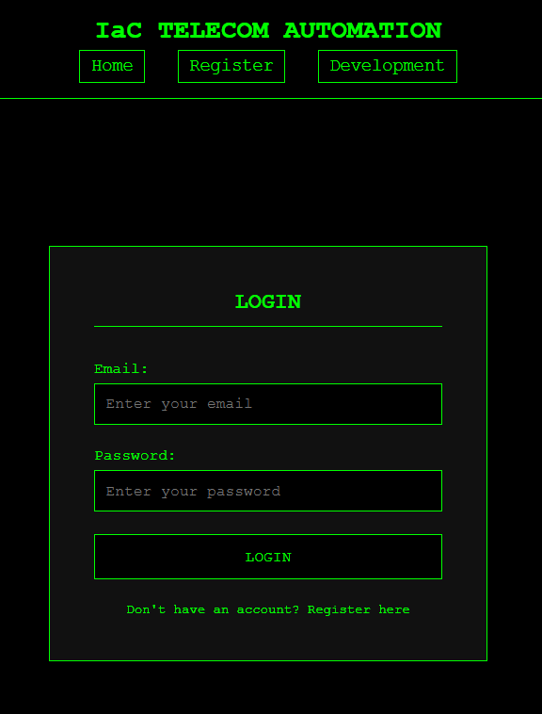

Figure 8: Login Page

3.4.3. Register Page:

- The screenshot presents the user registration page for the IaC TELECOM AUTOMATION platform, allowing new administrators to create secure accounts for infrastructure management.

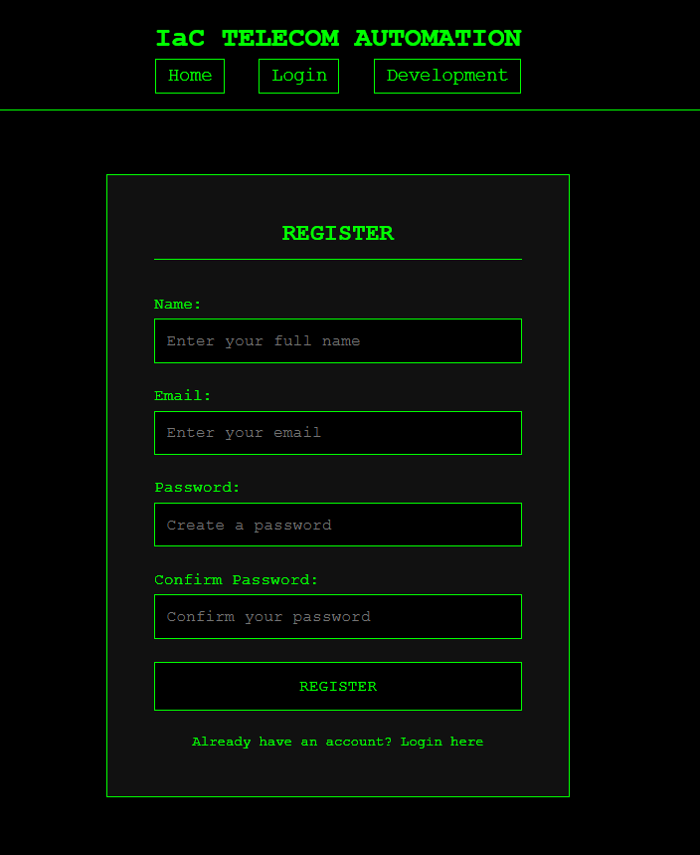

Figure 9: Register Page

3.4.4. Development:

- The screenshot provides a detailed "How It Works" technical breakdown within the portal, visualizing the full automation lifecycle from Infrastructure Provisioning via Terraform to Continuous Deployment through GitHub Actions.

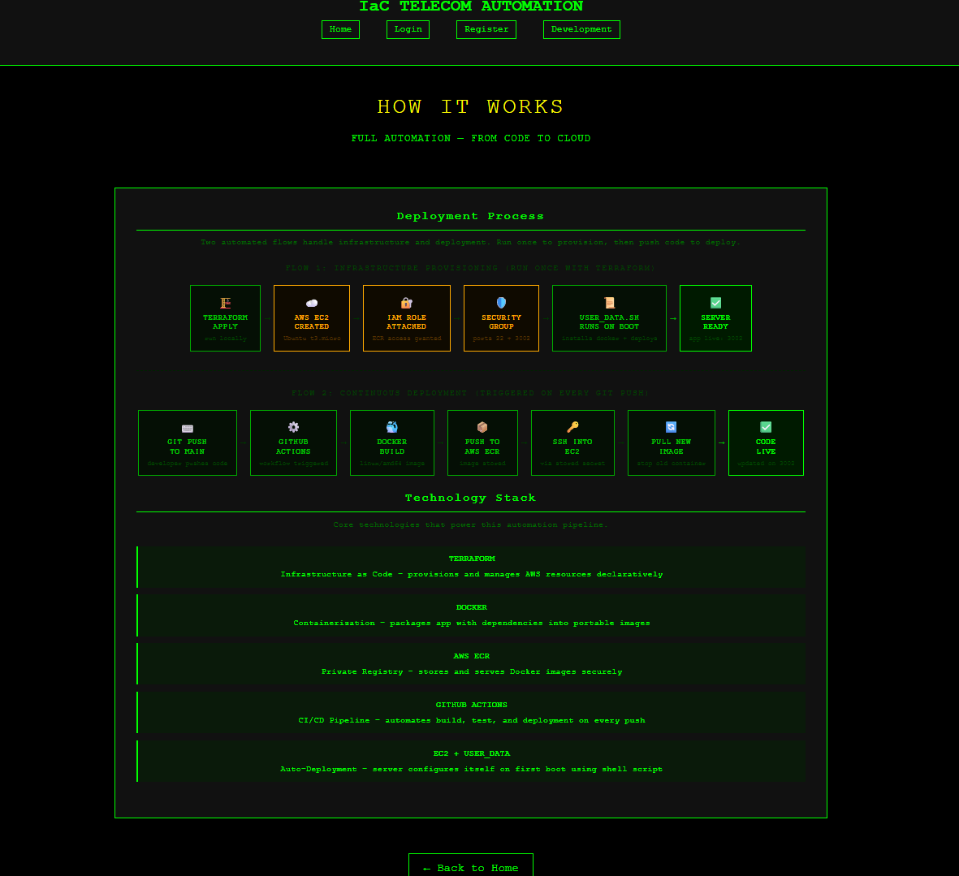

Figure 10: Development

3.4.5. Manual vs IAC provisioning:

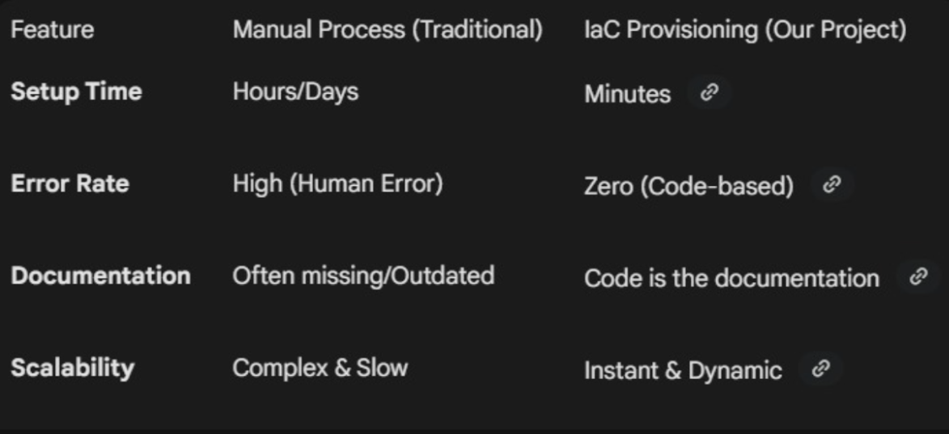

Figure 11: Manual vs IAC provisioning

4. Conclusion

- This project successfully demonstrates how Infrastructure as Code can revolutionize telecom operations. By combining a Node.js management portal with powerful tools like Terraform and Kubernetes, we have built a system that is not only automated but also secure and highly resilient. The integration of CI/CD ensures that the telecom services are always running the latest, most secure versions of the code.

5. Future Scope & Enhancements

- Multi-Cloud Support: Expanding the Terraform providers to support AWS, Azure, and Google Cloud simultaneously.
- AI-Driven Scaling: Integrating machine learning to predict telecom traffic spikes and scale Kubernetes nodes automatically.
- Disaster Recovery: Implementing automated state-file backups and cross-region failover mechanisms for higher reliability.

