ZEPTO SQL DATA ANALYSIS

- CREATION OF DATABASE
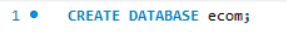
- CREATION OF TABLE
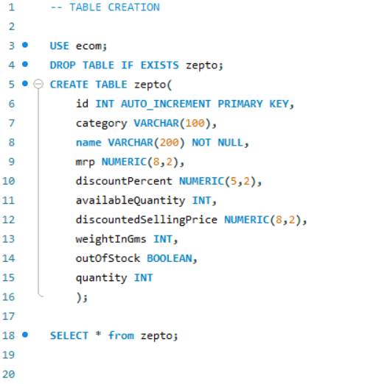
id: Unique identifier for each product entry (Synthetic Primary Key)
name: Product name as it appears on the app
category: Product category like Fruits, Snacks, Beverages, etc.
mrp: Maximum Retail Price (originally in paise, converted to ₹)
discountPercent: Discount applied on MRP
discountedSellingPrice: Final price after discount (also converted to ₹)
availableQuantity: Units available in inventory
weightInGms: Product weight in grams
outOfStock: Boolean flag indicating stock availability
quantity: Number of units per package (mixed with grams for loose produce)

- Data Exploration
Counted the total number of records in the datasets

Viewed a sample of the data set to understand structure and content

Checked for null values across all columns

Identified distinct product categories available in the data set

Compared in-stock vs out-of-stock product counts

Detected products present multiple times, representing different ids

- DATA CLEANING
Identified and removed rows where MRP or discounted selling price was zero.
Converted mrp and discountedSellingPrice from paise to rupees for consistency and readability

- BUSINESS INSIGHTS
- Found top 10 best-value products based on discount percentage

- Identified high-MRP products that are currently out of stock

- Estimated potential revenue for each product category

- Filtered expensive products (MRP > ₹500) with minimal discount

- Ranked top 5 categories offering highest average discounts

- Calculated price per gram to identify value-for-money products

- Grouped products based on weight into Low, Medium, and Bulk categories

- Measured total inventory weight per product category

- SCREENSHOTS-





