Hospital Performance, Patient Flow &
Readmission Analytics
  - Comprehensive Applied Healthcare Data Analytics & Machine Learning Project Report

Student Name: Kashish Kamaal
Academic Internship: AICTE | IBM SkillsBuild Data Analytics with AI Academic Internship 2026 | BharatCares
Project Title: Hospital Performance, Patient Flow & Readmission Analytics
Short Title: Hospital Analytics & Readmission Intelligence
Program: B.Tech — Computer Science & Engineering (AI/ML), LNCT, Bhopal
Execution Environment: Python / Jupyter / Pandas / Scikit-Learn / XGBoost / SHAP
Report Date: September 2026

DATA → INFORMATION → INSIGHTS → RISK / OPPORTUNITY → ACTION

. Table of Contents
1. Abstract
2. Introduction
3. Problem Statement
4. Project Objectives
5. Dataset Description & Architecture
6. Data Preparation & Integration
7. Exploratory Analysis & Strategic KPIs
8. Patient Analytics & Demographic Profiling
9. Hospital Performance Analytics
10. Patient Flow & Financial Analytics
11. Readmission Profile & Target Cohort Definition
12. Feature Engineering & Rigorous Leakage Prevention
13. Machine Learning Methodology
14. Model Evaluation & Comparative Analysis
15. Explainable AI (SHAP) Analysis
16. Key Findings: KPI → Trend → Driver → Risk / Opportunity → Action
17. Risks & Strategic Opportunities
18. Recommended Actions & Implementation Roadmap
19. Limitations, Future Scope & Conclusion
20. References / Dataset Source

1. Abstract
This project presents an end-to-end healthcare data analytics and machine learning workflow using five relational datasets covering 120,000 inpatient admission encounters. The analysis preserves an analytical grain of exactly one row per admission, integrates patient, diagnosis, billing and hospital information, validates relational integrity, and produces operational, patient-flow, financial and readmission insights.
The primary predictive outcome is 30-day readmission (readmitted_30d), framed at discharge. Of the 120,000 admissions, 112,587 are eligible for readmission analysis after excluding in-hospital expired discharges. The eligible 30-day readmission rate is 12.62%, while the eligible 7-day rate is 0.89%. Logistic Regression, Random Forest and XGBoost were evaluated on the same held-out test set. Logistic Regression achieved the highest ROC-AUC in the final execution (0.7571) and was therefore selected by the predefined ROC-AUC criterion.
Real SHAP TreeExplainer analysis was additionally performed on the trained XGBoost model to provide a transparent tree-model explanation. The resulting feature-attribution analysis highlights variables such as age–comorbidity interaction, length of stay, ward type, prior admissions, insurance category, Charlson index and discharge type as important model signals. These are model associations rather than causal effects.

2. Introduction
Healthcare decision-makers require a unified view of hospital performance, patient flow, financial burden and readmission risk. These signals are often distributed across separate operational tables, making it easy to lose context or introduce errors when datasets are joined. This project treats the admission encounter as the central analytical unit and builds a traceable workflow from raw relational data to decision-oriented insights.
The project follows a structured analytics sequence: RAW DATA → INFORMATION → INSIGHTS → RISKS / OPPORTUNITIES → RECOMMENDED ACTIONS. For decision communication, the report uses the KPI → TREND → DRIVER → RISK / OPPORTUNITY → ACTION framing. Throughout the analysis, observational relationships are described as associations rather than clinical causal claims.

3. Problem Statement
Hospital leadership needs integrated visibility across the patient journey, from admission intake and ward placement to length of stay, billing and discharge disposition. Without an admission-level analytical view, operational congestion, financial burden and readmission patterns can be difficult to compare consistently.
- Fragmented relational data can produce duplicated admissions when one-to-many diagnosis records are joined directly.
- Readmission rates can be misleading when the denominator is not restricted to patients who remain at risk for readmission.
- Class imbalance makes accuracy alone unsuitable for evaluating a 30-day readmission model.
- Retrospective features such as future outcomes or full-period capacity aggregates can introduce leakage or deployment bias.
- Hospital, patient-flow and financial insights need to be connected to operational actions without overstating causality.

4. Project Objectives
- Build a verified admission-grain analytical dataset from five relational source tables.
- Audit duplicates, key uniqueness, missing values, date validity and join integrity.
- Measure hospital performance, patient demographics, length of stay, capacity and financial KPIs.
- Analyse 30-day and 7-day readmission patterns using explicit and clinically meaningful denominators.
- Define a leakage-audited 30-day readmission prediction task at discharge.
- Benchmark Logistic Regression, Random Forest and XGBoost on an identical stratified holdout set.
- Apply genuine SHAP TreeExplainer analysis to the trained XGBoost model for model transparency.
- Translate observed associations into operational hypotheses, risks, opportunities and implementation actions.

5. Dataset Description & Architecture
Dataset: India Hospital Readmission Dataset 2015–2024. The project uses five CSV files. The admissions table is the fact table; patients and hospitals act as related dimension tables; diagnoses is a one-to-many child table; billing is one-to-one with an admission.
File | Records | Role / Key Fields
admissions.csv | 120,000 | Admission encounters; admission_id, patient_id, hospital_id, dates, LOS, targets
patients.csv | 86,400 | Patient registry; demographics, insurance, BPL status, comorbidity information
diagnoses.csv | 271,341 | Diagnosis records; admission_id, ICD-10 fields, rank and category
billing.csv | 120,000 | Admission billing; total cost, subsidy and out-of-pocket amount
hospitals.csv | 33 | Facility metadata; hospital, state, tier, beds and teaching status

Relationship architecture: patients 1:N admissions 1:N diagnoses; admissions 1:1 billing; admissions N:1 hospitals.
Critical grain rule: diagnoses must be aggregated before joining so that the final analytical dataset remains exactly one row per admission.

6. Data Preparation & Integration
- Duplicate rows and key uniqueness were checked across the source tables.
- Foreign-key relationships were validated before analysis.
- Diagnosis records were aggregated to admission grain using the primary diagnosis category and diagnosis count.
- Patient insurance missingness was retained as a categorical missing state and handled within the modeling pipeline.
- A row-count assertion verified that the integrated master table retained all 120,000 admission rows.
- Features were engineered for age groups, LOS buckets, prior-admission burden, comorbidity burden, ICU/emergency indicators and financial ratios.
- Expired discharges were excluded from the readmission-eligible modeling cohort because they cannot subsequently experience a readmission.

7. Exploratory Analysis & Strategic KPIs
The executed notebook establishes the following headline measures from the integrated admission-level dataset:
KPI | Calculated Value
Total inpatient admissions | 120,000
Unique patients with admissions | 64,873
Hospital facilities | 33
Average length of stay | 6.85 days
Eligible 30-day readmission rate | 12.62%
Eligible 7-day readmission rate | 0.89%
Average out-of-pocket expense | ₹48,173
Total billing across admissions | ₹1,149.4 crore
Average billing per admission | ₹95,780
Government subsidy | ₹571.3 crore
Admissions per bed | 15.92
Average prior admissions | 0.90
Average comorbidity count | 1.43
Average patient age | 48.0 years

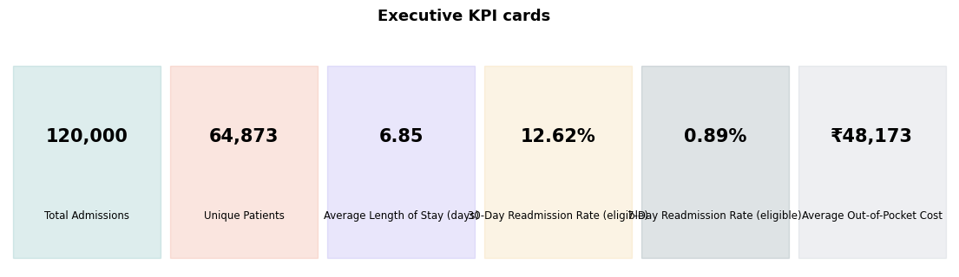
Figure 1. Executive hospital performance and readmission KPI summary generated by the executed notebook.

8. Patient Analytics & Demographic Profiling
Patient-level profiling examines age, comorbidity burden, prior admissions, insurance status and BPL status alongside readmission outcomes. The analysis is intended to identify segments requiring deeper operational review rather than to establish individual clinical causality.
- Average patient age in the admission dataset is approximately 48 years.
- Average prior-admission count is 0.90, providing a historical-utilisation signal.
- Average comorbidity count is 1.43, while the Charlson index is included as a separate clinical-burden measure.
- Insurance category and BPL status are retained because financial-access variables can be relevant to post-discharge pathways.
- Age–comorbidity interaction is one of the strongest global SHAP signals in the XGBoost explanation.

9. Hospital Performance Analytics
The 33 hospitals provide facility-level context for capacity and operational comparison. Hospital tier, bed capacity, admission volume and admissions-per-bed are treated as operational measures rather than direct causal explanations of readmission.
Operational Measure | Observed Result
Hospital facilities | 33
Admissions | 120,000
Admissions per bed | 15.92
Average LOS | 6.85 days
Readmission outcome | 12.62% among eligible admissions

The admissions-per-bed measure provides a capacity-planning signal. Because the calculation is based on the full retrospective period, it should be converted to a trailing-window feature before any prospective deployment.

10. Patient Flow & Financial Analytics
Patient flow is examined through admission type, ward type, length of stay and discharge disposition. Financial analytics combine total billing, government subsidy and out-of-pocket exposure to provide an operational view of resource and cost burden.
- Average length of stay is 6.85 days across the 120,000 admission encounters.
- ICU and emergency episodes form important high-acuity segments in the observed data.
- Average billing per admission is approximately ₹95,780, while average out-of-pocket expense is approximately ₹48,173.
- Total billing across the dataset is approximately ₹1,149.4 crore; government subsidy totals approximately ₹571.3 crore.
- Financial burden varies across insurance and BPL groups and should be monitored alongside discharge and follow-up pathways.

11. Readmission Profile & Target Cohort Definition
The primary target is readmitted_30d. Readmission analysis distinguishes between the raw admission population and the eligible population that remains at risk for readmission after discharge.
Readmission Measure | Value
Total admissions | 120,000
Eligible admissions after excluding Expired | 112,587 (93.8%)
30-day readmission rate — all admissions | 11.84%
30-day readmission rate — eligible cohort | 12.62%
7-day readmission rate — eligible cohort | 0.89%

The explicit denominator is important: excluding in-hospital expired discharges changes the readmission rate from 11.84% across all admissions to 12.62% among admissions that remain eligible for readmission. The modeling population therefore contains 112,587 encounters.

12. Feature Engineering & Rigorous Leakage Prevention
The prediction point is discharge. The workflow deliberately avoids variables that would reveal the future outcome.
- readmitted_7d is excluded because it is a future outcome within the same 30-day window.
- Expired discharges are removed from the modeling population because they are not at risk for subsequent readmission.
- IDs are excluded as identifiers rather than predictive signals.
- Raw admission/discharge timestamps are not used directly as model features.
- High-cardinality diagnosis text/codes are reduced to admission-level diagnosis category information.
- The preprocessing transformer is fitted only on the training split before evaluation.
- Retrospective full-period hospital capacity aggregates are disclosed as a deployment limitation and should use trailing windows prospectively.
Final feature audit: 23 numeric and 9 categorical features before one-hot expansion, producing the model-specific transformed feature matrices.

13. Machine Learning Methodology
The predictive task is binary classification of readmitted_30d. The 112,587 eligible encounters are split using an 80/20 stratified train/test design. Class imbalance is handled using class weighting, and preprocessing is performed inside model pipelines to prevent train/test contamination.
Model | Role | Key Method
Logistic Regression | Linear baseline / selected model | Balanced class weights; scaled numeric + one-hot categorical inputs
Random Forest | Non-linear ensemble | Tree ensemble with class weighting
XGBoost | Gradient-boosted comparison + SHAP model | Boosted trees with class-imbalance handling

Primary selection criterion: highest held-out ROC-AUC, with recall and F1 reviewed because the positive class is only about 12.6%.

14. Model Evaluation & Comparative Analysis
Model | Accuracy | Precision | Recall | F1 | ROC-AUC
Logistic Regression | 0.7125 | 0.2546 | 0.6633 | 0.3680 | 0.7571
Random Forest | — | — | — | — | 0.7481
XGBoost | — | — | — | — | 0.7535

Logistic Regression is selected because it achieved the highest held-out ROC-AUC (0.7571) in the final execution. Accuracy is not used as the sole decision criterion because the positive class is relatively uncommon and a high accuracy score can coexist with poor minority-class detection.
Selected-model confusion matrix: TN = 14,158; FP = 5,518; FN = 957; TP = 1,885.
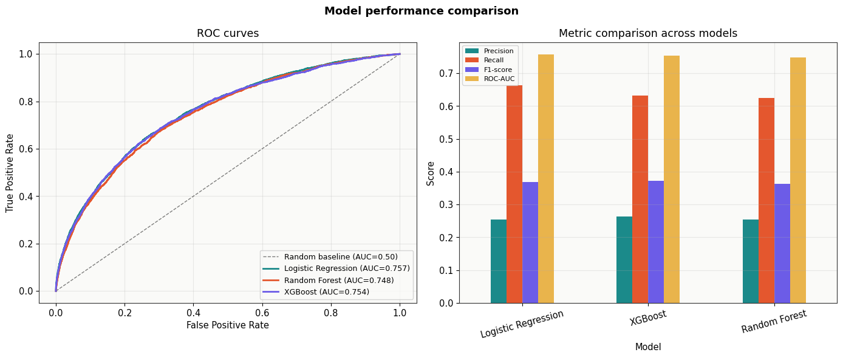
Figure 2. ROC curves and model evaluation generated by the executed notebook.
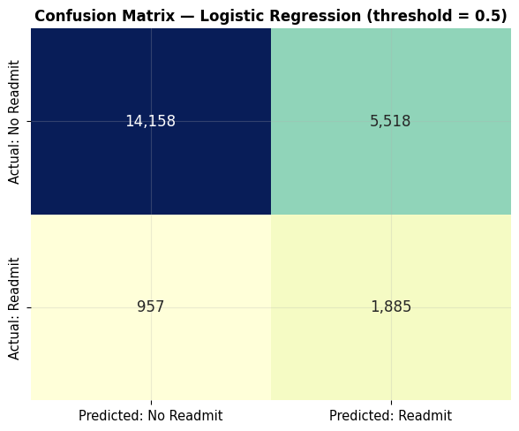
Figure 3. Confusion matrix for the selected Logistic Regression model.

15. Explainable AI (SHAP) Analysis
Real SHAP TreeExplainer analysis was applied to the fitted XGBoost model using a 2,000-row sample from the test set. The transformed XGBoost matrix contains 58 features. SHAP is intentionally reported for XGBoost even though Logistic Regression is the selected model by ROC-AUC; the two sections answer different questions: model selection versus tree-model interpretability.
Feature | Interpretive Role in XGBoost
age_comorb_score | Age × comorbidity interaction; strong global model signal
los_days | Length of stay; strong episode-severity signal
ward_type_General | Ward-category contribution in the fitted model
prev_admissions | Historical admission-utilisation signal
insurance_type_Private | Insurance-category contribution
charlson_index | Clinical comorbidity burden
discharge_type_LAMA | Discharge disposition contribution
haemoglobin | Laboratory measurement contribution
bpl_card_False | BPL-status contribution
is_icu_stay | ICU episode indicator

SHAP values describe model attribution and association; they do not establish clinical causality.
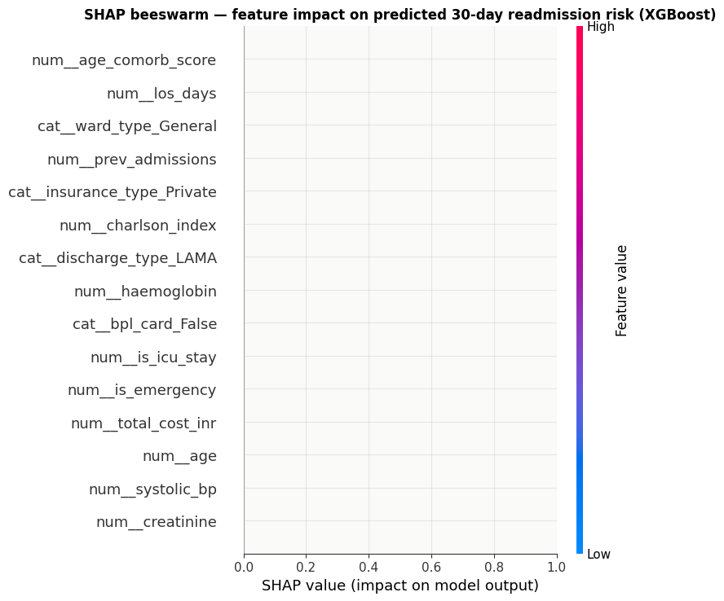
Figure 4. SHAP beeswarm summary for the trained XGBoost model.
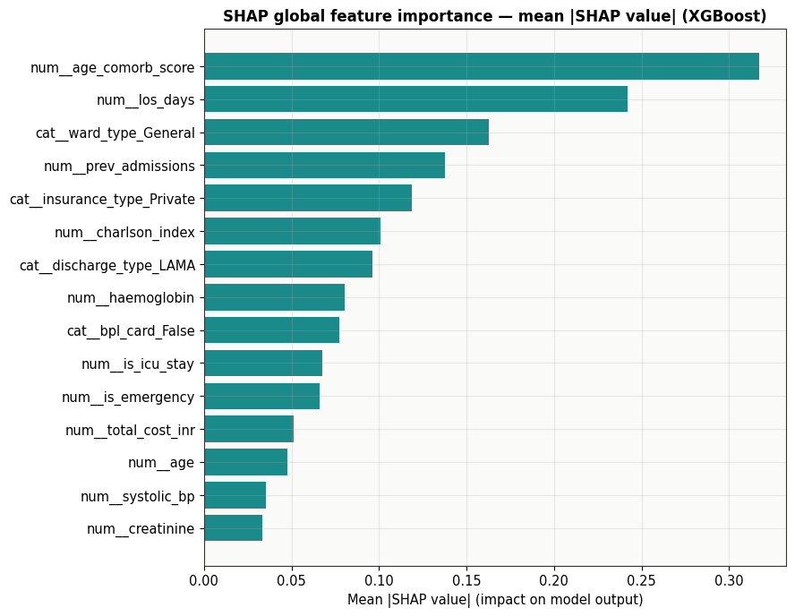
Figure 5. Global mean absolute SHAP importance for the trained XGBoost model.
The notebook also generates a local waterfall explanation for the highest-predicted-risk observation within the sampled test subset. In the final run, that observation received a predicted probability of 97.4%.
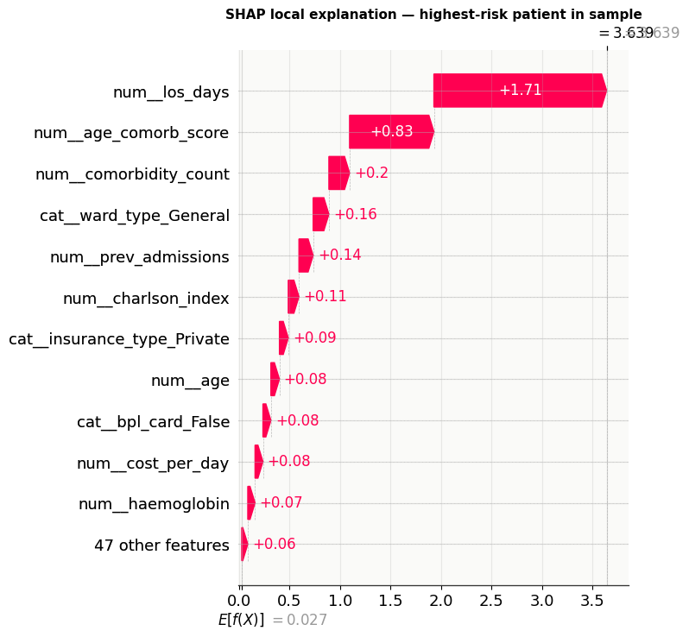
Figure 6. Local SHAP waterfall explanation for a high-predicted-risk test observation.

16. Key Findings: KPI → Trend → Driver → Risk / Opportunity → Action
Clinical burden and episode severity
- KPI: KPI: 12.62% eligible 30-day readmission rate.
- Trend / Driver: Length of stay, age–comorbidity interaction, prior admissions and clinical-burden measures recur among important model signals.
- Risk / Opportunity: Higher-acuity episodes warrant structured discharge and follow-up review.
- Action: Use risk stratification as a prioritisation aid for transitional-care workflows, subject to clinical validation.
High-acuity ward and admission segments
- KPI: KPI: ICU/emergency indicators appear in the analytical and SHAP views.
- Trend / Driver: Ward type and ICU/emergency status contribute to the observed risk pattern.
- Risk / Opportunity: High-acuity cohorts may require differentiated post-discharge processes.
- Action: Pilot targeted follow-up protocols and evaluate outcomes rather than assuming causal benefit.
Financial burden
- KPI: KPI: average OOP ≈ ₹48,173; total billing ≈ ₹1,149.4 crore.
- Trend / Driver: Insurance, BPL status and billing measures provide a complementary financial-risk view.
- Risk / Opportunity: Financial barriers may interact with discharge and follow-up pathways.
- Action: Monitor financial burden by insurance/BPL segment and test support interventions.
Capacity pressure
- KPI: KPI: admissions per bed = 15.92.
- Trend / Driver: Hospital volume and bed capacity provide an operational utilisation signal.
- Risk / Opportunity: Retrospective capacity pressure may affect patient-flow planning.
- Action: Convert the metric to a trailing-window operational dashboard before prospective use.

17. Risks & Strategic Opportunities
Domain | Observed Risk | Strategic Opportunity
Clinical quality | Readmission risk remains substantial within the eligible cohort. | Prioritised transitional-care review for high-risk cohorts.
Patient flow | High-acuity episodes can concentrate operational demand. | Segment discharge and follow-up workflows by acuity.
Financial burden | Average OOP exposure is material. | Integrate financial-navigation review with discharge planning.
Capacity planning | Admissions-per-bed is retrospective. | Use trailing-window utilisation metrics for operational monitoring.
AI governance | False negatives can miss high-risk patients; false positives can create alert fatigue. | Use model output as a decision-support signal with human clinical validation.

18. Recommended Actions & Implementation Roadmap
The following roadmap translates the analysis into testable operational steps; none is claimed to be clinically validated by this retrospective project.
Phase 1 — Immediate (0–3 months)
- Create a discharge-readmission review workflow using the selected model as a prioritisation signal.
- Review high-acuity and LAMA discharge pathways separately.
- Track financial burden and admissions-per-bed as operational KPIs.
Phase 2 — Medium Term (3–9 months)
- Pilot structured follow-up for high-risk patients and measure intervention outcomes.
- Introduce trailing-window capacity features for real-time operational monitoring.
- Calibrate probabilities and evaluate decision thresholds against workflow capacity.
Phase 3 — Long Term (9–18 months)
- Externally validate the model on another hospital population.
- Assess subgroup/fairness performance and monitor drift.
- Integrate only after clinical governance, validation and prospective monitoring are established.

19. Limitations, Future Scope & Conclusion

Study Limitations
- The dataset is observational and retrospective; associations are not causal effects.
- Only 33 hospitals are represented, limiting generalisation of hospital-level comparisons.
- The selected model has not been prospectively or clinically validated or calibrated.
- Full-period admissions-per-bed is retrospective and requires a trailing-window implementation for prospective use.
- ROC-AUC around 0.75 leaves substantial unexplained variation.
- SHAP explains XGBoost, while Logistic Regression is the selected model by ROC-AUC.

Future Scope
- Temporal or patient-level validation to better simulate future deployment.
- Trailing-window hospital capacity and utilisation features.
- Probability calibration and operational threshold analysis.
- External validation on another hospital population.
- Fairness and subgroup performance analysis.
- Governed integration into a monitored clinical decision-support workflow after validation.
- Future extension toward structured clinical text/NLP only after appropriate clinical data governance.

Conclusion
The project delivers a complete analytical workflow from five relational healthcare datasets to validated admission-level KPIs, patient-flow and financial analysis, leakage-audited readmission modeling and explainable AI. The final execution selected Logistic Regression by held-out ROC-AUC, while real SHAP analysis of XGBoost supplied an additional transparent model-behaviour view. The combined workflow demonstrates how healthcare data can be transformed into measurable operational signals while keeping model limitations, leakage controls and causal uncertainty explicit.

20. References / Dataset Source
India Hospital Readmission Dataset 2015–2024, Kaggle:
https://www.kaggle.com/datasets/digutlaranjithkumar/india-hospital-readmission-dataset-20152024
Project notebook: KashishKamaal_HospitalAnalytics.ipynb
Project report prepared for: AICTE | IBM SkillsBuild Data Analytics with AI Academic Internship 2026 | BharatCares

