NIP Project — Submission Template
Pega Platform project · This document is your complete submission
Read this before you start:
1. Fill in Section 1 completely. The Pega application name must follow the format NIP-[Project]-[YourName].
2. Create a new Operator in Pega with your full name and log in as that operator before taking any screenshot.
3. When you create your test case, enter YOUR FULL NAME in the Issue Description (Vehicle) or Movie Name (Movie) field.
4. Complete only the section for your chosen project. Delete the other project section.
5. Paste one screenshot per user story (10 total). Follow the screenshot rules in your selected project section.
6. Answer every question in Sections 3 and 4 in your own words.
7. Save the file using this format: ProjectName_FirstName_LastName.docx. Use VehicleService or MovieTicket as the ProjectName. Examples: VehicleService_Ravi_Kumar.docx or MovieTicket_Ravi_Kumar.docx.

Section 1 — Your Details
Full Name | Kashish Kamaal
Email ID (registered on NIP) | kashish.kamaal@gmail.com
Phone Number | 8839727750
College Name | Lakshmi Narain College of Technology, Bhopal
Course (e.g. IT, CS) | CSE AIML
State | Madhya Pradesh
Project Chosen (Vehicle Service OR Movie Ticket Booking) | Vehicle Service Management
Pega Application Name (e.g. NIP-VehicleService-YourName) | NIP-VehicleService-KashishKamaal
Case Type Name (exact) | Vehicle Service Request
Pega Instance URL
Operator Name (created in Pega with your full name)

Section 2A — Vehicle Service Management Application
Complete this section only if you selected this project. Delete the other project section before submitting.

Screenshot rules — IMPORTANT before you start:
1. Name your Pega application as: NIP-VehicleService-YourName OR NIP-MovieTicket-YourName
2. Create a new Operator in Pega with your full name (Security → Operators) and log in as that operator.
3. When you create your test case, enter YOUR FULL NAME in the Issue Description (Vehicle) or Movie Name (Movie) field.
4. The logged-in operator name must be visible in every screenshot wherever the Pega interface displays it.
5. The student's full name must be visible in all running-case screenshots.
6. Configuration screenshots must clearly show the relevant application or rule name.
Screenshots that do not show these will not be accepted.

US-001 — Submit Vehicle Service Request
What is expected:
Case created, customer submits Vehicle ID, Vehicle Model, Issue Description. Validation applied.
Screenshot — paste your screenshot below this line:
[ Paste screenshot here - follow the screenshot rules above ]

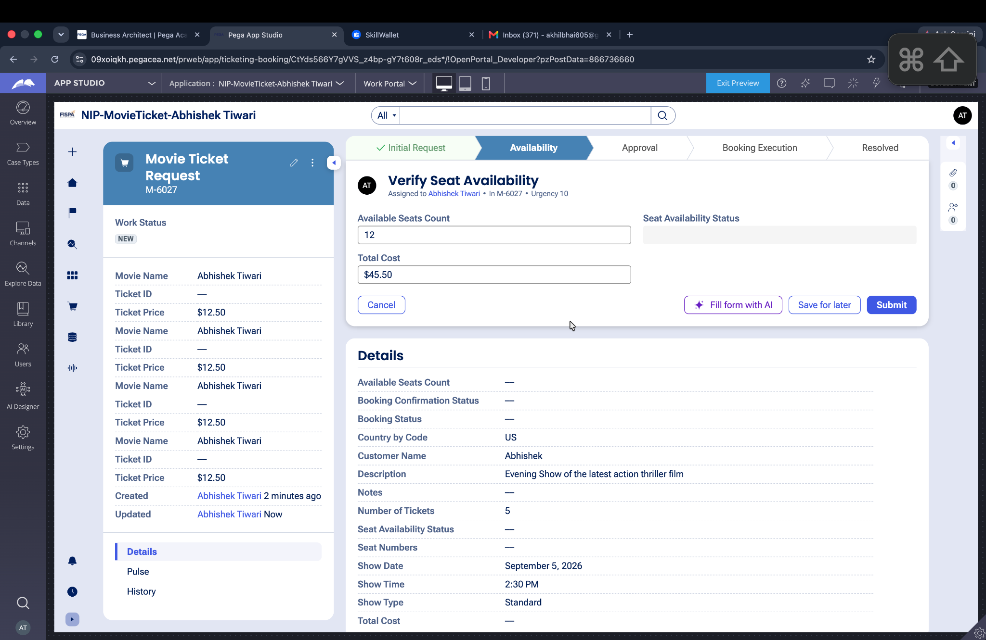

What I built for this (1–2 lines in your own words):
I created the Vehicle Service Request intake flow to capture the vehicle details and issue description. The request is validated before moving to the inspection stage.

US-002 — Perform Vehicle Inspection
What is expected:
Inspection stage with Service Advisor step. Inspection Notes and Condition Rating captured.
Screenshot — paste your screenshot below this line:
[ Paste screenshot here - follow the screenshot rules above ]



What I built for this (1–2 lines in your own words):
I configured the Inspection stage for the Service Advisor to inspect the vehicle and record inspection notes and condition details before generating the estimate.

US-003 — Generate Service Estimate
What is expected:
Labor Cost and Parts Cost captured. Total Cost calculated automatically by declare expression.
Screenshot — paste your screenshot below this line:
[ Paste screenshot here - follow the screenshot rules above ]

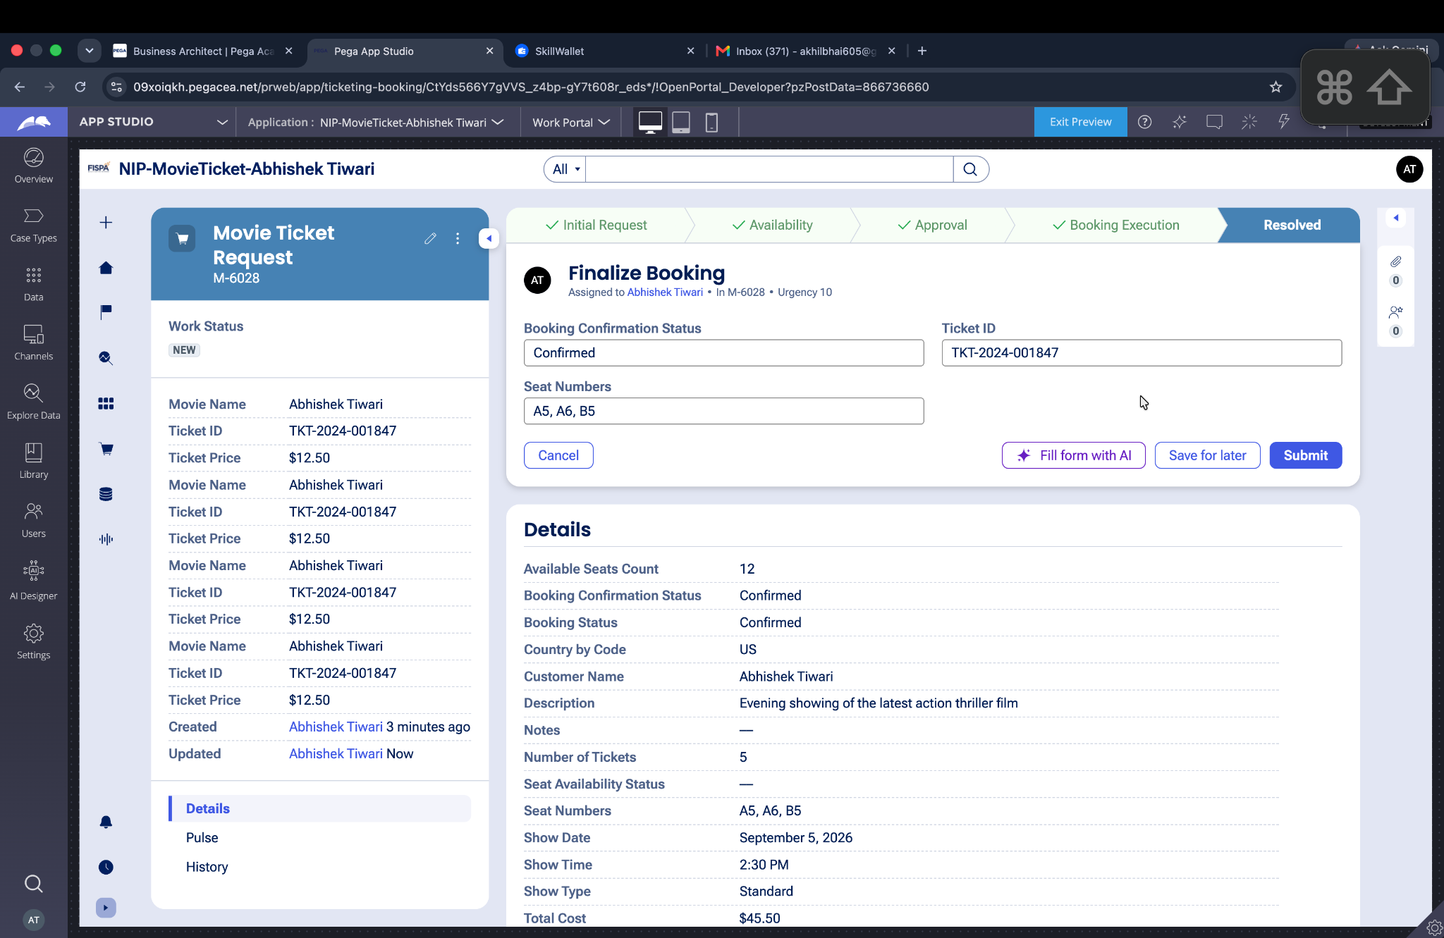

What I built for this (1–2 lines in your own words):
I configured the estimate process to capture Labor Cost and Parts Cost and calculate the Total Cost automatically for the service request.

US-004 — Approve Service Estimate
What is expected:
Approval stage assigned to Customer. Approval Status captured. Flow branches on approve/reject.
Screenshot — paste your screenshot below this line:
[ Paste screenshot here - follow the screenshot rules above ]

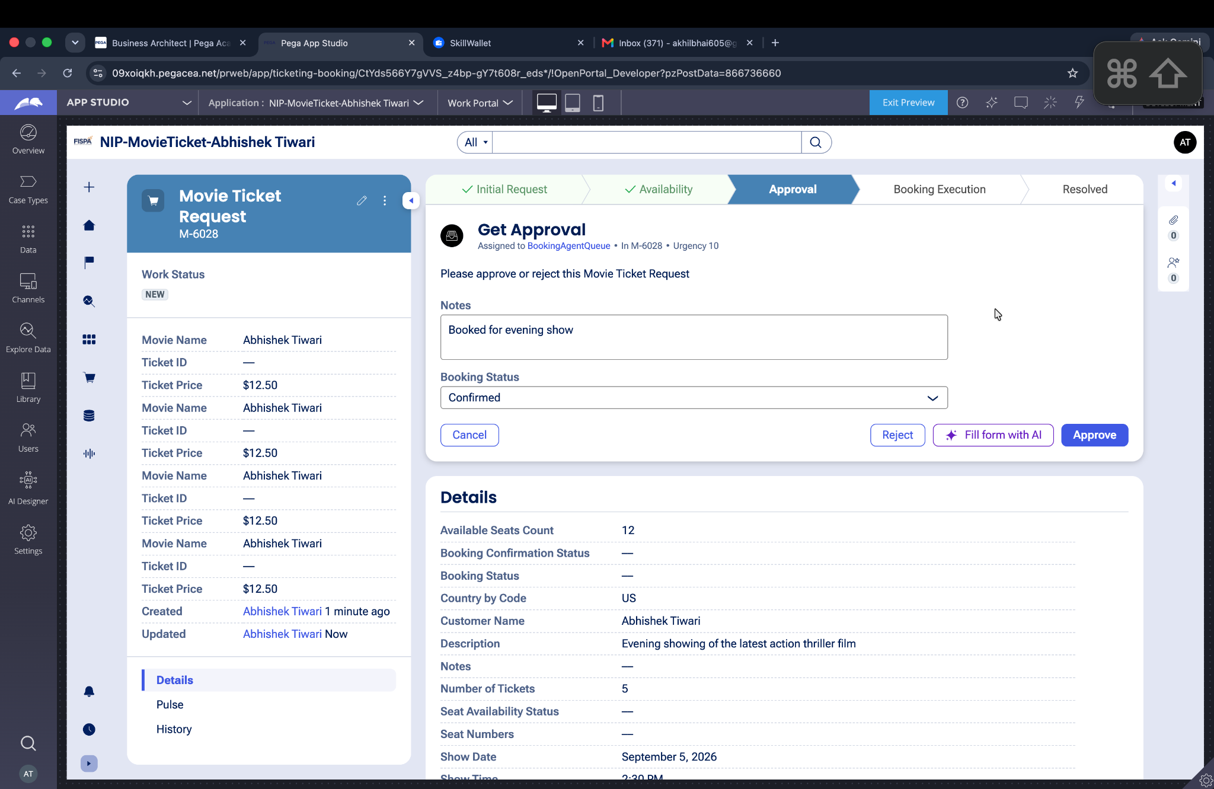

What I built for this (1–2 lines in your own words):
I configured the Customer Approval stage where the customer reviews the estimate and records an approval or rejection decision.

US-005 — Maintain Vehicle Data
What is expected:
Reusable Vehicle data object created with Vehicle ID, Model, Type — linked to case.
Screenshot — paste your screenshot below this line:
[ Paste screenshot here - follow the screenshot rules above ]

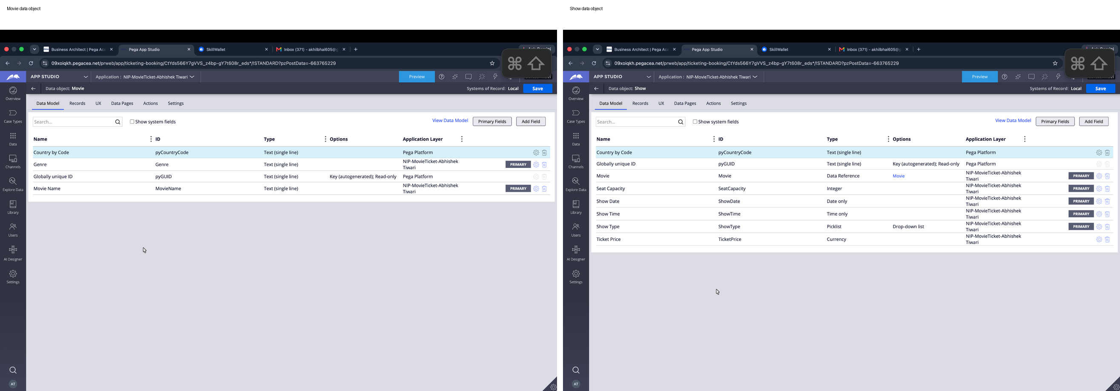

What I built for this (1–2 lines in your own words):
I created the reusable Vehicle data object and linked it with the service request so vehicle information can be maintained and reused throughout the case.

US-006 — Review Service Estimate
What is expected:
Approval screen shows Labor Cost, Parts Cost and Total Cost clearly to the Customer persona.
Screenshot — paste your screenshot below this line:
[ Paste screenshot here - follow the screenshot rules above ]

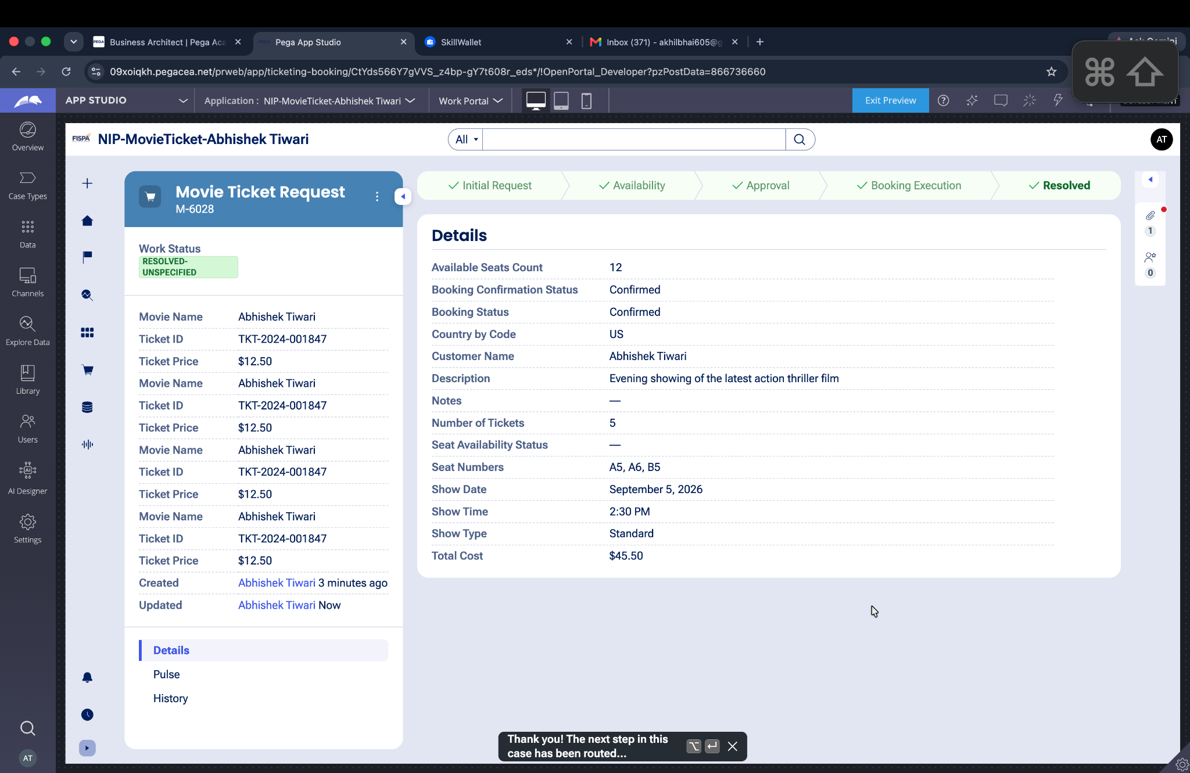

What I built for this (1–2 lines in your own words):
I configured the estimate review screen to clearly display Labor Cost, Parts Cost, and Total Cost to the customer before approval.

US-007 — Auto Assign Technician
What is expected:
Service Execution stage with routing to HeavyVehicleQueue or LightVehicleQueue. Assigned Technician and Service Status properties maintained.
Screenshot — paste your screenshot below this line:
[ Paste screenshot here - follow the screenshot rules above ]

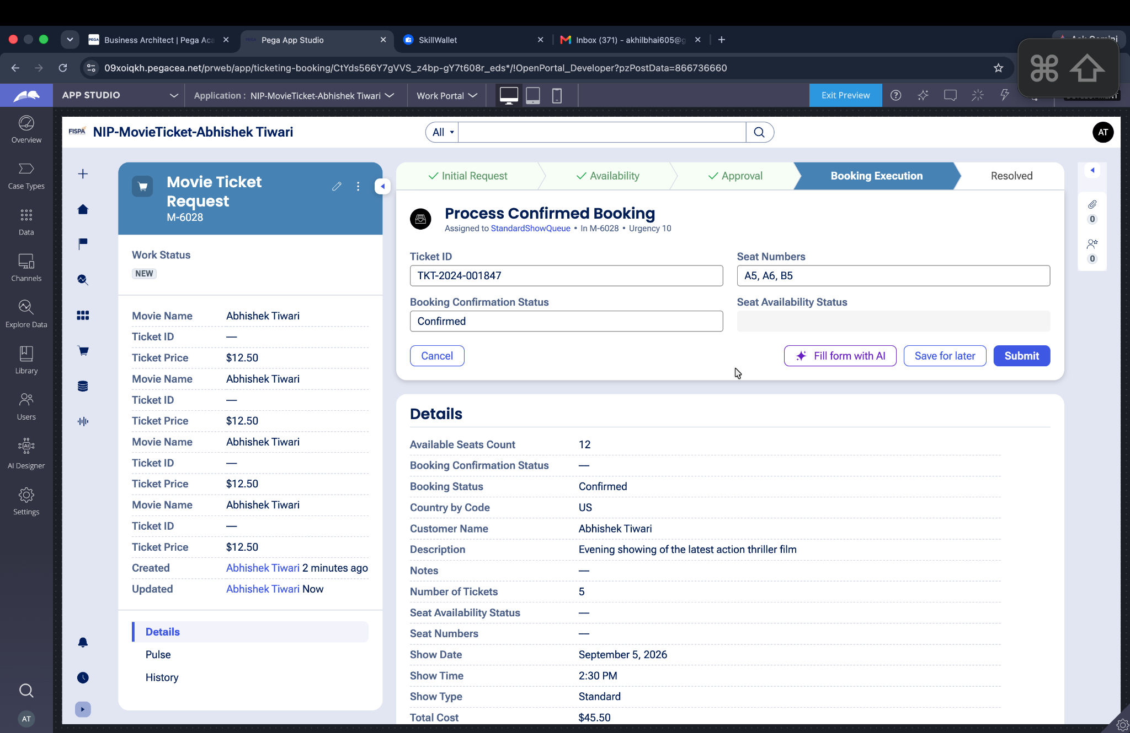

What I built for this (1–2 lines in your own words):
I configured the Service Execution stage to assign the service work to the appropriate technician and maintain the technician assignment and service status.

US-008 — Notify Service Completion
What is expected:
Correspondence rule created and triggered on case resolution. Email includes case and vehicle details.
Screenshot — paste your screenshot below this line:
[ Paste screenshot here - follow the screenshot rules above ]

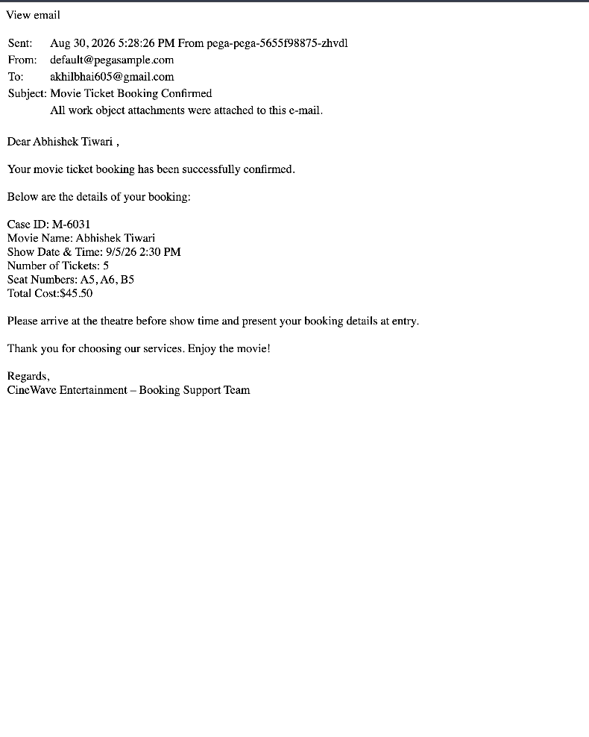

What I built for this (1–2 lines in your own words):
I configured a service completion notification so the customer can receive an update when the vehicle service request is completed.

US-009 — Define Service SLA
What is expected:
SLA configured on the case type. Goal: 2 days. Deadline: 3 days. Priority increases on breach.
Screenshot — paste your screenshot below this line:
[ Paste screenshot here - follow the screenshot rules above ]

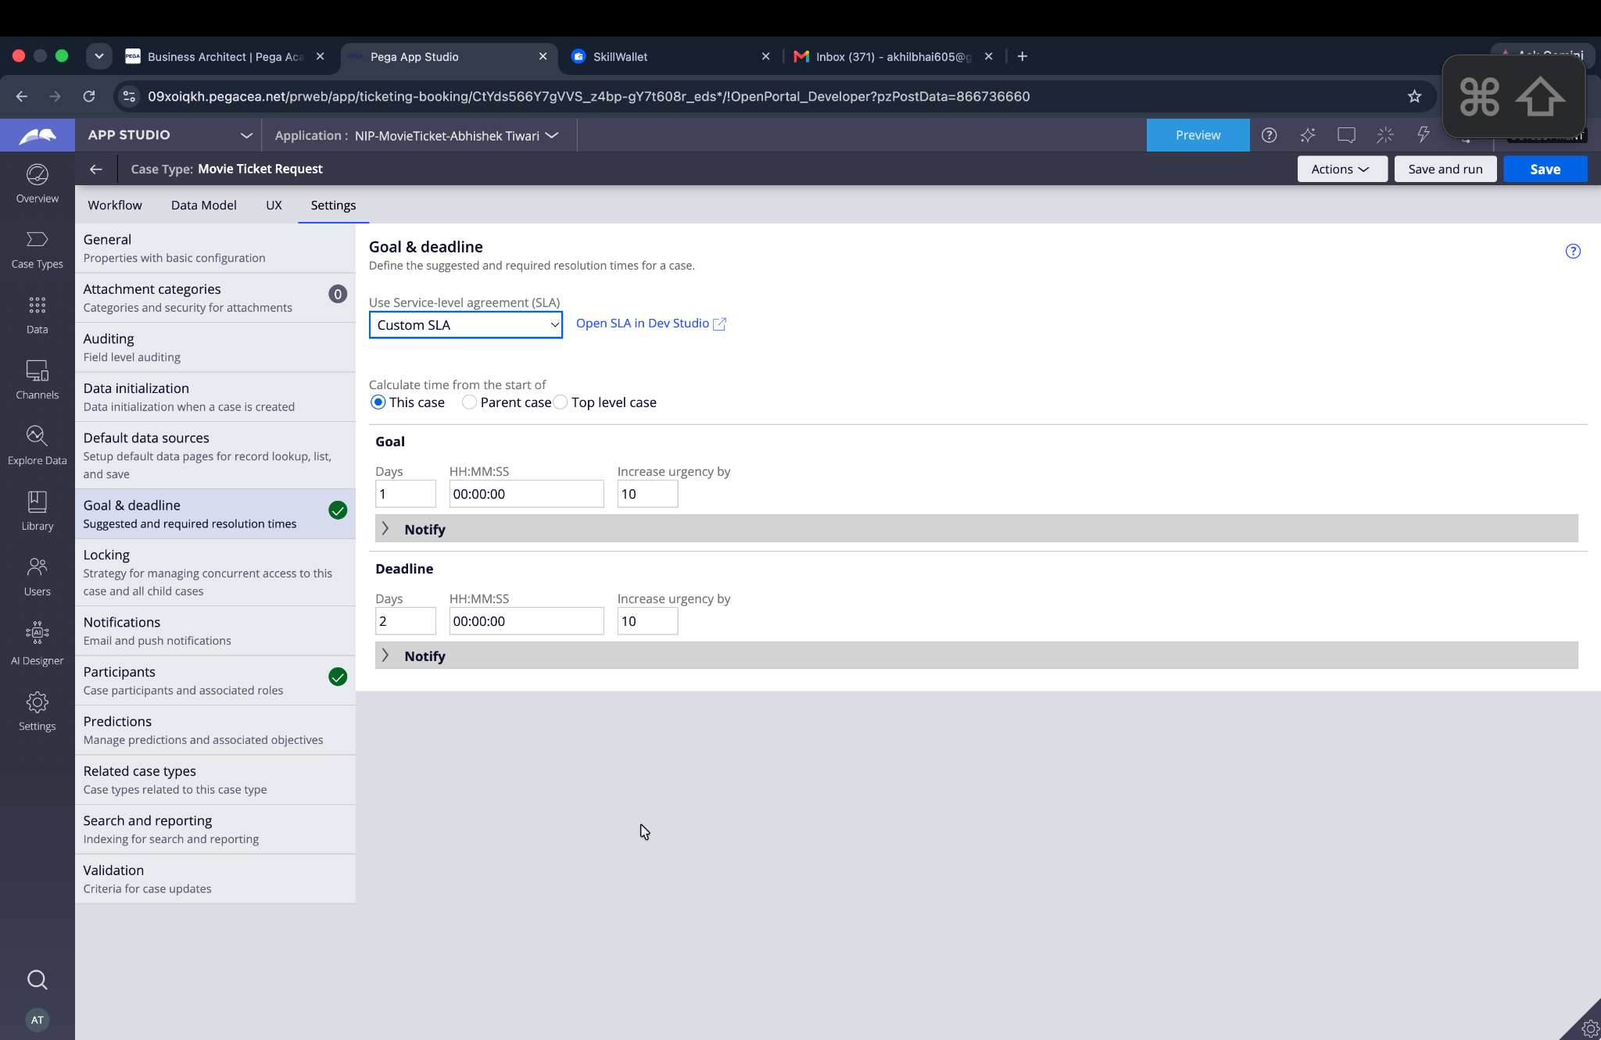

What I built for this (1–2 lines in your own words):
I configured an SLA for the Vehicle Service Request with a 2-day goal and 3-day deadline to track timely service completion.

US-010 — Route by Vehicle Type
What is expected:
Routing rule or Decision Table routes to HeavyVehicleQueue or LightVehicleQueue based on Vehicle Type property.
Screenshot — paste your screenshot below this line:
[ Paste screenshot here - follow the screenshot rules above ]

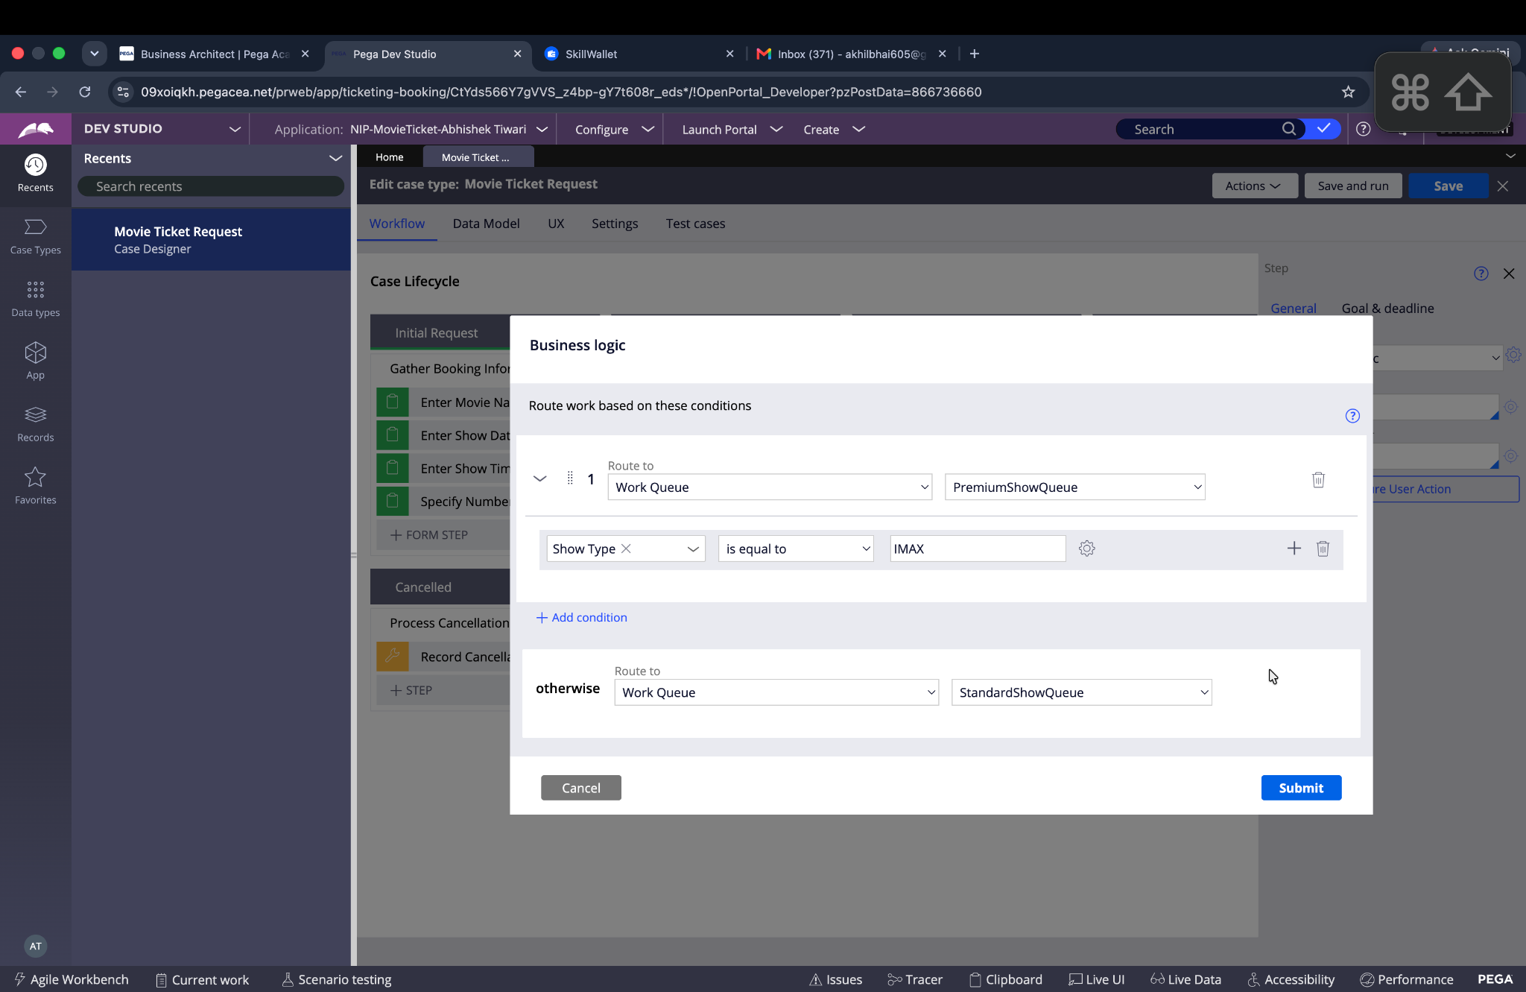

What I built for this (1–2 lines in your own words):
I configured vehicle-type-based routing so heavy vehicles can be handled by HeavyVehicleQueue and other vehicles by LightVehicleQueue.

Section 3 — About Your Application
These answers are checked against your screenshots. Write exactly what is in your application.

Q1. List your stages in the order they appear in your case lifecycle.
Stage names in order, separated by commas.
Request Intake, Inspection, Customer Approval, Service Execution, Completion

Q2. Name the data object(s) you created and the properties inside them.
Data object name and its properties.
Customer — customer information and contact details.
Vehicle — Vehicle ID, Vehicle Model, Vehicle Type and vehicle-related details.
Service Request — Service Request Title, Service Request Type, Vehicle, Customer, Service Appointment, Service Advisor Inspection Status and Service Estimate.
Service Estimate — Labor Cost, Parts Cost and Total Cost.
Service Appointment — appointment details for vehicle inspection/service.
Service Technician — technician assignment and service-related details.
Service Notification — notification details related to service updates and completion.

Q3. What is the exact name and type of the rule you used to calculate Total Cost?
Provide:
• Rule Name
• Rule Type
• Properties used in the calculation
• Formula used
Rule Name: Calculate Total Cost
Rule Type: Declare Expression
Properties used: Labor Cost, Parts Cost, Total Cost
Formula: Total Cost = Labor Cost + Parts Cost

Section 4 — Your Understanding
Short, honest and specific answers score well.

Q4. What did Blueprint generate for you, and what did you add or change yourself afterwards?
Be specific about what was already there and what you built or modified on top.
Blueprint generated the initial Vehicle Service Management application structure, including the case types, stages, steps, data objects, personas, channels and initial business rules. Afterwards, I configured the application for my project, created the operator, reviewed the generated workflow, configured the required case data and routing, and set up the rules needed for estimate calculation, approval, technician assignment, notifications and SLA handling.

Q5. Was there anything Blueprint created that you had to correct or configure further? Describe one example.
A real example from your own work.
Yes. Some Blueprint-generated decision tables showed warnings because the number of columns in one or more rows did not match the table headers. I reviewed these generated rules and checked the application configuration so that the required routing and decision logic could be configured correctly.

Q6. Explain your case flow from creation to resolution, in order.
What happens first, who does what, when the case closes.
The case starts when the Customer submits a vehicle service request with the vehicle and issue details. During Request Intake, the service data is collected and the intake is confirmed. The case then moves to Inspection, where a Service Advisor is assigned, the vehicle is inspected and a service estimate is generated. In Customer Approval, the customer reviews the estimate and approves or rejects it. If approved, the case moves to Service Execution, where a Technician is assigned based on vehicle type, the vehicle is serviced and the SLA is tracked. Finally, the Completion stage confirms the service, generates the report and notifies the customer before the case is resolved.

Q7. Pick two design choices you made in your application and explain why you made them.
For each design choice, provide:
• What you implemented
• Why you chose that approach
• What benefit it provides to the application
What I implemented: I used separate HeavyVehicleQueue and LightVehicleQueue work queues for technician routing.
Why: Different vehicle types can require different technicians and service handling.
Benefit: It automatically sends the service work to the appropriate queue and makes technician assignment more organized.

What I implemented: I used a separate Service Estimate data object with Labor Cost, Parts Cost and Total Cost.
Why: Estimate information is an important part of the approval process and should be maintained separately from the basic service request information.
Benefit: It keeps the case data organized and allows Total Cost to be calculated automatically before customer approval.

Q8. What was the hardest part, and how exactly did you fix it?
Specific and honest. A real challenge scores much better than a generic answer.
The hardest part was configuring the generated application correctly after Blueprint creation, especially understanding the generated rules and routing configuration. I used the application workflow and Data & Integrations screens to verify the generated objects, reviewed the warnings, and configured the required operator, case data, routing and business rules step by step instead of changing the generated application structure unnecessarily.

Q9. If the approval step was only needed when Total Cost is above a certain amount, what would you change in your application?
Explain what you would change and where. You do not need to build this.
I would add a conditional decision before the Customer Approval stage based on the Total Cost property. If Total Cost is above the defined threshold, the case would continue to Customer Approval. If Total Cost is at or below the threshold, the approval stage would be skipped and the case would proceed directly to Service Execution. This condition could be implemented using a Decision Table or When rule in the case workflow.

Q10. List three exact rule names from your application that you personally created or modified.
Include the rule name and rule type for each one (for example: CalculateTotalCost - Declare Expression).
Customer Decision — Decision Table
Identify SLA Type — Decision Table
Approve Estimate — Decision Table
Q11. List all personas used in your application.
List the persona names exactly as they appear in your application.
Customer, Service Advisor, Technician, Fleet Manager, System Administrator, Notification Recipient, Application Control Agent
Q12. List all work queues used in your application and explain when each one is used.
For each work queue, provide its exact name and the condition or type of work routed to it.
HeavyVehicleQueue — Used when a service request is for a heavy vehicle and the work needs to be routed to the appropriate technician queue.
LightVehicleQueue — Used when a service request is for a light vehicle and the work needs to be routed to the appropriate technician queue.
Before You Submit — Check These
Read through once before uploading.
1. Section 1 filled in. Application named as NIP-[Project]-[YourName]. Names match the actual application.
2. New Operator created in Pega with my full name. I logged in as that operator for all screenshots.
3. Only my chosen project section remains — the other project section is deleted.
4. All 10 user story screenshots are pasted and follow the operator, running-case, application, and rule-name evidence requirements.
5. Every question in Sections 3 and 4, including Q10, Q11, and Q12, is answered in my own words.
6. This file is named using the required format: ProjectName_FirstName_LastName.docx (for example, VehicleService_Ravi_Kumar.docx or MovieTicket_Ravi_Kumar.docx) and uploaded as required.

