Start :

Step 1 : Start XAMPP (Meet@123)

Step 2 : Open CMD (win+R then type cmd and enter)

Step 3 : Run = cd C:/Meet/Btech_ICT/4th Sem/DE-1-B/T_B_F

Step 4 : Run = node server/server.js

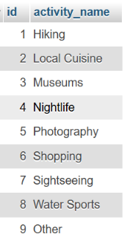Database :  
  
1.activities



2.completed_trip

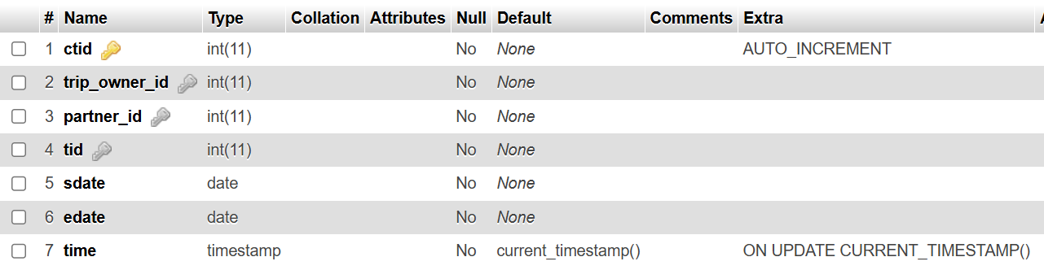

3.completed_trip_traveller

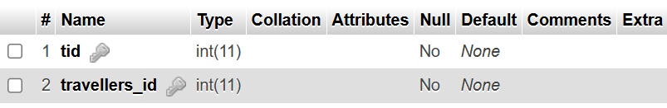

4.connections

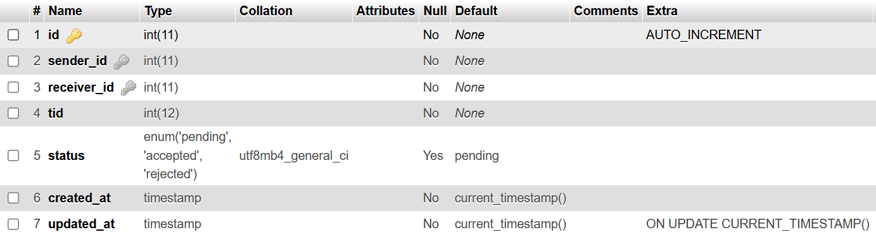

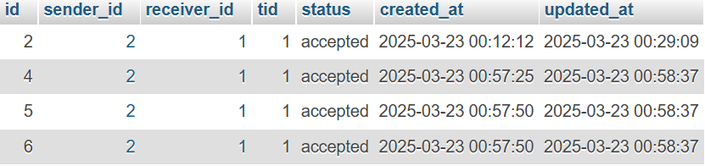

5.feedback

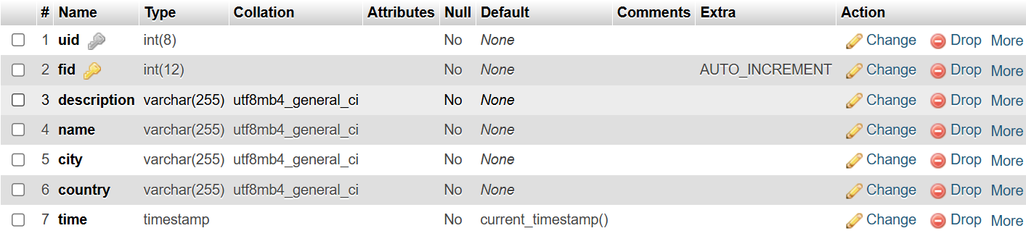

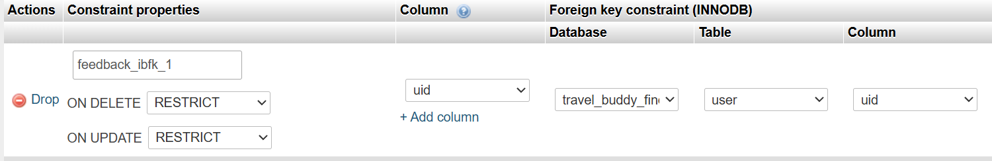

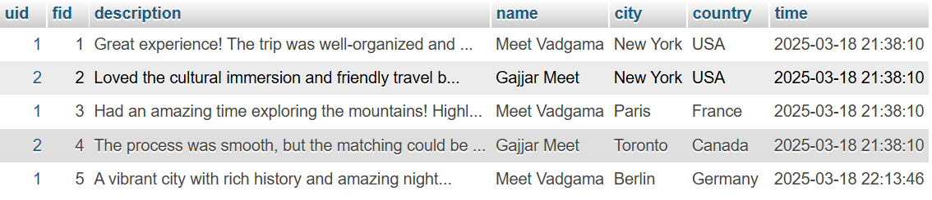

6.Identity_verification

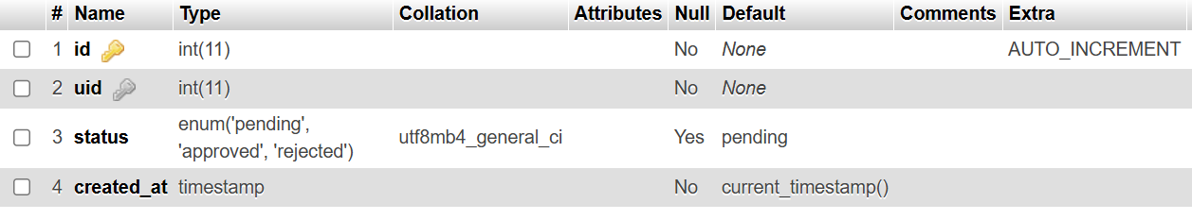

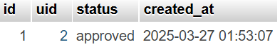

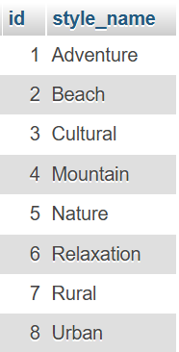7.travel_styles



8.trip

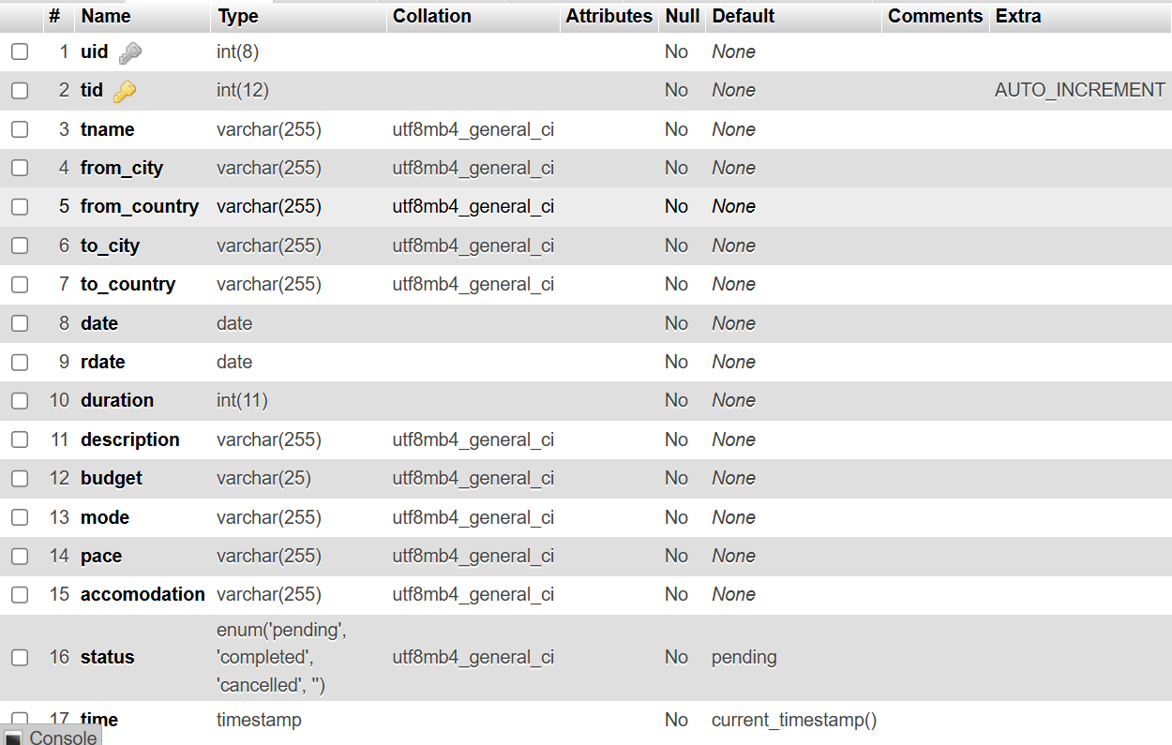

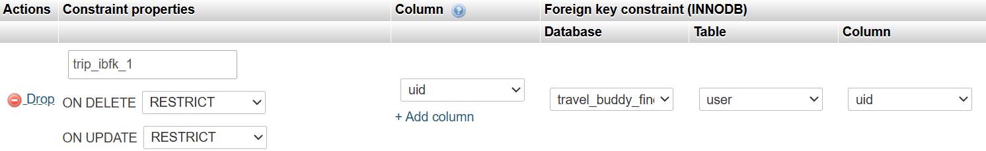

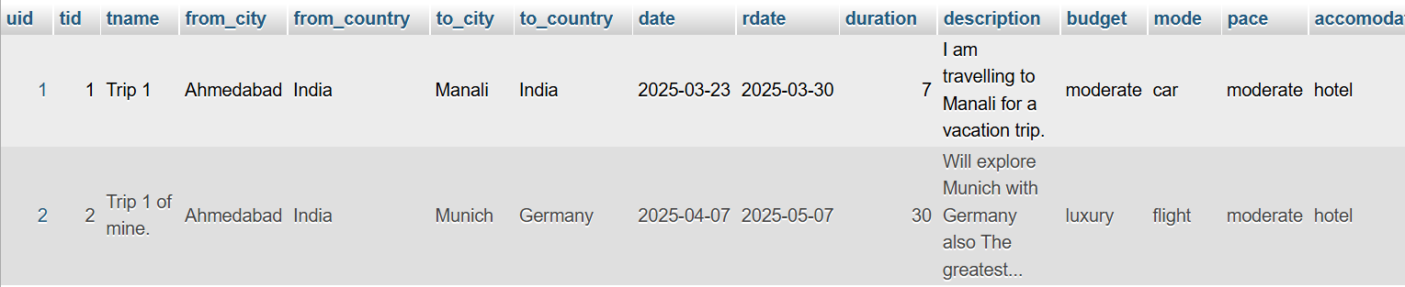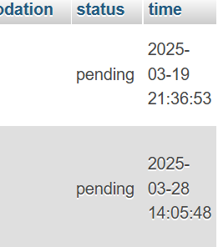

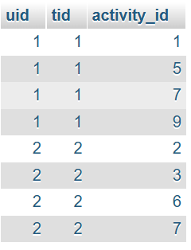9.trip_activities

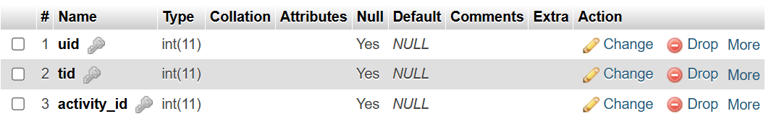

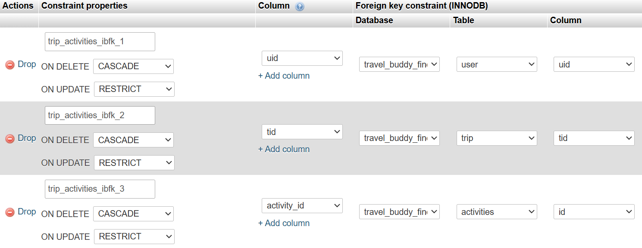

10.user

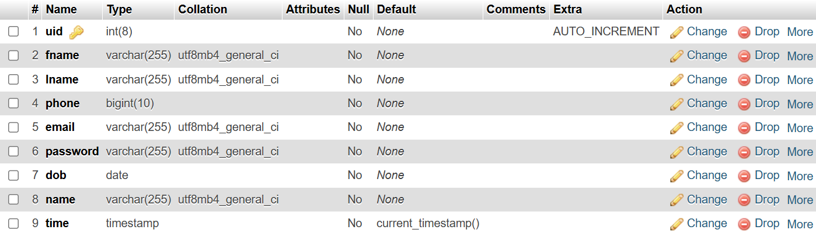

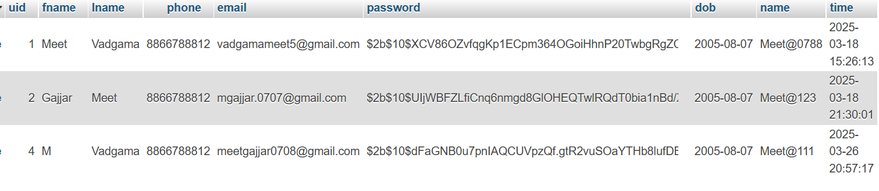

11.user_full_info

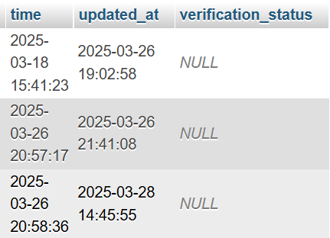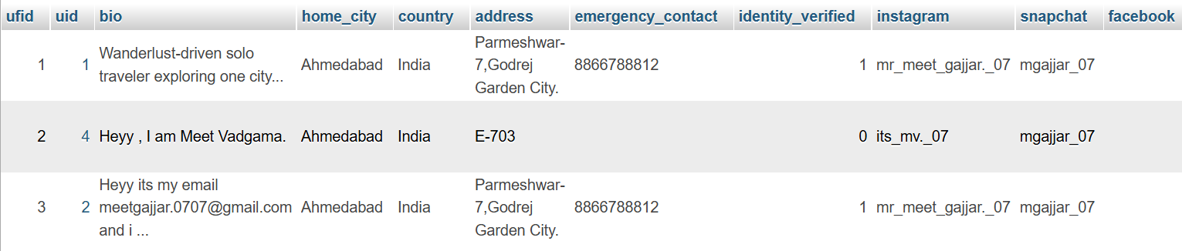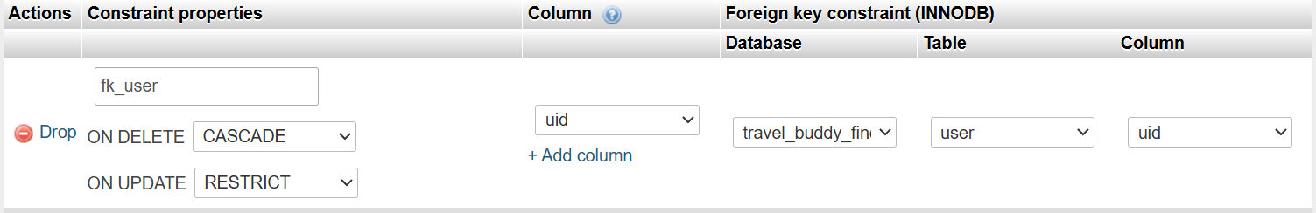

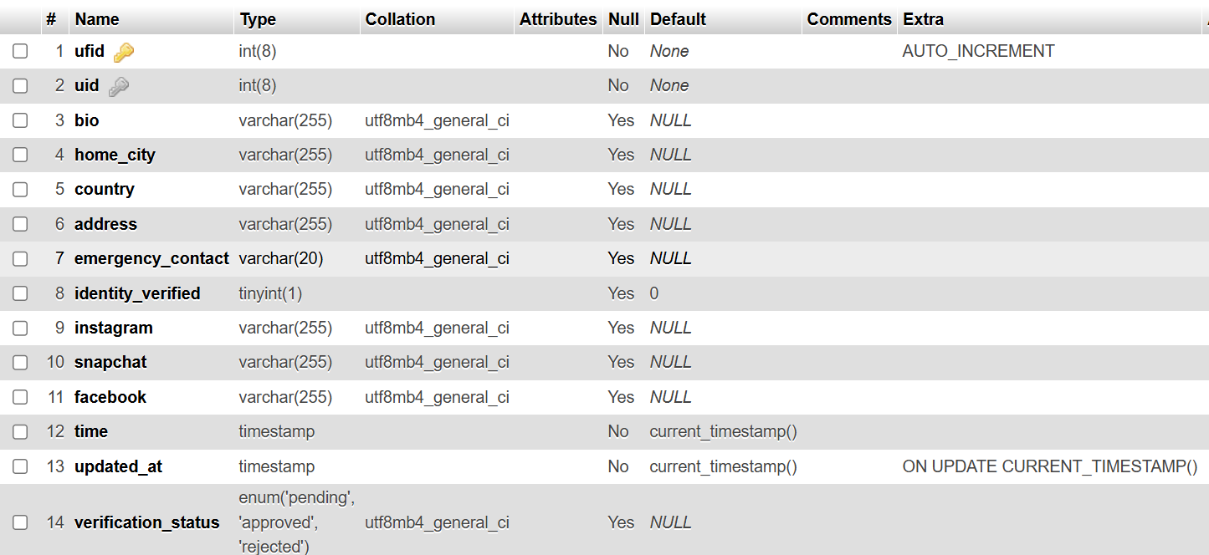

12.user_travel_styles

