Analysing purchasing behaviours using classification and clustering techniques

1. Introduction

The dataset used in this study is derived from the UCI Wholesale Customers Dataset, containing annual spending data for 440 customers across five product categories. The primary objective of this analysis is to segment customers based on their purchasing behaviour using unsupervised clustering techniques and evaluate the effectiveness of these methods in revealing natural groupings within the data.

The study applies both K-Means and Hierarchical Clustering algorithms, with performance evaluated using metrics such as the Silhouette Score and visualisation through PCA-based dimensionality reduction.

Additionally, a Support Vector Machine (SVM) model is implemented to predict the customers Region labels using their spending patterns, allowing a comparison between unsupervised segmentation and supervised classification approaches. The insights gained from this analysis can guide targeted marketing strategies, such as customer-specific promotions and improved resource allocation based on purchasing behaviour.

2. Exploratory Data Analysis (EDA)
Before applying clustering techniques, an exploratory analysis was conducted to understand the distribution, relationships, and potential anomalies in the dataset.

2.1 Dataset Overview
The dataset contains 440 customers and 7 columns that can broadly be divided into
- Five spending features (Fresh, Milk, Grocery, Frozen, Detergents_Paper)
- Two categorical labels (Channel and Region) with nominal numerical values

2.2 Missing or Duplicate values
There are no missing values or duplicates in the dataset

2.2 Summary Statistics
The spending features vary widely in scale. The distributions of most spending features are right-skewed, indicating the presence of high-spending customers.

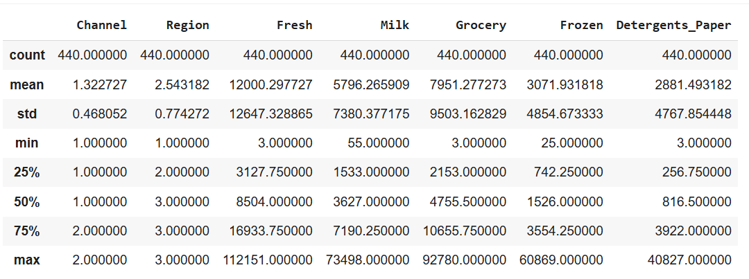

2.3 Distribution Analysis

2.3.1 Count Plots
The distribution of nominal categorical variables (Channels and Region) was visualised using the count plots below.
- Channel 1 accounts for most customers (298 out of 440), while Channel 2 represents the remaining portion.
- Region 3 contains the highest number of customers (316), followed by Region 1 (77) and Region 2 (47).

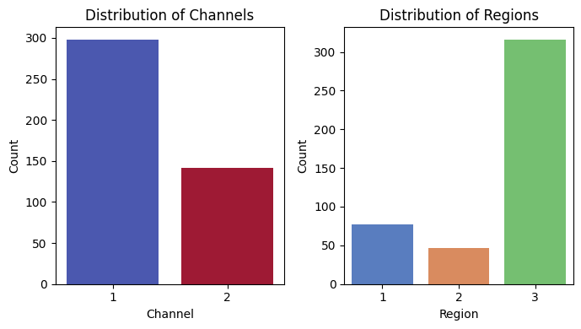

2.3.2 Box plots
Boxplots were generated for all numeric features to identify outliers and to understand the spread of data.
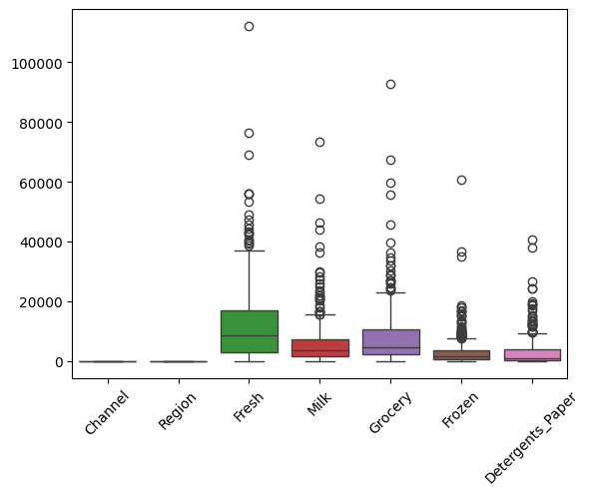

2.3.3 Pair plots
Pairplots were used to examine pairwise relationships between the spending features.

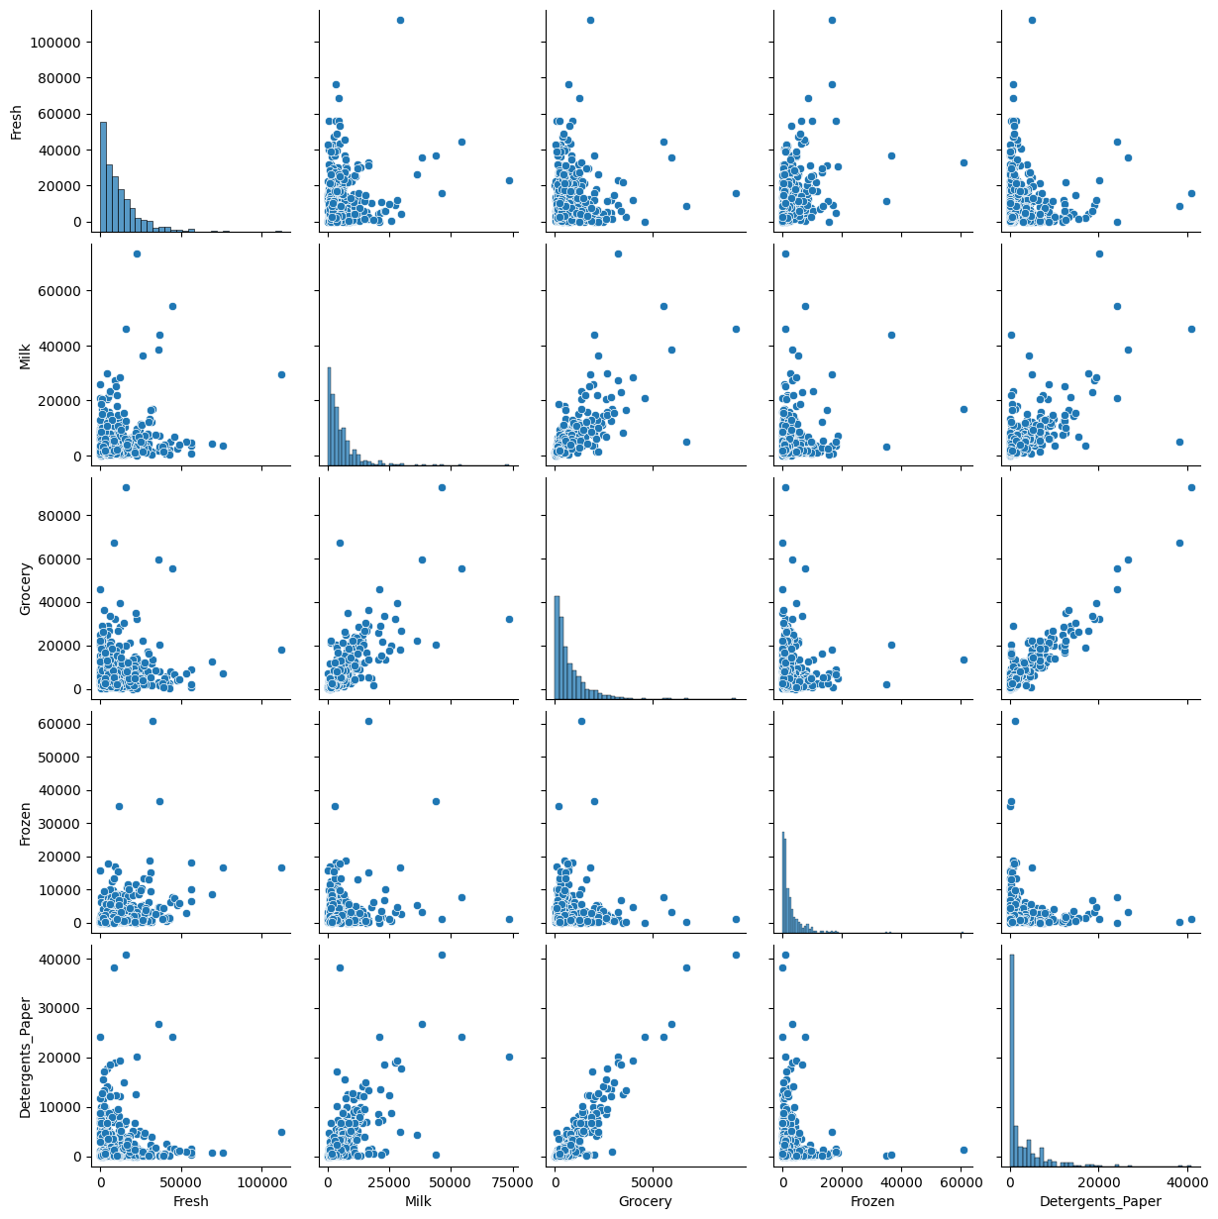

Strong correlations were observed between certain categories, such as Grocery and Milk, suggesting that some customers consistently purchase these products together.

2.4 Feature Relationship and Variance Analysis
To explore relationships among the five spending variables (Fresh, Milk, Grocery, Frozen, and Detergents_Paper) correlation and variance analyses were conducted. This helps identify potential redundancies in the features that might affect the performance of clustering.

2.4.1 Correlation Analysis
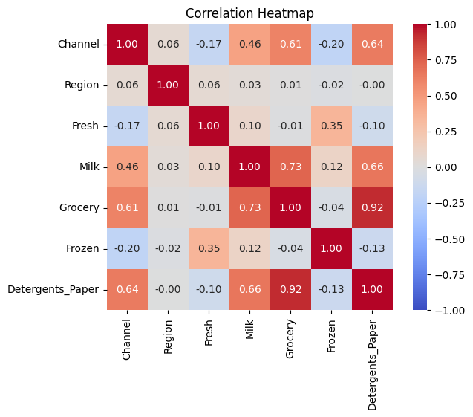
The analysis revealed two key behaviours
- Household/Retail Purchasers characterized by high spending on Grocery, Milk, and Detergents_Paper.
- Perishable/Food Service Buyers characterised by spending on Fresh and Frozen items.

The strongest correlation was observed between Grocery and Detergents_Paper (r = 0.92), indicating substantial redundancy. Retaining both these features could distort the cluster formation by over emphasizing this shared spending behaviour. Therefore, Detergents_Paper was removed to reduce multicollinearity.

2.4.2 Variance Analysis
The variance results show that Fresh has the highest dispersion (1.60 × 10⁸), followed by Grocery and Milk. This large difference in scale means that, without scaling, high-variance features like Fresh could dominate the clustering process.
The combination of high correlation and uneven variance among features underscored the importance of feature scaling and dimensionality reduction prior to clustering.

3. Data Preprocessing
To ensure effective and unbiased clustering, the dataset underwent several preprocessing steps including outlier removal, addressing multicollinearity, correcting skewness, and feature scaling. These steps ensure that all features contribute proportionally to distance-based clustering algorithms like K-Means and Hierarchical algorithms.

3.1 Outlier Detection and Removal
Since clustering algorithms like K-Means and Hierarchical clustering are sensitive to extreme values, outliers were identified using the Z-score method. Records with any feature exceeding a Z-score of +/-3 were removed.

Description | Count
Original dataset | 440
After outlier removal | 416

3.2 Feature Selection and Separation
The categorical attributes Channel and Region were excluded from clustering and retained only for post-analysis interpretation.
Based on the correlation analysis, Detergents_Paper (r = 0.92 with Grocery) was dropped to reduce redundancy.
The final features used for clustering were:
- Fresh
- Milk
- Grocery
- Frozen

3.2 Skewness Correction and Transformation
All four spending variables exhibited strong positive skewness (ranging from 1.36 to 2.11), indicating that most customers spent relatively small amounts while a few spent significantly more.

Feature | Skewness
Fresh | 1.36
Milk | 1.73
Grocery | 1.53
Frozen | 2.11
To normalize the data distribution and stabilize variance, a Yeo–Johnson transformation was applied. Post transformation, Kernel Density Estimation (KDE) plots confirmed that the features were more symmetric and suitable for clustering.
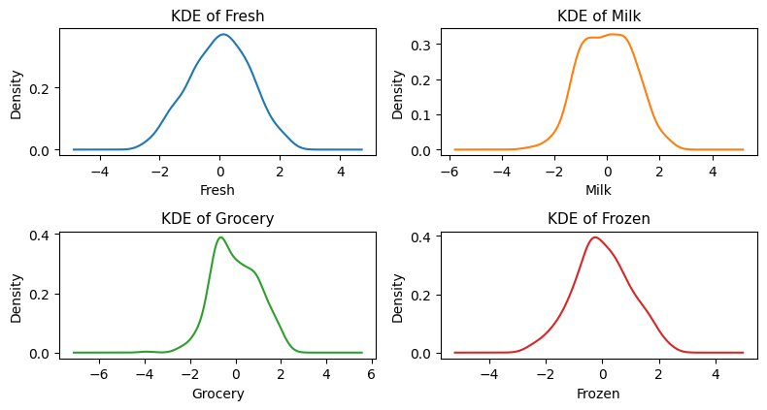

3.3 Feature Scaling
Because of varying magnitudes across spending categories, the transformed data were standardized using StandardScaler from scikit-learn. This centered all features around zero with unit variance, ensuring balanced contribution in distance-based algorithms.
After preprocessing, the final dataset used for clustering consisted of 416 observations and 4 standardized features, while Channel and Region were retained for cluster validation and business interpretation

4. K-Means Clustering

K-Means clustering was applied to the standardized dataset to segment customers based on their annual spending across four features (Fresh, Milk, Grocery, and Frozen). Since K-Means requires predefining the number of clusters (k), both the Elbow and Silhouette methods were used to determine the optimal number of clusters.

4.1 Determining the Optimal Number of Clusters

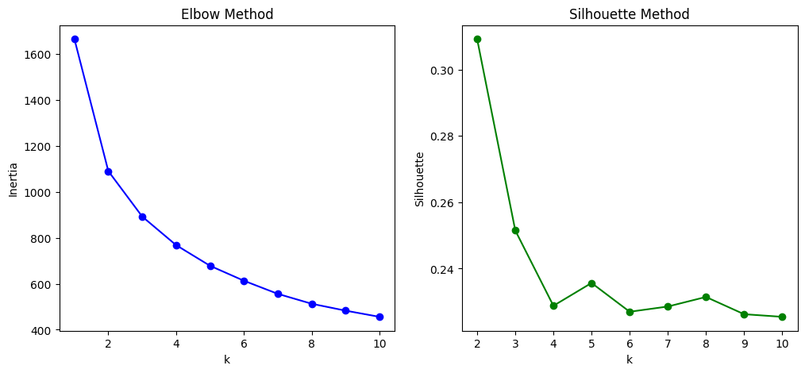

The Elbow Method shows a clear inflection point at k = 2, where the inertia begins to flatten. Similarly, the Silhouette Score peaks at 0.31 for k = 2, which indicates well-separated and compact clusters.

Together, these methods consistently suggest that two clusters best capture the structure of customer spending behaviour.

4.2 Model Training and PCA Visualisation
The K-Means algorithm was then fitted with k = 2 using n_init = 20 and a fixed random seed for reproducibility. The resulting clusters were visualized in 2D and 3D PCA plots.

4.2.1 2D/3D PCA Cluster Visualization and Interpretation
The 2D PCA plot visualizes the two customer clusters identified by the K-Means algorithm after dimensionality reduction.
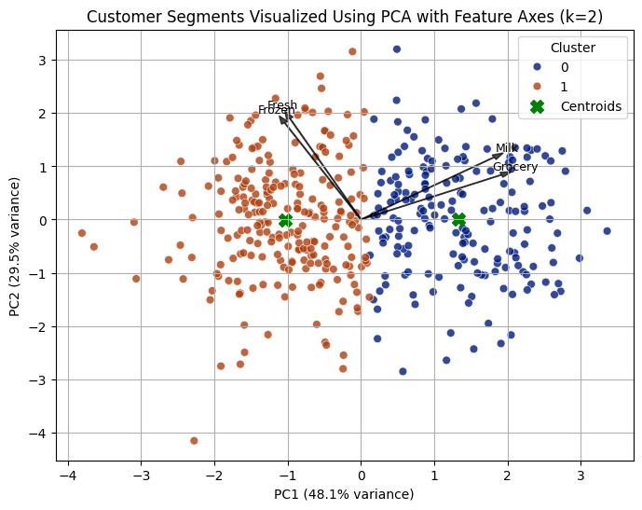
The first two principal components (PC1 and PC2) explain 78% of the total variance, meaning they capture most of the variability in customer spending behaviour across the four features (Fresh, Milk, Grocery, and Frozen).

Each point in the plot represents a customer, colour-coded according to its assigned cluster:
- Cluster 0 (orange) concentrated on the left side aligned with the Fresh and Frozen feature directions.
- Cluster 1 (blue) positioned on the right side oriented towards the Milk and Grocery axes.
- The green “X” markers indicate the centroids, representing the mean position of each cluster in the reduced feature space.

The visual separation along the PC1 axis suggests that this principal component effectively differentiates customers based on spending preferences particularly the high spending Fresh and Frozen items (cluster 0) versus high spending on Milk and Grocery products(cluster1).

The relatively compact and distinct grouping around each centroid confirms that the two-cluster structure is meaningful and well-separated. This supports the silhouette score (0.31) that indicated moderate but interpretable cluster cohesion and separation.

The 3D PCA visualizations, explaining 94% of total variance, reinforces these findings. Together, they confirm that the two-cluster solution effectively captures distinct customer spending patterns, consistent with the chosen k = 2.

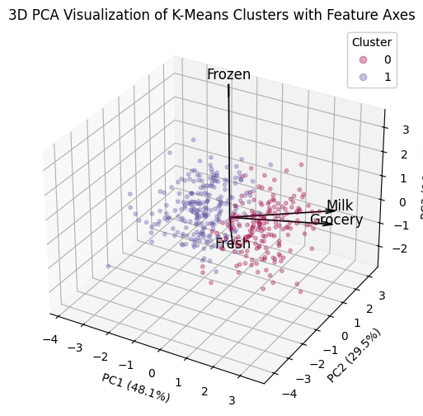

4.3 Cluster Composition and Profiling

4.3.1 Cluster Composition by Channel and Region

Cluster composition analysis reveals that Channel is a stronger differentiator than Region. Cluster 0 is dominated by Channel 2 (Retail) customers, while Cluster 1 mainly consists of Channel 1 (Hospitality) clients.
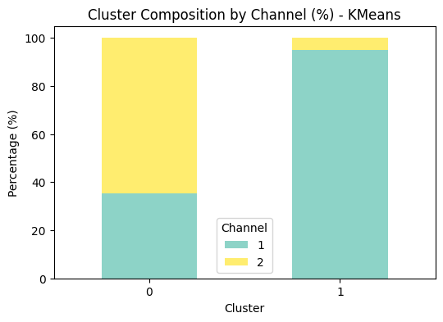

In contrast, Region 3 is predominant in both clusters, suggesting consistent geographic distribution.

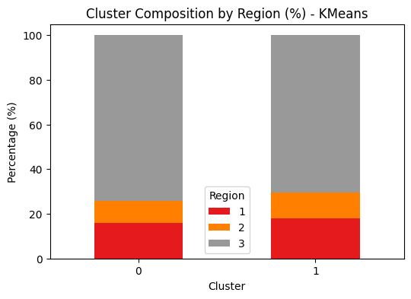

4.3.2 Customer Spending Profile
The average spending across product categories for each K-Means cluster is shown below. Although Detergents_Paper was excluded from clustering due to multicollinearity, it was retained for post-clustering analysis to provide a complete view of spending behaviour.
Cluster | Fresh | Milk | Grocery | Frozen | Detergents_Paper | Profile
0 | 7,334 | 8,292 | 11,839 | 1,390 | 4,670 | High in Grocery-related items -retail/household customers.
1 | 13,537 | 2,171 | 2,934 | 3,489 | 574 | Focus on Fresh (perishable items) -restaurants and hospitality.

4.3.3 Cluster Visualisation and Comparison
Three visualization techniques were used to interpret and compare the K-Means clusters (k = 2).
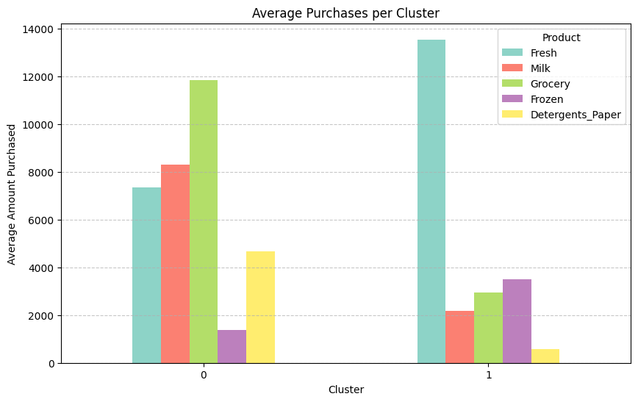
The bar chart shows absolute average spending per category, revealing that Cluster 0 spends heavily on Grocery, followed by Milk and Fresh, while Cluster 1 prioritizes Fresh items.
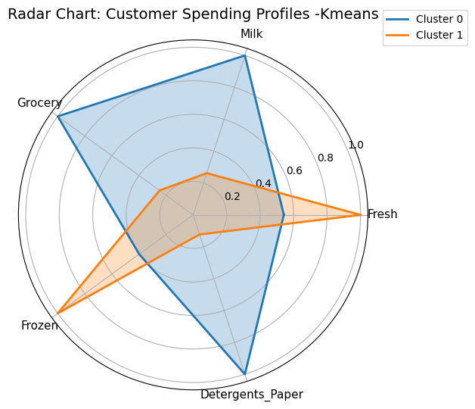
The radar chart normalizes these values to highlight proportional differences, showing Cluster 0’s broad retail-oriented spending versus Cluster 1’s focus on perishable goods.
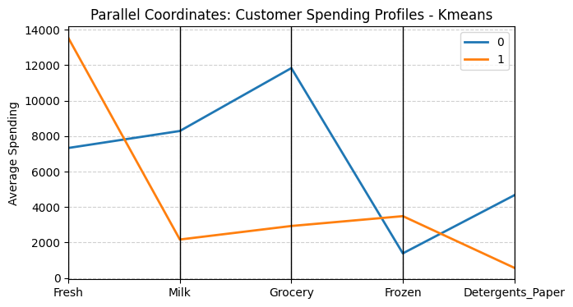

The parallel coordinates plot visualizes both clusters spending trends across all features simultaneously, clearly showing opposing peaks, Cluster 0 in Grocery-related items and Cluster 1 in Fresh categories.

Overall, K-Means identified two distinct and interpretable customer segments:
- Cluster 0: Retail-focused, high spenders on household items.
- Cluster 1: Fresh-produce oriented businesses such as restaurants or cafe.
These consistent patterns across visualizations confirm the stability and interpretability of the clustering results.

5. Hierarchical Clustering
Hierarchical clustering was applied to the same scaled dataset to compare results with the K-Means segmentation. Unlike K-Means, hierarchical clustering builds a nested tree structure (dendrogram) by successively merging the most similar observations based on distance metrics.

5.1 Linkage Method Evaluation
Different linkage methods were tested to determine the most suitable clustering approach. The Ward linkage method, which minimizes the variance within clusters at each merging step, produced the highest silhouette score.

Linkage Method | Silhouette Score
Ward | 0.280
Complete | 0.179
Average | 0.200

Therefore, Ward linkage was selected as the optimal method for hierarchical clustering as it indicated the best balance between compactness and separation.

5.2 Dendrogram and Cluster Selection
A dendrogram was generated to visualize the progressive merging of clusters. The largest vertical gap in the dendrogram suggested a natural division into two clusters, consistent with the K-Means result.

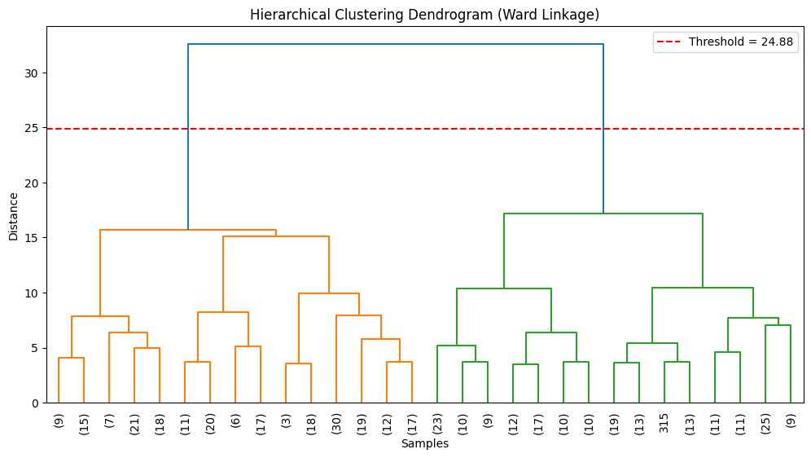

5.3 Cluster Visualization
The hierarchical clustering output were projected into 2D and 3D PCA plots for better interpretability.
The 2D PCA visualization reveals two distinct groups with limited overlap, confirming that the hierarchical model effectively separated customers based on their spending patterns. The feature axes show that:
- The Fresh and Frozen features align closely with one principal component, representing perishable spending behaviour.
- The Milk and Grocery axes contribute mainly to the other component, representing non-perishable and packaged goods spending.
This directional separation highlights that customers differ primarily along these two dimensions i.e. fresh versus grocery-oriented purchasing tendencies.
The 3D PCA visualization, which together explains approximately 94% of total variance, provides an even clearer depiction of the cluster boundaries in three-dimensional space. Cluster 0 is generally positioned along the Fresh/Frozen axes, while Cluster 1 extends along the Milk/Grocery axes, illustrating how each segment aligns with distinct business types, hospitality (perishables) versus retail (packaged goods).
Overall, both 2D and 3D PCA projections confirm that hierarchical clustering with Ward linkage successfully identifies meaningful and interpretable customer segments based on spending characteristics.
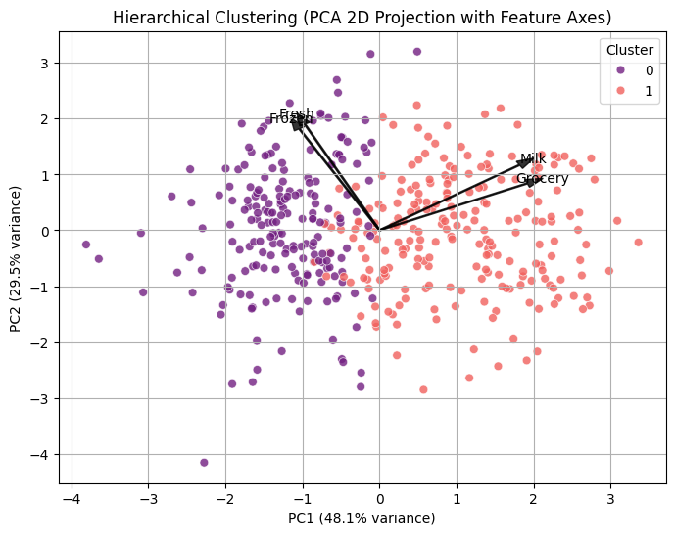
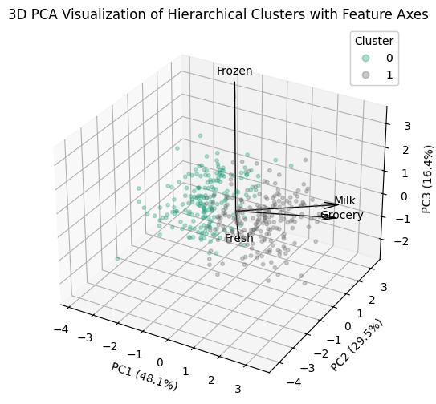

5.4 Cluster Composition and Customer Profiling
After identifying two clusters using the Hierarchical clustering, their compositions were analysed with respect to Channel and Region attributes, followed by an examination of spending characteristics across the five product categories.

5.4.1 Cluster Composition by Channel and Region
The analysis indicates that channel appears to be a strong differentiator between clusters, while regional distribution remains even.

Channel Distribution
Cluster 0 is mostly composed of Channel 1 customers (96%), indicating that this group primarily represents food service businesses such as restaurants, cafe and hotels.
Cluster 1 shows a more balanced distribution, with a slight dominance of Channel 2 (Retail) customers (55%), suggesting that this cluster mainly represents retail or household consumers who purchase packaged goods more frequently.
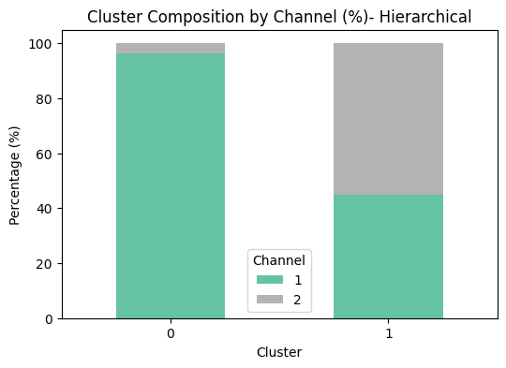

Region Distribution
Both clusters are heavily concentrated in Region 3, which contributes most customers overall. This suggests that this region may be the company’s key market area.
Cluster 0 maintains a slightly higher proportion of customers from Regions 1 and 2, consistent with its broader distribution of hospitality clients across regions.
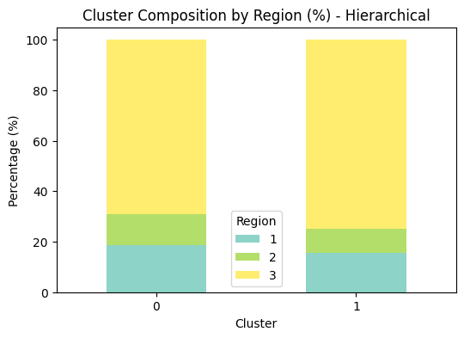

5.4.2 Customer Spending Profile
Cluster | Fresh | Milk | Grocery | Frozen | Detergents  _Paper | Profile
0 | 14,776 | 1,988 | 2,889 | 3,878 | 505 | Focus on perishable items restaurants and hospitality.
1 | 7,374 | 7,352 | 10,281 | 1,430 | 3,995 | High in grocery related items retail/household customers.

5.4.3 Cluster Visualisation and Comparison
To better interpret the customer segments produced by hierarchical clustering, the cluster centroids were visualised using multiple complementary plots.

Bar Chart
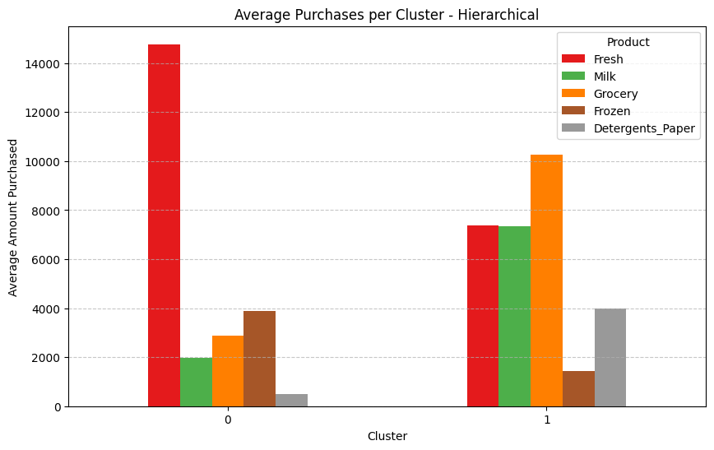
The bar chart clearly illustrates that Cluster 0 has the highest spending on Fresh products, while Cluster 1 spends substantially more on Grocery followed by Milk and Fresh. This pattern indicates that Cluster 0 represents hospitality clients (e.g., restaurants or cafe) focusing on perishable goods, whereas Cluster 1 represents retail or household consumers purchasing packaged and daily-use items.

Radar Chart
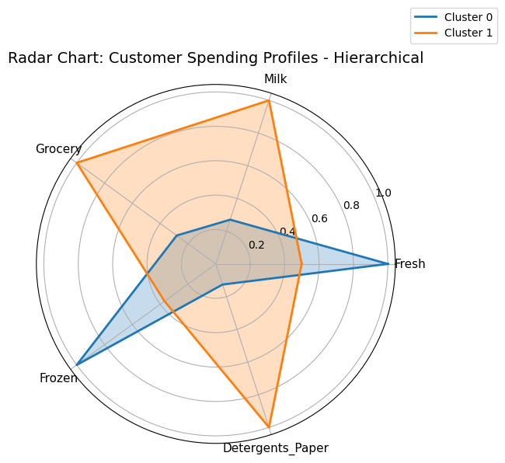
The radar chart highlights the relative contribution of each spending category within each cluster. The contrasting polygon shapes reveal distinct consumption profiles - Cluster 0 peaks in Fresh and Frozen spending, while Cluster 1 forms strong peaks for Milk and Grocery.

Parallel Coordinates Plot
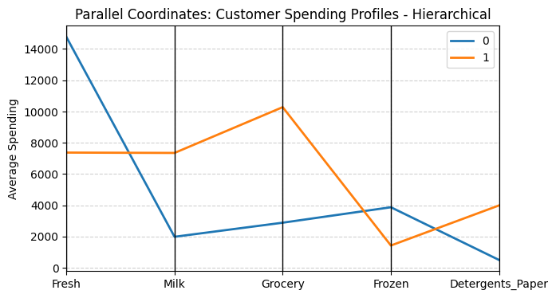
The parallel coordinates plot confirms these differences across all features simultaneously. The two lines cross at multiple points, emphasizing inverse spending trends between clusters, particularly between Fresh versus Grocery.

The alignment of Hierarchical and K-Means results strengthens confidence that the two discovered segments represent genuine behavioural patterns rather than algorithmic bias. In summary, both K-Means and Hierarchical clustering consistently identified two stable, well-separated customer groups, validating the robustness of the segmentation approach.

6. Comparison of KMeans and Hierarchical Clustering

6.1 Clustering Performance Evaluation
To quantitatively evaluate clustering quality, Silhouette Score was used as a primary metric for assessing cohesion and separation between clusters.
Method | Silhouette Score | Interpretation
K-Means (k=2) | 0.31 | Moderate cohesion and separation. Clusters are compact and well-formed.
Hierarchical (Ward linkage) | 0.28 | Slightly less separation but consistent cluster structure
The silhouette scores indicate that both algorithms capture a meaningful segmentation, with K-Means performing marginally better due to clearer distance-based optimization of cluster centroids, resulting in more clearly defined boundaries between customer groups.

6.2 Comparison of KMeans and Hierarchical
Both algorithms successfully identified two clear customer groups, but their performance and interpretability differed slightly in the experiment.

K-Means Clustering
Strengths
- Achieved a higher silhouette score (0.31), indicating stronger cluster separation and cohesion.
- Produced more compact and well-defined clusters
- Easily repeatable and tuneable by adjusting k and initialization parameters.
Weaknesses
- Requires pre-specifying the number of clusters (k) and the results depend on correct choice.
- Sensitive to initial centroid placement and outliers, which can distort boundaries.
- May perform poorly on non-spherical or overlapping data, though preprocessing reduced this risk.

Hierarchical Clustering
Strengths
- Does not require specifying k in advance as the dendrogram allowed data-driven selection of cluster cut-offs.
- Provides hierarchical relationships, revealing sub-group structures among customers.
- Useful for visual interpretation and exploratory analysis of smaller datasets.
Weaknesses
- Slightly lower silhouette score (0.28), indicating less distinct separation than K-Means.
- Computationally expensive for larger datasets.
- Results can vary based on linkage method used.

Despite these differences, both algorithms yielded consistent, interpretable clusters representing similar customer groups thereby validating the robustness of the segmentation results.

Summary Comparison
Metric | K-Means | Hierarchical (Ward)
No. of Clusters | 2 | 2
Silhouette Score | 0.31 | 0.28
Explained Variance (PCA 2D) | 78% | 78%
Dominant Channel | Channel 1 (Hospitality) | Channel 1 (Hospitality)
Dominant Region | Region 3 | Region 3

7. Comparison of Unsupervised and Supervised Methods
To evaluate the effectiveness of unsupervised and supervised learning techniques in understanding customer purchasing behaviour, the clustering results from K-Means and Hierarchical Clustering were compared with the classification performance of a Support Vector Machine (SVM) model trained to predict the Region label.

7.1 Unsupervised Methods (K-Means and Hierarchical Clustering)
The unsupervised clustering aimed to segment customers based solely on their purchasing patterns across the features Fresh, Milk, Grocery, and Frozen.
Both K-Means and Hierarchical clustering identified two distinct customer segments, representing different spending behaviours (e.g., high fresh and frozen vs. high grocery and detergent spenders).

Evaluation using internal metrics yielded the following results:

- K-Means Silhouette Score: 0.31
- Hierarchical Silhouette Score: 0.278

These moderate scores indicate that while clusters were meaningful, some overlap existed between segments, suggesting that customer behaviour does not perfectly align with predefined regional categories. Cluster profiling further revealed that customers in Channel 1 tended to belong to one cluster, while Channel 2 customers were concentrated in another, reinforcing the natural business distinction captured by the unsupervised models.

7.2 Supervised Method (Support Vector Machine -SVM)
The SVM model was trained using the same transformed and scaled features used for clustering.
Using SMOTE balancing, the model was fine-tuned through Grid Search with 10-fold cross-validation, yielding:

- Accuracy: 0.82
- Macro F1-score: 0.82
- Micro-average AUC: 0.948
- Macro-average AUC: 0.941

The ROC curves for each region demonstrated really good separability (AUC between 0.91 and 0.95), confirming that the model effectively captures the relationship between purchasing patterns and regional differences.
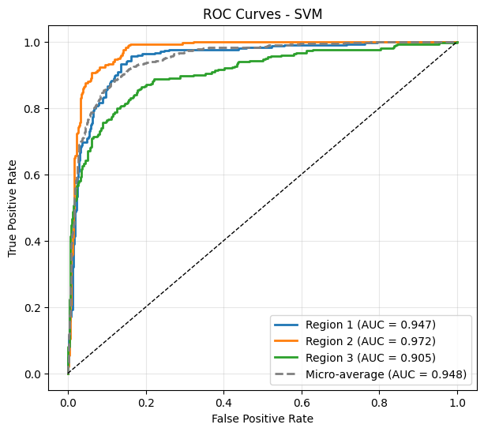

The confusion matrix revealed strong classification for all three regions, with minor overlap between the regions (mostly Region 3) which is consistent with the cluster overlap seen in the unsupervised analysis.
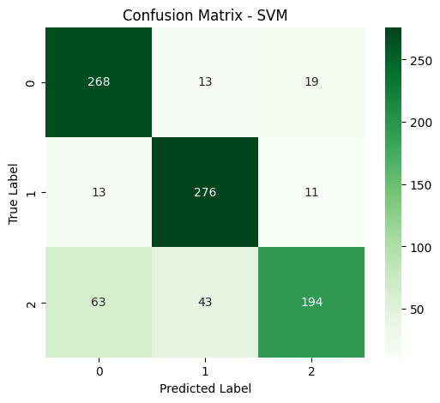

Comparison and Insights
Aspect | Unsupervised (K-Means, Hierarchical) | Supervised (SVM)
Objective | Discover natural spending segments | Predict known region labels
Performance Metric | Silhouette score (0.31 and 0.28) | Macro F1 Score = 0.82, AUC = 0.948
Feature Use | Spending features only | Spending features only
Interpretability | Moderate (requires profiling) | High (clear label mapping)
Overlap | Noticeable between segments | Minimal

The comparison shows that unsupervised methods effectively revealed natural groupings in customer spending, useful for market segmentation without prior labels. However, the SVM classifier achieved much stronger discriminative performance, confirming that regional distinctions are indeed reflected in the data when supervised learning is applied.

8. Business Strategies Based on Customer Segments
The clustering and classification results provide actionable insights into customer purchasing behaviours, supporting targeted marketing and operational strategies.

1. Targeted Promotions
Cluster analysis revealed two key customer segments:
- Retail-oriented buyers, with higher spending on Grocery and Milk.
- Hospitality and food-service clients, with greater expenditure on Fresh products.
The business can tailor promotions accordingly. For example, bulk purchase discounts and loyalty programs for retail buyers, and flexible delivery schedules or seasonal offers for hospitality customers

2. Regional Marketing Initiatives
SVM classification, with an F1 score of 82% and AUC of 0.948, effectively predicts regional spending behaviour. Marketing efforts can be tailored for each region. For example, focus on household essentials in Regions 1 and 2, and offer diverse, personalised promotions in Region 3, where spending patterns are more varied.

3. Channel-Specific Engagement
Channel 1 customers, representing retailers, show a broader product mix. Tiered pricing and bundling offers can strengthen retention.
Channel 2 customers, with more focused purchasing habits, would benefit from subscription or reorder reminder programs to encourage repeat sales.

4. Inventory and Supply Planning
By leveraging cluster-based demand forecasting, inventory for high-demand categories such as fresh and grocery products can be prioritised. This ensures efficient stock management, reduces wastage and aligns supply with customer demand.

Overall, combining unsupervised segmentation with supervised prediction enables a data-driven strategy that aligns marketing, logistics, and sales planning with actual customer behaviour.

9. Conclusion
This analysis combined clustering and classification techniques to explore and predict customer purchasing behaviour.
K-Means and Hierarchical Clustering revealed two clear customer segments, retail-focused buyers and hospitality clients providing valuable insights for market segmentation.
The SVM classifier, fine-tuned with SMOTE and Grid Search, achieved strong predictive performance (Macro F1 = 0.82, AUC = 0.948), confirming that regional spending patterns are well captured in the data.
Together, these methods demonstrate that while clustering uncovers natural behavioural patterns, supervised learning provides precise, actionable predictions to support data-driven marketing, supply chain management, and strategic planning.

10. References
- Cardoso, M. (2013). Wholesale customers [Dataset]. UCI Machine Learning Repository. https://doi.org/10.24432/C5030X.

