Customer Credit Risk Classification Using Decision Tree

1.Introduction
Credit risk assessment helps financial institutions identify customers who are likely to repay loans and those who may default. This report focuses on classifying customers as good or bad credit risks using a decision tree model. The dataset contains numerical and categorical information on customer demographics, financial behaviour, and employment status.
The goal is to build a decision tree classifier with cost matrix where the cost of misclassifying a bad customer as good is ten times higher compared to misclassifying a good customer as bad. The report covers data preprocessing, feature engineering, hyperparameter tuning, threshold optimization, feature importance analysis, overfitting assessment, attribute interpretation and importance as well as managerial recommendations.

2. Data Preprocessing

The dataset contained both numeric and categorical features describing customer financial and personal characteristics. Initial checks confirmed there were no duplicates, inconsistent values, or invalid entries. Outliers were observed in features such as age and amount. However, these were retained, as decision trees are robust to extreme values and can naturally handle such variability without performance degradation.

Missing values were imputed prior to model training. Numeric variables were filled with median values, while categorical variables were filled with the mode. For features with inherent order, such as checking status, savings, and employment duration, manual ordinal encoding was applied to preserve ranking information. Additionally, a derived feature (amount_per_duration) was created to capture repayment burden relative to loan term.

Rationale for Dropping Original Features

The raw columns (amount, duration, checkingstatus1, savings, employ, history) were removed after feature engineering and ordinal encoding to avoid redundancy. Retaining both the original and engineered/encoded features could introduce duplicate information, potentially bias the model and make interpretation more complex. Dropping the originals ensures that the Decision Tree receives a cleaner, more informative feature set, reducing unnecessary splits and improving model interpretability.

A preprocessing pipeline was then constructed to apply one-hot encoding to nominal categorical variables and pass the processed dataset into the Decision Tree classifier.

2.1. Handling Missing Values
Missing values in the dataset were addressed using simple imputation strategies based on feature type.
For numeric features (duration, amount, age, residence, cards, liable), missing values were replaced with the median, which is robust to outliers.
For categorical features (checkingstatus1, history, purpose, savings, employ, status, others, property, housing, job, otherplans, foreign), missing values were filled with the mode, representing the most common category.
This approach ensures a complete dataset while preserving the underlying distribution of each feature.

2.2. Numerical Features
The numeric features in the dataset included duration, amount, age, cards, residence and liable. The distribution of these features and analysis is provided below.
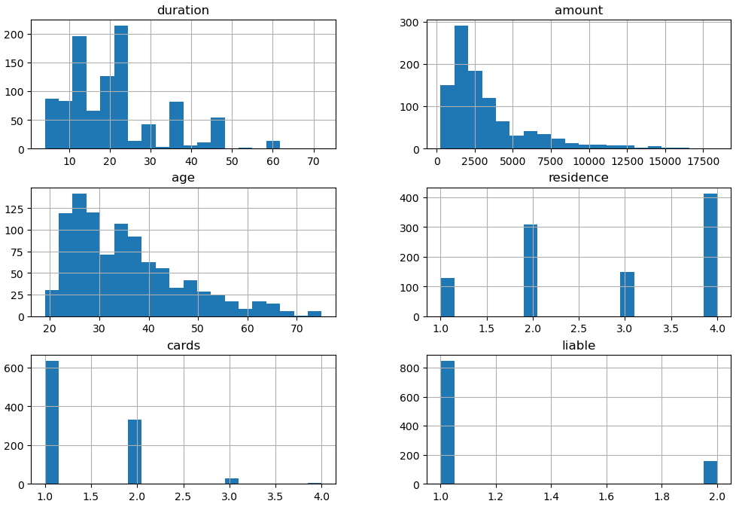
Duration
This represents the loan term in months and ranges from 4 to 72. The distribution is skewed toward shorter-term loans, with the majority of loans concentrated in the lower range. Missing values were imputed using the median. No scaling was applied, as decision trees are insensitive to the feature scale.
Amount
It captures the loan value and exhibits a right-skewed distribution, spanning from several hundred to several thousand. Missing values were filled with the median to maintain robustness.
Age
Age of the customers mostly falls between 20 and 60, with a small number of outliers above 70. Median imputation was used, and outliers were not removed, as decision trees are resilient to extreme values.
Cards
The feature indicates the number of credit cards held. Most customers have a single card, with a few having two or three, resulting in a skewed distribution.
Liable
This feature captures the number of people responsible for maintenance and shows almost no variability, as nearly all customers have a value of one. Median imputation was applied. While this feature has low predictive power, it was retained, as decision trees can ignore uninformative variables.
Residence
Represents the number of years at the current residence. The feature shows moderate variability, with most customers residing between 1 and 4 years. Missing values were imputed using the median. Longer residence is often associated with greater stability, which may provide predictive value.

2.3. Categorical Features
The dataset contains several categorical features, including checkingstatus1, history, purpose, savings, employ, status, others, property, housing, job, foreign, and otherplans.

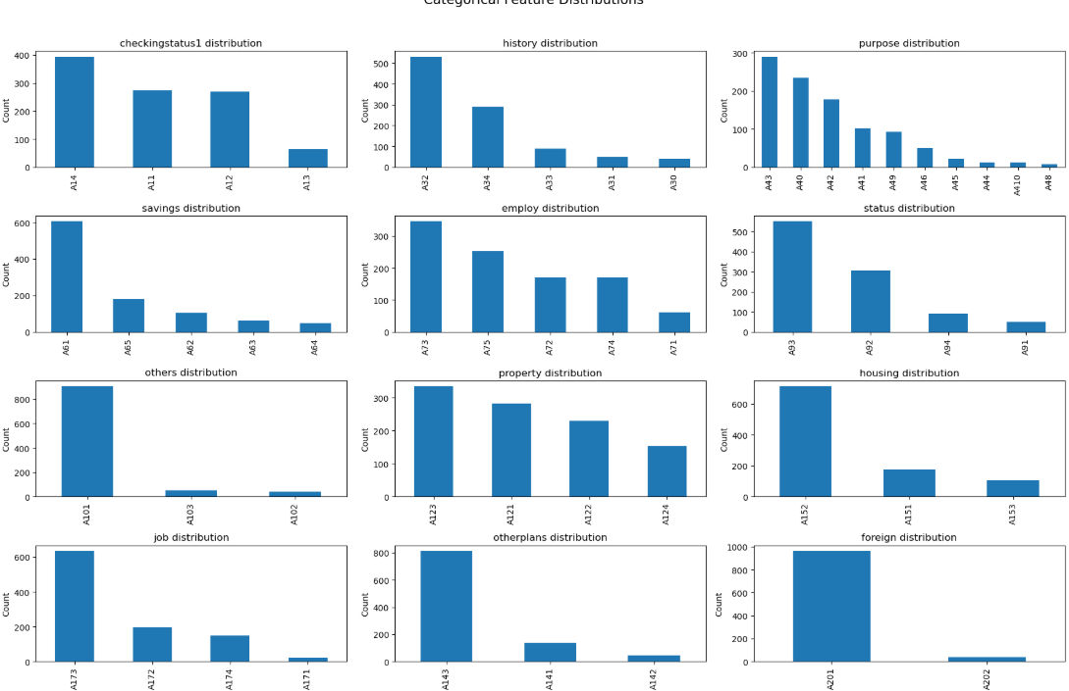

2.3.1 Ordinal Encoding of Categorical Features
To enable the decision tree classifier to utilize categorical information effectively, several categorical variables were ordinally encoded based on their inherent risk or magnitude. Ordinal encoding assigns integer values to categories in a way that preserves the natural order, allowing the model to capture relative differences between levels.
The following features were encoded:
Savings
Higher savings were considered lower risk. The categories were mapped to the corresponding numeric values as shown below.
- A65 (unknown/no savings) :1
- A61 (< 100 DM): 2
- A62 (100–500 DM): 3
- A63 (500–1000 DM): 4
- A64 (≥ 1000 DM): 5

Credit History
A better credit history was mapped to a higher numeric value.
- A30 (no credits taken / all credits paid back duly): 4
- A31 (all credits at this bank paid back duly) :3
- A32 (existing credits paid back duly till now): 2
- A33 (delay in paying off in the past): 1
- A34 (critical account / other credits existing): 0
Employment Duration
Longer employment duration was associated with higher numeric value.
- A71 (unemployed): 0
- A72 (< 1 year): 1
- A73 (1–4 years): 2
- A74 (4–7 years): 3
- A75 (≥ 7 years): 4
Checking Account Status
Better checking account status indicated lower risk.
- A11 (< 0 DM): 0
- A14 (no checking account): 1
- A12 (0–200 DM): 2
- A13 (≥ 200 DM): 3
By converting these categorical variables into ordinal integers, the model can exploit the ordered relationship among categories, improving its ability to distinguish between high-risk and low-risk loans.

2.3.2 Nominal Encoding of Categorical Features
One hot encoding was applied to below categorical features.
- purpose
- status
- others
- property
- Housing
- Job
- foreign
- otherplans

2.4. Engineered Features
An additional feature, amount_per_duration, was created to better represent the loan amount relative to its duration. It is calculated by dividing the total loan amount by the loan duration.

3. Target Variable
The target variable (Default column) denotes whether a customer is Good (0) or Bad (1). The dataset exhibits moderate class skew, with 70% Good and 30% Bad customers. Such imbalance means that a naïve model predicting all customers as Good would already achieve 70% accuracy but completely fail to identify high-risk cases. To mitigate this, the modelling process incorporated class weights, a custom cost-sensitive evaluation metric, stratified K-Fold cross-validation, and threshold optimization. These steps ensured the model prioritized reducing costly false negatives (Bad customer misclassified as good) rather than simply maximizing overall accuracy.

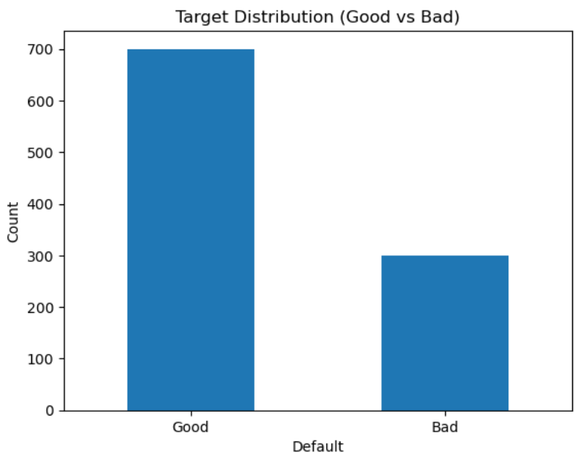
4. Model Training and Hyperparameter Tuning

The predictive model was developed using a Decision Tree Classifier within a pipeline that combined preprocessing (including one-hot encoding of nominal features) with model training. To ensure robust evaluation and reduce the risk of overfitting, the dataset was split into training and test sets, and 10-fold stratified cross-validation was applied to preserve the proportion of Good (0) and Bad (1) cases.

4.1. Custom Cost Function

Given the class imbalance, standard accuracy could be misleading. Therefore, a custom misclassification cost function was implemented, assigning a higher penalty to false negatives (missed bad cases) than to false positives. Specifically, false negatives were weighted 10 times, while false positives were weighted 1 time. This reflects the practical importance of correctly identifying high-risk applicants in a credit risk setting, where granting a loan to a bad customer has a higher cost than wrongly rejecting a good customer. The custom cost function was integrated into the classifier via a custom scoring metric.

4.2. Baseline Model
A baseline Decision Tree Classifier was trained using the preprocessing pipeline prior to hyperparameter tuning. The training set was split using stratified sampling to maintain the target distribution. Model performance was assessed using 10-fold Stratified Cross-Validation, and evaluation on the holdout test set included the cost matrix, confusion matrix, accuracy, and ROC-AUC score.

4.2.1 Training and Test Performance
The baseline model yielded the following results:
Training Set
- Mean CV Cost: 150.1
- CV costs (per fold): [143 137 151 179 162 152 155 190 129 103]

Testing Set
- Accuracy: 0.735
- ROC-AUC: 0.696
- Misclassification Cost (FN*10 + FP*1): 269

Confusion Matrix for test set
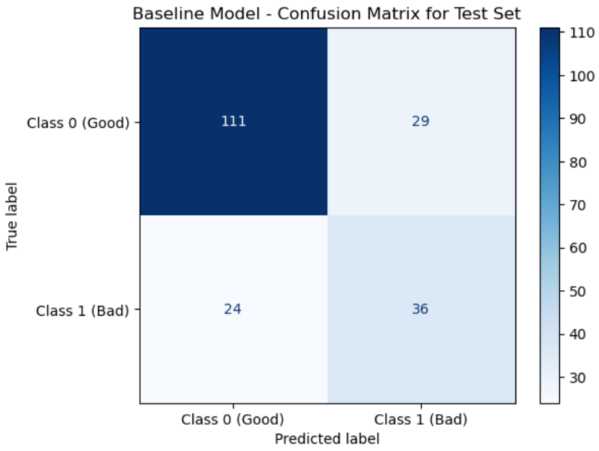

ROC-AUC for test set
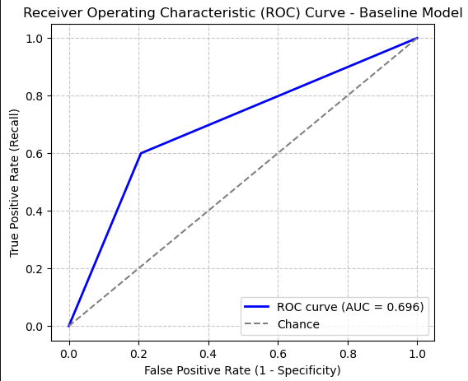

4.3. Improved Model
To enhance predictive performance and address class imbalance, the Decision Tree Classifier was tuned using GridSearchCV with the custom misclassification cost function.

4.3.1 Hyperparameter Tuning
A parameter grid was explored for max_depth, min_samples_split, min_samples_leaf, and class_weight, using stratified 10-fold cross-validation for evaluation.
- Tree depth: Shallow trees (low max_depth) underfit the data, producing poor ROC-AUC and high misclassification costs, while deeper trees risked overfitting with strong training performance but weak generalization.
- Splitting criteria: Increasing min_samples_split and min_samples_leaf helped control overfitting by enforcing broader, more stable splits that improved generalization.
- Class weights: Adjusting class weights significantly impacted performance, with higher weights on the minority (Bad) class reducing false negatives and lowering cost.
The optimal model achieved the following parameters:
- class_weight = {0:1, 1:3}
- max_depth = 4
- min_samples_split = 2
- min_samples_leaf = 12

Finally, the decision threshold was optimized via cross-validation to directly minimize the total misclassification cost. The median threshold across folds was 0.188, balancing false negatives and false positives according to the cost function and yielding the lowest expected financial loss.

4.3.2 Training and Test Performance

Train Evaluation
- Best CV cost: 80.0
- Median Threshold (CV): 0.188
- CV Costs per fold: [38, 43, 55, 50, 58, 53, 53, 76, 54, 56]

Test Evaluation
- Test Accuracy: 0.535
- Test ROC-AUC: 0.746
- Misclassification Cost (FN*10 + FP*1): 5*10 + 88= 138

Confusion Matrix for test set
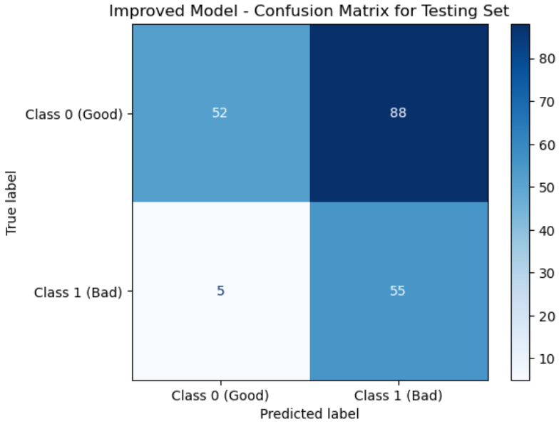

ROC-AUC for Test Set
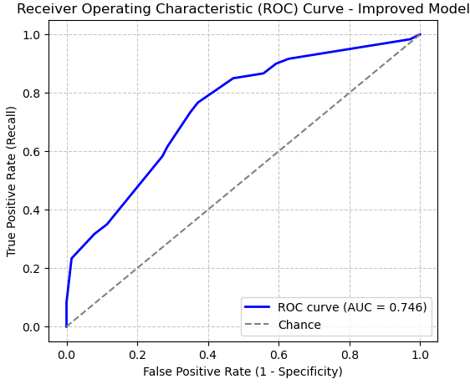

The improved model demonstrates a substantial reduction in misclassification cost on the test set compared to the baseline model, reflecting better identification of high-risk (Bad) applicants, despite a moderate decrease in accuracy. Adjusting the class weights and decision threshold was instrumental in achieving this improvement.

4.4 Comparison of Test Results - Baseline and Improved Models
Metric | Baseline Model | Improved Model
Accuracy | 0.735 | 0.535
True Negatives (TN) | 111 | 52
False Positives (FP) | 29 | 88
False Negatives (FN) | 24 | 5
True Positives (TP) | 36 | 55
ROC-AUC | 0.696 | 0.746
Misclassification Cost (FN×10 + FP×1) | 269 | 138

The improved model shows a clear trade-off between accuracy and business value. While its overall accuracy drops from 0.735 in the baseline model to 0.535, this decline is largely due to a sharp increase in false positives (29 to 88). However, the improved model substantially reduces the number of false negatives from 24 to 5, which is far more important in a credit risk setting since failing to identify high-risk customers is significantly costlier than wrongly rejecting good ones. As a result, the misclassification cost decreases dramatically from 269 to 138, and the ROC-AUC improves from 0.696 to 0.746, indicating stronger discriminative ability. Overall, despite lower accuracy, the improved model better aligns with the business objective of minimizing financial losses by prioritizing the correct identification of risky customers.

4.5 Attribute Importance and Interpretation
Analysis of feature importances from the improved Decision Tree model reveals that financial status and prior credit behaviour are the most critical determinants of customer quality. The top features are:
- Checking Account Status (0.487): The most influential predictor, indicating that customers with poor or no checking accounts are at significantly higher risk of default. This aligns with business intuition, as checking account balances reflect liquidity and short-term financial discipline.
- Other Credit Plans (0.117): Customers holding additional financial commitments are more likely to default, as competing obligations strain repayment capacity.
- Employment Duration (0.095): Longer employment history correlates with stability and reduced credit risk.
- Age (0.067): Older customers tend to show more responsible financial behaviour, while younger customers may be riskier borrowers.
- Savings (0.061): Higher savings balances reduce the likelihood of default, providing a buffer against financial shocks.
- Credit History (0.059): Past repayment behaviour is a strong indicator of future performance, particularly delays or critical accounts.
- Property Ownership (0.048): Property acts as collateral and is associated with financial security.
- Loan Amount per Duration (0.035): Higher repayment burden relative to loan duration increases risk.
- Residence Duration (0.027): Longer residence implies greater stability and lower mobility risk.
- Loan Purpose (0.005): While important, purpose of the loan is less predictive compared to the above features.
These findings are intuitive. Financial liquidity (checking status, savings), repayment history, and stability (employment, residence) naturally influence creditworthiness.

4.6 Decision Tree Visualisation
The Decision Tree diagram shown below provides a visual representation of how the model makes classification decisions based on feature splits. This visualisation reinforces the feature importance analysis.
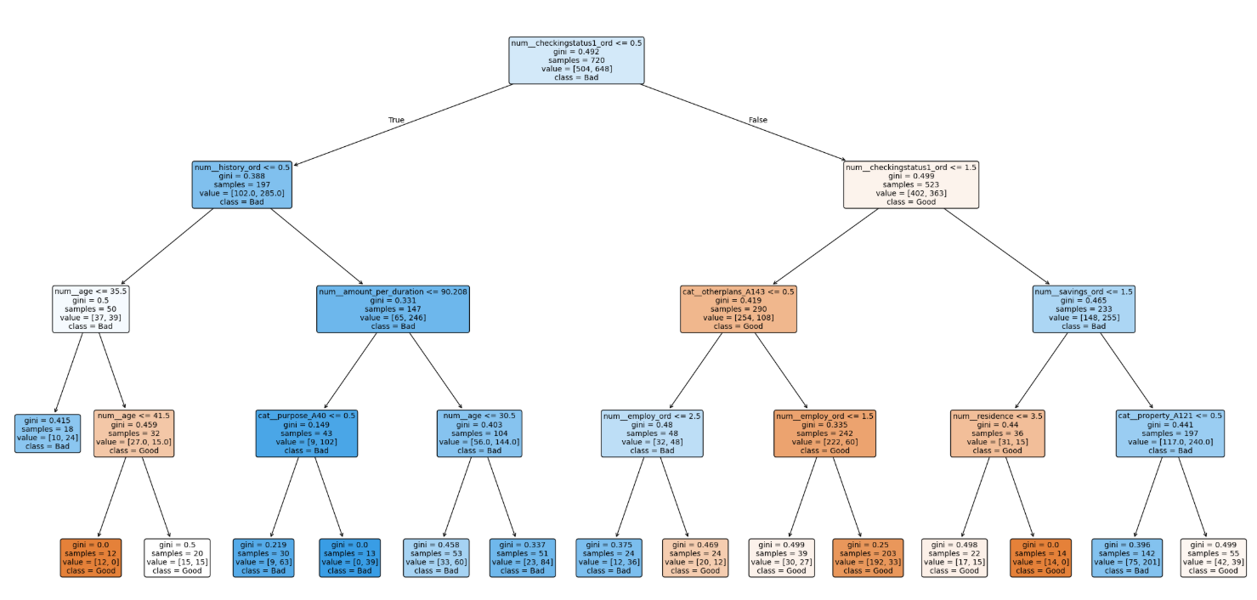

4.7 Overfitting Assessment
To assess whether the Decision Tree model was overfitting, a learning curve analysis was conducted using ROC-AUC as the evaluation metric. Training and validation scores were computed and plotted across increasing subsets of the training data as shown in the diagram below:
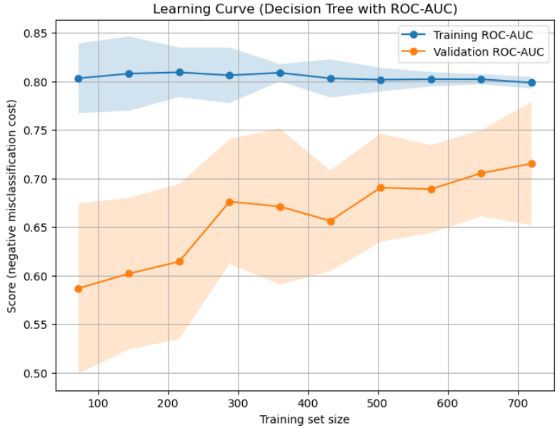
The learning curve revealed that for smaller training sizes (72–216 records), the model achieved a high training ROC-AUC (0.80) but much lower validation ROC-AUC (0.59–0.61). This indicates that with limited data, the model tended to overfit, memorizing patterns that did not generalize well.
As the training set size increased, the validation ROC-AUC steadily improved, reaching 0.715 at the full training set, while the training ROC-AUC remained stable (0.80). The gap between training and validation scores narrowed, suggesting that the model generalized better with more data.
The final test ROC-AUC of 0.746 further supports that the model performs reasonably well on unseen data, with only mild overfitting present.

4.8 Managerial Recommendations
The findings have practical implications for credit risk assessment.
- Focus on Checking Account Status: Since this is the strongest predictor, customers with low or no checking balances should be flagged as higher risk. Policies such as stricter loan approval criteria or higher interest rates could be applied to this group.
- Target Stable Customers: Longer employment duration, property ownership, and savings levels all signal reliability. These customers should be prioritized for loan approvals or offered more favourable terms.
- Youth Risk Awareness: Younger applicants may require additional assessment or stricter thresholds to account for higher default risk.
- Cross-Selling Strategies: Customers with multiple financial obligations (other plans) are more likely to default. Marketing strategies should avoid aggressively offering additional credit products to already leveraged individuals.
- Dynamic Thresholding: Instead of a fixed 0.5 probability cut-off, applying a cost-sensitive threshold leads to more effective identification of risky customers.
In summary, the model provides actionable insights that align with business logic and can guide lending decisions to minimize financial losses while still capturing reliable customers.

5. Conclusion

A cost-sensitive Decision Tree model was designed to classify customers into good and bad credit risks. By incorporating feature engineering, ordinal and nominal encoding, and hyperparameter tuning, the model improved its ability to capture key risk factors such as checking account status, credit history, and employment stability. The use of a custom cost function and optimized decision threshold significantly reduced the financial impact of misclassifications, particularly false negatives. Results demonstrated a test ROC-AUC of 0.746 with a substantial reduction in misclassification cost (138) compared to the baseline (269). Overall, the model provides actionable insights that support more effective lending decisions, targeted marketing strategies, and risk mitigation in customer credit management.

6. References
- Tan, P.-N., Kumar, V., & Steinbach, M. (2006). Introduction to data mining (1st ed.). Pearson Addison Wesley.
- https://scikit-learn.org/stable/modules/generated/sklearn.tree.DecisionTreeClassifier.html

