Governance Phase Space, Lock-In, and Schismogenesis: A Computational Framework for Long-Run Freedom Dynamics
[Author Name]
[Affiliation] | ORCID: 0009-0004-7972-3566
Correspondence: [email] | Data and code: [repository URL]
CC BY 4.0
Keywords: governance dynamics; agent-based modelling; Markov chain; lock-in; schismogenesis; comparative historical analysis; EDR composite; succession mechanisms

1. Introduction
How do governance systems sustain or lose the freedoms that make them resilient to collapse? This question has occupied comparative historians and cliodynamicists since Turchin's (2003) secular cycles analysis established that the long-run oscillation of social complexity is structurally driven. What that literature has lacked is a measurement framework covering the full range of governance forms — from pre-state hunter-gatherer bands to modern bureaucratic states — that allows systematic comparison of the mechanisms by which freedom is sustained, suppressed, and occasionally recovered.

This paper presents such a framework and tests its core predictions against 389 governance systems spanning 12,000 years. The framework integrates three mechanisms: (1) a governance phase space defined by two composite indices — SAP (sovereignty, administration, competitive politics) and EDR (exit, disobedience, and arrangement freedom); (2) the lock-in sequence by which rising surplus legibility suppresses the three freedoms through a six-stage causal chain; and (3) a schismogenesis dynamic by which contact between governance systems produces bifurcation rather than convergence over civilisational time.

The framework draws on Graeber and Wengrow's (2021) historical analysis in The Dawn of Everything but operationalises its claims quantitatively, testing the thesis that governance diversity reflects deliberate differentiation through network analysis, an agent-based model, and three detailed case studies.

1.1 Contribution to Cliodynamics
The framework makes four contributions. First, a measurement instrument (the EDR-SAP phase space) calibrated against six independent external datasets, covering a wider temporal and governance range than existing cross-national indices. Second, a mechanistic model of freedom suppression (the lock-in sequence) linking surplus legibility to succession mechanism dynamics through a testable causal chain. Third, a continuous-time Markov chain (CTMC) succession model producing L-conditional stationary distributions directly comparable to the empirical cross-section. Fourth, an agent-based model of governance network dynamics demonstrating the sufficiency of local schismogenesis rules for generating the empirically observed bipolar network topology.

2. The Governance Phase Space

2.1 Measurement Framework
The isonomia governance dataset codes 389 systems on six continuous 0–1 indices derived from primary and secondary historical sources. Three constitute the SAP composite: sovereignty (S), administration (A), and competitive politics (P). Three constitute the EDR composite: exit freedom (E), disobedience freedom (D), and arrangement freedom (R). Construct validity is confirmed across six independent external datasets (Table 1).

Table 1. Cross-validation against six independent external datasets.
Dataset | Target variable | r | n | Sig.
V-Dem v16 | Liberal democracy | 0.868 | 16 | ***
V-Dem v16 | Deliberative democracy | 0.912 | 12 | ***
Polity5 | DEMOC score | 0.847 | 11 | ***
WJP Rule of Law 2025 | Expression & privacy | 0.904 | 7 | **
Freedom House FIW | Aggregate rights | 0.923 | 9 | ***
CCP Constitutions v5 | Exec. constraint | 0.681 | 11 | *
Seshat Databank | Admin composite | 0.604 | 14 | *
Seshat Databank | Military composite | 0.774 | 12 | **

Note. *** p < 0.001; ** p < 0.01; * p < 0.05.

2.2 Phase-Space Structure
The SAP-EDR correlation across all 389 systems is r = −0.738 (p < 0.0001). Fourteen systems maintain EDR ≥ 0.70 with SAP ≥ 0.70 — the counter-cases analysed in Section 3.2. The resilience threshold θ ≈ 0.45 is identified empirically as the EDR level below which Turchin-Tainter collapse dynamics become significantly more probable (Figure 1).

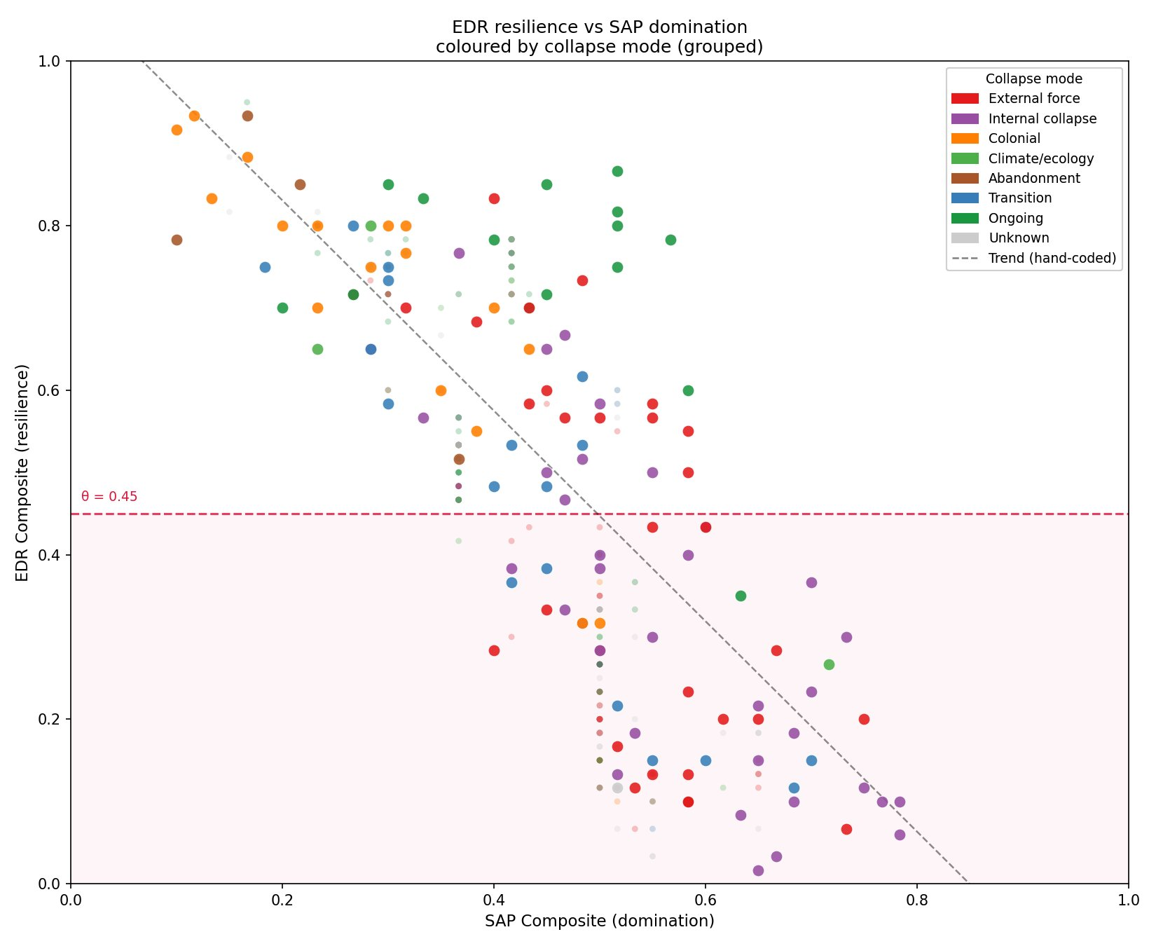
Figure 1. EDR resilience composite versus SAP domination composite across 389 governance systems (hand-coded n = 125, larger points; auto-coded n = 264, smaller points), coloured by collapse mode. Dashed line: regression trend for hand-coded systems (r = −0.738, p < 0.0001). The θ = 0.45 resilience threshold (dashed horizontal) separates the fragile regime (166 systems, 42%) from the resilient regime (223 systems). Counter-cases — high-EDR systems with SAP > 0.60 — appear in the upper right.

3. The Lock-In Sequence

3.1 Mechanism
Surplus legibility (L) measures how countable and extractable a society's primary productive output is to external administrative agents (Scott, 2017). The lock-in sequence operates in six stages: (1) L rises through agricultural intensification; (2) rising L creates demand for information infrastructure (I); (3) high I enables rising administrative apparatus (A); (4) A suppresses exit freedom (E) through mechanisms binding people to place; (5) without credible exit options, D weakens; (6) institutional experimentation is redefined as disorder and R approaches zero. The EDR composite falls below θ.

Four case studies trace this sequence. Natufian to Uruk (~12,500–3,000 BCE): Natufian Communities (L = 0.10, EDR = 0.93) through agricultural intensification (Ubaid, L = 0.50, EDR = 0.70) to early state formation (Early Uruk, L = 0.70, EDR = 0.47). Qin Legalism (~350–207 BCE): Shang Yang reforms maximised L through household registration (L = 0.90, EDR = 0.03) — the lock-in sequence near its practical limit. Inca Empire (~1438–1533 CE): The quipu knotted-cord system (L = 0.90, I = 0.60) achieved near-total legibility without writing, demonstrating that legibility is organisational capacity, not literacy. Zomia Highland Communities: Scott's (2009) analysis documents deliberate maintenance of low legibility (L = 0.05, EDR = 0.92) as structural resistance to administrative incorporation.

3.2 Counter-Cases and the D₀ Moderator
Seven systems maintain EDR ≥ 0.70 with L ≥ 0.60 (Norway, Switzerland, Iceland, Germany, Estonia, the Venetian Republic, and the Roman Republic early period). All share pre-existing institutionally robust disobedience freedom (D₀ ≥ 0.55) established before legibility reached its current level. The D₀ moderator raises the cost of Stage 4 (E suppression): where disobedience is structurally encoded as a legitimate political act, the administrative apparatus cannot bind populations without provoking organised resistance.

4. Succession Mechanism Dynamics

4.1 Static Attraction Basin Model
Three-phase empirical analysis across 117 hand-coded governance systems (working set: coding confidence ≥ 2, succession type and L, D₀ coded; 8 charismatic systems excluded). Phase 1: cross-tabulation of succession type against L regime yields χ²(4) = 25.08, p < 0.0001. At low L, consensus and rotation account for 45% of systems; at high L, 8%. Among high-L systems, D₀ discriminates elective from hereditary: median D₀ = 0.55 for elective (n = 12) versus 0.17 for hereditary (n = 26); Mann-Whitney p = 0.0001, rank-biserial r = −0.782; OR = 6.46 (Figure 2, panels A and E).

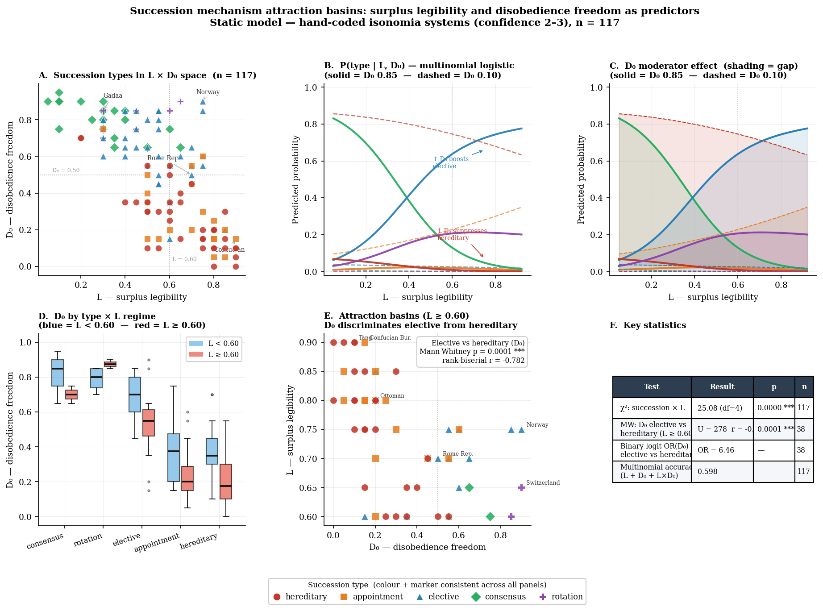
Figure 2. Succession mechanism attraction basins. Panel A: all 117 systems positioned in L × D₀ space by succession type. Panel B–C: multinomial logistic predicted probability curves at low and high D₀. Panel D: D₀ distributions by L regime and succession type. Panel E: high-L systems only, showing basin separation at D₀ ≈ 0.45 (OR = 6.46, p = 0.0001). Panel F: phase-transition summary statistics.

4.2 Empirical Transition Matrix and CTMC
Phase 2 analyses 43 type-changing transitions across 44 systems. Elite reform events produce zero hereditary outcomes (11 cases); internal succession crises produce 56% hereditary. Logistic regression: each SD increase in L at transition time multiplies the odds of an appointment destination by OR = 2.24 (permutation p = 0.005).

Phase 3 estimates a CTMC from 149 spells (39 events, 110,589 system-years). The L-conditional stationary distributions (Table 2) reveal that appointment succession is the primary attractor at high L (π = 0.595, Δ = +0.460 from low L), not hereditary succession. The D₀ moderator operates dynamically: high-D₀ elective systems exit elective succession at 0.55 per 1,000 years versus 2.74 for low-D₀ systems (ratio 5.03×; Cox PH joint test p = 0.026).

Table 2. CTMC stationary distributions at low and high surplus legibility.
Succession type | All L | Low L (< 0.60) | High L (≥ 0.60) | Δ
Hereditary | 0.322 | 0.414 | 0.263 | −0.151
Appointment | 0.367 | 0.135 | 0.595 | +0.460
Elective | 0.243 | 0.394 | 0.115 | −0.279
Consensus | 0.041 | 0.050 | 0.004 | −0.046
Rotation | 0.028 | 0.007 | 0.023 | +0.016

Note. Appointment is the primary attractor at high L (Δ = +0.460). The consensus founding-state finding: π(consensus) ≈ 0.04 at all L levels yet 16% of the cross-section is consensus. Zero documented cases show any return to consensus from appointment or hereditary succession — a one-way valve directly supporting the Graeber-Wengrow claim about asymmetric freedom loss.

5. Schismogenesis and the Governance Citation Network

5.1 The Citation Network
The governance systems are connected by a citation network of 773 relationships across 353 nodes, typed as comparator (n = 449), parallel (n = 204), or contrast (n = 120). Power-law degree distribution (γ ≈ 1.92); mean degree 4.38. Fourteen Louvain communities, modularity M = 0.557. EDR assortativity r = 0.405 versus region assortativity r = 0.024 — communities are organised by governance philosophy, not geography (the geographic null, Figure 3 centre panel). The degree-4 sign reversal (Figure 4) is the network's primary structural claim: positive EDR correlation at degrees 1–3 (r = 0.582, 0.560, 0.314) reversing to r = −0.391 at degree-4 (p < 0.0001).

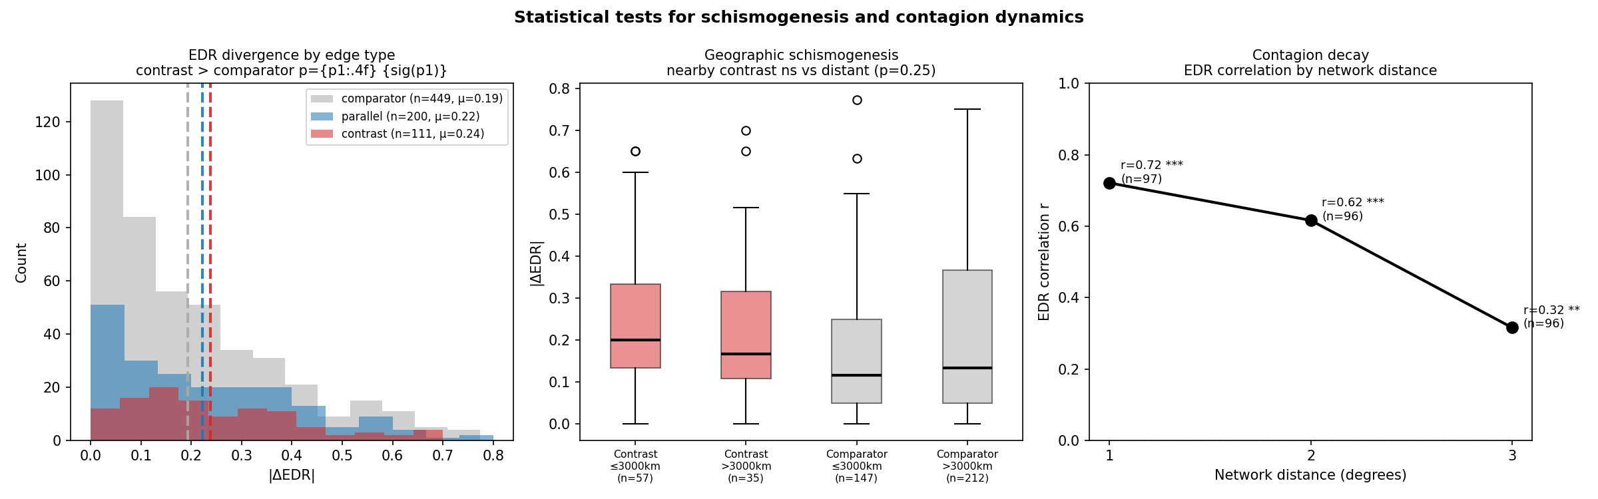
Figure 3. Statistical tests for schismogenesis and contagion dynamics. Left panel: EDR divergence by edge type (contrast μ = 0.24 > comparator μ = 0.19, p = 0.00015). Centre panel: geographic null — nearby and distant contrast pairs do not differ significantly (p = 0.25), confirming schismogenesis is ideational not spatial. Right panel: contagion decay — positive EDR correlation at degrees 1–3, sign reversal at degree-4 (r = −0.391, p < 0.0001).

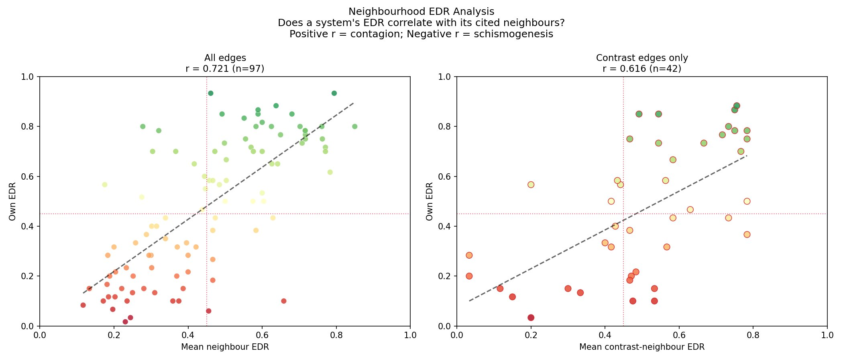
Figure 4. Neighbourhood EDR analysis. Left: all edges — degree-1 correlation r = 0.721 (n = 97), showing strong positive EDR correlation among direct citation partners. Right: contrast edges only — r = 0.616 (n = 42). The degree-4 sign reversal (r = −0.391 for the full graph, not shown at this scale) requires traversing the full network to reach the governance antipode.

5.2 The Schismogenesis ABM
We formalise the schismogenesis mechanism following Bateson (1935): the process by which differentiated identities develop and intensify through contact. The model contains N = 200 agents initialised from a three-cluster distribution (40% high-EDR at μ = 0.75, 20% bridge at μ = 0.48, 40% low-EDR at μ = 0.20, σ = 0.12). The bridge cluster is essential: two-cluster bimodal initialisation produces the sign reversal at degree 2→3 rather than the empirical 3→4.

At each step, each agent selects a contact (homophilic by default, contrast-seeking with probability p = 0.12), forms or updates an edge (comparator if |ΔEDR| < α, contrast if |ΔEDR| ≥ α), and updates its EDR: comparator edges pull toward the neighbour (contagion, strength β); contrast edges push away (schismogenesis, strength γ); an anchor force returns EDR toward its initial value (strength 0.025) preventing full polarisation. An optional per-agent lock-in coupling (δ > 0) applies EDR drift when surplus legibility exceeds a threshold.

5.3 Calibration Results
A parameter sweep over 60 combinations × 20 replicates identifies best-fit parameters α = 0.20, β = 0.003, γ = 0.006 (γ/β = 2.0; loss = 0.553). The calibrated model reproduces the sign reversal at the correct position: r_d1 = 0.651, r_d2 = 0.567, r_d3 = 0.414, r_d4 = −0.561 (empirical: 0.582, 0.560, 0.314, −0.391). Modularity M = 0.448 (empirical 0.557). The γ/β ≥ 1.0 condition is a necessary requirement: when contagion dominates (γ < β), the network converges to a single cluster and no sign reversal emerges (Figure 5, panel A).

Three structural gaps remain (r_d4 overshoots, cross-theta contrast fraction too high, ΔEDR of contrast edges too large), all reflecting the distance-based edge-formation rule's inability to encode historically specific contact patterns. This calibration ceiling is the model's most theoretically informative result: schismogenesis is a necessary condition for bipolarity, but the full citation network structure requires historically structured awareness sets.

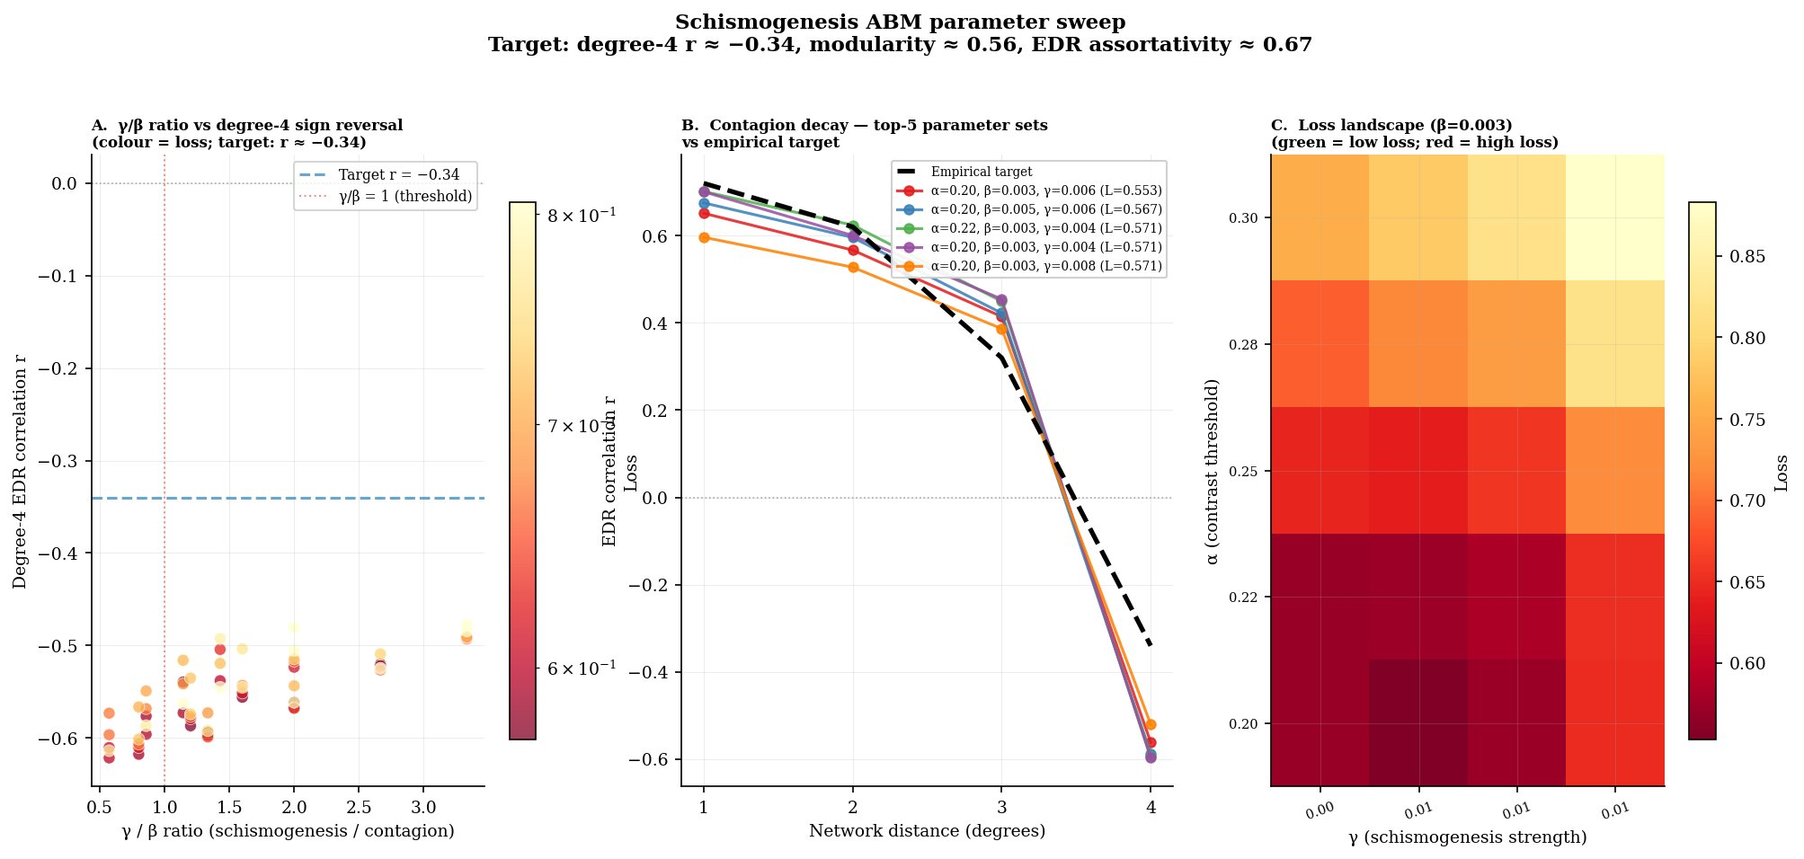
Figure 5. ABM parameter sweep results (60 combinations × 20 replicates). Panel A: γ/β ratio versus degree-4 correlation — all runs produce r_d4 < 0, confirming the sign reversal, but overshooting the target (dashed). Panel B: contagion decay for top-5 parameter sets versus empirical target (dashed black), showing correct shape at degrees 1–3. Panel C: loss landscape — α is the dominant parameter; optimal at α = 0.20 (lower boundary of swept range).

5.4 Case Study Validation
Three Graeber-Wengrow case studies validate the model. Each focal agent is initialised with its documented EDR, L, and citation partners from the network database (Figure 6).

Celtic Tribal Assemblies: EDR 0.70 → 0.802 ± 0.090 (stable_high confirmed). Three contrast partners (Roman Republic, Greek Democracy, Phoenician Merchant Oligarchies) drive EDR upward via schismogenesis — contact with Mediterranean administrative urbanism strengthens rather than erodes the alternative.

Zomia Highland Communities: EDR 0.92 → 0.972 ± 0.037 (stable_high confirmed). Four contrast partners (Confucian Bureaucracy, Ming Yellow Register Census, Khmer Devaraja × 2) drive EDR to the ceiling. Near-zero variance (±0.037) reflects stability when contrast partners are maximally dissimilar. Scott's (2009) thesis that Zomia maintained high illegibility because of lowland state contact is directly reproduced.

Iroquois Confederacy / Haudenosaunee: EDR 0.77 → 0.616 ± 0.080 with L-coupling onset at step 200 (stable_then_decline confirmed). Before colonial L-imposition, EDR rises to ~0.88. At step 200, colonial administration raises L to 0.65 and activates δ = 0.008 per-step drift; EDR declines to 0.616 by step 500. This two-phase trajectory couples the schismogenesis mechanism (sustains high EDR) with the lock-in sequence (overwhelms it at colonial contact) — neither mechanism alone predicts the observed arc.

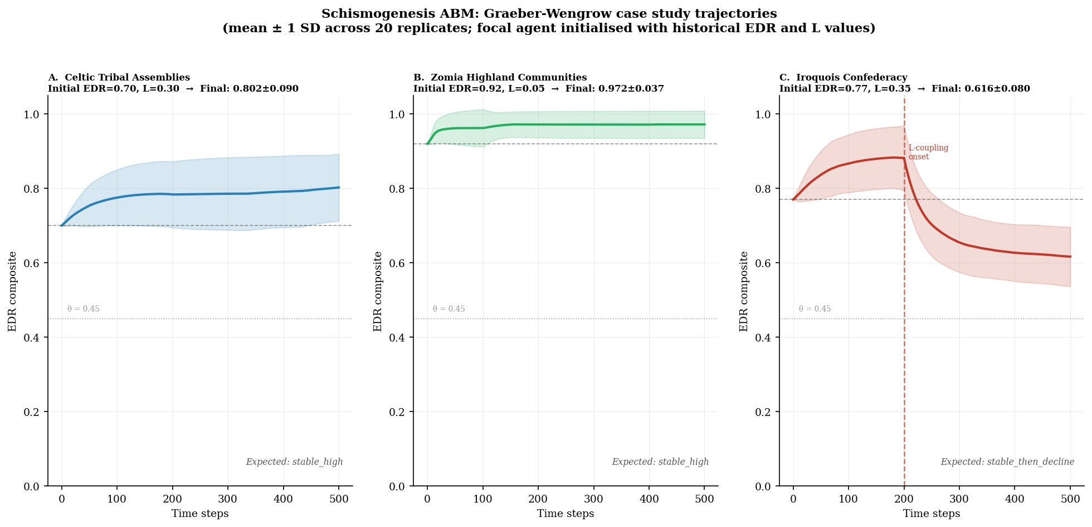
Figure 6. Graeber-Wengrow case study trajectories (mean ± 1 SD across 20 replicates; focal agent initialised with historical EDR and L values and empirical citation network neighbours). A: Celtic Tribal Assemblies — schismogenesis with Mediterranean contrast partners drives EDR upward (stable_high confirmed). B: Zomia Highland Communities — contrast with lowland states pins EDR near maximum (stable_high confirmed). C: Iroquois Confederacy / Haudenosaunee — pre-colonial stability followed by decline when colonial L-imposition activates the lock-in coupling at step 200 (stable_then_decline confirmed).

6. Integrated Discussion

6.1 A Unified Account of Long-Run Governance Dynamics
The three mechanisms are not independent. The lock-in sequence explains the L-conditional shift in the CTMC stationary distributions: rising L strengthens the appointment attractor because the administrative infrastructure high L creates is precisely what appointment-based governance exploits. The schismogenesis mechanism explains why this shift is not universal: high-EDR systems are reinforced in their distinctiveness by contrast with appointment-converging low-EDR systems, as long as γ/β ≥ 1.0. The D₀ moderator connects both: pre-existing disobedience freedom quintuples the stability of elective succession (succession model) through the same mechanism that preserves counter-cases under high L (phase-space model). The Haudenosaunee case integrates all three: schismogenesis sustains high EDR through contrast-based identity formation; the lock-in sequence overwhelms it when colonial L-imposition raises L above threshold; the two-phase trajectory is only predicted by their conjunction.

6.2 The Graeber-Wengrow Argument and the One-Way Valve
The consensus founding-state finding and the ABM calibration ceiling together support the Graeber-Wengrow claim about asymmetric freedom loss. The one-way valve is visible in the transition matrix: zero documented cases show any return to consensus from appointment or hereditary succession. The deliberate differentiation is visible in the schismogenesis signal (contrast edges have larger ΔEDR, p = 0.00015). The calibration ceiling is consistent with the Graeber-Wengrow thesis: the contrast relationship is not about maximising EDR distance but about marking boundaries with specific alternatives that are visible and relevant — historical contingency matters beyond what distance-based rules can provide.

6.3 Contemporary Implications
Digital administrative systems raise both L and I simultaneously at a pace that may outstrip the development of constitutional D mechanisms. The Norwegian and Swiss counter-cases identify the protective mechanism: D₀ established before L rises. The schismogenesis model suggests governance contact between dissimilar systems tends to intensify rather than reduce differences — consistent with contemporary evidence of democratic backsliding in systems with high exposure to authoritarian governance models.

7. Limitations
Single-value L and D₀ coding. Each system is assigned a single characteristic value, not a time series, attenuating dynamic effects in the CTMC.

Selection bias in the transition dataset. Documented transitions are concentrated among historically rich polities; pre-state and oral-tradition societies are underrepresented.

Markov property. The CTMC assumes transition rates depend only on the current state. History-dependent models require more than 43 type-changing transitions to estimate.

ABM plausibility vs. simulation. The schismogenesis ABM tests whether local rules are sufficient to generate the observed topology. It is not a historical simulation. Three-cluster initialisation approximates 14 empirical Louvain communities; historically structured awareness sets are the primary direction for improvement.

8. Conclusion
We have presented a unified computational framework for long-run governance dynamics integrating three mechanisms. The phase-space framework (SAP-EDR, r = −0.738, validated across six external datasets) provides the measurement scaffold. The lock-in sequence (CTMC logistic regression OR = 2.24, permutation p = 0.005; D₀ moderator ratio 5.03×, Cox PH p = 0.026) provides the mechanistic account of freedom suppression. The schismogenesis ABM (sign reversal reproduced, M = 0.448, three G-W case studies confirmed) provides the network-level account of governance differentiation.

The central empirical claim: governance systems that maintain high EDR under high L are those that established institutionally robust disobedience freedom before legibility rose — confirmed in the static model (OR = 6.46), the dynamic model (5.03×), and the case study trajectories. Three research directions follow: extending the CTMC to history-dependent transition rates; replacing distance-based edge formation with historically structured awareness sets; and applying the framework to contemporary digital governance where L and I are rising rapidly.

References
Bateson, G. (1935). Culture contact and schismogenesis. Man, 35, 178–183.
Bateson, G. (1958). Naven (2nd ed.). Stanford University Press.
Blondel, V. D., Guillaume, J.-L., Lambiotte, R., & Lefebvre, E. (2008). Fast unfolding of communities in large networks. Journal of Statistical Mechanics, P10008.
Clauset, A., Shalizi, C. R., & Newman, M. E. J. (2009). Power-law distributions in empirical data. SIAM Review, 51(4), 661–703.
Coppedge, M., Gerring, J., Knutsen, C. H., Lindberg, S. I., Teorell, J., et al. (2023). V-Dem dataset v16. Varieties of Democracy Project. https://www.v-dem.net
Cox, D. R. (1972). Regression models and life-tables. Journal of the Royal Statistical Society B, 34(2), 187–220.
Elkins, Z., Ginsburg, T., & Melton, J. (2025). Comparative Constitutions Project: Constitute, v5. https://comparativeconstitutionsproject.org
Freedom House. (2021). Freedom in the World 2013–2021: Aggregate category and subcategory scores. Freedom House.
Gavrilets, S. (2010). Rapid transition towards the egalitarian syndrome. PLOS Computational Biology, 8, e1002035.
Graeber, D., & Wengrow, D. (2021). The dawn of everything: A new history of humanity. Allen Lane.
Marshall, M. G., & Gurr, T. R. (2020). Polity5: Political regime characteristics and transitions, 1800–2018. Center for Systemic Peace.
Motesharrei, S., Rivas, J., & Kalnay, E. (2014). Human and nature dynamics (HANDY). Ecological Economics, 101, 90–102.
Newman, M. E. J. (2006). Modularity and community structure in networks. Proceedings of the National Academy of Sciences, 103(23), 8577–8582.
Scott, J. C. (2009). The art of not being governed. Yale University Press.
Scott, J. C. (2017). Against the grain: A deep history of the earliest states. Yale University Press.
Tainter, J. (1988). The collapse of complex societies. Cambridge University Press.
Turchin, P. (2003). Historical dynamics. Princeton University Press.
Turchin, P. (2016). Ages of discord. Beresta Books.
Turchin, P., Currie, T. E., Turner, E. A. L., & Gavrilets, S. (2013). War, space, and the evolution of Old World complex societies. Proceedings of the National Academy of Sciences, 110(41), 16384–16389.
Turchin, P., et al. (2015). Seshat: The Global History Databank. Cliodynamics, 6(1), 77–107.
World Justice Project. (2025). WJP Rule of Law Index: Historical data 2012–2025. https://worldjusticeproject.org

