CONCEPTION AND ORGANIZATION

Frontend (React):
- Login/Register pages: User authentication UI
- Dashboard: Financial overview, spending pace tracker
- Transactions: CRUD for expense/income entries
- Chat: Conversational AI interface with financial context sidebar

Backend (Node.js/Express):
- Auth routes: /register, /login, /salary (JWT-based)
- Transaction routes: GET/POST/DELETE /transactions
- Chat route: POST /chat/message (integrates OpenAI with user financial data)

Database (MongoDB):
- Users collection: name, email, password (hashed), salary
- Transactions collection: userId, amount, category, type, date, description

AI Integration:
- System prompt defines AI as financial coach
- Financial context injected: income, expenses, spending pace, categories
- Conversation history maintained for continuity

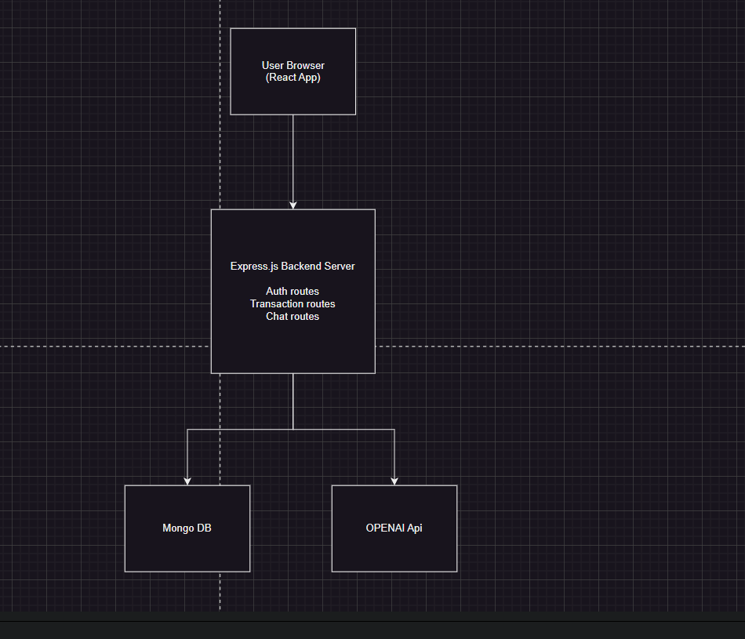

- For personal organization I was using Trello,

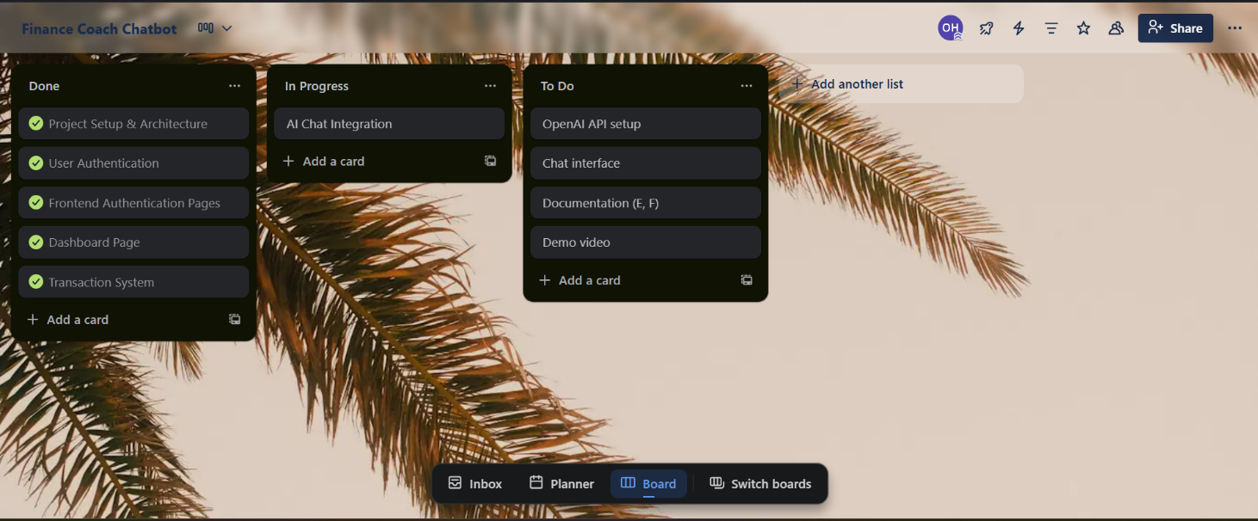





Inside each existed a set of checklists that had to be completed, for example:

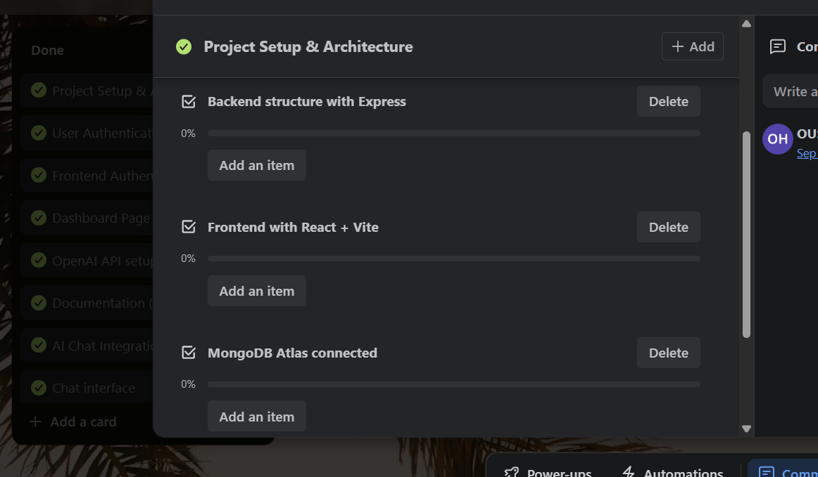

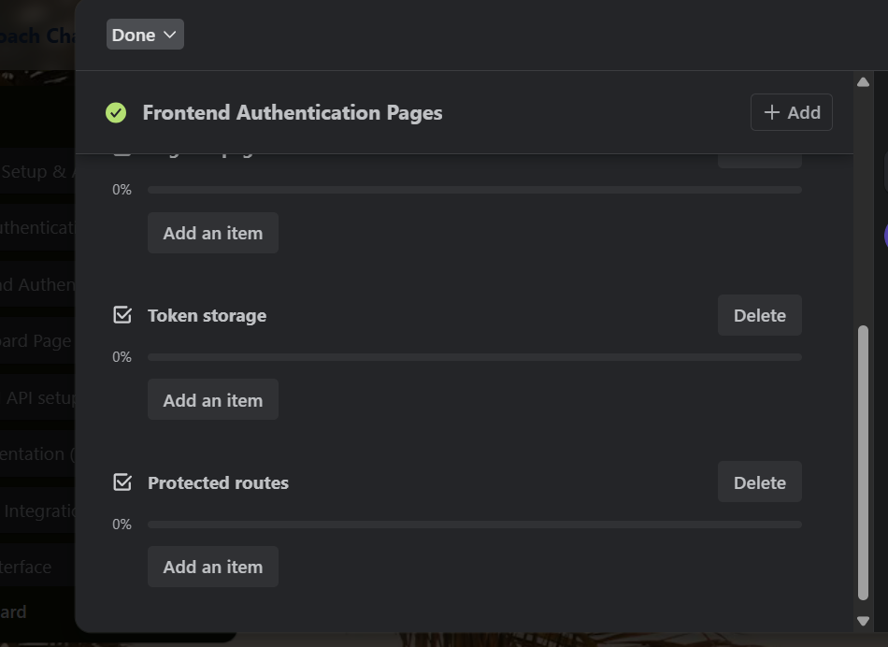

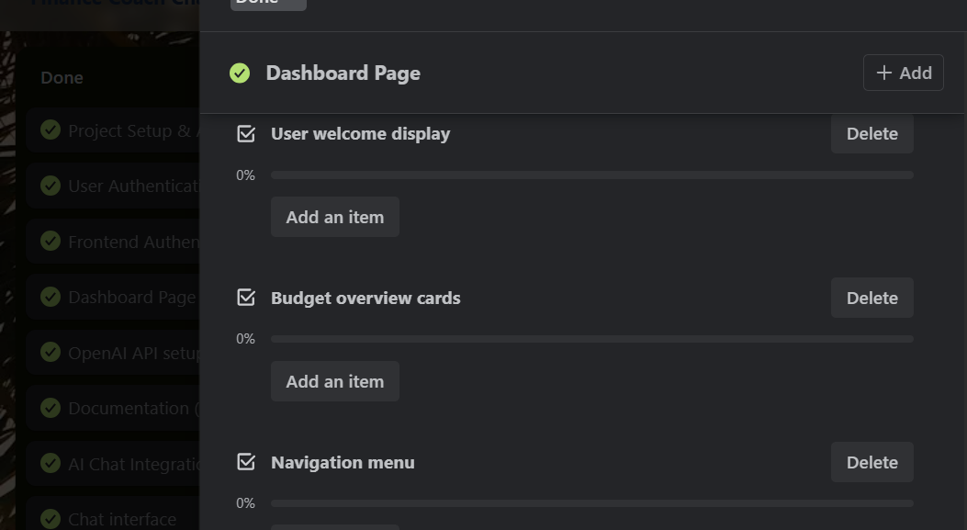

FEEDBACK:

- I originally gave myself more time for the backend and frontend development but it turned out much easier to go through now that we have done a bunch of projects on Full stack. That alone gave me good confidence going forward into integrating the AI and making a simple full stack website more interactive.
- The Trello cards helped me go through integrating the AI smoothly by following the steps I had to do ( I also got most of these steps from chatgpt considering it is our first time diving into something like that, which meant that each task was well explained and detailed and allowed a smooth development)
- I didn’t go deep into implementing a hard detailed architecture and diagrams but even the simple one helped me understand how the chatbot would be connected to my system and what can I do with it(made it access the db and have access to user specific information)
- Getting AI to understand financial context required several prompt iterations and took a longer time of testing than I had given on personal time. As well as the CSS to get a consistent theme.

LESSONS LEARNED:
- Context injection is crucial for AI quality - the more financial data I gave it, the better its advice
- User experience matters - spending significant time on UI made the app feel professional
- Testing with real transaction data helped identify edge cases (negative balances, end of month, etc.)

