**FINAL PROJECT DOCUMENTATION**

**“UKM President E-Voting System”**

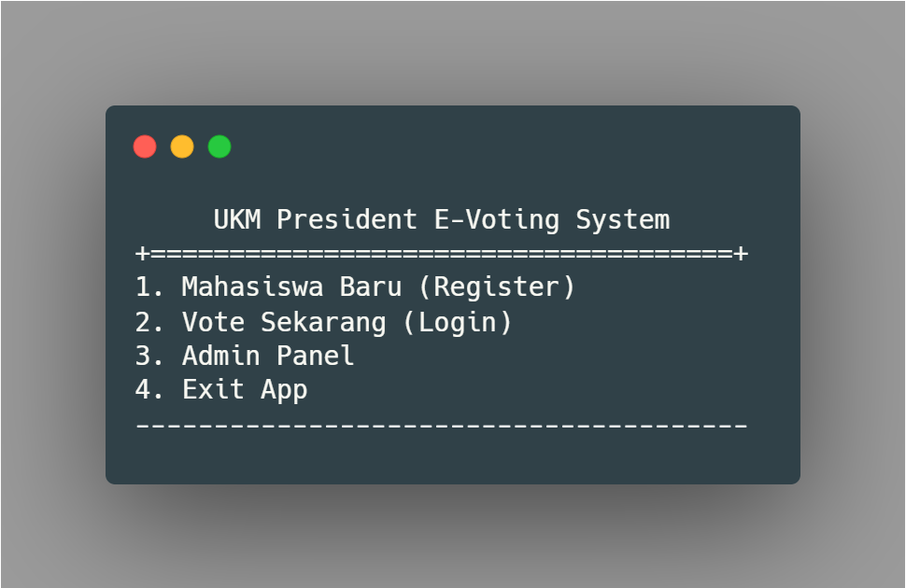



**Created by:**

**Muhammad Rikhza Maulana / 2440112885**

**Tyaga Padhana / 2440048794**

**Hafizhsyah Dylan / 2440104965  
Aditya Bintang / 2440063605**

**Our Lecturer:**

**Mr. Hendra, S.Kom., M.T.**

## **BAB 1 INTRODUCTION**

### **Background Of The Project**

Voting is an event that uses the most votes to decide viewpoints. Especially in Indonesia, the vital thing to note is ensuring the principle of "langsung, umum, bebas, rahasia" and the vote count results should be fair, transparent, accessible to the public. However, some organizations, specifically UKM (Unit Kegiatan Mahasiswa) in Binus University, still use traditional voting or use the third-party online form to organize the voting event; this is where e-voting can be applied. In this case, E-Voting is useful for UKM to help in terms of voting for prospective UKM President. Thus, e-voting will process incoming votes, total votes, and display voting results with their own database.

### **Project Overview**

UKM President E-Voting System is an application to manage all events related to the chairman's election activities in UKM. In technical, this application's programming feature consists of iteration or looping, dynamic array, input class exception handling, bubble sort Algorithm, and clear screen for Windows Prompt and Linux Terminal. with one fully featured admin page, will make the election process fair, transparent and accessible. Validation that includes on the register and login pages will minimize errors or bugs for users to carry out activities related to user management. All voting data will be stored logically and will make it safe because there is no human intervention.

### **Goals Of Project**

The UKM President E-Voting System aims to carry out low-cost voting and fast vote-counting using safe and comfortable conduct audits. With this system, the vote count will be shorter, save on the cost of printing ballots, voting is more straightforward, and the equipment can be used repeatedly. Also, because the database is created independently, it will make the system more secure.

### **Benefit Of Project**

The benefits of using the UKM President E-Voting System include easy calculation, ease in conducting elections, preventing fraud, storing data securely, and reducing costs.

## **BAB 2 ALGORITHM & FLOWCHART**

### **Project Algorithm**

PSEUDOCODE UKM President E-Voting System

----------------------------------------------------------------------

**Begin**

initialize array vVote, vSuara, vNo,vName, vPass, vKetum, vVisi, vMisi

initialize String adminUser = "admin", adminPass = "123", usernameGlobal

do call title()

switch menu:

input menu

case 1 : call registerSystem()

case 2 : call loginSystem()

case 3 : call adminLogin()

case 4 : print "TERIMA KASIH"

default : print "PILIH MENU YANG TERSEDIA"

endswitch

while menu != 4

new method title(): print "UKM President E-Voting System"

print "1. Register"

print "2. Login"

print "3. Admin Panel"

print "4. Exit App"

new method registerSystem(): print " -ACCOUNT REGISTER- "

do input username

if username not numeric then continue

while username length < 10

do input password

input verifPassword

if verifPassword not equal password

Then continue

while password length < 6

add username into array vName

add password into array vPass

print "DATA LOGIN" + username +

password

new method LoginSystem(): print " -ACCOUNT LOGIN- "

do input username

while username not contains vName

do input password

while password not contains vPass

print "Berhasil Login"

call userPanel()

new method adminLogin(): print " -LOGIN ADMIN- "

do input username

while username not matches adminUser

do input password

while password not matches adminPass

call adminPanel()

new method userPanel(): print " -Halaman User- "

print " 1. Lihat Visi Misi "

print " 2. Vote Pilihanmu "

print " 3. Exit "

do switch menu:

case 1 : print vNo, vKetum, vVisi,

vMisi

case 2 : input pilihan

add pilihan into vVote

case 3 : print "log out" break

endswitch

while menu !=3

new method adminPanel(): print " -HALAMAN ADMIN- "

print "1. Tambahkan Kandidat 6. Lihat List User"

print "2. Lihat List Kandidat 7. Cari User"

print "3. Hapus Kandidat 8. Hapus User"

print "4. Perbarui Kandidat 9. Perbarui User"

print "5. Lihat Hasil Voting 10. LOG OUT"

switch adminChoose:

case 1: input jumlahKandidat

do int i

input ketum

input visi

input misi

i++

add ketum into array vKetum

add visi into array vVisi

add misi into array vMisi

while i < jumlahKandidat

case 2: print vKetum, vVisi, vMisi

case 3: input hapus

if hapus contains vKetum then

remove array vKetum.hapus,vVisi.hapus, vMisi.hapus

endif

case 4: input perbarui

if perbarui contains vKetum then

set array vKetum, vVisi, vMisi by

input

endif

case 5: print vVote

print "urut dari besar ke kecil"

call bubbleSortDescending()

print "urut dari kecil ke besar"

call bubbleSortAscending()

case 6: print vName, vPass

case 7: input cari

/*Sequential Search Algorithm*/

for i:vName.length

if cari contains vName then

print "ditemukan"

print array vName.cari, vPass.cari

else print "tidak ditemukan"

case 8: input hapus

if hapus contains vName then

remove array vName, vPass

print "Berhasil di hapus"

else print "tidak ditemukan"

case 9: input update

if update contains vName then

set array vName, vPass by input

print "Berhasil di update"

else print "tidak ditemukan"

case 10: print "Log Out" break

endswitch

/*BUBBLESORT ALGORITHM*/

new method bubbleSortDescending()

new method bubbleSortAscending()

new method swap()

**END**

-------------------------------------------------------------------------------------------------------------------------------

### **Project Flowchart User Point of View**

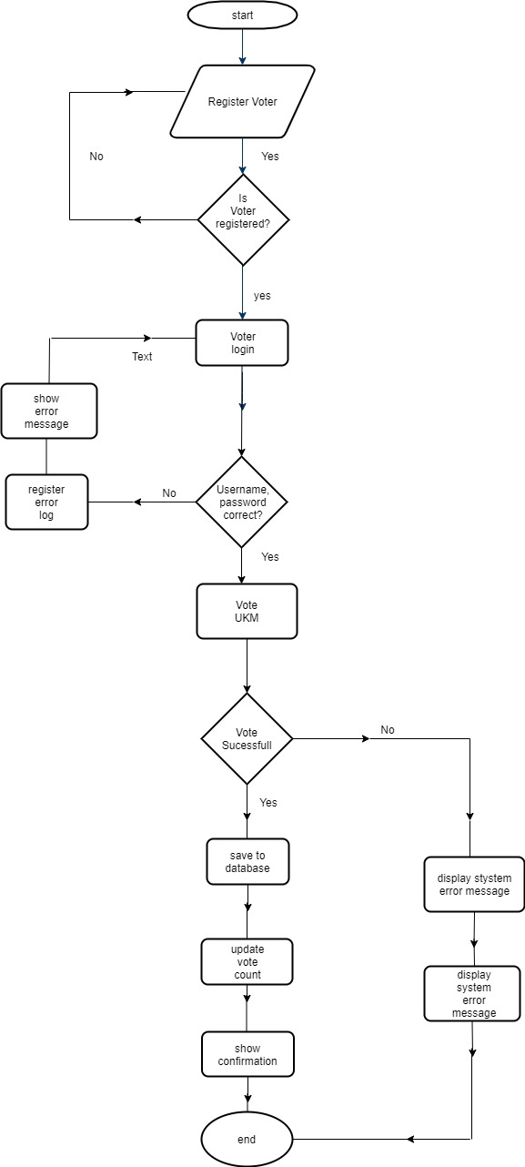

### **Project Flowchart Main Program**

[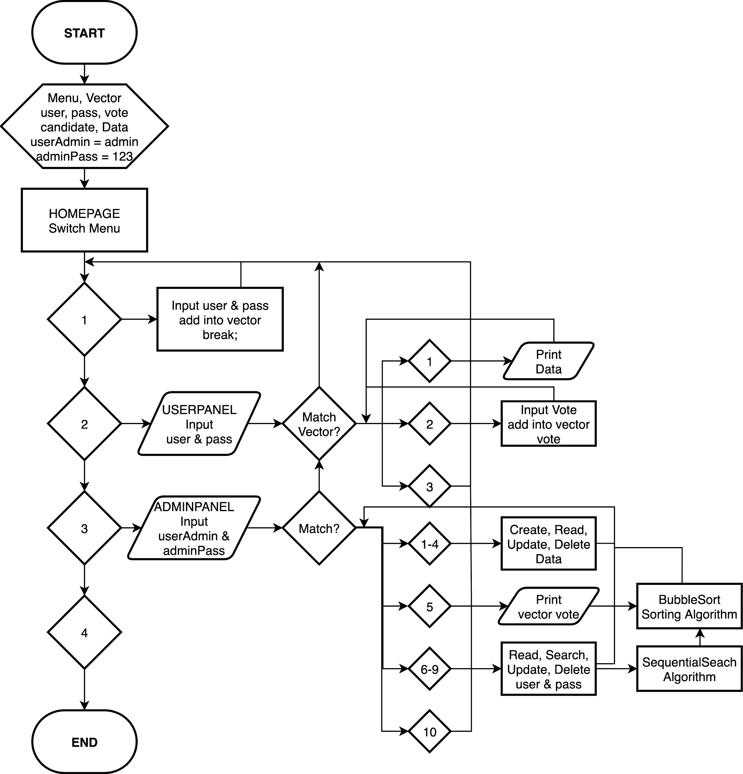](https://app.diagrams.net/?page-id=-8RGNDHhi_MV_0JgUl_W&scale=auto#G1ivfhPfuppTsVpuSrXrOwRaeTYugM60lj)

## **BAB 3 USER MANUAL**

### **Home Page**

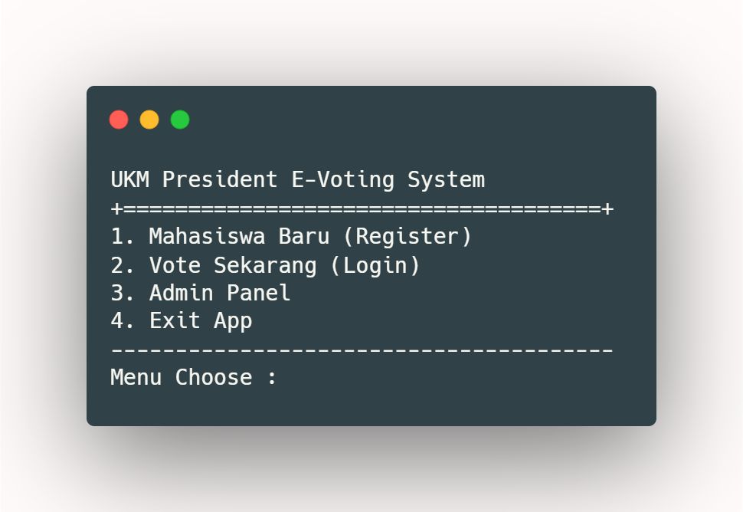

When entering the application, the first time it appears is the homepage with four menus. The first menu is redirecting to the registration form for the new student. The second menu is redirecting to login and begin voting for the student that already registered. The third menu is redirecting to the admin page for login.

### **Admin Panel (Menu 3)**

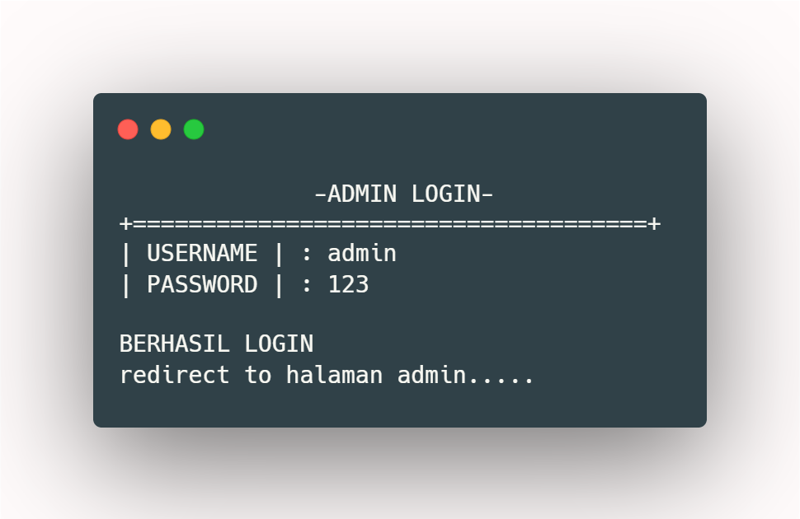

Admin login page will ask the username and password for login as admin. The default account for admin :

USERNAME : admin

PASSWORD : 123

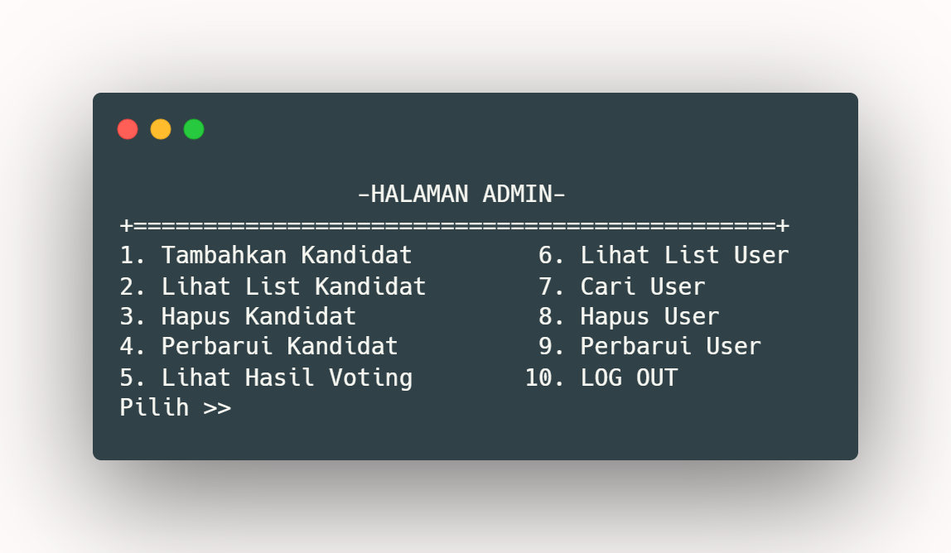

If login as admin successfully, it will redirect to the admin page with fully-featured to manage the candidate and user related to the voting activity.

### **create, read, update, and delete (CRUD) to manage candidate**

|  |  |
| --- | --- |
|  |  |
|  |  |

### **search, read, update, and delete to manage users**

|  |  |
| --- | --- |
|  |  |
|  |  |

---

The last is menu 5, it will show the result if voting has been finished with sorting menu (from higher to lower / lower to higher)

|  |  |
| --- | --- |
| IF THERE IS NO VOTES | IF USERS ALREADY VOTES |

### **Register Page (Menu 1)**

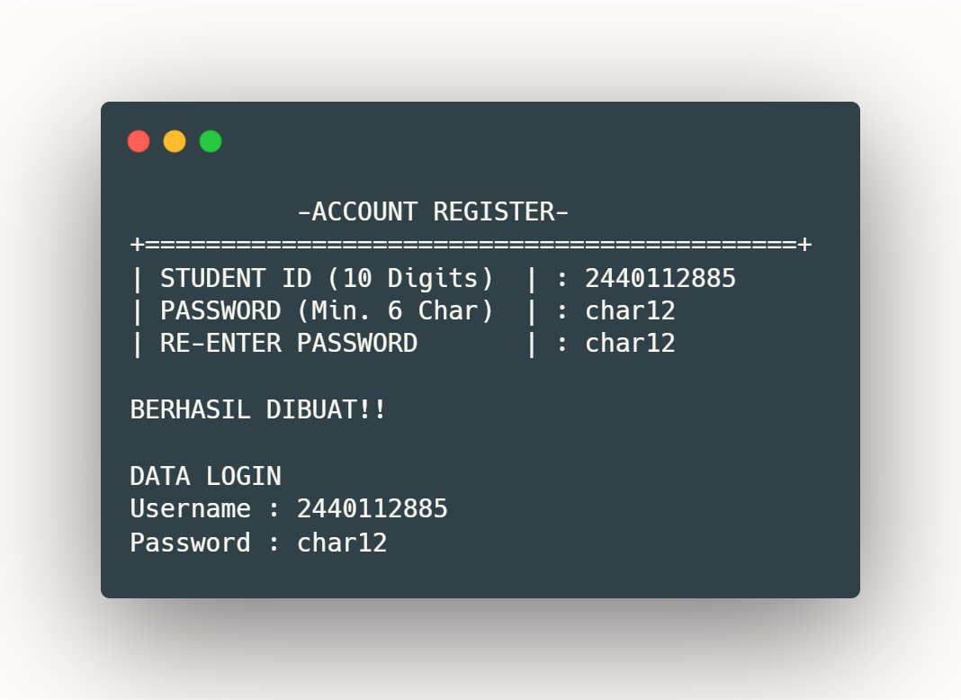

Register page will ask Student ID and Password to create credentials for the user account. After finished, it will redirect to the home page again.

### **User Login Page (Menu 2)**

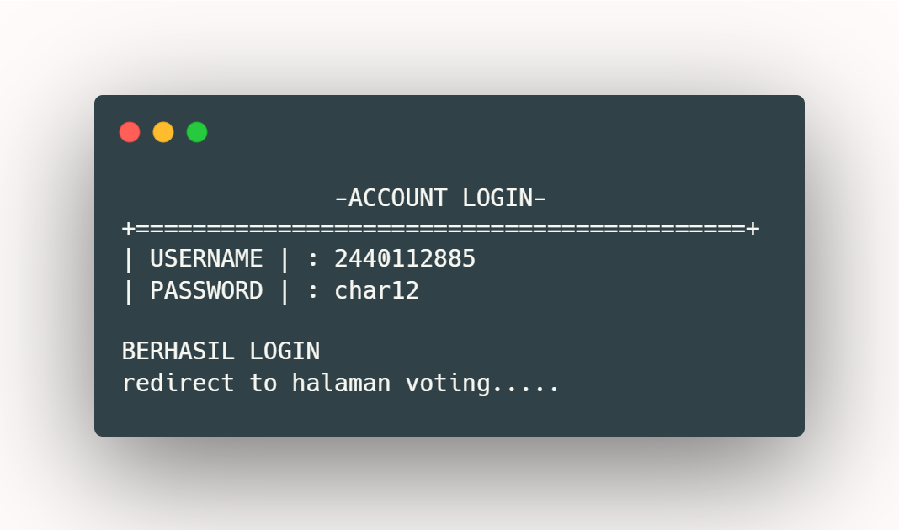

User login page will ask the username and password for login and start voting. The default account for user :

USERNAME : defuser10

PASSWORD : 123

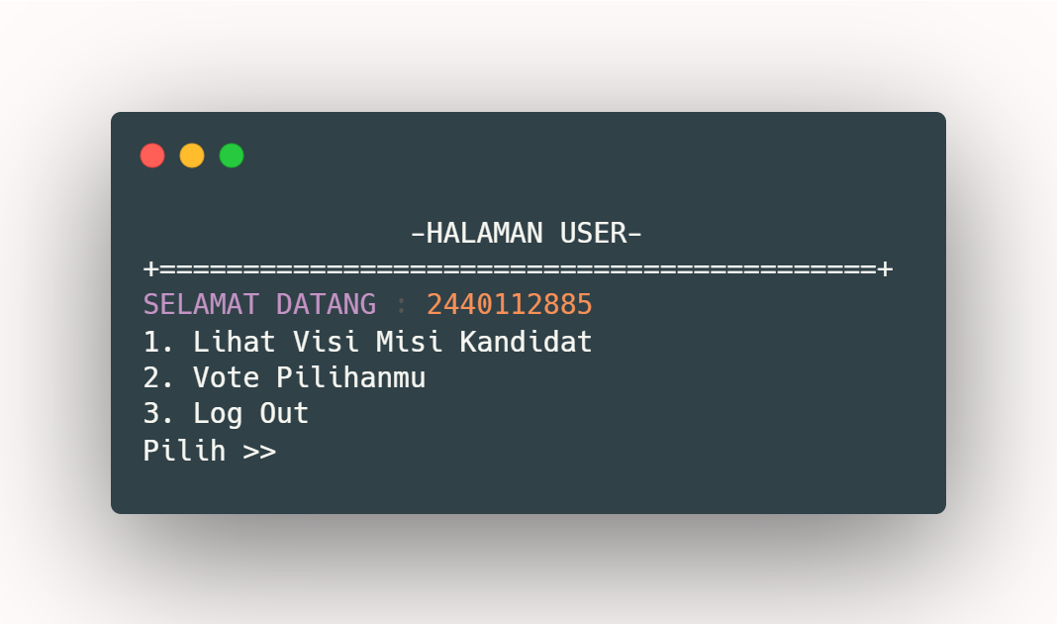

If logged in as a user successfully, it will redirect to the user page with a feature to show all candidates jointly vision missions and to vote the chosen candidates and will generate the votes data.

|  |  |
| --- | --- |
| SHOW CANDIDATE INFORMATION | VOTE YOUR CHOSEN CANDIDATE  If choose ‘no’ it will back to the user page |