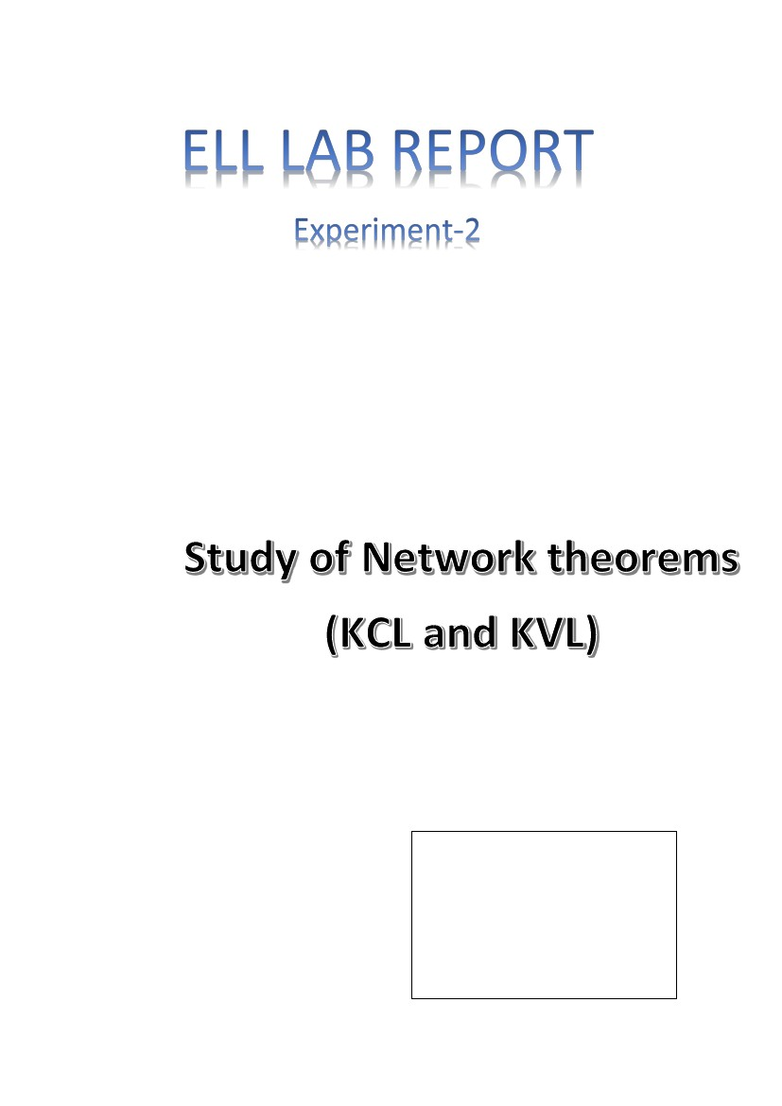
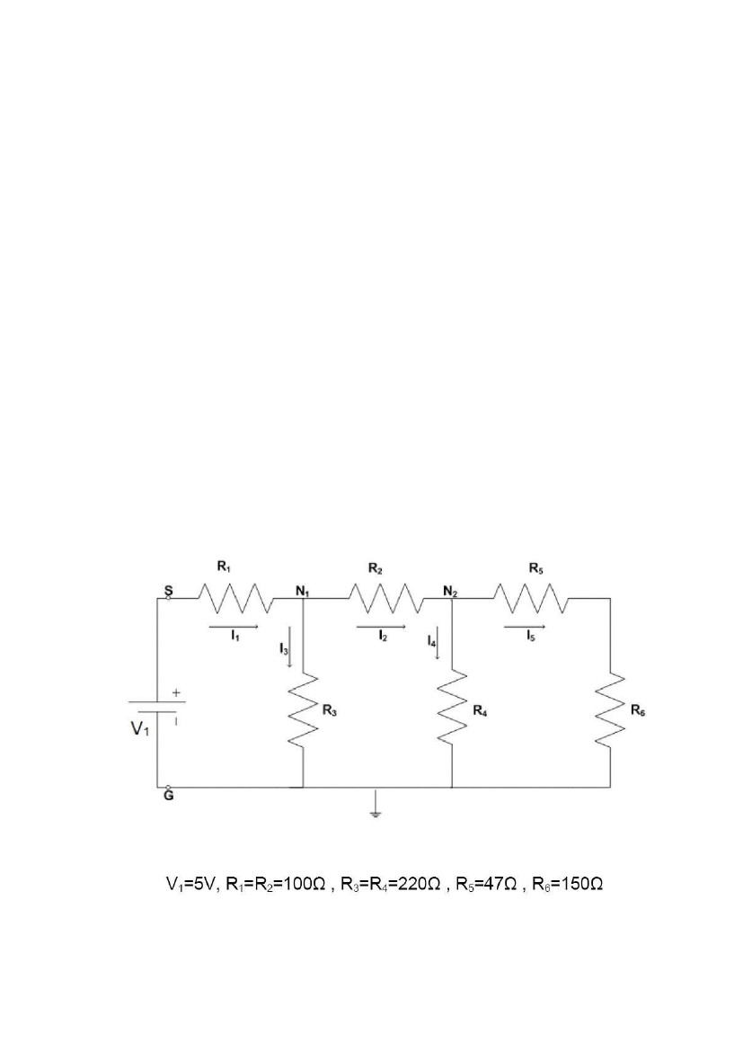
\
SHASHWAT GARG
2019TT11038
GROUP-26

PART-1:Verifying Kirchoff’s Laws
THEORY:
Kirchhoff's Current Law (KCL)
•
The sum of all currents that enter an electrical circuit junction is 0. The
currents entering the junction haven a positive sign and the currents that
leave the junction have a negative sign. Node Cannot store Charge is the
basic principle behind this law.
KCL example:
•
I1 and I2 enter the junction and I3 leave the junction. Let, I1=2A, I2=3A,
I3=-1A, then I4= ?
Solution: ΣIk = I1+I2+I3+I4 = 0
I4 = -I1 - I2 - I3 = -2A - 3A - (-1A) = -4A Since I4 is negative, it leaves the junction
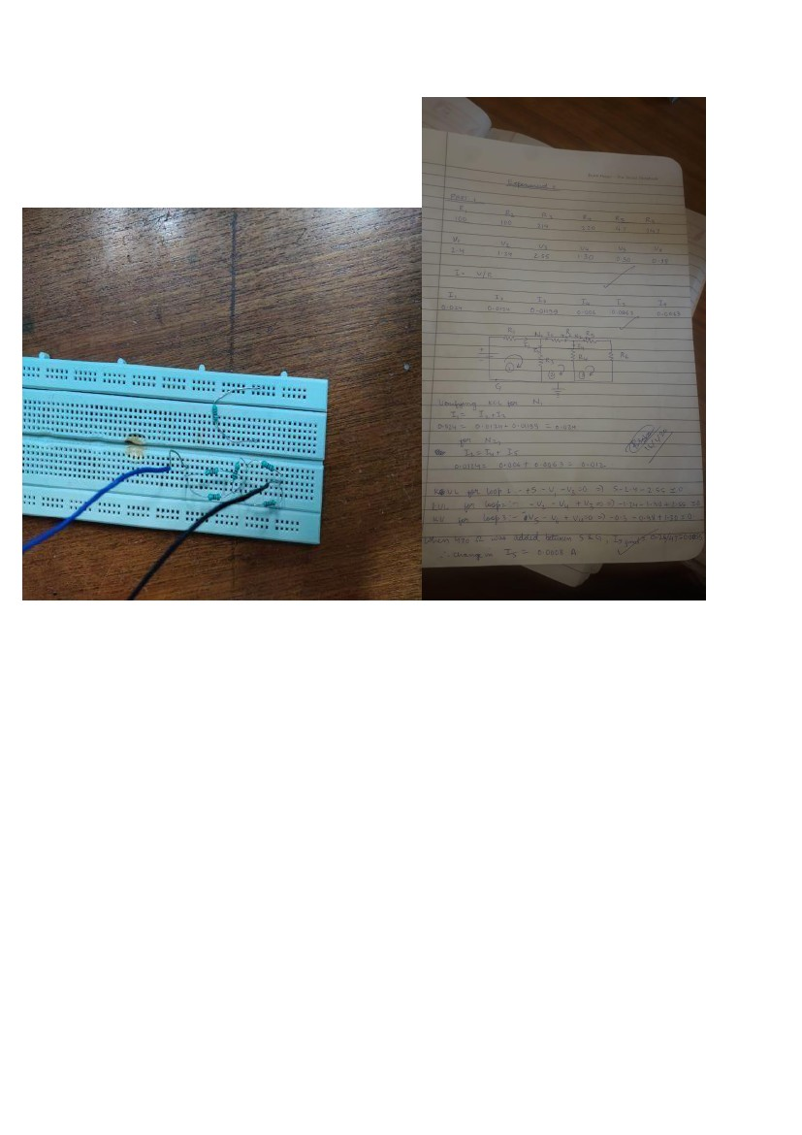
PROCEDURE:
1.Connect the resistors in the way shown in the diagram.
2.Measure resistance of every resistor using a digital
mutimeter.
3.Measure the Voltage across each resistor.
4.Using Ohm’s Law calculate the current through each
resistor.(V=IR)
Observations
VS = 5V DC
Values
R1
R2
R3
R4
R5
R6
Measured
Resistance
(Ω)
Measured
Voltage (V)
Calculated
Current
(mA)
100
2.4
100
214
220
47
147
1.24
2.55
1.3
0.3
0.98
0.024
0.0124
0.0119
0.006
0.0063
0.0063
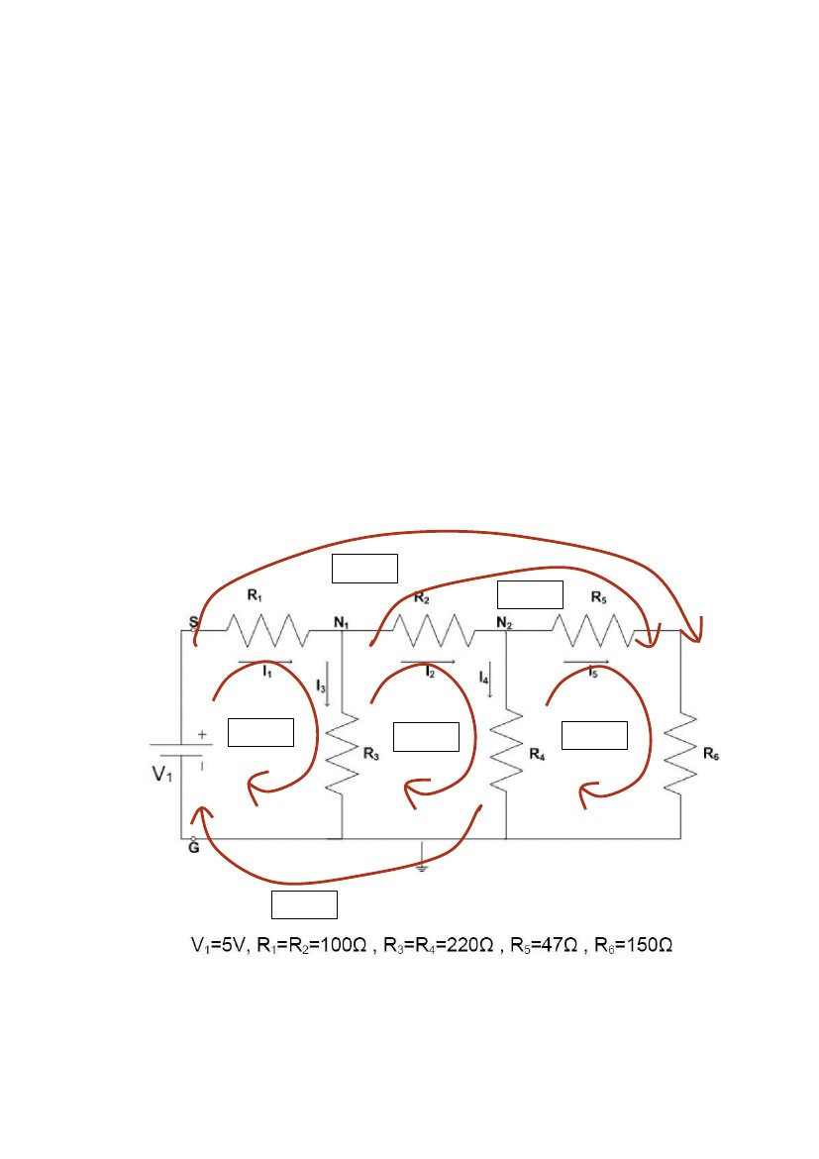
For 470 Ω resistor connected in parallel SG
V5’ = 2.821 V
I5’ = 6.13 mA (Approxiamately)
Note: The variation in the reading may be due to
some finite resistance in the connecting wires.
Moreover, due to deflection in the reading of the
multimeter, the values obtained might not be
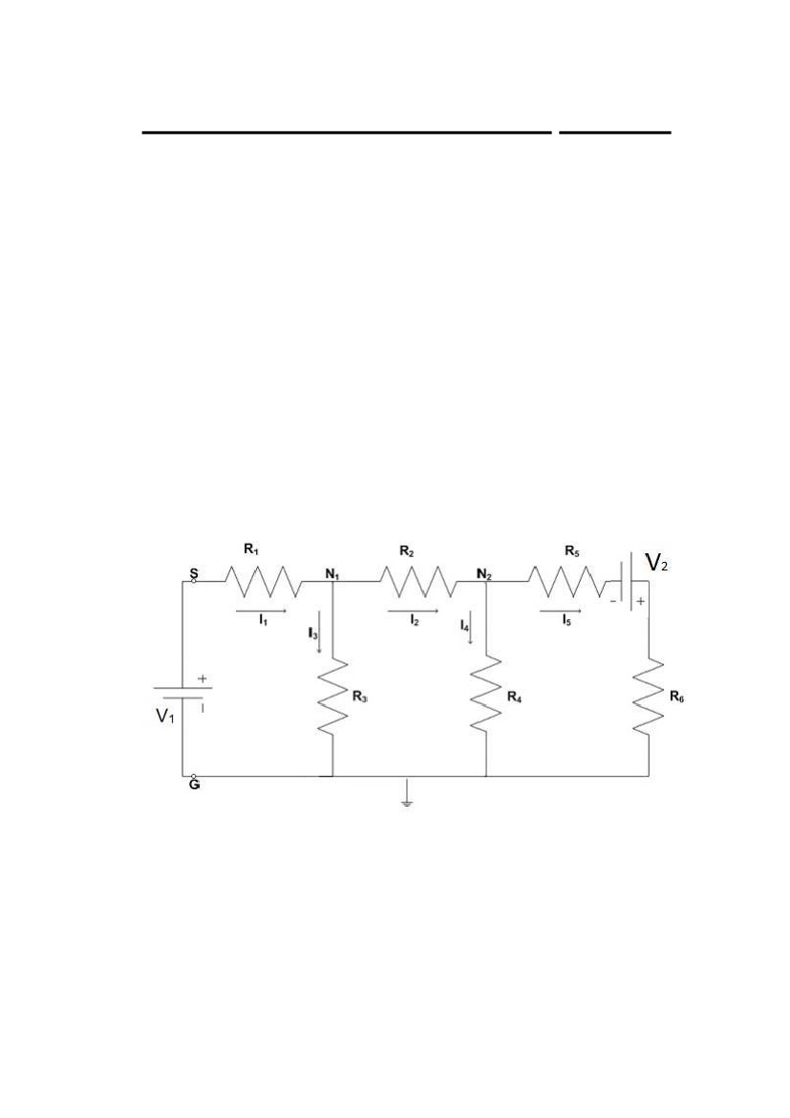
exact, as the error in the values are acceptable till
they are not more than the Least Count.
. Calculations for verification of KCL:
Applying KCL Equation for Node 1:
ΣIk = -I1 +I3 + I2 = (-24.8) + (12.90) + (11.30) mA
= +0.006A ~ 0
Applying KCL Equation for Node 2:
ΣIk = -I2 +I4 + I5 = (-12.90) + (6.00) + (6.00) mA
= +0.009A ~ 0
We get nearly zero sum of currents for both nodes, which is consistent with KCL.
Calculations for verification of KVL:
Loop 6
Loop 5
Loop 1
Loop 2
Loop 3
Loop 4
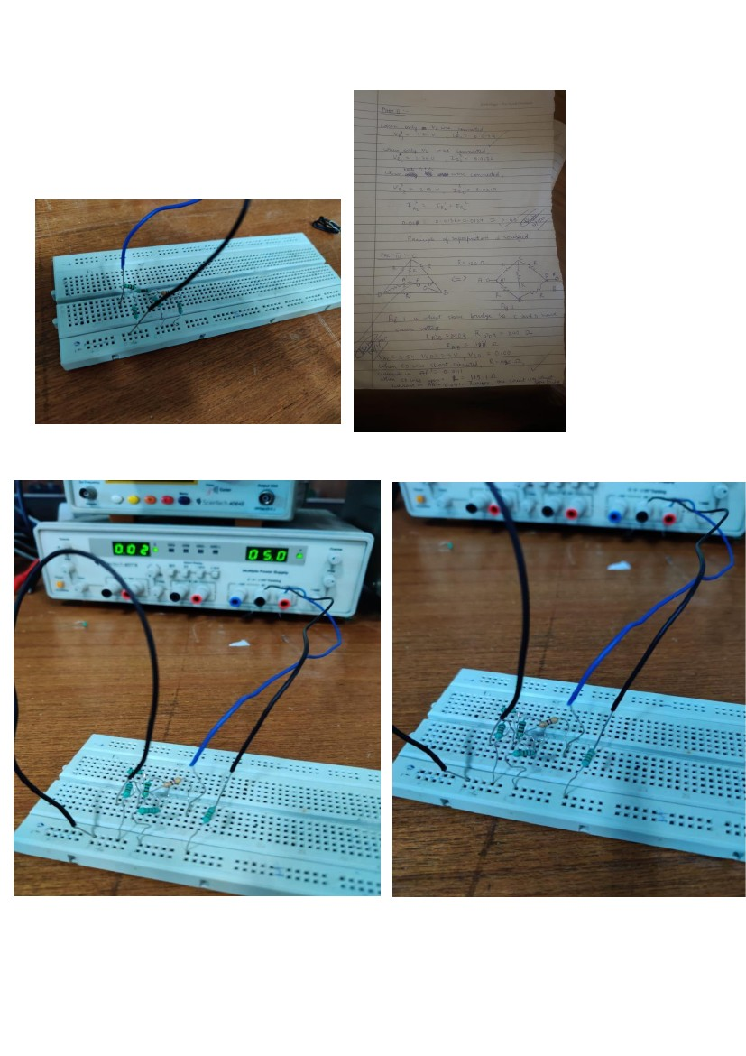
PART-2:Verification of the Superposition Principle
AIM:
To verify the superposition principle experimentally
THEORY:
The superposition principle, also known as superposition property, states that, for
all linear systems, the net response at a given place and time caused by two or
more sources is the sum of the responses that would have been caused by each
source individually.
In this case the sources are the voltage sources V1 and V2, which individually cause
the response to be a current of I1’ and I2’ respectively in the given branch containing
resistance R5.
Verification of the Superposition Principle
Then by superposition principle, when both sources are simultaneously applied,
then the resultant current I5 through R5 will be equal to the algebraic sum of I1’
I5=I1’+I2
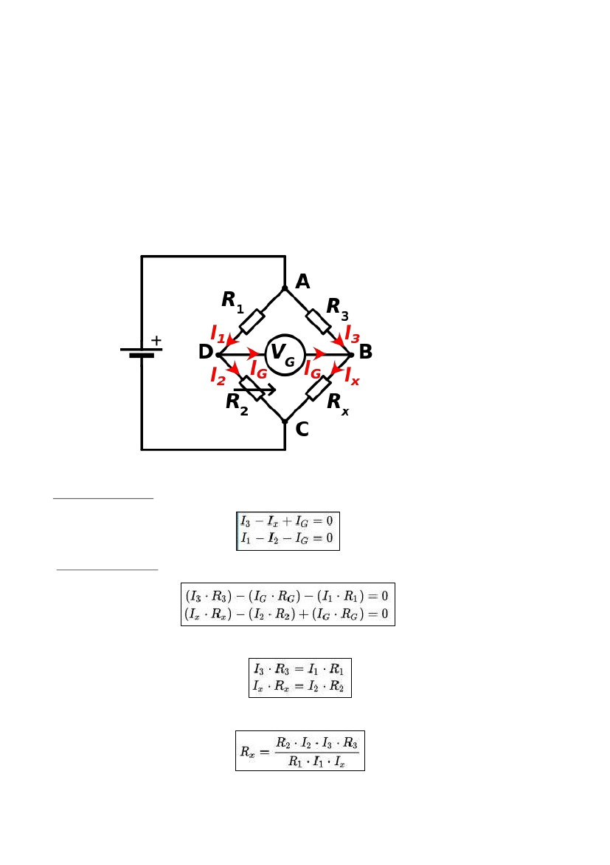
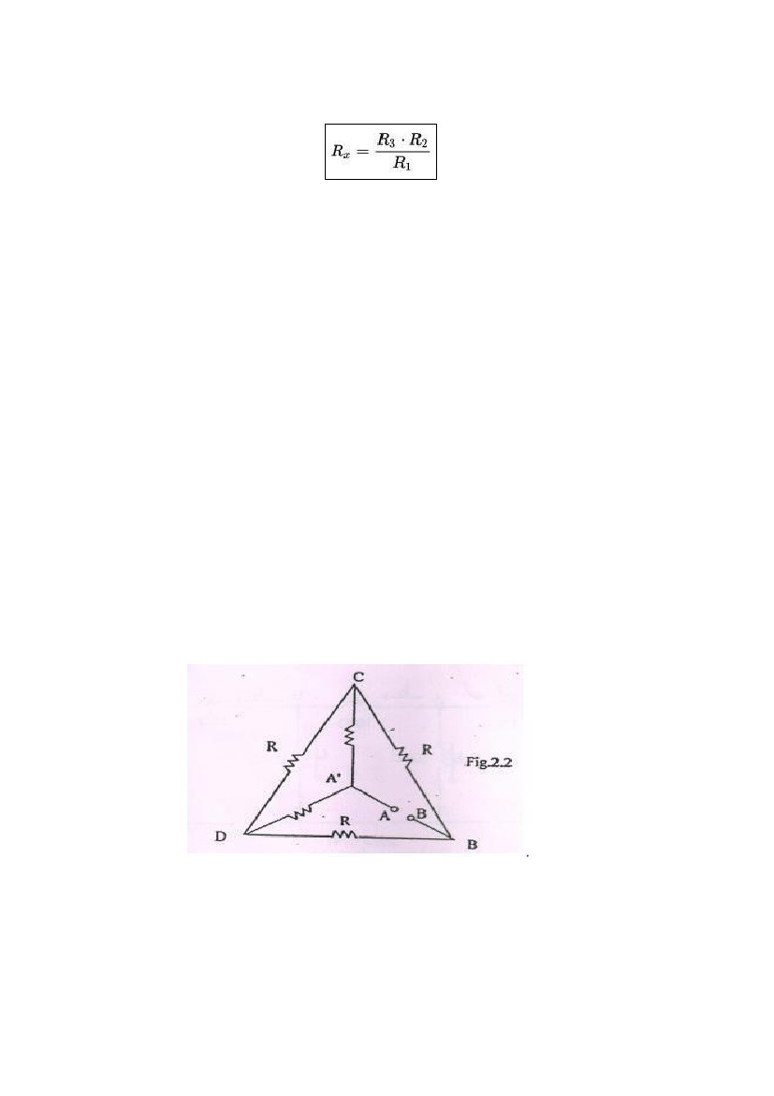
PART-3:Verifying Principle of Wheatstone Bridge
THEORY:
A Wheatstone bridge is an electrical circuit used to measure an unknown electrical resistance by balancing two
branches of a circuit as shown below, one part of which contains the unknown resisitance.
First, Kirchhoff's current law is used to find the currents at junctions B and D:
Then, Kirchhoff's voltage law is used for finding the voltage in the loops ABD and BCD:
When the bridge is balanced, then IG = 0, so the second set of equations can be rewritten as:
Then, the equations are divided and rearranged, giving:

From the first rule, I3 = Ix and I1 = I2. The desired value of Rx is now known to be given as:
ACTUAL SETUP:
1.
2.
The circuit is made on the breadboard as shown.
Measure the input resistances across A and B and verify the values from the
ones calculated
B
by using a formula 3. Apply a voltage of 5V between A and
4.
Measure the voltages across
•
•
B and C
5.
6.
7.
B and D
•C and D
Replaced branch CD with a short.
Measured the resistance and calculate current in AA’
Replaced branch CD with an open, measured the resistance and calculated the
current

Observations and Calculations
Input Resistance across AB = 117.3 Ω By
formula:
Resistance across AB =
Thus,
∆RAB = 0.7 Ω ~ 0 Also
we have,
VBC = 2.46 V
VBD = 2.46 V
VCD = 0.010 V ~ 0
= R = 120 Ω
With CD replaced by Short:
R = 119.8 Ω
I = 41.736 mA
With CD replaced by an open:
R = 120 Ω
I = 41.67 mA
Thus,
∆I = 41.736 – 41.67 mA ~ 0
CONCLUSION
From this experiment we verified that Kirchoff’s voltage
law, and Kirchoff’s Current law. Also, we have verified
superposition theorem. As a study, we also verified the
Wheatstone Bridge setup. We saw that the theoretically
calculated values for the superposition principle were in
agreement with those observed during the experiment.
Within limits of experimental error, we also verified that
the sum of all currents that enter an electrical circuit
junction is zero (KCL), and that sum of all voltages and
potential differences in an electrical loop is zero (KVL).
Precautions
1.
Make the connections neat and tight
Don’t leave the switch on for a long period of
time.
2.
3.
Wear proper covered shoes.
Sources of Error
1.
Scale of multimeter not appropriate for
measurements
Loose Connections.
Resistance of wires not taken into account which
neglects the fact that resistors dissipate power.
Change in the connections while circuit is closed.
2.
3.
4.

