Q1.How are inline and block elements different from each other?

Sol: Basically, an inline element does not cause a line break (start on a new line) and does not take up the full width of a page, only the space bounded by its opening and closing tag. It is usually used within other HTML elements.

Examples of inline element are:

* anchor <a> tag
* emphasis <em> tag
* image <img> tag

while A block-level element always starts on a new line and takes up the full width of a page, from left to right. A block-level element can take up one line or multiple lines and has a line break before and after the element.

Examples of block level element are :

* Heading tags <h1>to <h6>
* List (Ordered, Unordered, Description and List Item) tags <ol> , <ul> ,<dl> , <li>
* Pre-formatted text tag <pre>
* Blockquote tag <blockquote>

Q2. Explain the difference between visibility:hidden and display:none

Sol:The **display: none** property is used to hide elements without deleting them. It does not take up any space whereas on the other hand the **visibility: hidden** property also hides an element, but affects the layout i.e. takes up space.

Q3: Explain the clear and float properties.

Sol:

Float Property : The CSS float property specifies how an element should float.The float property is used for positioning and formatting content e.g. let an image float left to the text in a container.

img {

float: right;

}

Clear Property : The clear property specifies what should happen with the element that is next to a floating element.

div1 {

float: left;

}

div2 {

clear: left;

}

Here, it means that the <div2> element is pushed below the left floated <div1> element.

Q4: explain difference between absolute, relative,fixed and static.

Sol:

**Static** - this is the default value, all elements are in order as they appear in the document.

**Relative** - the element is positioned relative to its normal position.

**Absolute** - the element is positioned absolutely to its first positioned parent.

**Fixed** - the element is positioned related to the browser window.

Q5 : Write the HTML code to create a table in which there are 4 columns( ID , Employee Name, Designation, Department) and at least 6 rows. Also do some styling to it.

Sol : Solution is attached with the document.Refer to it

Q6: Why do we use meta tags?

Sol: Meta tags provide information about the webpage in the HTML of the document. This information is called "metadata" and while it is not displayed on the page itself, it can be read by search engines and web crawlers.

The <meta> tag is used to provide such additional information. This tag is an empty element and so does not have a closing tag but it carries information within its attributes.You can include one or more meta tags in your document based on what information you want to keep in your document but in general, meta tags do not impact physical appearance of the document so from appearance point of view, it does not matter if you include them or not.

Q7: Explain box model.

Sol: The CSS box model is a container that contains multiple properties including borders, margin, padding, and the content itself. It is used to develop the design and structure of a web page. It can be used as a set of tools to personalize the layout of different components. According to the CSS box model, the web browser supplies each element as a square prism.

* Content - The content of the box, where text and images appear
* Padding - Clears an area around the content. The padding is transparent
* Border - A border that goes around the padding and content
* Margin - Clears an area outside the border. The margin is transparent

Q8: What are the different types of CSS Selectors?

Sol: In CSS, selectors are used to target the HTML elements on our web pages that we want to style. There are a wide variety of CSS selectors available, allowing for fine-grained precision when selecting elements to style. A CSS selector is the first part of a CSS Rule. It is a pattern of elements and other terms that tell the browser which HTML elements should be selected to have the CSS property values inside the rule applied to them. The element or elements which are selected by the selector are referred to as the *subject of the selector*.

There are several different types of selectors in CSS.

1. CSS Element Selector
2. CSS Id Selector
3. CSS Class Selector
4. CSS Universal Selector
5. CSS Group Selector

Q9: Define Doctype.

Sol: A doctype or document type declaration is an instruction that tells the web browser about the markup language in which the current page is written. The Doctype is not an element or tag, it lets the browser know about the version of or standard of HTML or any other markup language that is being used in the document.A DOCTYPE declaration appears at the top of a web page before all other elements. According to the HTML specification or standards, every HTML document requires a document type declaration to ensure that the pages are displayed in the way they are intended to be displayed.

Q10: Explain 5 HTML5 semantic tags.

Sol: A semantic element clearly describes its meaning to both the browser and the developer.HTML5 has introduced many semantic elements but 5 of them are:

**Section:** A page can be split into sections like Introduction, Contact Information, Details etc and each of these sections can be in a different section tag.

**nav:** It is used to define a set of navigation links in the form of navigation bar or nav menu.

**Main:** It defines the main content of the document. The content inside main tag should be unique.

**Header:** As the name suggests, it is for the header of a section introductory of a page. There can be multiple headers on a page.

**Footer:** Footer located at the bottom of any article or document, they can contain contact details, copyright information etc. There can be multiple footers on a page.

Q11: Create HTML for web-page.jpg (check resources, highest weightage for answers)

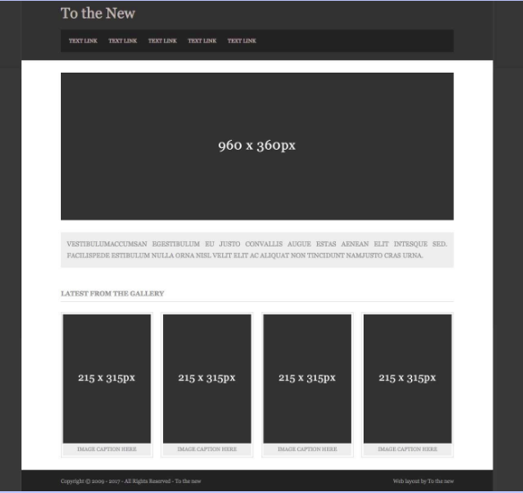

Sol : The solution files are attached with this document. Refer to them.

Q12: Create HTML for form.png (check resources, highest weightage for answers)

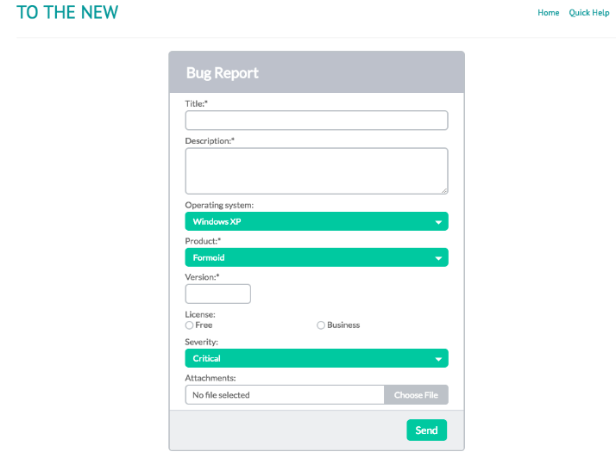

The solution files are attached with this document. Refer to them.