**Screenshort file**

**Scaling the EC2 Instance Based on Monitored CloudWatch Metrics**

Step no 1: create a launch template

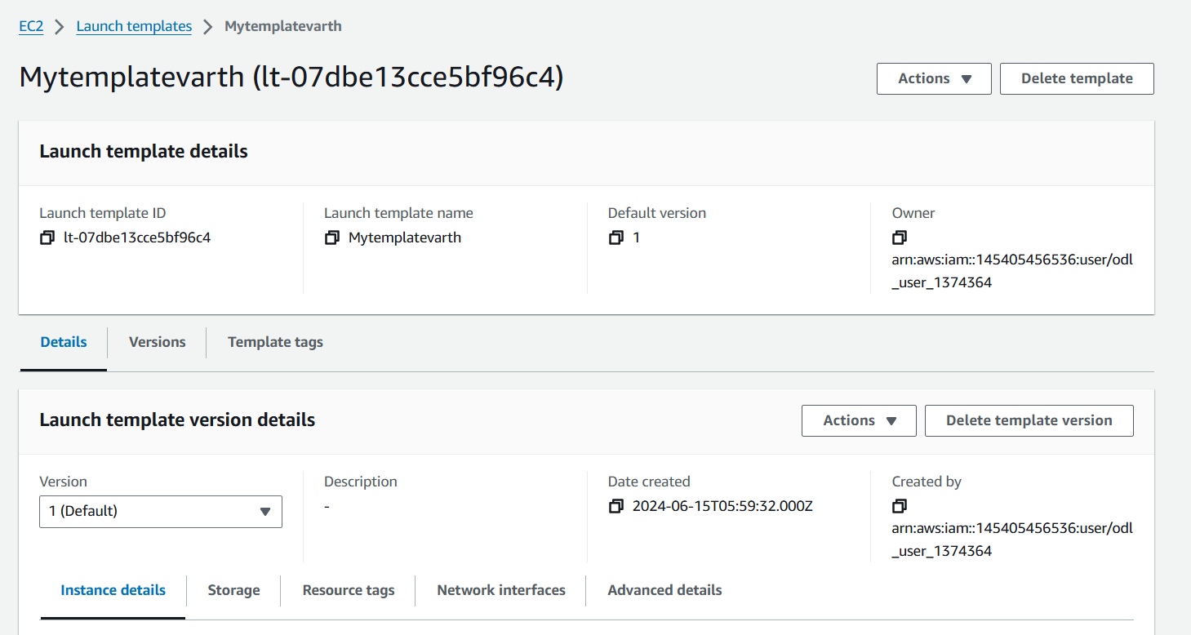

Step no 2 : Create auto-scaling group with elastic load balancer

Step 3 : Test the load balancer

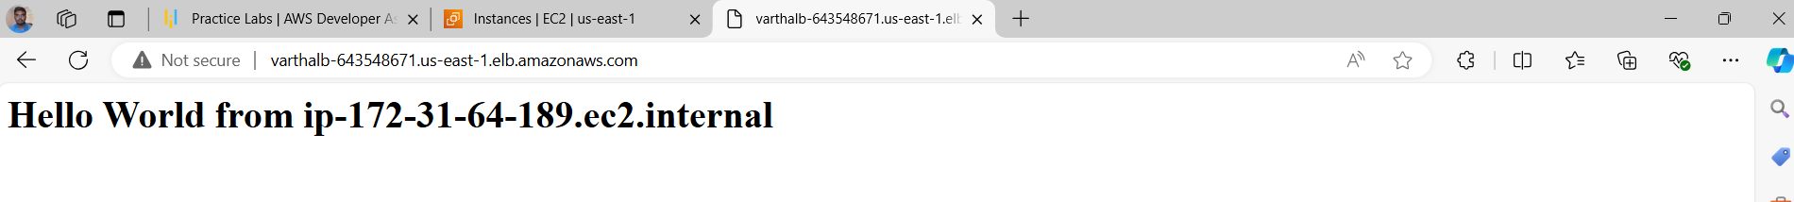

Step 4:Create a Dynamic scaling policy

Step5: Test scale out operation

Step6:Test scale in operation

