- Do a git clone and download the files from git
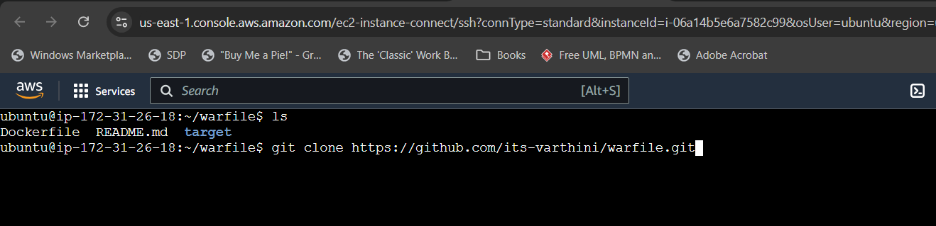
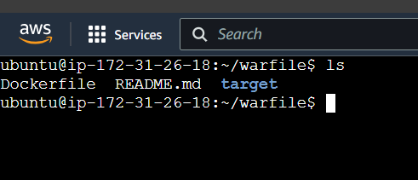
2)build the docker image using Dockerfile
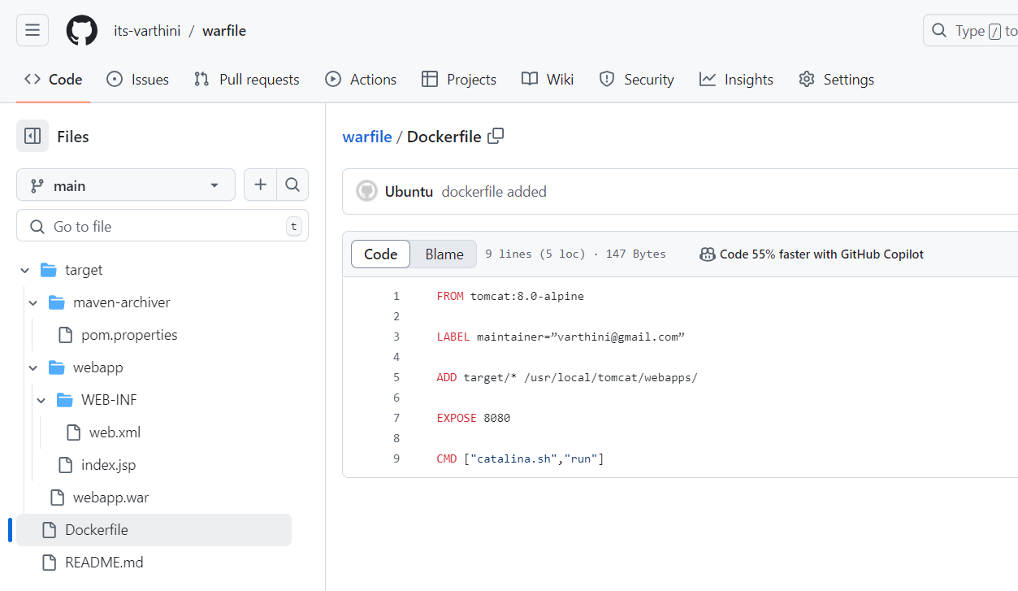

FROM tomcat:8.0-alpine
LABEL maintainer=”varthini@gmail.com”
ADD target/* /usr/local/tomcat/webapps/
EXPOSE 8080
CMD ["catalina.sh","run"]
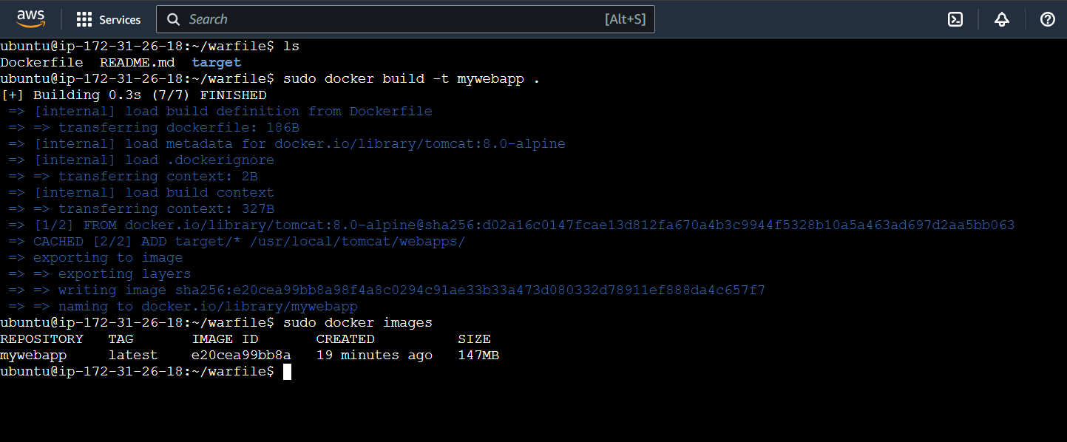
3)Run a container using the image we created.
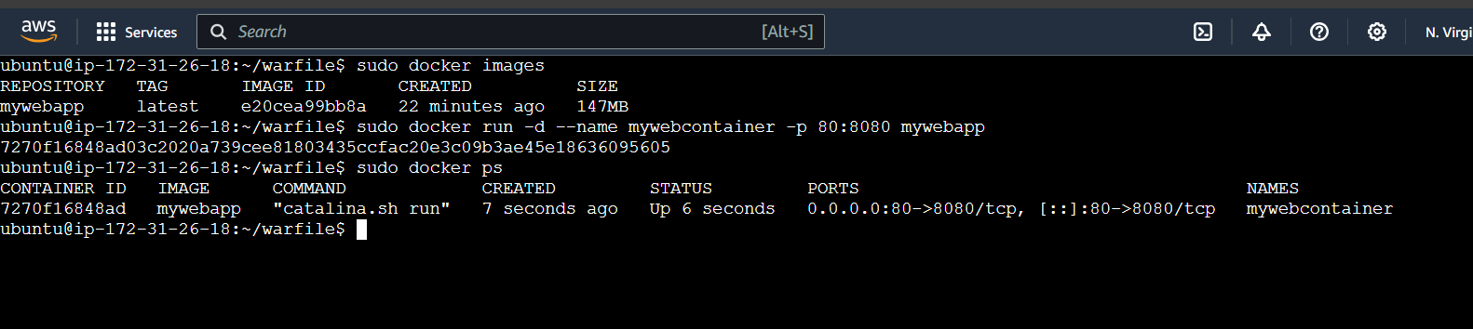
4) http://35.174.7.30:80 hit this url in browser to see tomcat server running
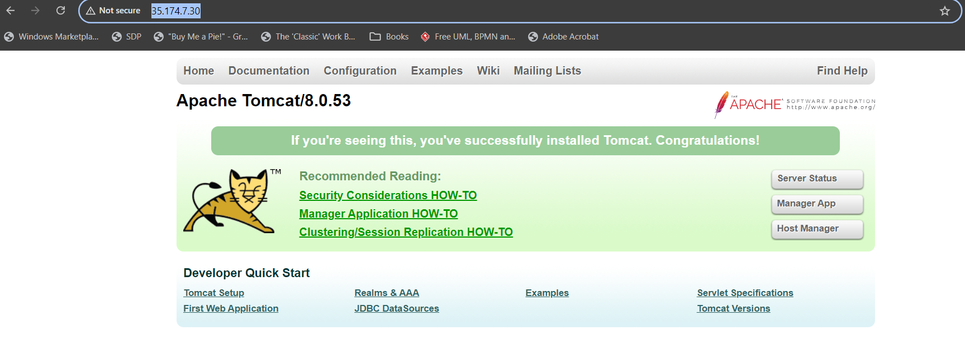
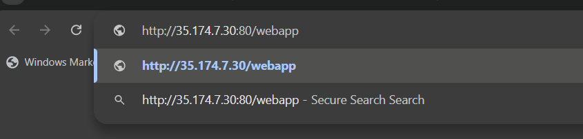

5) http://35.174.7.30:80/webapp to check our application running
The webapp is nothing but the name of our war file that we copied inside while creating container image.
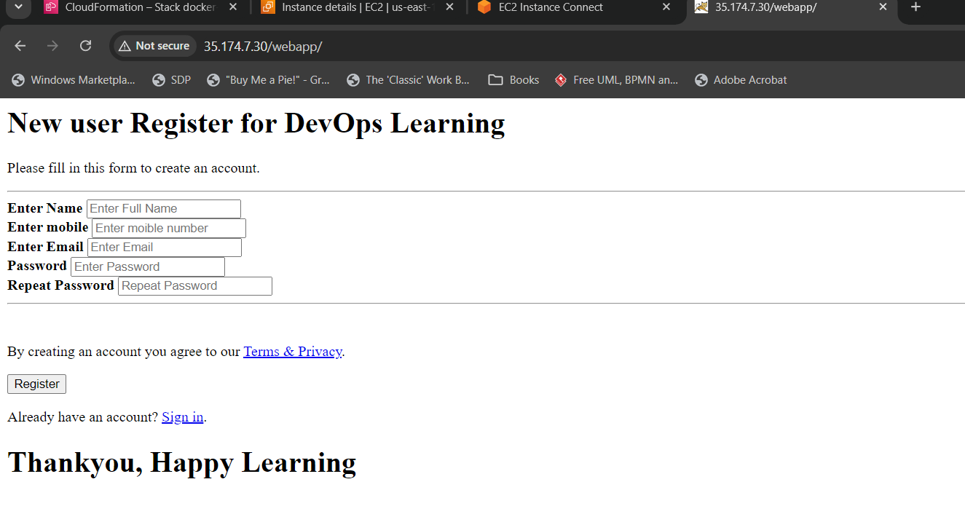
Correction:
We can just copy the war file alone to run the application in tomcat
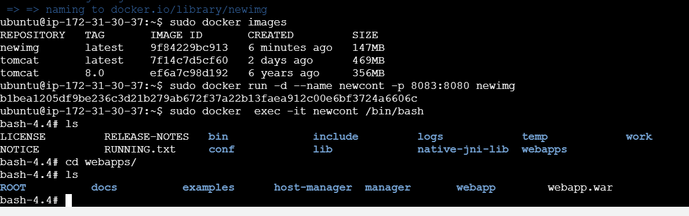
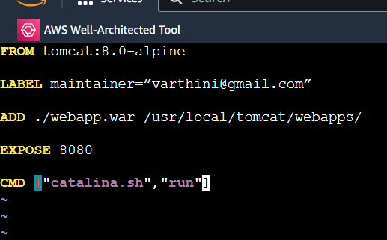
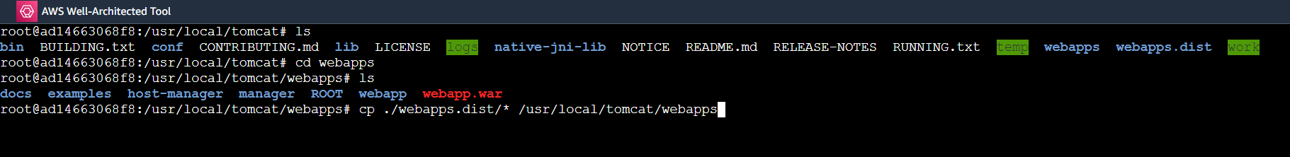

Jenkins to run in different port
- Change port in Debian/Ubuntu: /etc/default/jenkins as HTTP_PORT=9090
Sudo Systemctl daemon reload
Sudo systemctl restart jenkins
(if not working change port in /lib/systemd/system/jenkins.service)
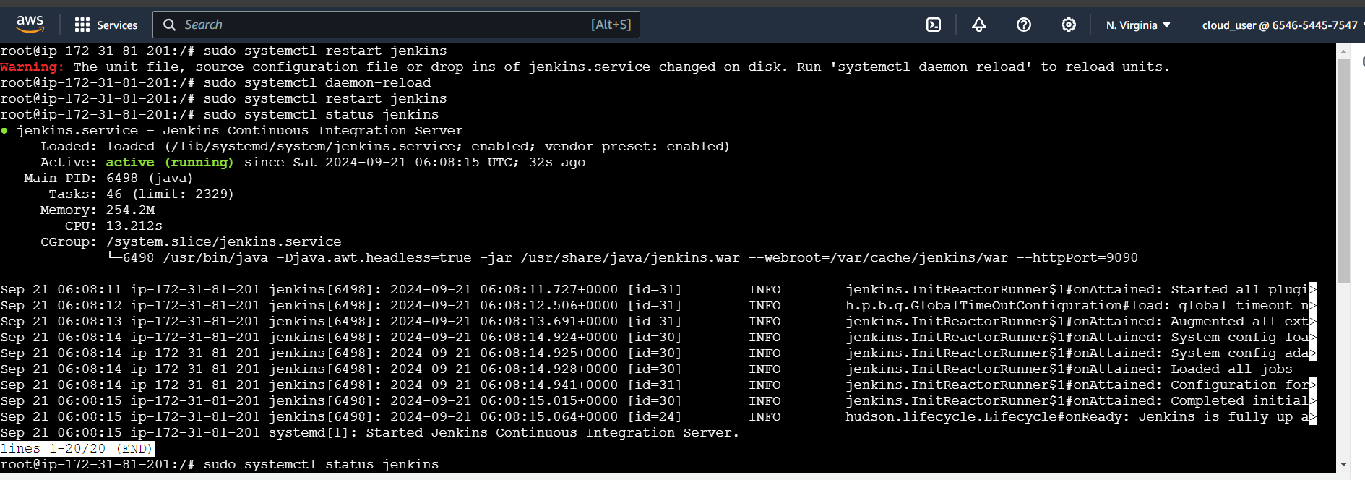

Pre requisite:
-EC2 machine with Jenkins ,docker installed ,
-usermod -aG add user in docker group
-Jenkins port changed to 9090 ,
-inside Jenkins UI manage plugin add Docker pipeline plugin
-add dockerhub usrname password in credentials section.
