Creating Main.tf and provider.tf files in the machine having Terraform installed



Set session token as well using command :

**aws configure set aws_session_token**

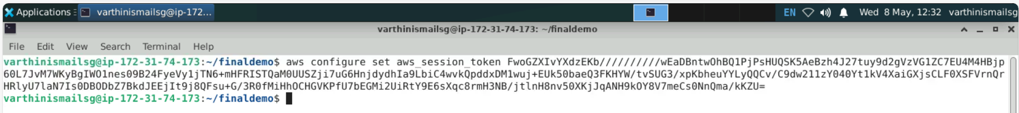

check the terraform code using command :

**terraform init**

**terraform plan**

Use command: **terraform apply**

to create an **EC2 instance** named **Jenkins-sr** with a **security group** named **Jenkins-Security Group**

Enter **yes** to perform the action by terraform

Login into AWS and see the created instance

SSH to the created instance and in the terminal execute **ansible-install.sh** shell file to install ansible in the instance.

check Ansible is installed using the command

**ansible --version**

Create a playbook named **jenkins-playbook.yml**

Execute the playbook using the command

To check Java installed use the command:

**java --version**

To check Jenkins is installed use the command :

**sudo systemctl status jenkins**

To check Jenkins is installed use the command :

**python3 --version**

**Conclusion:**

In the above screenshots, I have demonstrated the **infrastructure provisioning** using **Terraform** and **installing software** using **Ansible**. I have provided the code files I used for this demo in the source code section.