Step 1 : create a key with same name in aws console and copy in local machine where terraform and ansible running.

Use same key inside instance.tf file for creating aws instance.

Create a webserver(ubuntu machine) install terraform , ansible and awscli in it.

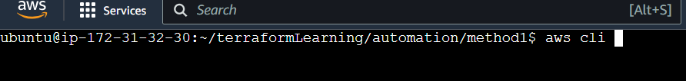

Create ansible.cfg , aws-exam-testing.pem providers.tf instance.tf files in a folder.

Use chmod 400/600 to change the permissions of aws-exam-testing.pem.



Instance.tf file set the ami , Secgroup , availability zone ,key name (key should be created in same AZ as instance)

In provisioner check host and user as ubuntu(the instance we are going to create)

After terraform plan and apply we can hit the public dns of newly created instance to see below output

