USER MANUAL AUTOMATED APPOINTMENT REMINDER SYSTEM
Week 13 – Initial Project
Prepared by: April Joy S. Legaspi
Technology: Flutter and Dart
GitHub Repository:
https://github.com/its1aprilj/week13-appointment-reminder.git
1. INTRODUCTION
The Automated Appointment Reminder System is a software project designed to help users manage appointment information and monitor reminder processing. It provides an application interface for viewing appointments, checking their statuses, and performing available appointment-related actions.
This user manual provides step-by-step instructions on how to open, use, and test the application. It also explains the appointment statuses, basic troubleshooting procedures, and important safety practices.
Project Scope
The submitted GitHub repository contains the Flutter frontend of the system. The Laravel backend is maintained separately and must be running for features that communicate with the API to function.
Important Note: Reminder delivery during Week 13 testing is simulated. The system records simulated delivery results and does not claim that actual SMS or email messages were sent.
2. SYSTEM REQUIREMENTS
The following are required to run the application:
- Windows computer
- Flutter SDK installed
- Dart SDK included with Flutter
- Android Studio
- Google Chrome browser
- Laravel backend project
- Configured database for the backend
- Internet or local network connection when required by the API configuration
3. STARTING THE APPLICATION
3.1 Opening the Flutter Project
- Open Android Studio.
- Select Open.
- Locate the Flutter project folder named appointment_reminder_week13.
- Select the folder and wait for Android Studio to load the project.
- Open the Terminal panel.
3.2 Installing Dependencies
In the Android Studio terminal, execute: flutter pub get Wait until the dependencies finish installing.
3.3 Running the Application in Google Chrome
Execute the following command: flutter run -d chrome Wait for Flutter to build and launch the application in Google Chrome.
Screenshot 1: Application Running in Google Chrome
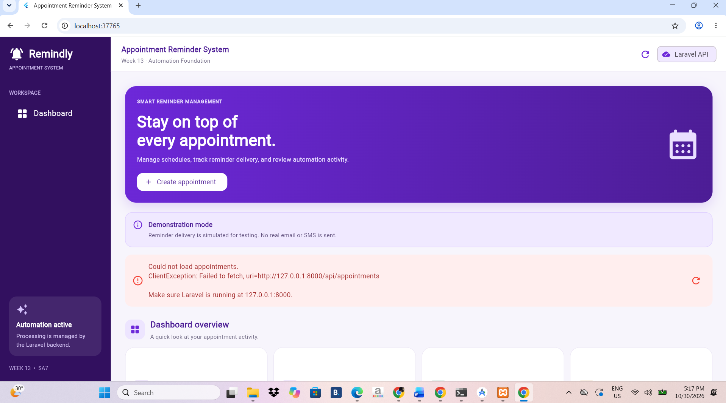

Figure 1. Automated Appointment Reminder System running in Google Chrome.

3.4 Starting the Laravel Backend
If the application requires API communication, start the Laravel backend.
- Open another terminal or Command Prompt.
- Navigate to the backend project directory: cd "C:\Users\AprilJoy\StudioProjects\appointment_reminder_api"
- Start the Laravel development server: php artisan serve
- Keep the terminal open while testing the application.
- Ensure that the Flutter application is configured with the correct API base URL.
4. SYSTEM USAGE PROCEDURES

4.1 Viewing the Appointment Dashboard
The dashboard or appointment list allows users to view the appointment records available in the application.
Steps:
- Open the application in Google Chrome.
- Wait for the dashboard or appointment list to load.
- Review the displayed appointment information.
- Check the status of each appointment.
- Select an appointment to view more information, if the option is available.
Screenshot 2: Appointment Dashboard
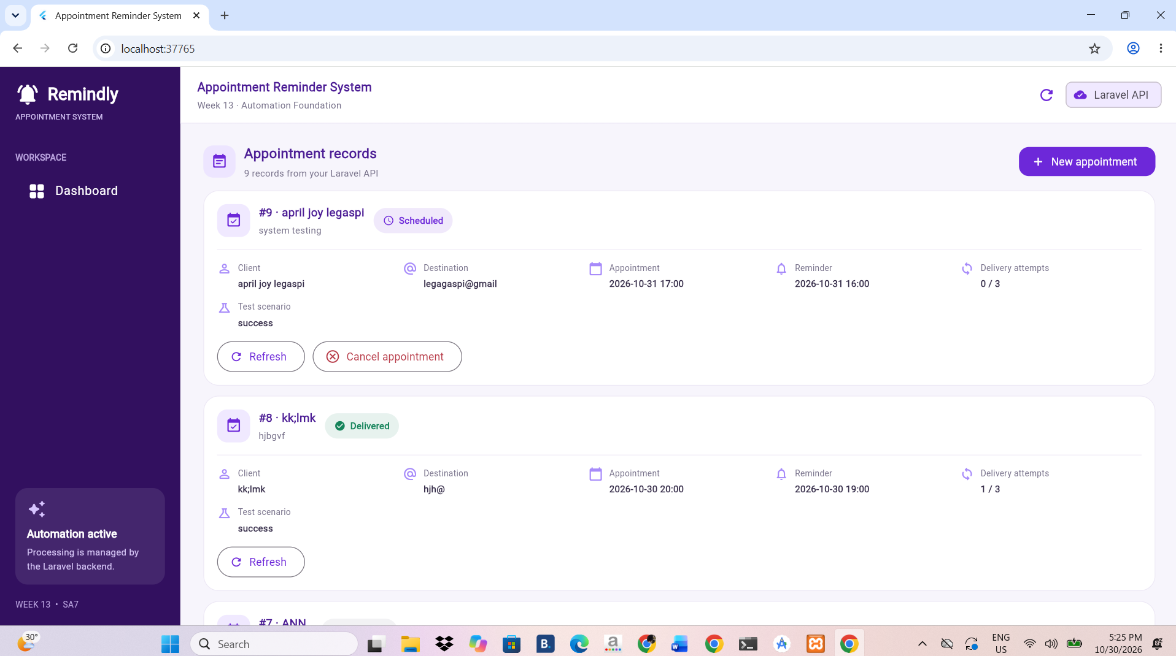

Figure 2. Appointment dashboard displaying available appointment records.

4.2 Creating an Appointment
This procedure applies if the current application build provides an appointment creation function.
Steps:
- Locate the Add Appointment, New Appointment, or equivalent button.
- Select the button to open the appointment form.
- Enter the required appointment information.
- Review the entered details for accuracy.
- Select Save or Submit.
- Check whether the new appointment appears in the appointment list.
Screenshot 3: Appointment Creation Form

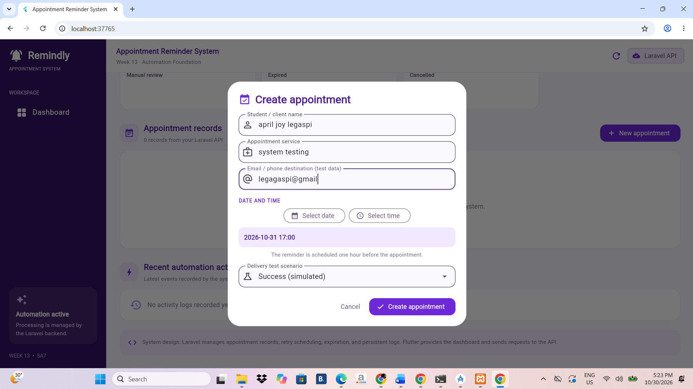

Figure 3. Appointment creation form.

4.3 Viewing Appointment Details
Users can inspect the information associated with an appointment.
Steps:
- Open the appointment list.
- Select the appointment to inspect.
- Review the displayed appointment details.
- Check its current status.
- Return to the appointment list using the available navigation control.
Screenshot 4: Appointment Details
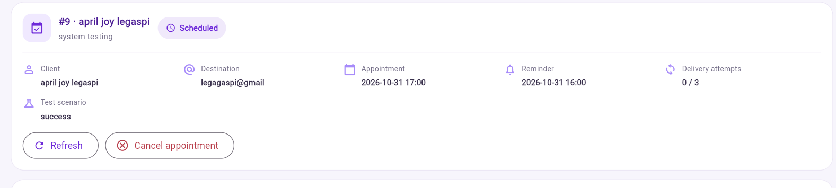

Figure 4. Appointment information and status.
4.4 Rescheduling an Appointment
Status: Not Available in the Current Week 13 Version
The current version of the Automated Appointment Reminder System does not yet include an appointment rescheduling function. Users cannot modify an existing appointment's date or time through the application.
This feature may be considered for implementation in a future version.
Note: Rescheduling procedures and screenshots are not included because this function is not currently available.

4.5 Cancelling an Appointment
This procedure applies if the application provides an appointment cancellation option.
Steps:
- Select the appointment to be cancelled.
- Locate the Cancel option.
- Review the confirmation prompt, if displayed.
- Confirm the cancellation.
- Return to the appointment list.
- Verify that the appointment status has changed.
Screenshot 6: Cancelled Appointment
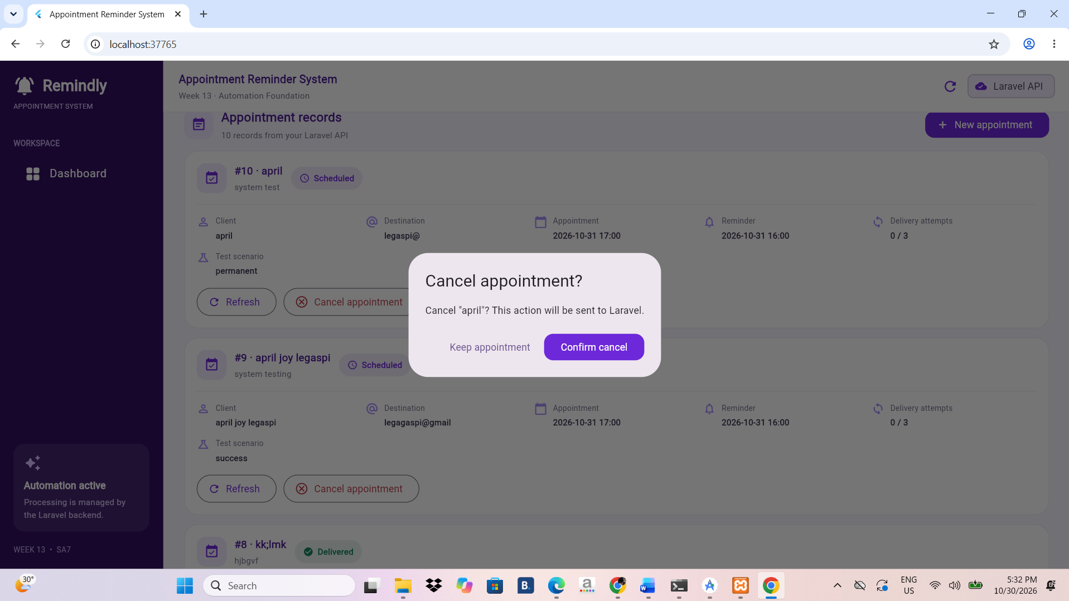

Figure 6. Appointment cancellation or cancelled appointment status.

5. APPOINTMENT AND REMINDER STATUS GUIDE
The following statuses are used in the Week 13 project tests:
Scheduled
The appointment or reminder is scheduled for processing.
Retrying
A temporary simulated delivery problem occurred, and another attempt has been scheduled.
Delivered
The system recorded a successful simulated reminder delivery. This does not mean that an actual SMS or email was sent.
Manual Review
The system requires further inspection or action because the reminder encountered a problem that cannot be handled through automatic retries.
Cancelled
The appointment was cancelled, and pending reminders should no longer be processed.
Expired
The appointment time has passed, and the reminder is no longer eligible for normal processing.

6. SAFETY, PRIVACY, AND DATA INTEGRITY
The following practices must be observed when using and testing the system:
- Use sample appointment records during demonstrations.
- Do not enter unnecessary confidential or sensitive personal information.
- Never upload database passwords, API keys, access tokens, or .env files to GitHub.
- Verify appointment details before saving, rescheduling, or cancelling.
- Do not modify database records without authorization.
- Use only authorized access to the application and backend.
- Keep screenshots accurate and ensure they represent actual application results.
- Clearly identify simulated reminder delivery in demonstrations and documentation.

7. EVIDENCE SCREENSHOTS CHECKLIST
The following screenshots should be included as evidence of the application's operation:
-dashboard
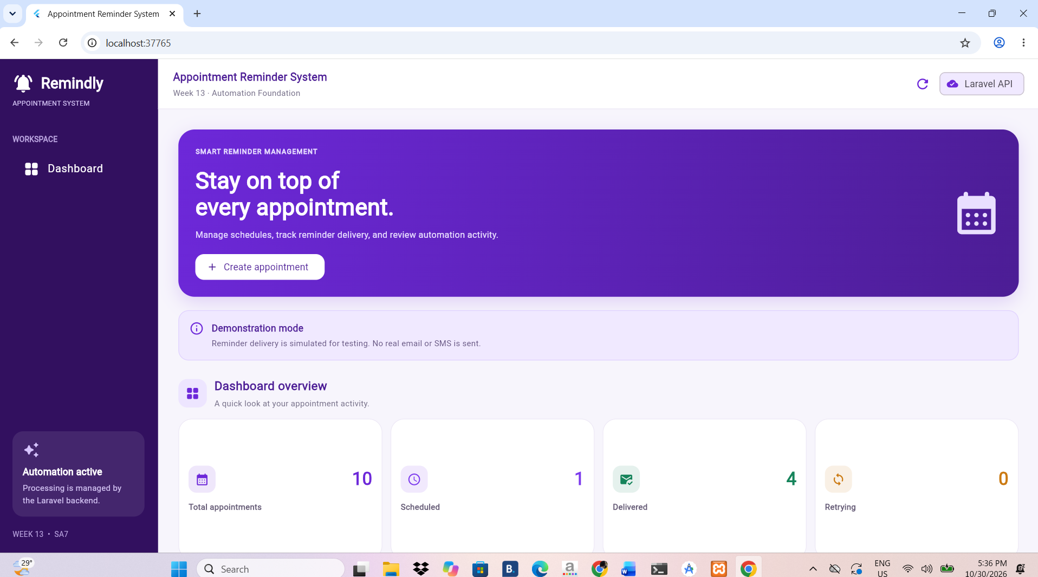

– Appointment dashboard or appointment list
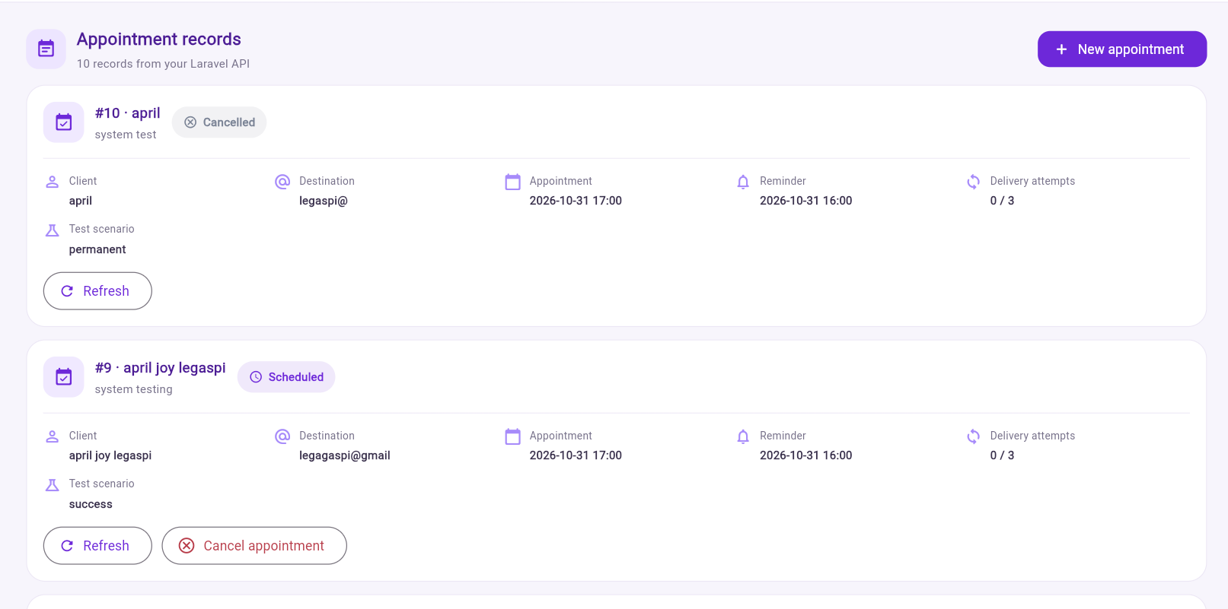

Appointment creation form

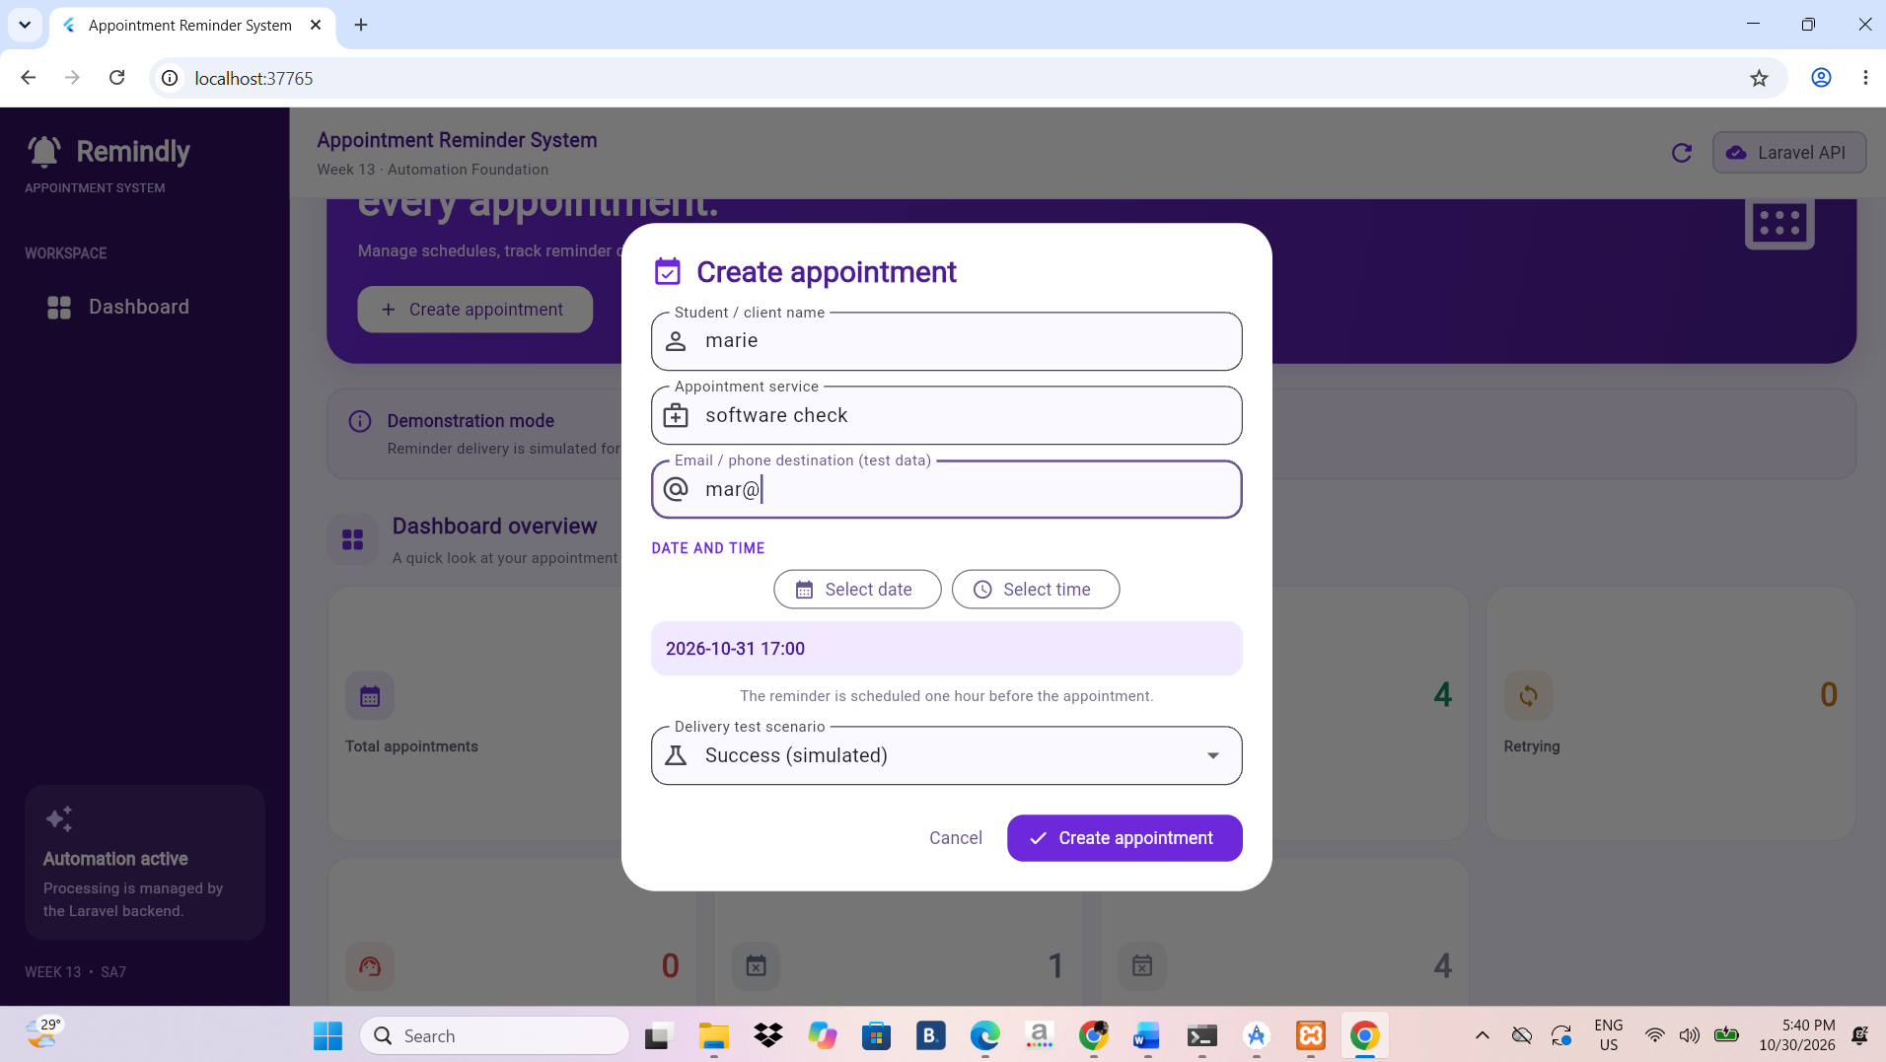

Appointment details and status
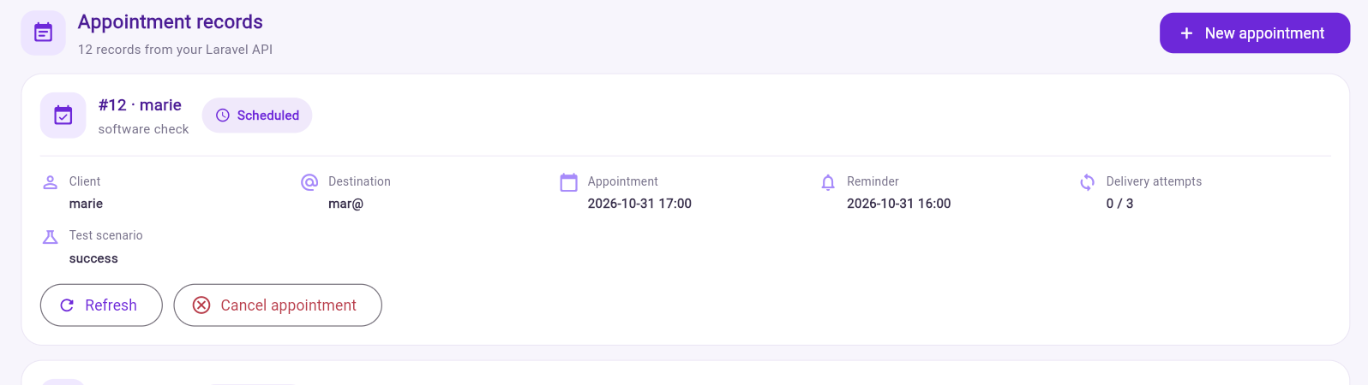

Cancellation function, if implemented
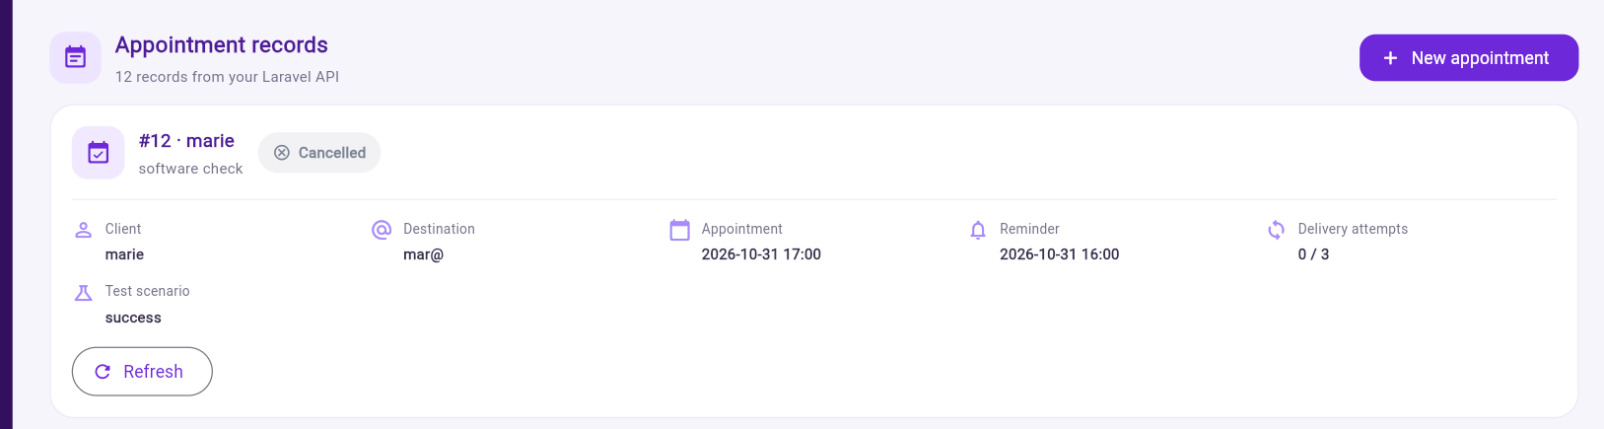

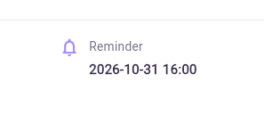
Reminder status or reminder logs

Expired appointment test result, if visible
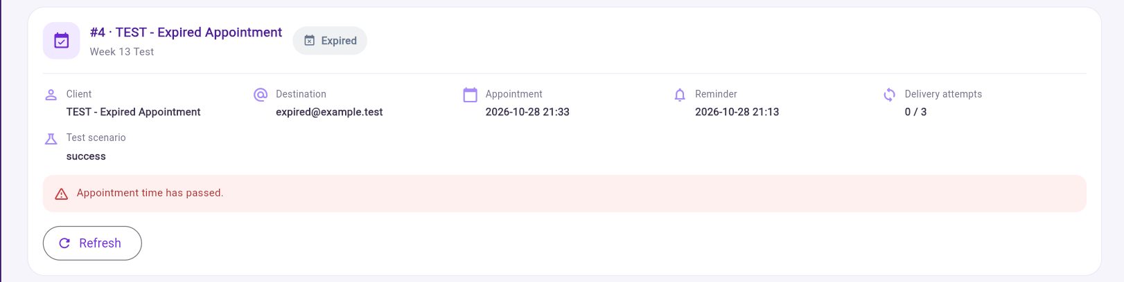

Evidence Integrity: All screenshots must be captured from the actual running application or genuine test output. Do not use edited or fabricated screenshots as proof of completed functionality.
8. TROUBLESHOOTING
Problem: The application does not start.
Solution:
- Check whether Flutter is installed.
- Open the correct project folder.
- Run flutter pub get.
- Run flutter run -d chrome again.
Problem: Google Chrome is not detected.
Solution:
- Make sure Google Chrome is installed.
- Execute:
flutter devices
Problem: The application cannot connect to the backend.
Solution:
- Check whether the Laravel server is running.
- Verify the API base URL configured in the Flutter project.
- Check the backend terminal for errors.
- Confirm that the database is accessible.
Problem: Appointment records do not appear.
Solution:
- Check the backend connection.
- Verify the database configuration.
- Refresh the application.
- Check the Laravel terminal for errors.
Problem: A function is not available.
Solution:
The function may not yet be included in the current Week 13 version. Only demonstrate and document features that are actually implemented and tested.
9. GITHUB REPOSITORY AND SUBMISSION
The Flutter frontend source code is available in the following GitHub repository:
Repository Link:
https://github.com/its1aprilj/week13-appointment-reminder.git

