Duality AI – Space Station Hackathon Report

# 1. Title

Project Name: Space Station Object Detector  
Tagline: Accurate object detection in synthetic space environments using YOLOv8.

# 2. Methodology

We used Duality AI’s Falcon platform to obtain synthetic images from a simulated space station. The dataset included labeled images for three object classes: Toolbox, Fire Extinguisher, and Oxygen Tank.  
  
Steps followed:  
1. Set up the YOLOv8 training environment using Anaconda  
2. Prepared the dataset in YOLO format (train/val/test)  
3. Configured data.yaml with paths and class labels  
4. Trained YOLOv8n model for 50 epochs  
5. Evaluated using mAP, precision, recall, and confusion matrix  
6. Generated prediction visuals on the test set

# 3. Results & Performance Metrics

The model was trained for 50 epochs, and the final metrics are based on the validation set performance. The best results were achieved around epoch 41.

**Final Validation Results:**

* Precision: 0.970
* Recall: 0.909
* mAP@0.5: 0.945
* mAP@0.5:0.95: 0.863

**Per-Class Breakdown (Calculated from Confusion Matrix):**

* **Fire Extinguisher:**
  + Precision: 0.965
  + Recall: 0.958
* **ToolBox:**
  + Precision: 0.874
  + Recall: 0.905
* **Oxygen Tank:**
  + Precision: 0.934
  + Recall: 0.919

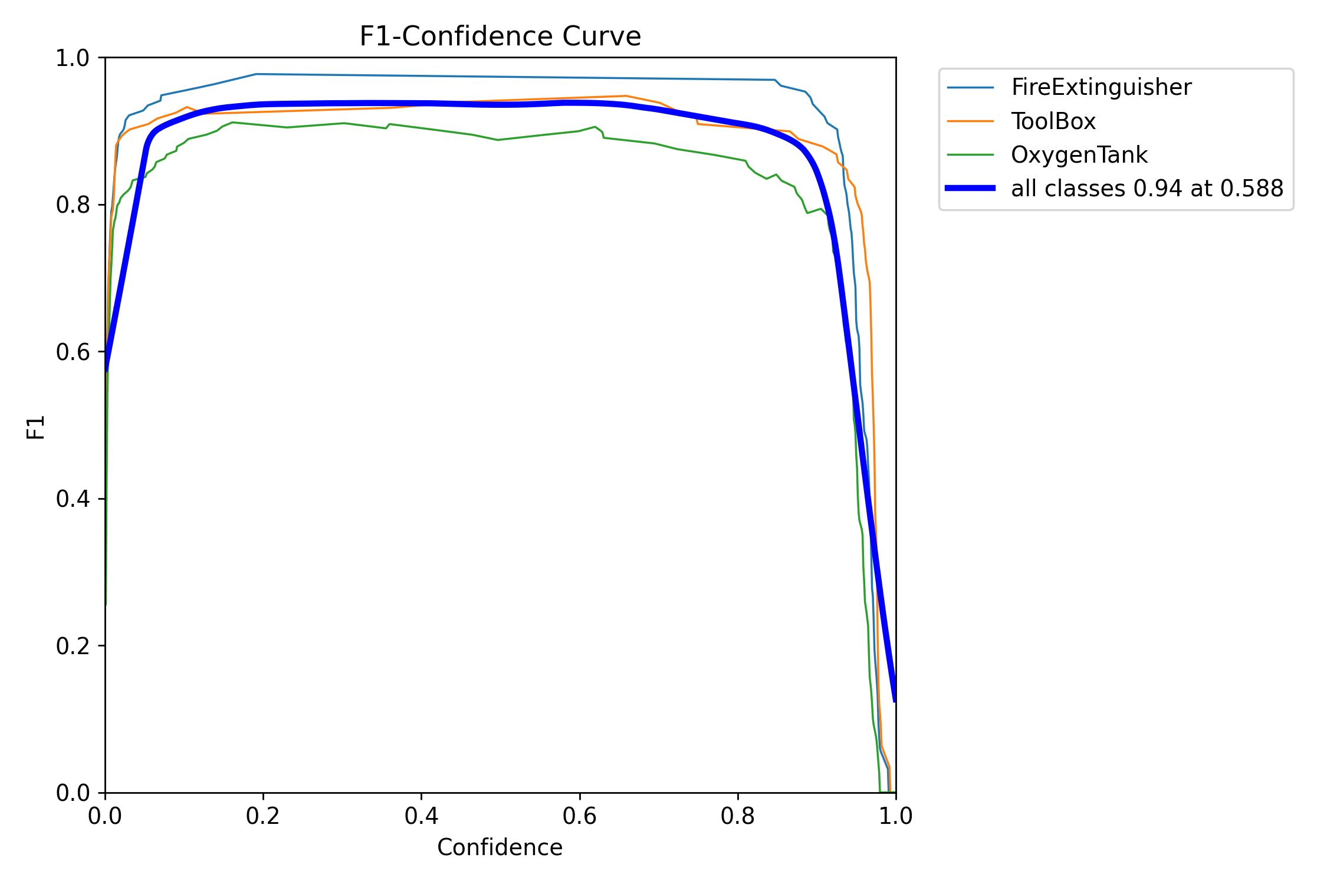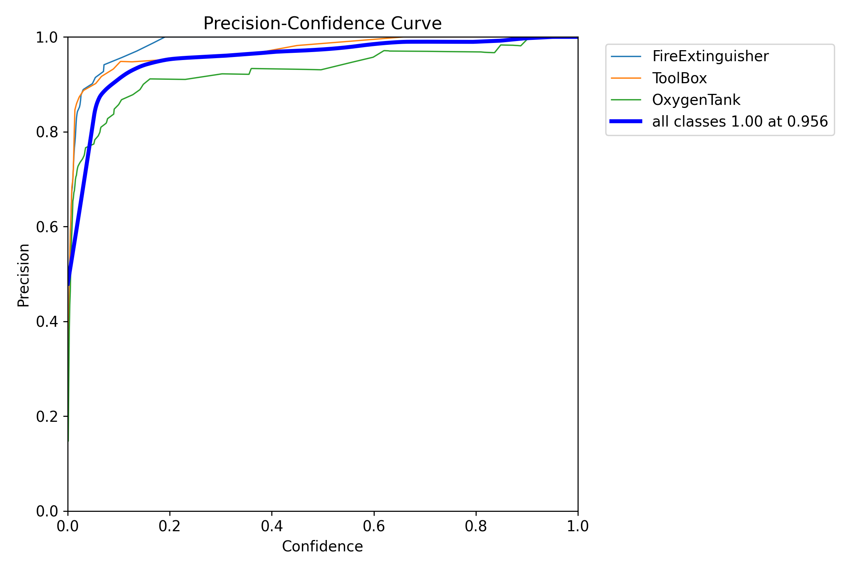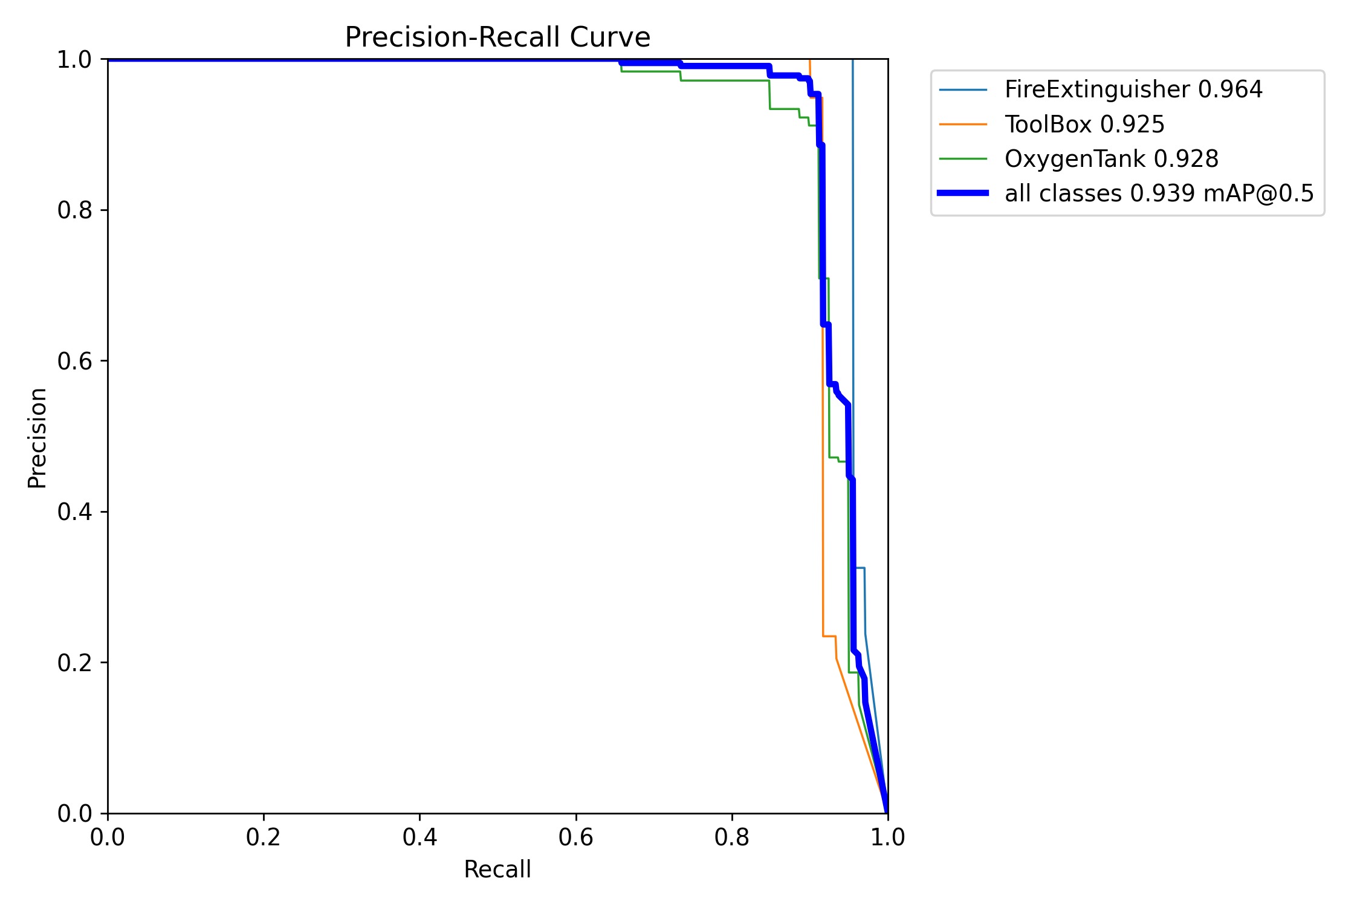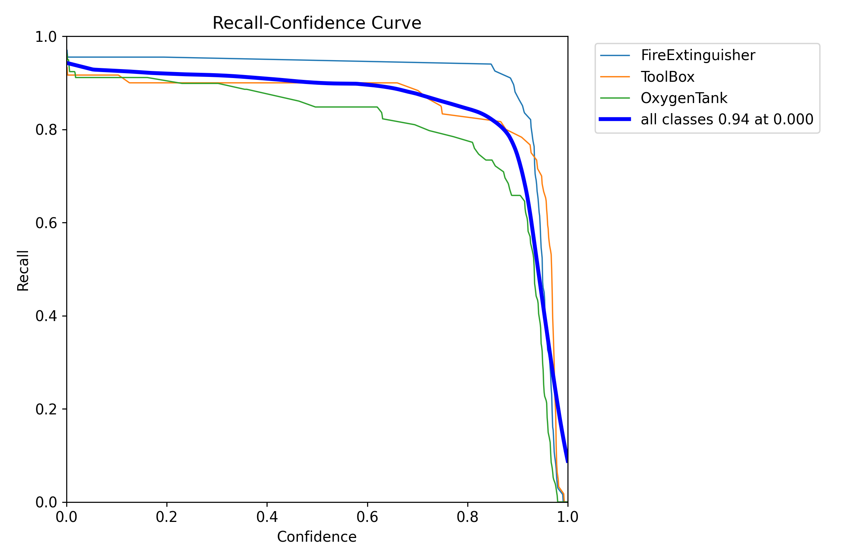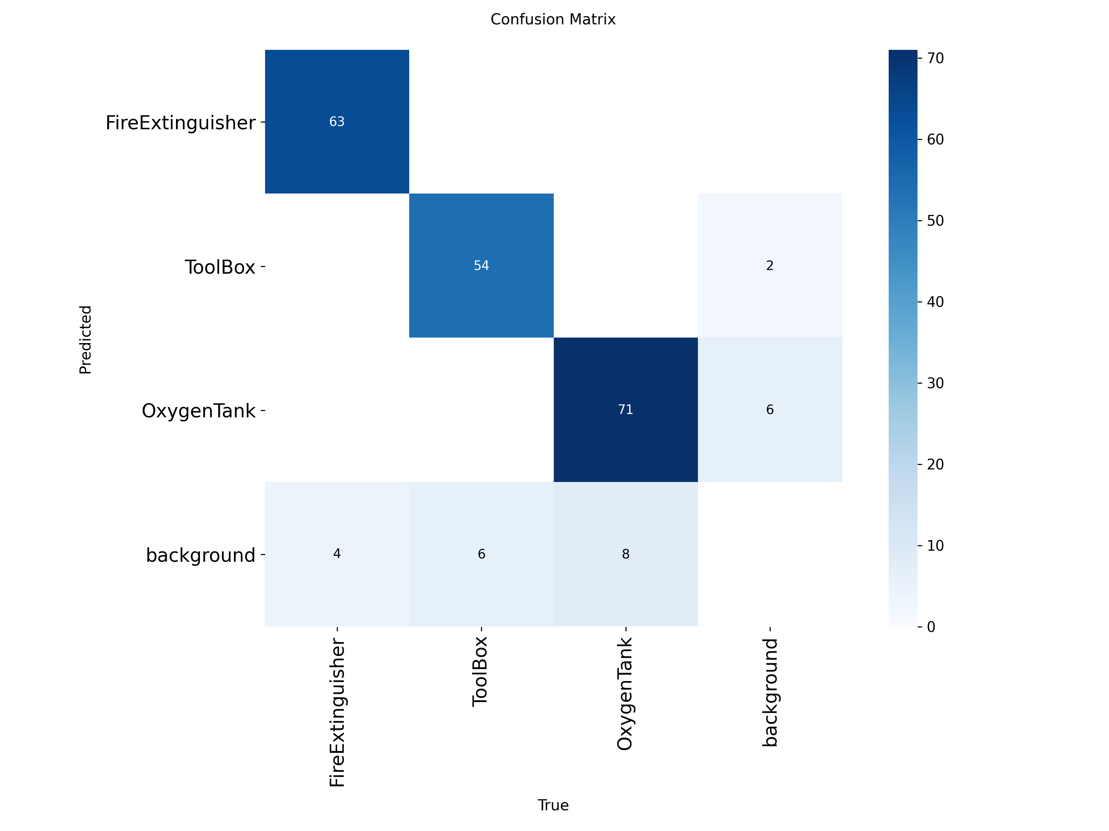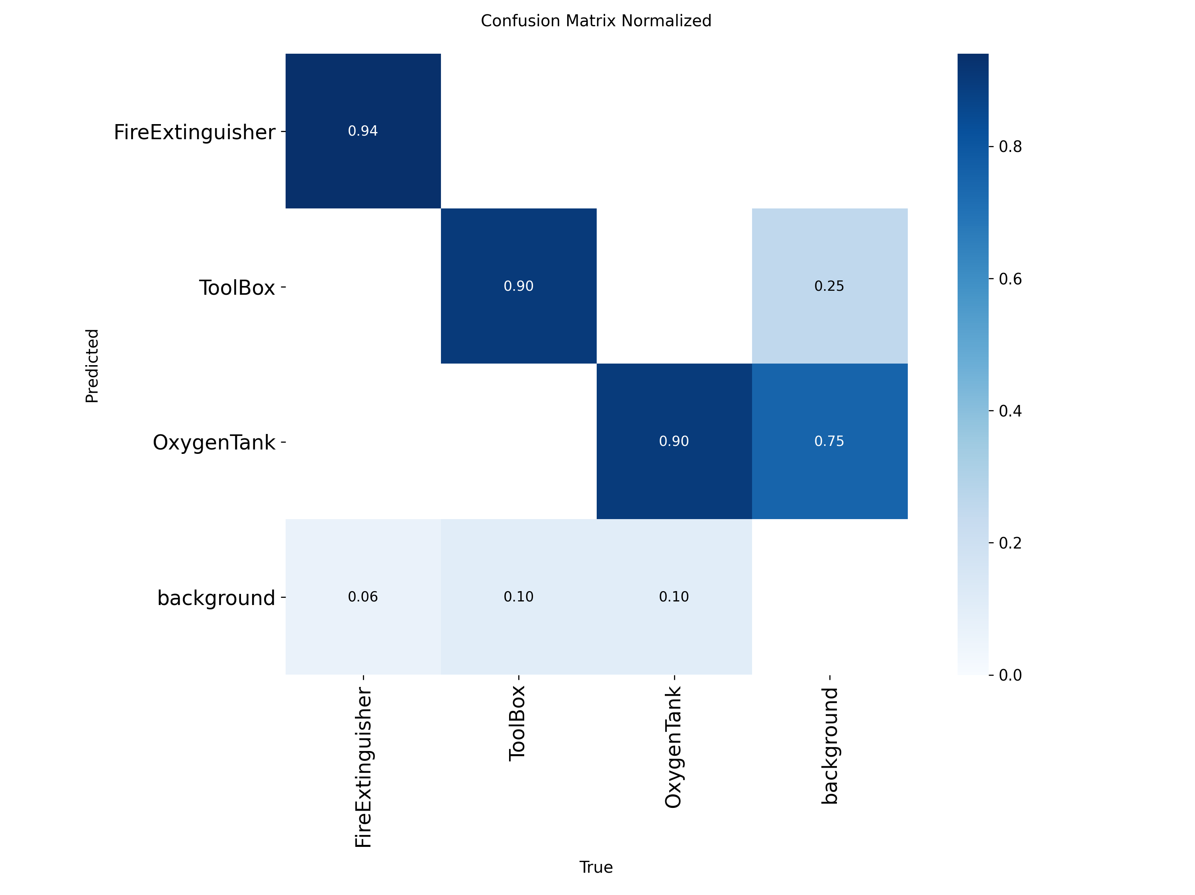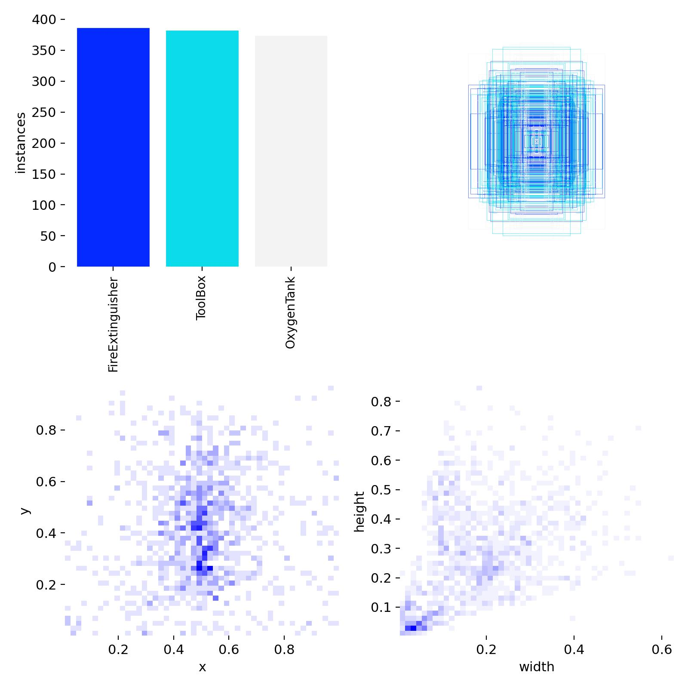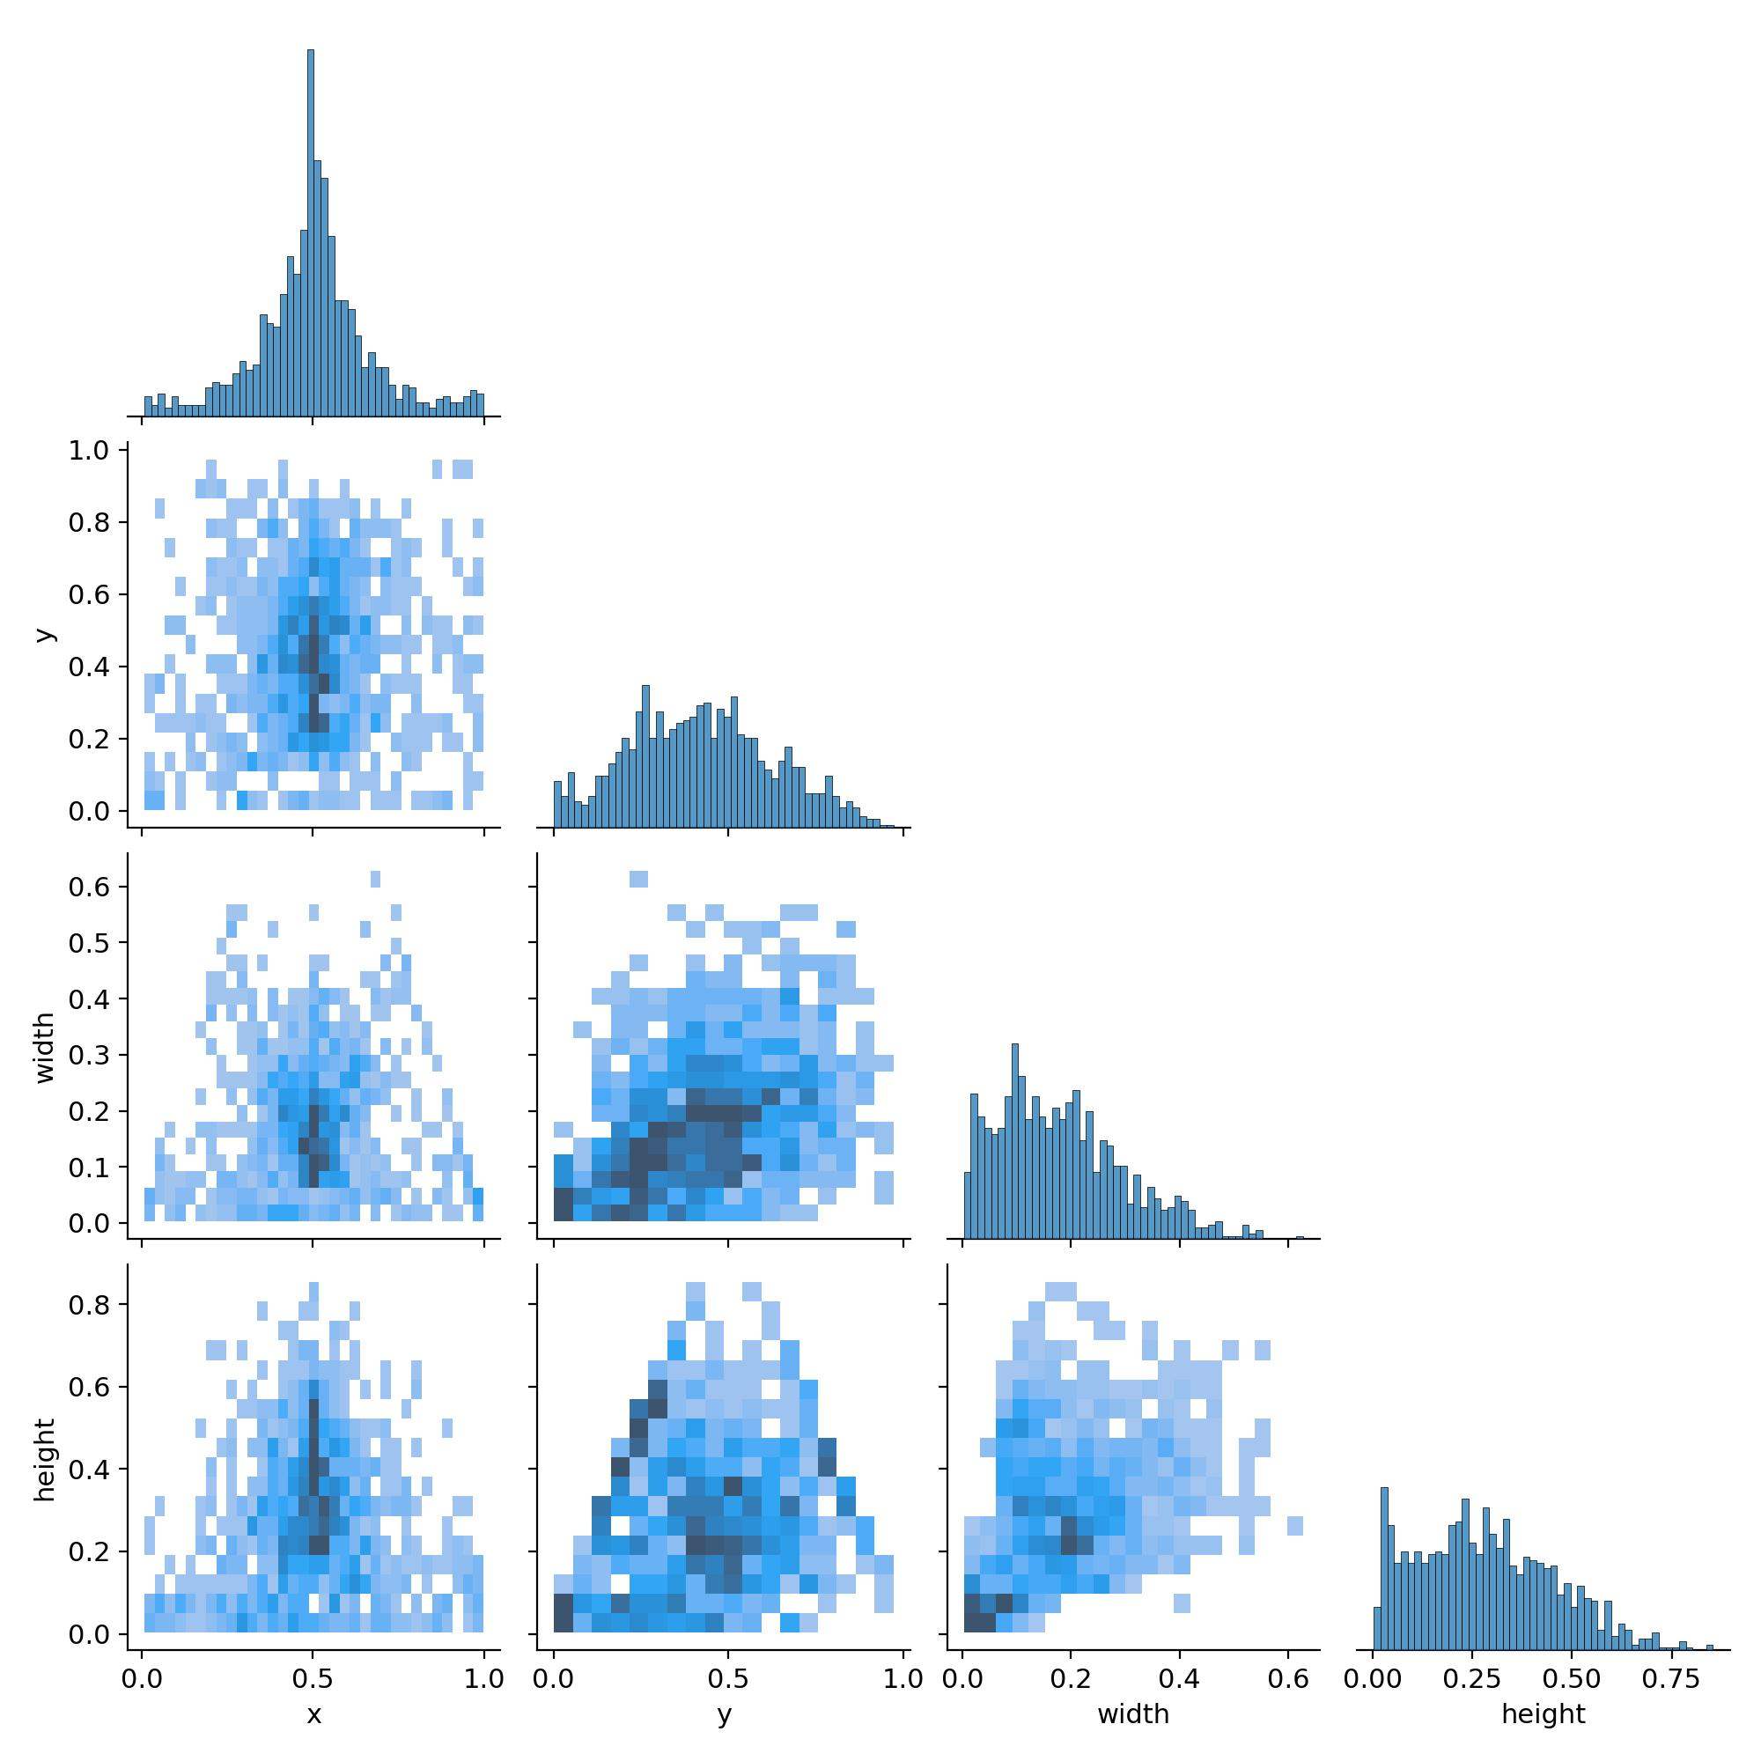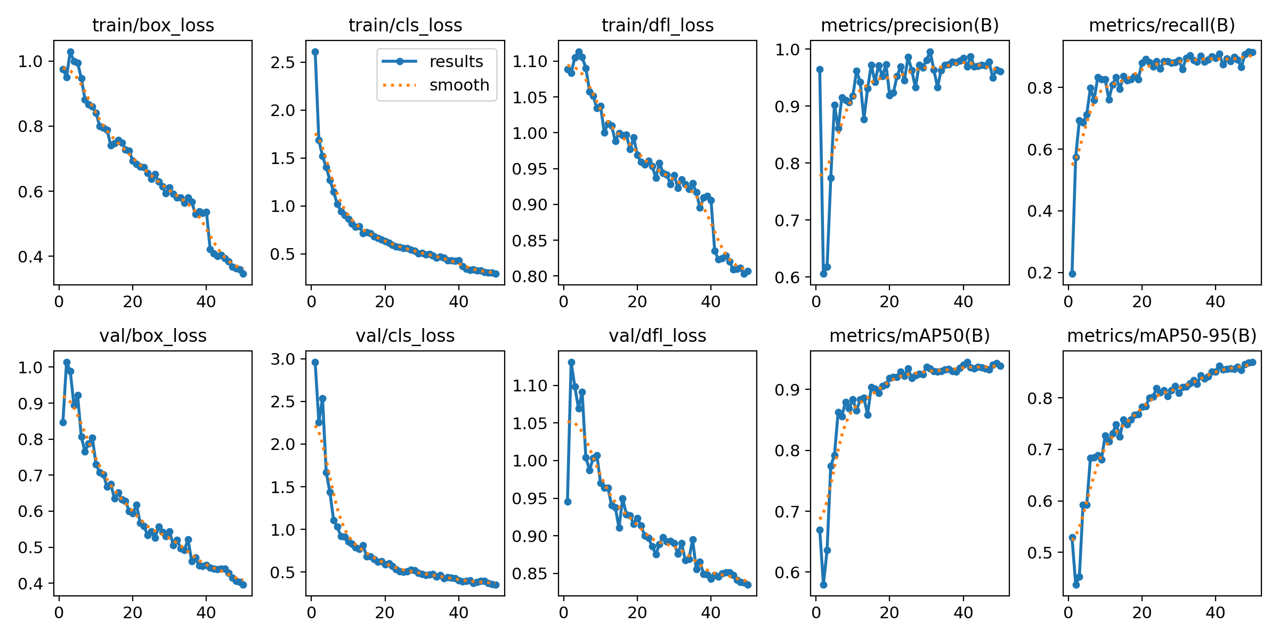

# 4. Challenges & Solutions

• Challenge: Detecting overlapping objects under occlusion  
 ➤ Solution: Applied data augmentation and improved validation  
  
• Challenge: Slow training on CPU-only hardware  
 ➤ Solution: Used lightweight YOLOv8n model and reduced batch size  
  
• Challenge: Initial misclassifications of Oxygen Tank  
 ➤ Solution: Enhanced dataset with diverse angles and lighting conditions

# 5. Conclusion & Future Work

We successfully trained a high-performing object detection model using synthetic data. With a mAP@0.5 of 93.9% and generalization across IoUs, the model proves reliable.  
  
Future Work:  
• Integrate into real-time space monitoring application  
• Enable continuous learning using Falcon updates  
• Expand to detect more space-related objects

### 6. Bonus – Use Case Proposal: The "Astro-Assist" Application

We propose the development and implementation of a mobile/desktop application called "Astro-Assist". This application will serve as an intelligent safety and inventory management system, leveraging the trained YOLOv8 model to provide real-time situational awareness to both astronauts on the space station and ground-based mission control teams.

**Key Features:**

* **Real-Time Inventory Dashboard:** A live feed from station cameras will be processed by the model to detect and track critical objects. A dashboard will display the status and location of all tracked items (e.g., Fire Extinguisher, Toolbox, Oxygen Tank).
* **Automated Anomaly Alerts:** The system will automatically generate alerts if critical safety equipment is misplaced, missing from its designated stowage, or not returned after a procedure.
* **"Last Seen" Locator:** If an item is misplaced, crew members can query the system to find its last known location, showing a timestamp and a snapshot from the relevant camera.
* **Augmented Reality (AR) Overlay:** For on-station crew, a tablet or AR headset interface could overlay digital labels and bounding boxes onto objects in the live camera view, making them easier to locate quickly.