Abhishek Patel

Roll No :19/78106

Operating System

Commands…

1.ls

🡪ls, ls -l, ls-a, ls-h, ls-r, ls-ls, ls version.

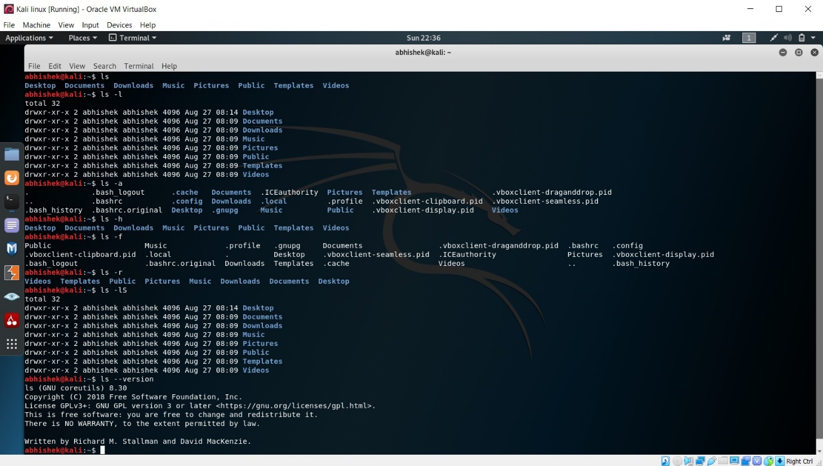

2.cp

🡪cp, cp-i.

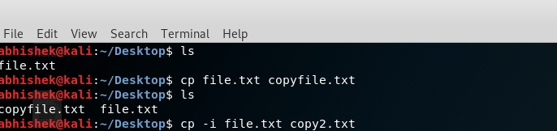

3.mv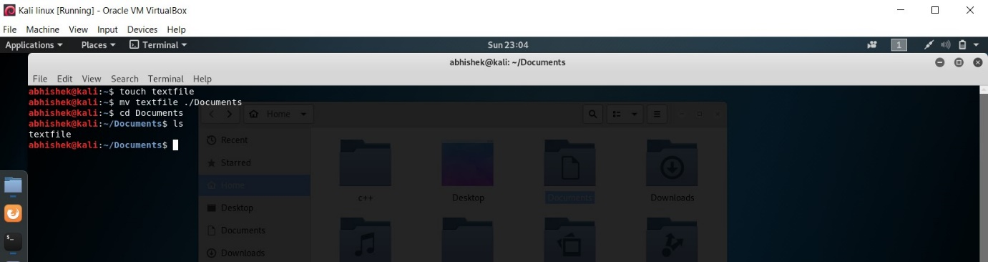

4.chmod

🡪chmod -R, chmod u+x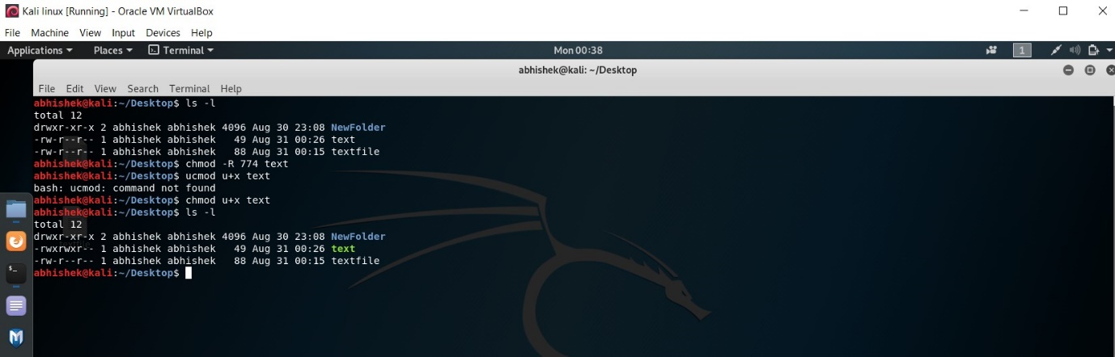

5.mkdir

🡪mkdir, mkdir~, mkdir -p,

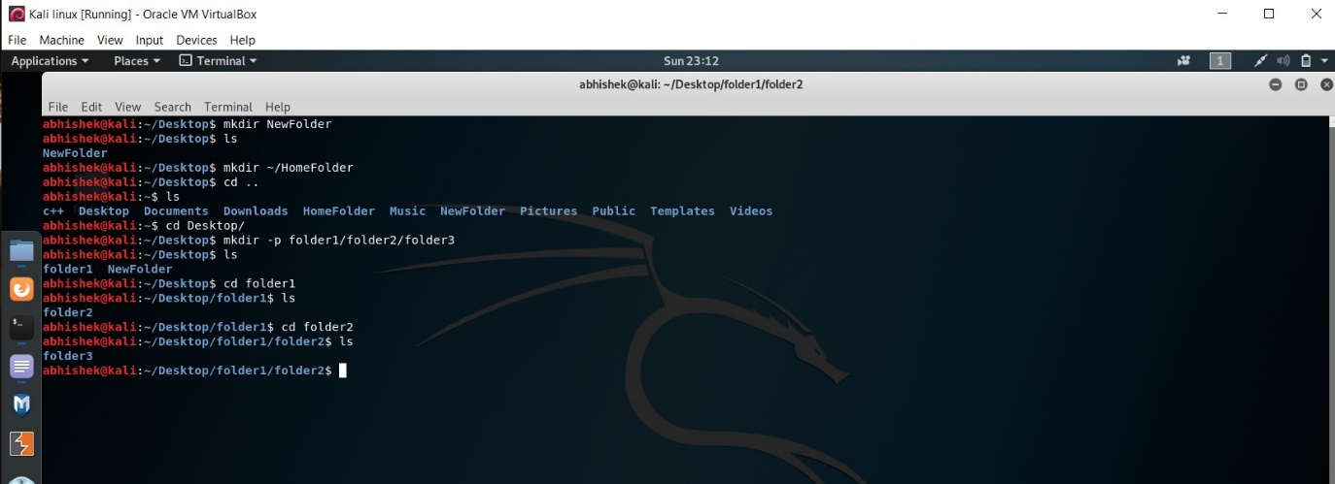

6.rmdir

🡪rmdir, rmdir -v, rmdir -p, rm --version

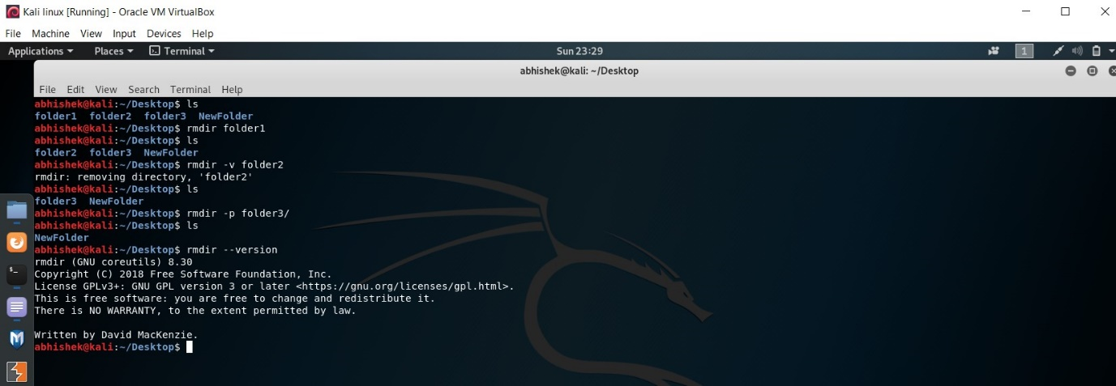

7.rm

🡪rm, rm -i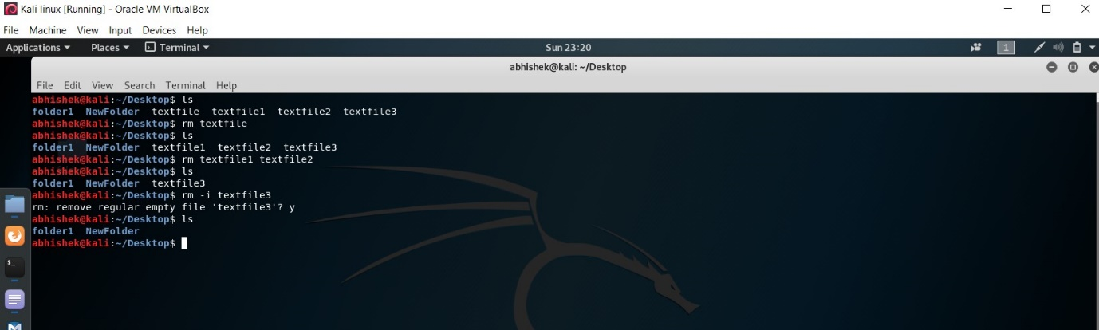

8.cd

🡪cd, cd . ,cd~, cd .. 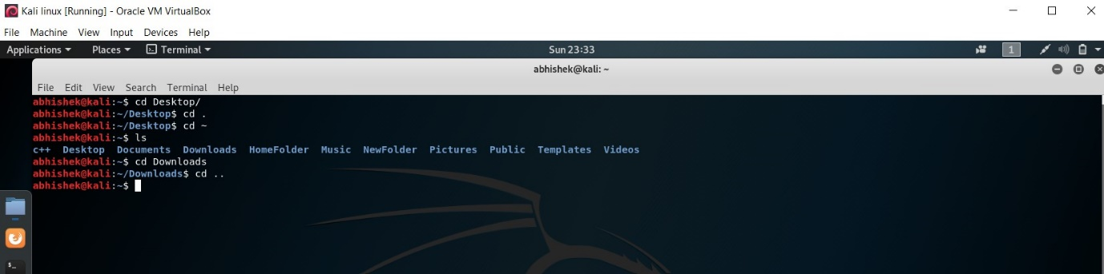

9.pwd

🡪pwd, pwd -L, pwd -P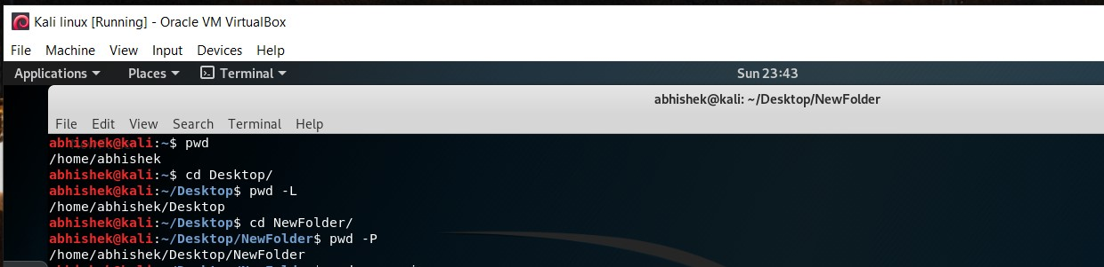

10.grep

🡪grep, grep -i, grep -c, grep -l, grep -w

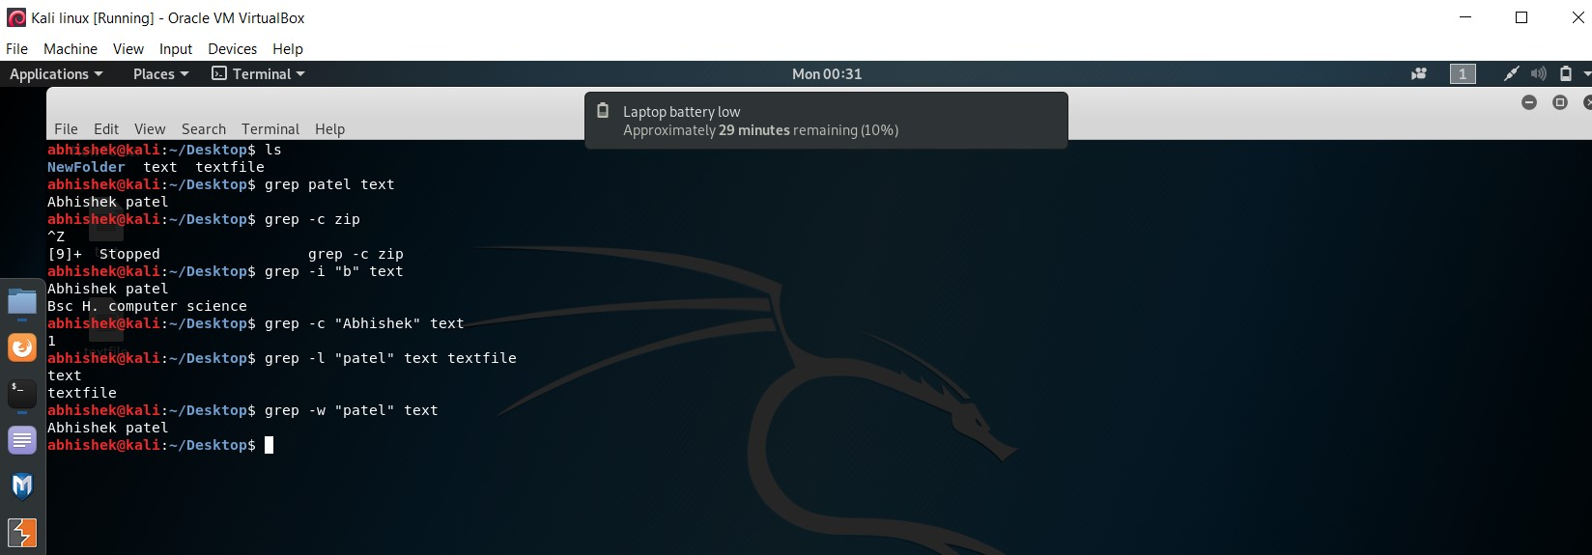

11.cat

🡪cat>text, cat text>>textfile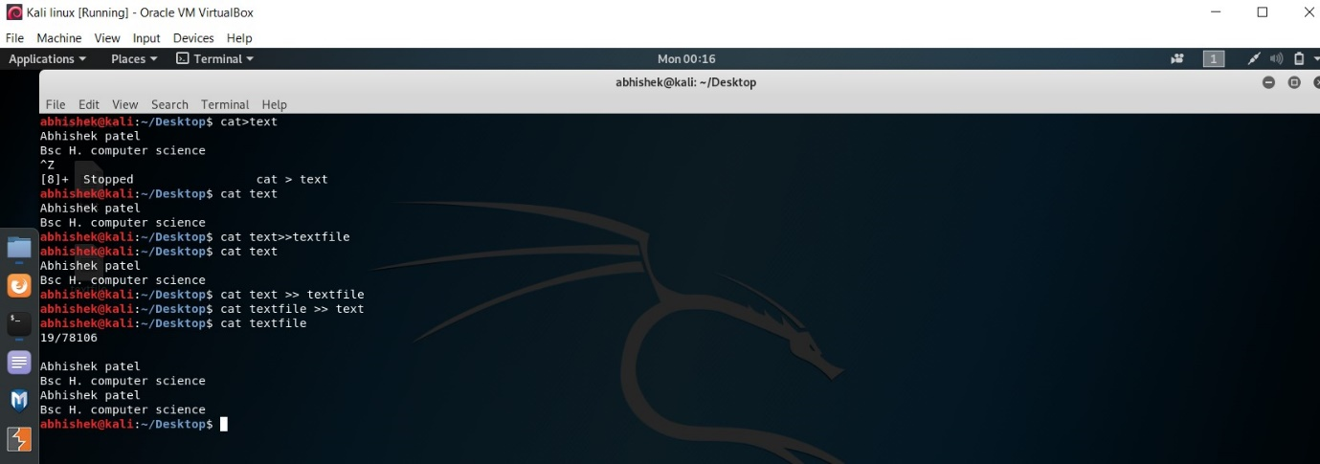

12.passwd

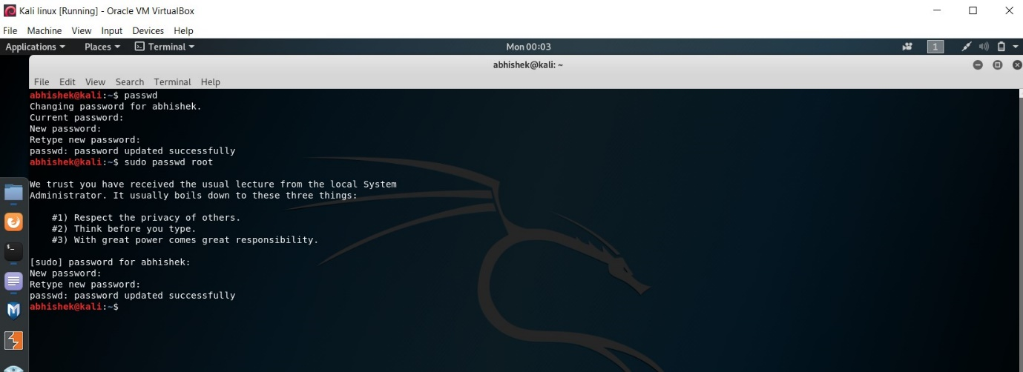

13.who

🡪who, who -H, who -q, who -T, who -a, man who, whoami

