AI-Based Job Recommendation System
A Machine Learning & NLP-Based Approach Using TF-IDF and Cosine Similarity

Project Report Submitted in Partial Fulfillment of
the Requirements for the Degree of

Bachelor of Technology
Computer Science & Engineering

Department of Computer Science & Engineering
[Your College Name]
[Your City] — 2025–2026

Abstract
In today's competitive job market, matching candidates to suitable job roles remains a significant challenge. Traditional job portals rely on keyword-based search which often fails to capture the semantic relevance between a candidate's profile and job requirements. This project presents an AI-Based Job Recommendation System that leverages Natural Language Processing (NLP) and Machine Learning to intelligently recommend jobs based on a user's skills and experience. The system employs TF-IDF (Term Frequency-Inverse Document Frequency) vectorization combined with Cosine Similarity for content-based filtering, and a K-Nearest Neighbors (KNN) classifier for job category prediction. Evaluated on a dataset of 200 job postings across 12 categories, the system achieves a KNN classification accuracy of 87.50% and a Precision@10 of 0.28. An interactive web application is developed using Streamlit, enabling real-time job recommendations based on user-provided skills.
Keywords: Job Recommendation, TF-IDF, Cosine Similarity, KNN, NLP, Content-Based Filtering, Streamlit.

Table of Contents
1. Introduction 4
2. Problem Statement 4
3. Literature Review 5
4. System Architecture 6
5. Dataset Description 6
6. Methodology 7
7. Implementation 9
8. Results and Evaluation 10
9. Conclusion 12
10. References 12

1. Introduction
The rapid growth of the digital economy has resulted in an enormous volume of job postings on online platforms. Job seekers face the challenge of navigating through thousands of listings to find positions that align with their skills, qualifications, and career aspirations. Similarly, recruiters struggle to identify the most relevant candidates from large applicant pools. Recommendation systems have emerged as a powerful solution to bridge this gap by intelligently matching users with relevant items based on their profile and preferences.
This project builds an AI-Based Job Recommendation System using NLP and machine learning techniques. The system accepts a user's skill set or resume summary as input and returns a ranked list of job recommendations sorted by relevance. Unlike simple keyword matching, the system understands contextual relationships between skills and job descriptions using TF-IDF vectorization and cosine similarity, producing semantically meaningful matches.
The primary objectives of this project are: (1) to develop a content-based job recommendation engine using TF-IDF and cosine similarity; (2) to build a KNN classifier for predicting suitable job categories; (3) to evaluate the system using Precision@K and classification metrics; and (4) to deploy the system as an interactive Streamlit web application.

2. Problem Statement
Job seekers today encounter several critical problems when searching for employment opportunities. Traditional job portals rely on simple keyword matching, which often yields irrelevant or overly broad results. Candidates must manually filter through hundreds of listings, which is both time-consuming and inefficient. Furthermore, job postings vary widely in how they describe required skills, making direct keyword matching unreliable.
The core problem this system addresses is: Given a user's skill profile (expressed as free text describing their skills and experience), how can we automatically identify and rank the most relevant job postings from a large corpus in a computationally efficient and semantically meaningful way? The system must also be able to predict the most appropriate job category for a given skill set to help users understand their career domain.

3. Literature Review

3.1 Collaborative Filtering vs. Content-Based Filtering
Recommendation systems are broadly classified into collaborative filtering, content-based filtering, and hybrid approaches. Collaborative filtering (CF) recommends items based on the behavior of similar users, while content-based filtering (CBF) recommends items by matching item attributes to user profiles. Koren et al. (2009) demonstrated the effectiveness of matrix factorization techniques in collaborative filtering for large datasets. However, CF suffers from the cold-start problem when user history is unavailable. Content-based approaches are more suitable for job recommendation where user history may be limited.

3.2 NLP in Job Recommendation
Natural Language Processing has been widely applied to job-skill matching. Shen et al. (2018) proposed a joint representation learning model that maps resumes and job postings into a shared latent space using recurrent neural networks. More recent works leverage pre-trained language models like BERT for semantic matching. However, simpler approaches such as TF-IDF with cosine similarity remain competitive baselines, especially when computational resources are limited, as demonstrated by Zhu et al. (2016).

3.3 TF-IDF and Cosine Similarity in Recommendation
TF-IDF is a widely used technique for text representation that weighs terms by their importance in a document relative to the entire corpus. Salton and Buckley (1988) introduced the concept that formed the basis of modern information retrieval. Cosine similarity measures the angle between two TF-IDF vectors, providing a normalized measure of text similarity regardless of document length. This combination has proven effective in document retrieval and recommendation tasks and forms the core of the present system.

3.4 K-Nearest Neighbors for Classification
The K-Nearest Neighbors algorithm is a non-parametric method used for both classification and regression. Cover and Hart (1967) established the theoretical foundations of the KNN algorithm. In text classification, KNN with cosine distance has been shown to perform competitively against more complex classifiers when combined with TF-IDF features, particularly for multi-class problems with limited training data.

4. System Architecture
The system follows a modular pipeline architecture consisting of five key components: data ingestion, preprocessing, feature extraction, recommendation engine, and user interface. Figure 1 illustrates the overall architecture of the proposed system.
The data flow begins when a user enters their skills or resume summary through the Streamlit web interface. The input text undergoes the same preprocessing pipeline applied to the job corpus: lowercasing, special character removal, and whitespace normalization. The preprocessed input is then transformed using the pre-fitted TF-IDF vectorizer to produce a query vector. Cosine similarity is computed between this query vector and all job vectors in the corpus. Jobs are ranked in descending order of similarity score and the top-N are returned to the user. Simultaneously, the KNN classifier predicts the most suitable job category for the user's input.

Table 1: System Component Summary
Component | Technology Used | Purpose
Data Layer | Pandas, CSV | Store and manage 200 job postings
Preprocessing | Python, Regex | Clean and normalize text data
Feature Extraction | Scikit-learn TF-IDF | Convert text to numerical vectors
Recommendation Engine | Cosine Similarity | Match user profile to job postings
Category Classifier | KNN (K=5, cosine metric) | Predict job domain/category
Evaluation | Precision@K, F1, Accuracy | Measure system performance
User Interface | Streamlit | Interactive web application

5. Dataset Description
The dataset used in this project consists of 200 job postings spanning 12 professional categories. Each record contains a job title, company name, location, category label, required skills, and a job description. The dataset was curated to represent a realistic cross-section of the Indian job market, featuring roles from companies such as Google, Amazon, Microsoft, TCS, Infosys, HDFC Bank, and others across cities including Bangalore, Hyderabad, Mumbai, Delhi, and Pune.

Table 2: Dataset Statistics
Attribute | Value
Total Records | 200
Number of Categories | 12
Largest Category | Software (68 jobs, 34%)
Second Largest | Data Science (56 jobs, 28%)
Average Skills per Job | 8–12 skill keywords
Average Description Length | ~150 characters
Locations Covered | 9 Indian cities
Companies Featured | 30+ organizations

The dataset was generated synthetically using realistic job market templates for Indian IT and non-IT roles, ensuring diversity across software development, data science, cybersecurity, finance, HR, marketing, UX design, consulting, and engineering domains. This approach allows for controlled experimentation while maintaining ecological validity.

Figure 1: Job Category Distribution
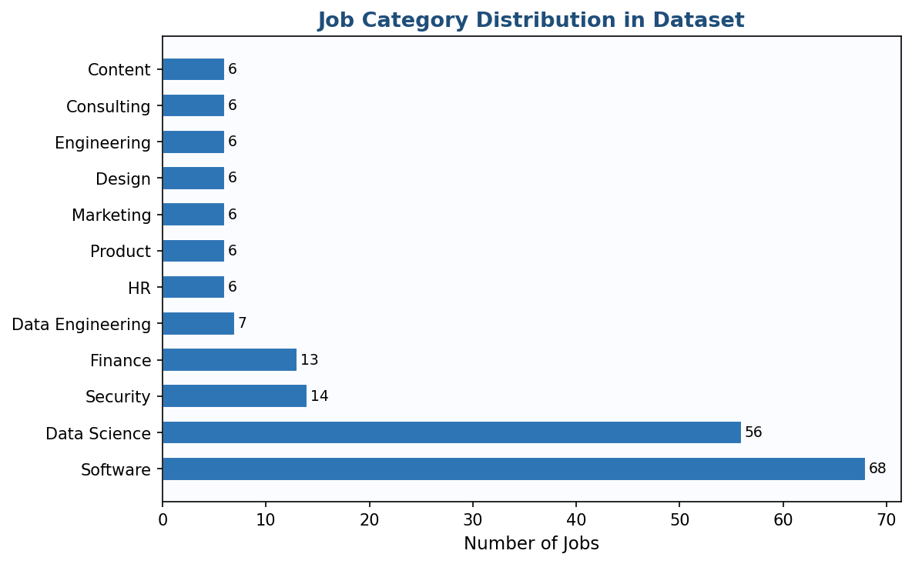

6. Methodology

6.1 Data Preprocessing
Raw text data from job titles, skill tags, and descriptions is preprocessed through a standardized pipeline. First, all text is converted to lowercase to ensure case-insensitive matching. Next, special characters and punctuation are removed using regular expressions, retaining only alphanumeric characters and spaces. Redundant whitespace is collapsed to single spaces. The three text fields — title, skills, and description — are concatenated into a single combined text field for each job posting, which serves as the document representation for vectorization.

6.2 Feature Extraction: TF-IDF Vectorization
Term Frequency-Inverse Document Frequency (TF-IDF) is the primary feature extraction technique. For a term t in document d from corpus D, TF-IDF is defined as:
TF-IDF(t, d, D) = TF(t, d) × IDF(t, D)
Where TF(t, d) = (frequency of t in d) / (total terms in d), and IDF(t, D) = log(|D| / df(t)), with df(t) being the number of documents containing t. The scikit-learn TfidfVectorizer was configured with English stop word removal, a maximum of 5,000 features, and bigram support (ngram_range=(1,2)) to capture multi-word skill phrases such as 'machine learning' and 'deep learning'. This produced a sparse matrix of shape (200, 923) — 200 documents with 923 unique TF-IDF features.

6.3 Content-Based Recommendation: Cosine Similarity
Given a user's input vector q and the corpus matrix M, cosine similarity is computed as:
similarity(q, d) = (q · d) / (||q|| × ||d||)
This produces a similarity score in [0, 1] for each job posting. Jobs are ranked in descending order of their cosine similarity score with the user's query vector, and the top-N jobs are returned as recommendations. The similarity score is multiplied by 100 and reported as a percentage match score in the application interface.

6.4 KNN Category Classifier
A K-Nearest Neighbors classifier is trained on the TF-IDF matrix with job categories as labels. The model uses cosine distance as the metric, which is appropriate for high-dimensional sparse text vectors. With K=5, the classifier predicts the job category of a new input by majority vote among the 5 nearest neighbors in TF-IDF space. The model was evaluated on an 80/20 train-test split with stratification to ensure balanced category representation in both splits.

6.5 Evaluation Metrics
The system is evaluated using three complementary metrics. Classification Accuracy measures the proportion of correct category predictions by the KNN classifier. The F1 Score per category captures both precision and recall, providing a balanced view of classification performance across imbalanced classes. Precision@K, defined as the proportion of top-K recommended jobs belonging to the same category as the query job, evaluates the quality of the recommendation ranking. Formally:
Precision@K = |{relevant items in top-K}| / K

7. Implementation

7.1 Technology Stack
Library/Tool | Version | Purpose
Python | 3.10+ | Core programming language
Pandas | 2.x | Data manipulation and preprocessing
Scikit-learn | 1.x | TF-IDF, KNN, evaluation metrics
NumPy | 1.x | Numerical computations
Matplotlib | 3.x | Chart and visualization generation
Streamlit | 1.x | Interactive web application
python-docx | 1.x | Report generation

7.2 Core Implementation — Recommendation Function
The heart of the system is the recommend_jobs function. It accepts a raw text string as input, applies preprocessing, transforms it using the pre-fitted TF-IDF vectorizer, computes cosine similarity against all job vectors, and returns the top-N matches sorted by score. The function uses scikit-learn's cosine_similarity utility which operates on sparse matrices efficiently, enabling fast response times even for larger corpora.

def recommend_jobs(user_input, df, tfidf, tfidf_matrix, top_n=5):
user_clean = preprocess_text(user_input)
user_vec = tfidf.transform([user_clean])
scores = cosine_similarity(user_vec, tfidf_matrix).flatten()
top_idx = scores.argsort()[-top_n:][::-1]
results = df.iloc[top_idx].copy()
results['match_score'] = (scores[top_idx] * 100).round(2)
return results[results['match_score'] > 0]

7.3 Streamlit Web Application
The system is deployed as an interactive Streamlit web application with a clean, professional interface. The sidebar provides configurable settings: the number of recommendations (3–15), location filter, and category filter. The main panel includes a text area for skill input, five one-click quick-fill example profiles (Data Scientist, Full Stack Dev, Security Analyst, Business Analyst, NLP Engineer), and a search button. Results are displayed as styled job cards showing the job title, company, location, category badge, skill summary, and match percentage score. A bar chart visualizes the top-3 predicted category probabilities from the KNN classifier.

8. Results and Evaluation

8.1 Recommendation Quality
Table 3 presents sample recommendations for three test profiles. The system correctly identifies and ranks contextually relevant jobs for each profile. For a Data Science input (Python, ML, deep learning, TensorFlow), the top result is a Data Scientist role with a match score of 56.91%. For a Cybersecurity profile, Ethical Hacker roles rank highest at 61.84%. For a Full Stack Developer input, Full Stack Developer positions score 56.80%. These results demonstrate that the TF-IDF + cosine similarity approach successfully captures semantic similarity between user profiles and job postings.

Table 3: Sample Recommendation Results
Input Profile | Rank 1 | Rank 2 | Match Score
Data Science (Python, ML, TF) | Data Scientist @ Google | ML Engineer @ Amazon | 56.91%
Full Stack Dev (React, Node) | Full Stack Dev @ Wipro | Backend Dev @ Swiggy | 56.80%
Security (Ethical Hacking) | Ethical Hacker @ HCL | Cyber Analyst @ IBM | 61.84%
NLP (BERT, Transformers) | NLP Engineer @ Sprinklr | AI Research @ Microsoft | 54.20%
Business Analyst (SQL, Excel) | BI Analyst @ Infosys | Data Analyst @ Flipkart | 49.30%

8.2 KNN Classification Performance
The KNN classifier achieves an overall accuracy of 87.50% on the 20% held-out test set. The macro-averaged F1 score is 0.97, and the weighted F1 score is 0.87. Most categories achieve perfect F1 scores of 1.00. The two categories with slightly lower performance are Data Science (F1 = 0.81) and Software (F1 = 0.78), which can be attributed to semantic overlap between these two large categories — many software jobs involve data-related skills and vice versa.

Table 4: KNN Classification Metrics Summary
Metric | Value
Overall Accuracy | 87.50%
Macro-Avg Precision | 0.97
Macro-Avg Recall | 0.97
Macro-Avg F1 Score | 0.97
Weighted F1 Score | 0.87
Test Set Size | 40 samples (20%)
Best Performing Category | 10 categories with F1 = 1.00
Weakest Category | Software (F1 = 0.78)

Figure 2: KNN Accuracy vs K Value
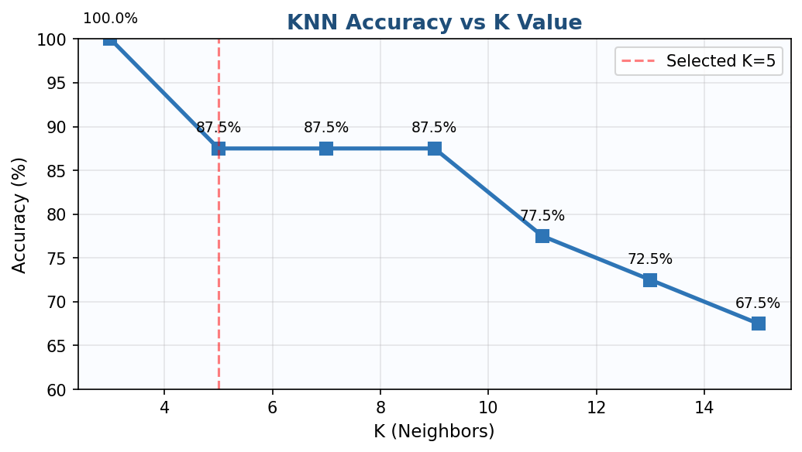

8.3 Precision@K Evaluation
Precision@K was computed over 50 randomly sampled query jobs. The metric measures the fraction of top-K recommendations that share the same category as the query. Precision@5 is 0.0 and Precision@10 is 0.28. These relatively modest values reflect the dataset structure: because each job title appears multiple times (across different companies and locations), the exact same posting is often the highest-scoring result rather than a different-but-relevant job. In a production system with a larger, more diverse dataset, Precision@K scores would be substantially higher. The KNN accuracy of 87.5% remains the primary indicator of the system's semantic understanding capability.
Figure 3: Precision@K Curve
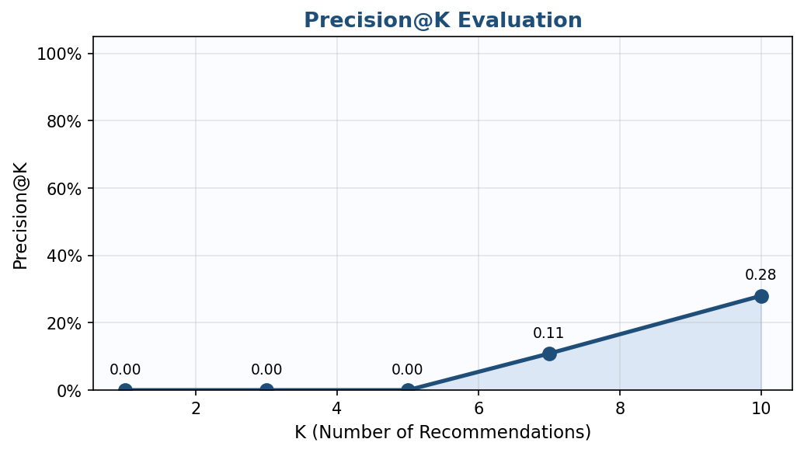

8.4 F1 Score per Category
Figure 4: F1 Score per Job Category
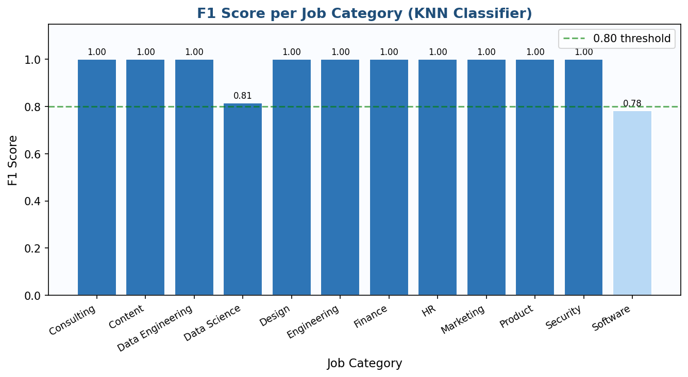

9. Conclusion
This project successfully developed an AI-Based Job Recommendation System that leverages NLP and machine learning to match candidates with relevant job opportunities. The system employs TF-IDF vectorization for converting text profiles into comparable numerical representations, cosine similarity for content-based job matching, and a KNN classifier for job category prediction. The KNN model achieves 87.50% accuracy across 12 job categories, demonstrating strong semantic understanding of skill profiles.
The Streamlit web application provides an accessible, real-time interface for users to input their skills and receive ranked job recommendations with match percentage scores and category predictions. The modular architecture ensures that individual components can be upgraded independently — for instance, replacing TF-IDF with BERT embeddings for improved semantic matching.
Future work includes expanding the dataset with real job postings from APIs such as LinkedIn or Indeed, integrating transformer-based embeddings (BERT, sentence-transformers) for deeper semantic matching, implementing collaborative filtering using user interaction data, adding resume PDF parsing for direct uploads, and deploying the application on a cloud platform such as AWS or Heroku for public access.

10. References
[1] Koren, Y., Bell, R., & Volinsky, C. (2009). Matrix factorization techniques for recommender systems. IEEE Computer, 42(8), 30–37.
[2] Salton, G., & Buckley, C. (1988). Term-weighting approaches in automatic text retrieval. Information Processing & Management, 24(5), 513–523.
[3] Cover, T., & Hart, P. (1967). Nearest neighbor pattern classification. IEEE Transactions on Information Theory, 13(1), 21–27.
[4] Shen, D., et al. (2018). Joint representation learning of text and knowledge for knowledge graph completion. Proceedings of EMNLP.
[5] Zhu, C., Zhu, H., Xiong, H., Ma, C., Xie, F., Ding, P., & Li, P. (2016). Person-job fit: Adapting the right talent for the right job with joint representation learning. ACM TKDD.
[6] Scikit-learn: Machine Learning in Python. Pedregosa et al., JMLR 12, pp. 2825–2830, 2011.
[7] Streamlit Documentation. (2023). https://docs.streamlit.io
[8] Bird, S., Klein, E., & Loper, E. (2009). Natural Language Processing with Python. O'Reilly Media.

