

Department of Electrical and Computer Engineering

ENCS3320-Computer Networks **(Network Layer Project)**

**Due date: 13/6/2024**

RULES:

1. This is a group project, so you are allowed to work in groups of max 3 students.
2. You are required to use Packet Tracer to solve this mini project.
3. Important: each snapshot should include the date and time of your computer.

SUBMISSION:

1. A technical report in pdf format (only pdf format) on moodle (itc.birzeit.edu) that containssnapshots withdetailed explanation**,** commands, runs, etc.
2. Labels are required to be added to the complete topology in the .pkt file.
3. You are also required to submit .pkt file of the full design with the required addressing and routing.

OBJECTIVES:

1. Learn to use packet tracer.
2. Learn to do IP subnetting and address assignment.
3. Learn to configure end devices like PCs and servers.
4. Learn to implement routing protocols on routers.
5. Learn to test and debug your network.

TOPOLOGY:

The topology illustrates in **Figure 1** contains the following devices:

1. Routers (**Router-PT**)
2. Switches (**Switch-PT**)
3. Server (**Server-PT**)
4. PCs (**PC-PT**)

The number of devices in the subnetworks are as listed in Table 2. However, you need to include/configure only the following devices in **Packet Tracer**:

1. Data center: 2 servers and 1-switch.
2. Company 1: 3 PCs and 1 switch.
3. Company 2: 2 PCs, 1 server, and 1 switch.
4. Company 3 Office 1: 3 PCs and 1 switch.
5. Company 3 Office 2: 2 PCs and 1 switch.
6. Core: 5 Routers with proper interfaces.

Part1: Wireshark

Using Wireshark, capture few TCP, DHCP and ICMP packets. Show the packets and explain at least 4 fields of each packet.

Part2: Packet Tracer

REQUIREMENTS:

0: IP subnetting and assignment

1. You are required to assign the IP addresses of the routers and end devices with respect to **one of the student IDs** in your group as follows:

* Assume the ID is 121**2031** then the IP is 1**20**.**31**.4.0/**23**.
* Design the required IP Addressing scheme and subnets using the above address space and the number of devices in **Table 2** and the topology given in **Figure 1**.

1. Note that any solution without including the ID as above **will not be accepted**.
2. Include a table in your report with the following information for all subnets (edge and core).

**Table 1: Subnetting details**

|  |  |  |  |  |  |  |
| --- | --- | --- | --- | --- | --- | --- |
| Subnet | Subnet Mask “using the slash notation” | Network IP | Broadcast IP | First IP | Last IP | Maximum number of IPs in this subnet |
| R1-R2 Link |  |  |  |  |  |  |
| Data Center |  |  |  |  |  |  |
| Company A |  |  |  |  |  |  |
| : |  |  |  |  |  |  |
| : |  |  |  |  |  |  |
|  |  |  |  |  |  |  |
|  |  |  |  |  |  |  |

1: Topology

1. Build the topology given in **Figure 1** using packet tracer based on the IP addressing scheme you designed in **Part0**.
2. Configure the interfaces of all routers as instructed in the figure.
3. End devices (i.e. PCs and Servers) in the datacenter and companies networks are getting their IPs in a static manner based on the assigned sunet IPs.

2: Configuring servers

1. Three servers are used in this topology: HTTP/WEB server and DNS server in Data Center network and a mail server in Company B network.
2. Configure the DNS server and WEB server with domain name www.ENCS3320.com
3. Create your website by modifying the index.html file in the HTTP server. Your website should contain:

* “ENCS3320-Course Website” in the title.
* “Welcome to Computer Networks course” (part of the phrase is in Red).
* Group members’ names and IDs.
* Try to make the page looks nice.

3: Routing Protocols

Use single area open shortest path first protocol (OSPF) on all routers.

4: Testing and Troubleshooting:

1. Test the connectivity between all PCs. You need to make **snapshots** of the results for ping and tracert commands between all PCs.
2. Access www.ENCS3320.com from all PCs, make **snapshots** for all cases.
3. Show the outputs of 1 and 2 as **snapshots** and record them in your report with detailed explanations.

**Table 2:** Number of hosts (PCs and Servers) per network **excluding** the router interface

|  |  |
| --- | --- |
| **Network** | **Number of End Devices (PCs and Servers)** |
| Data Center | 50 |
| Company A | 26 |
| Company B | 29 |
| Company C Office 1 | 10 |
| Company C Office 2 | 15 |

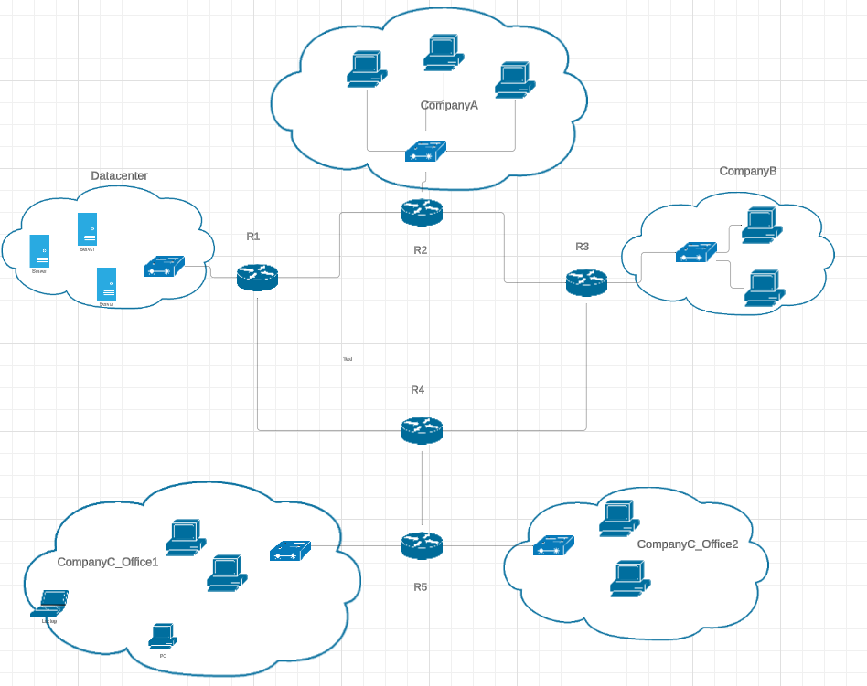

**Figure 1: Network Topology**