**(Basic) Graphics Programming using Visual Studio (VB, VC etc)**

Step 1: Download Visual Studio (Community 2017 (free)) from <https://www.visualstudio.com/vs/community/> or, check the VS_installer folder.

Step 2: Run the installer and find the following options:

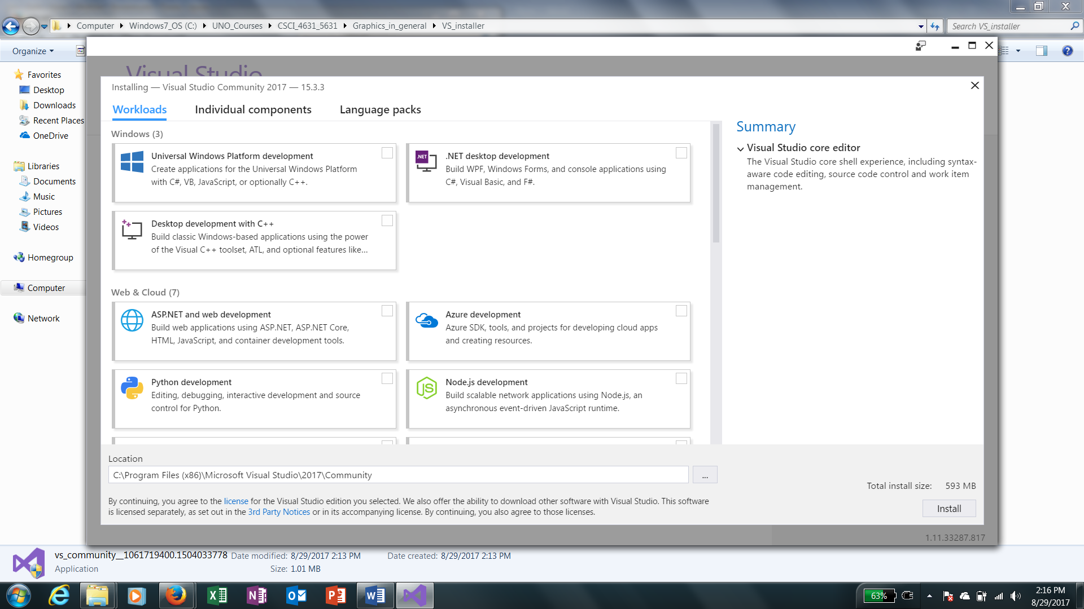

See the options:

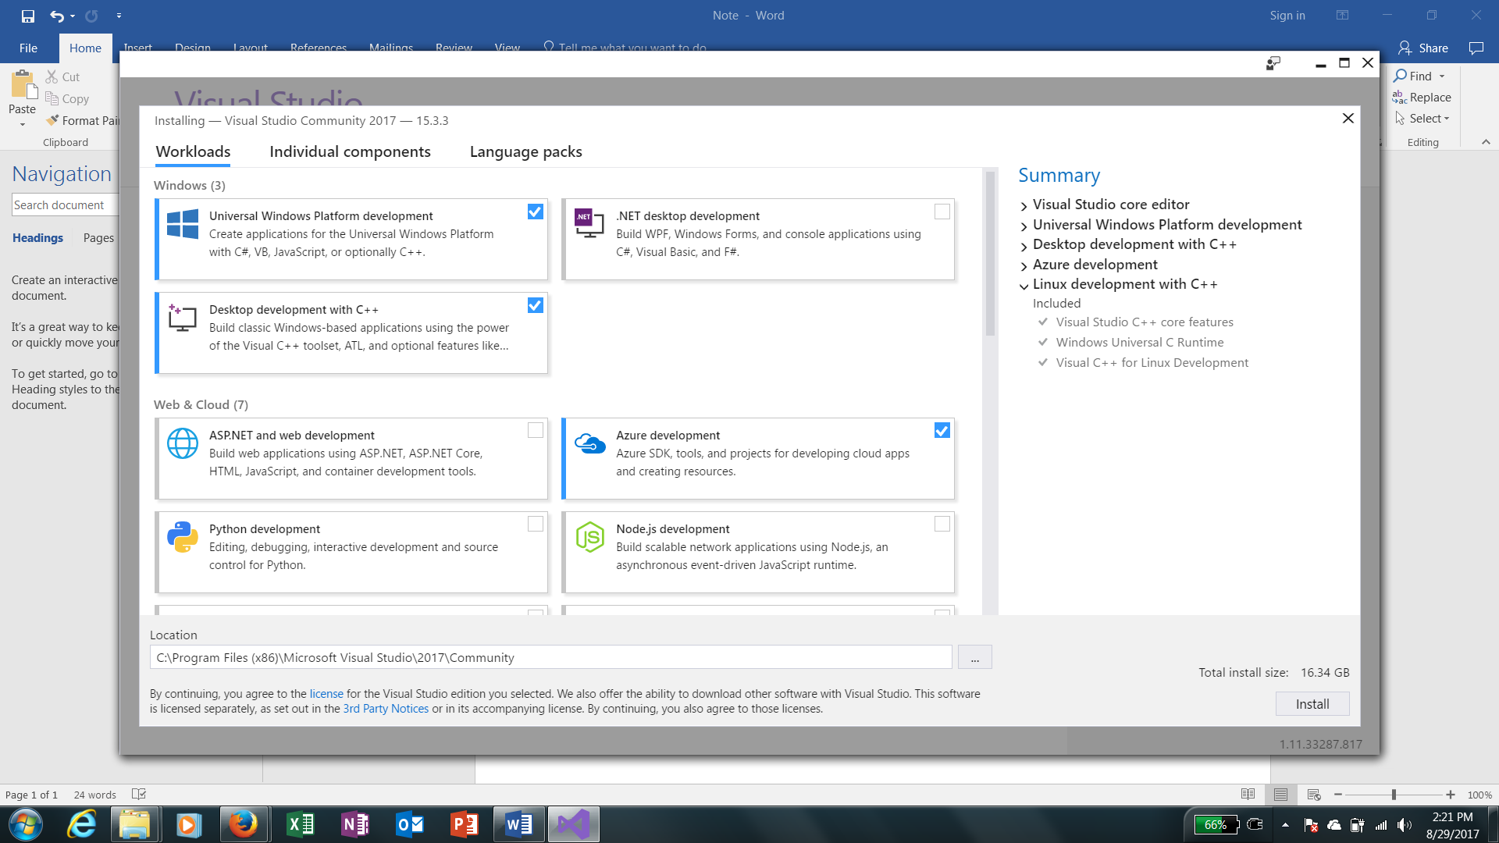

See the options:

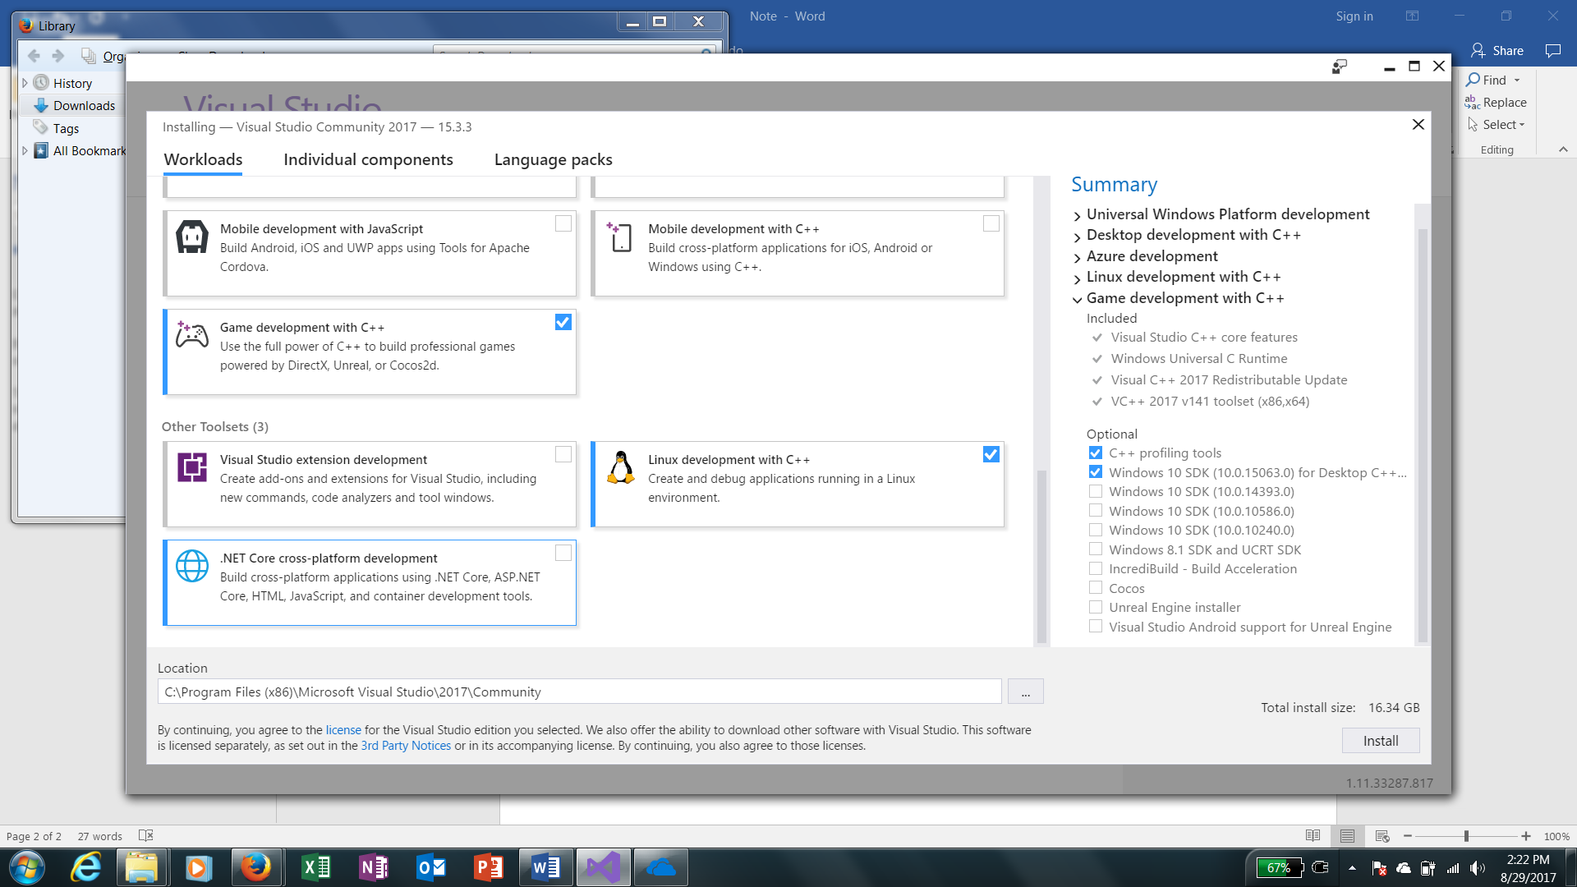

Once installed, for VB:

1. GoTo: File> New> Project:
2. Visual Basic > Windows Classic Desktop > Windows Forms App (.NET Frame Work) … see below:

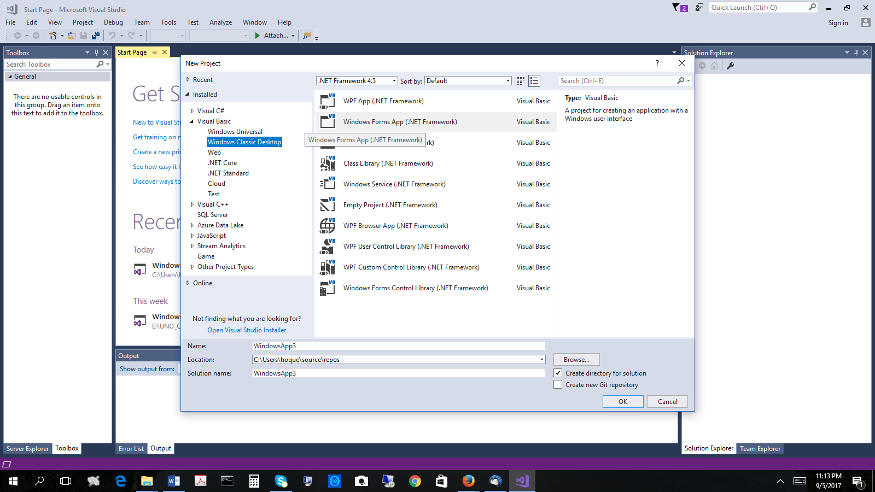

1. Once you press “ok” – you will get the following [you may need to pin the left-most toolbox to make it handy]

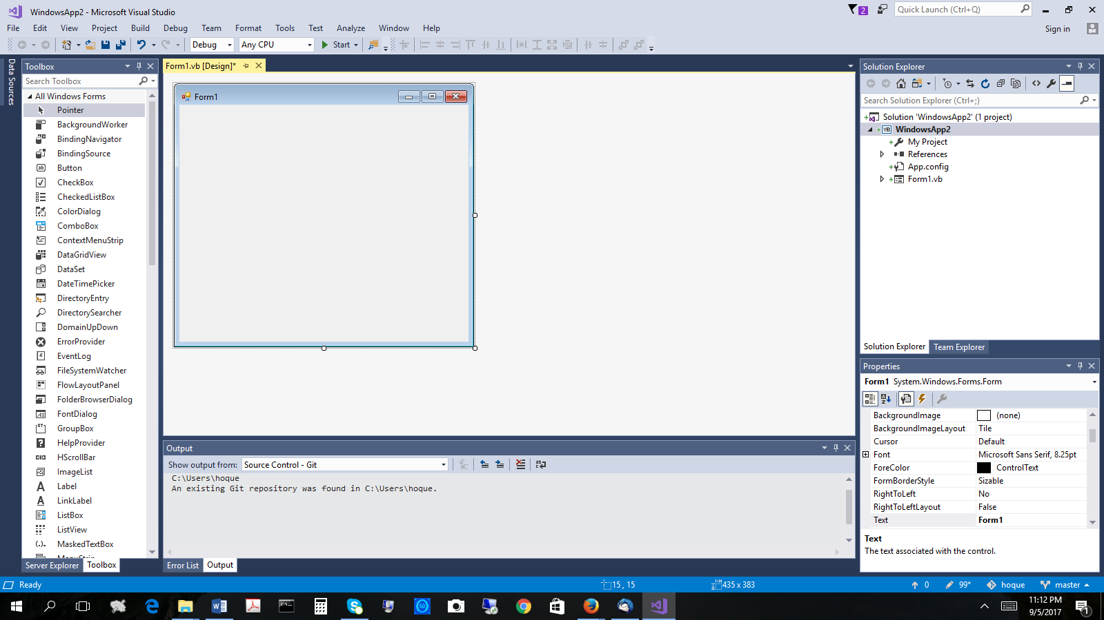

1. Work on designing your target program starting with the form.

You can similarly go for VC, - in this version I find the 1st form in VC crashes but addition of 2nd form works. So, you may remove the entries related to the 1st form and consider your second form as the 1st for – and start working similarly. In case of VC, you may need to explicitly the main() entry but not for VB.

--- x ---